**Hong Kong Institute of Vocational Education (Tsing Yi)**

**Department of Information Technology**

**Higher Diploma in Software Engineering (IT114105)**

**ITP4915M System Development Project**

**(2021/2022)**

**Prototype II and Final Report**

**Date: 9/6/2022**

|  |  |
| --- | --- |
| **Group No.** | **3** |

|  |  |  |
| --- | --- | --- |
| **Student** | **Contribution to the project (%)**  **(Total 100%)** | **Signature** |
| **Wong Wing Fung** | **25%** |  |
| **Li Zhi Wei** | **25%** |  |
| **Tam Chi Ka** | **25%** |  |
| **Hui Kwai Shing** | **25%** |  |

We declare that this is a group project and that no part of this submission has been copied from any other student’s work or from any other source except where due acknowledgement is made explicitly in the text, nor has any part been written for us by another person.

**Abstract**

This report reviews the current situation of Better Limited and we are required to develop a new computerize management system for the company. Better Limited is an electronic appliance retail store. The Company's primary business is to sell small to large electronic appliances, there are two retail stores located at Kowloon Bay and Tsuen Wan and a 6000 sq/feet warehouse. The Company has approximately 90 employees.

Recently, Better Limited is planning to expand the business in Hong Kong and Pearl River Delta Region, such as Shenzhen and Guangzhou, as the business becomes larger. We have planned to develop a new system to support the company to expand the business and meet their requirements for the new system.

To develop a better management system for the company, we have stated the functional and non-functional requirements of the new system in this report therefore we can have a clear concept on what kind of system we are going to implement.

Table of Contents

1.Introduction 8

1.1 Company background 8

1.2 Project background 8

1.3 Purpose of the System Requirements 9

1.4 The goal to be achieved by the management system 10

1.5 Product perspective 10

1.5.1 System interfaces 10

1.5.2 User interfaces 10

2. Problem Findings 11

2.1 Network security issues 11

2.2 System overload 12

2.3 System data backed up problem 12

2.4 System Data inconsistency problems 13

2.5 Access Control needed 13

2.6 Inventory management 13

2.7 Sales representative may lead to delivery issues 14

2.8 Sales representatives may not know if stock level is too low 14

3.Functional Requirement 15

Login System 15

3.1 Login Module  15

3.2 UI Language Changing Module 15

Sales Department 15

3.3 Sales Order System 15

3.4 Defect Item System 17

3.5 Delivery Order System 17

3.6 Customer System 18

3.7 Store Stock System 19

3.8 Print Receipt System 20

3.9 Reservation Delivery Service Module 21

3.10 Installation Service Request Module 22

3.11 Installation Worker Timetable 22

3.12 Reservation Installation Service the module 23

3.13 Re-order Item Module 23

3.14 Generate Purchase Order 24

3.15 The Stock Book Updates Automatically 25

3.16 Admin Module 25

4.Non-Functional Requirement 25

4.1 Security 26

4.1.1 Access Control 26

4.2 Usability 27

4.2.1 Intuitive UI 27

4.2.2 Notification 27

4.2.3 Schedule 27

4.3 Portability 27

4.4 Reliability 27

4.4.1 Roll back 28

4.4.2 Data Inconsistency 28

4.5 Data Retention 28

4.6 Interoperability 28

4.7 Performance 29

4.8 Localization 29

4.9 Maintainability 29

4.9.1 Maintenance  29

5. System Architecture 30

5.1 Hardware 30

5.1.1 Computer 30

5.1.2 Retail Sales department: 30

5.1.3 Accounting department: 30

5.1.4 Inventory department: 30

5.1.5 Technical Support department: 30

5.1.6 Purchase department: 31

5.1.7 About computer hardware details: 32

5.1.8 Server 32

5.2 Software 34

5.3 Network Configuration 36

6. How can an organization get benefit from this central computerized management system? 37

7. Constraint and Limitations 38

8. System Analysis and Design 39

8.1 Actor Description 39

8.2 Use Case Design 41

Sale Department 41

1.Sales Order System 41

2.Sales Delivery Order System 46

3.Sales Defect Item System 49

4.Sales Customer System 53

5.Sales Stock System 55

Inventory System: 59

1. Inventory Delivery Service System 59

2. Inventory Re-order System 62

3.Inventory Manage Goods System 67

4.Inventory Manage Goods System 70

5.Inventory Supplier System 73

Technical Support Department System 76

1. Technical Support Department Installation Service System 76

Admin System 80

9. Class Diagram 85

9.1 Data Dictionary 85

9.2 Order Management System 87

9.3 Sales Defect Item 87

9.4 Sales Stock Item System 88

9.5 Delivery and Installation 88

9.6 Inventory System 89

9.7 Inventory Good Management System 89

9.8 Inventory Supplier System 90

9.9 Technical Support System 90

9.10 Login System 90

9.11 Payment System 91

10. Sequence Diagram (3-Tier with MVC model) 91

10.1 Login System 92

10.2 Sales Order System 93

11 .State Machine Diagram 144

11.1 Sales Order Creation 144

11.2 Create replenishment request 145

11.3 Create Re-order Request 146

11.4 Create Purchase Order 147

11.5 Create Goods Returned Note 148

12. Entity Relation Diagram 149

13. Project Schedule 162

14.UI design 165

1. Login System 165

1.1 Input user name 165

1.2 display password 166

1.3 hide password 166

1.4 username or password incorrect 167

1.5 null value 167

1.7 Change password 168

1.8 Change password - input new password 169

1.8 Change password – null input 169

1.9 Change password – information incorrect 170

1.10 Change password – Different new passwords 170

1.11 Change password – Change password successful 171

2.Admin system 172

2.1 Null input 172

2.2 EmpID incorrect 173

2.3 Create successful 173

2.4 Update successful 174

2.4 Delete successful 174

2.5 Users list 175

3.Sales Order System 175

3.1 Delete Order2.Admin system 176

3.2 Payment Order Details 176

3.3 Deposit Order Details 176

3.4 Payment Receipt 177

3.5 Deposit Receipt 177

3.6 Print Payment Receipt 178

3.7 Print Deposit Receipt 178

3.8 Create Order (Payment Order) 179

3.9 Create Order (Deposit Order) 179

3.10 Create Delivery Order 180

3.11 Create Customer 180

3.12 Select Delivery Item 181

3.13 Update Payment Order 181

3.14 Update Deposit Order 182

4. Sales Delivery Order System 182

4.1 Check Delivery Order 182

4.2 Check Order Details 183

4.3 Delete Delivery Order 183

5. Sales Defect Item System 184

5.1 Check Defect Item 184

5.2 Delete Defect Item 185

5.4 Return Receipt 186

5.5 Print Return Receipt 187

6. Sales Stock Item System 187

6.1 Check Stock Quantity 187

6.2 Out of Stock Alert 188

6.3 Delete Stock Quantity 188

6.4 Edit Stock Quantity 188

6.5 Create Stock Quantity 189

7.Low level product alert 189

8.Add new inventory item 190

8.1Add new inventory item- successful 190

8.2Add new inventory item- error 191

9.1Delete inventory item- successful 192

9.2Update inventory item 192

10.1Update inventory item- successful 192

10.2Update inventory item- error 193

11.Reorder inventory item from supplier 193

11.1Reorder inventory item from supplier- successful 194

11.2Reorder inventory item from supplier- error 194

12.Ordering Item List 195

12.1Pre-print Goods Receive Note 195

12.2Print Goods Receive Note 196

12.3Add/Delete/Update supplier 196

13.1 Delivery Order Management System & Time Table 197

13.2 Order Detail – Delivery Order 198

13.3 Order Detail – Installation Order 198

13.4 Worker Task Manager – Delivery 199

13.5 Worker Task Manager – Installation 200

13.6 Order History 201

15. Test Case 201

1.Login System 201

2.Admin System 205

3.Inventory system: (add item) 206

Delete item 207

Update item 208

Reorder item 210

Return inwards 212

4.Delivery System: 214

5.Sales System 239

16.User Guideline 257

1.Login system 257

2.Admin system 260

3.Delivery Management System 264

4.Sales Department System 279

5. Inventory Department System297

17. How ITP4510, ITP4522 and ITP4915M modules help you to finish the project 325

18. Conclusion 327

19. Project Log 328

20. Reference 329

**1.Introduction**

**1.1 Company background**

Better Limited is an electronic appliance retail store. The Company's primary business is to sell small to large electronic appliances, such as hairdryers, TV, Air-Conditioner.

There is one office situated in Kowloon Bay and a 6000 sq/feet warehouse next to the office.  There are two retail stores located at Kowloon Bay and Tsuen Wan.

The Company currently employs approximately 90 employees.  There are five major departments in the Company: Sales (at retail stores), Accounting, Purchase, Inventory, and Technical Support.

Better Limited is planning to expand the business in Hong Kong and Pearl River Delta Region, such as Shenzhen and Guangzhou, as the business becomes larger.

Therefore, Better Limited needs to computerize the management system.

**1.2 Project background**

As Better Limited's business continues to expand. The Human Resource Management System is no longer available. Therefore, Better Limited needed to computerize the management system in order to simplify complex processes and saving manpower.

Our project will be computerizing the management system, the system will be connected to all departments to improve work efficiency, Incorporate such as sales, sales records, receipts, warehouse inventory, delivery services.... into the computerized management system.

**1.3 Purpose of the System Requirements**

The system needs to be able to create orders when items are sold or returned, and it will create sales data per day for the sales department, when the in-store or stock level at stock is close to or below the re-order level, the system will let the Inventory Department know it.

Every order is sent to the accounting department in real-time, and the deposit receipt will remain in the system's server deposit folder until payment is made.

For items that require installation, the Sales representative can use the system to arrange installation service with the Technical Support Department. and Similar to delivery.

The system needs to have a user interface in English and Simplified Chinese for employees to use

Every employee will have their own account to log in to the system, and their account password can be changed.

System will deploy computerized receipt printing to improve store efficiency and enhance store image.

**1.4 The goal to be achieved by the management system**

Our goal is to create a high-security system, and the system should be satisfied for over one hundred employees using at the same time, the System communication low delay in Hong Kong and Pearl River Delta Region. providing Backup and Recovery for the data. The Last is more user-friendly.

**1.5 Product perspective**

**1.5.1 System interfaces**

The management system should be run in OS system and Windows system.

**1.5.2 User interfaces**

The user interface is mainly represented graphically[1] and can be easily manipulated by the user via the keyboard and mouse. There will be toolbars and buttons in the interface.

**2. Problem Findings**

**2.1 Network security issues**

To connecting Pearl River Delta region branch and Hong Kong headquarters, may have remote access vulnerabilities, since Hong Kong and the Pearl River Delta region may not have sufficient secure connections. establishing a strong enough secure network connection can be expensive.

And there may be hackers attacking the system, we need to consider how to protect the system from cyber-attacks[2], how to protect data if the system is hacked, that is a problem we need to fix.

Solution:

Use the internal firewall[3] of the system to prevent unknown personnel from entering the system network, thereby improving network security and preventing hackers from invading.

Regarding the remote access vulnerability, we may create a VPN to connect Hong Kong and the Pearl River Delta to ensure it is safe

VPN[4] can provide encryption for data, make data exchange between Hong Kong and Pearl River Delta undetectable by hackers, improve security but can be expensive.

**2.2 System overload**

Since Better Limited now already has 90 employees and the number will still be growing up, we need to make sure the system can handle many users. and if the system overloads what will happen, what to do, and how to avoid that.

If we want to create a system that can handle huge user demands, it will need a lot of budgets, so need to think about how to cut the budget to make it possible

Solution:

Change buffer[5] size and extent, and may using Distributed system[6] to reduce the system pressure.

If it really can't handle it, the company can replace and increase the RAM/CPU to improve the performance of the system so that it will not be overloaded

**2.3 System data backed up problem**

Better Limited currently uses paper to record documents, if the paper is damaged, the information will disappear.

Solution:

Use database will be backed up once a day to prevent data loss and in the event of a failure, the latest functional backup must be immediately restored.

At the same time, employees can search the required data through the system (use date, keywords).

**2.4 System Data inconsistency problems**

Better Limited are using paper to record documents currently, different departments may use different recorded data.

Solution:

As with question 2.3, all departments using the database can see the same data, and if someone edits the data will update the data in real-time, no data inconsistencies occur.

The data refresh rate[7] will be maintained once per second.

**2.5 Access Control needed**

Our system involves different departments such as Accounting, Purchase, Inventory, and Technical Support. We need to ensure that the permissions of each department do not affect other departments,

Because someone might do something malicious to other departments, we need to prevent this from happening

Solution:

To prevent someone from doing malicious operations in the system, The system needs an audit log[8] to record everyone's operations and restrict everyone's permissions only the top management has administrator such as the Technical Support departments.

**2.6 Inventory management**

Better Limited sells a lot of types of electronic equipment, it can be confusing to find what people are looking for, and stock varies from store to store. In order to ensure that the inventory in the system is correct, manual inventory is required, resulting in a waste of human resources.

Solution:

The system should have an easy-to-find user interface, The system should have image display and search functions. Whenever the product is replenished and sold, the system will automatically increase or decrease the product to ensure that the number of products is correct

**2.7 Sales representative may lead to delivery issues**

For some large items, the Sales representative will arrange delivery with the Inventory Department. The availability of delivery workmen will be checked before the delivery can be made successfully.  For items that require installation, the Sales Representative will arrange installation service with Technical Support Department.

Sales representatives may make human errors in the process, leading to delivery issues, such as wrong delivery dates. Because he must deal with a lot of products.

Solution:

The system will list all delivery dates and items that need to be installed. Make sure sales reps make the right decisions.

**2.8 Sales representatives may not know if stock level is too low**

Sales representatives are required to do lots of work. They may ignore many events which require them to check initiatively. One of the events is the level of stock being too low.

Solution:

The system can set automatic reminders, and the system will automatically notify the sales representative when the stock is insufficient.

**3.Functional Requirement**

**Login System**

**3.1 Login Module [9]**

When employees need to use the system, they must enter their account and password to ensure the system’s security. Besides, employees have the option to change their passwords in the login module.  Change old password need to input correctly security questions answer, account number and their old password.

If their password is entered incorrectly, the system will request they enter their password again. Different account will go to different department.

**3.2 UI[10] Language Changing Module**

Since the system needs to be used in the Pearl River Delta Region and Hong Kong, languages supported by the system include English, Simplified Chinese.

**Sales Department**

**3.3 Sales Order System**

**Create Order**

When a sales representative creates an order, the system determines the order type based on the stock quantity. If the quantity purchased is greater than the quantity in stock, the order type will be deposit order. If the quantity purchased is less than the quantity in stock, the order type will be payment order. Customers should pay a 20% deposit if purchased an amount of more than $5000 in the unavailable product. When sales create an order, the stock quantity will automatically reduce the number of items purchased.

Order types include:

* Payment order
* Deposit order

**Check Order**

Sales representative and sales manager can check order in sales department, order information includes:

* Order ID
* Payment Type
* Create Date
* Employee ID
* Payment Method
* Store Region
* Total Amount

**Search Order**

Sales representative and sales manager can input order ID in textbox to check the order.

**Check Order Details**

Sales representative and sales manager can check order details in sales department, order have two types of details, they are deposit order details and payment order details.

Deposit order details include:

* Order ID
* Item ID
* Item Name
* Item Quantity
* Item price
* Total Amount
* Deposit Amount
* Outstanding Amount,
* Create Date
* Customer ID

Payment order details include:

* Order ID
* Item ID
* Item Name
* Item Quantity
* Item price
* Payment Amount
* Create Date

**Update Order**

Sales representative and sales manager can update order details if customers want to modify their deposit and item information.

**Delete Order**

Sales representative and sales manager can delete order if customer cancel the order.

**3.4 Defect Item System**

**Create New Defect Item**

If customer go to store to return defect items, sales representative and sales manager can create a defect item record. They will select information in existing product list, list information includes:

* Defect Item Name
* Item Quantity
* Return Price

**Create Old Defect Item**

If customer return defect items is not products in existing products in store. Sales representative and sales manager must input information includes:

* Item Name
* Return Price
* Item Quantity

**Check Defect Item**

Sales representative and sales manager can check defect item information in sales department, defect item information includes:

* Defect ID
* Defect Item Name
* Defect Item Quantity
* Return Price
* Employee ID

**Delete Defect Item Record**

Sales representative and sales manager can delete defect item record.

**3.5 Delivery Order System**

**Create Delivery Order**

If sales representatives and sales manager select need delivery service in creating order phase, they can create a delivery order. Delivery order has 15 timeslots every day, 1 to 5 represent morning delivery positions, 6 to 10 represent noon delivery positions, 11 to 15 represent afternoon delivery positions. Besides, they should select delivery item.

**Check Delivery Order**

Sales representatives and sales manager can check delivery order information. Delivery order information includes:

* Delivery ID
* Create Date
* Status
* Expected Delivery Date
* Timeslot
* Completed Delivery Date
* Employee ID
* Customer ID
* Installation Need

**Check Delivery Details**

Sales representatives and sales manager can check delivery order details information.

Details information includes:

* Delivery Order Product ID
* Quantity
* Delivery ID
* Product ID
* Amount

**Delete Delivery Order**

Sales department create a delivery order. If inventory department has not assigned worker to delivery. Sales representatives and sales manager can delete the delivery order.

**Search Delivery Order**

Sales representative and sales manager can input delivery ID in search box to check the delivery order.

**3.6 Customer System**

**Create New Customer**

If customers have no information store in our company, sales representative and sales manager should create a new customer when creating a deposit receipt or order needs delivery service.

Create new customer should input information includes:

* Customer Name
* Delivery Address
* Address District
* Phone Number

**Search Customer**

Sales representative and sales manager can input phone number in search box to check the customer information.

**3.7 Store Stock System**

**Check Stock Quantity**

Sales representative and sales manager can check store stock quantity. When the stock quantity is less than 20% of the maximum stock quantity, system will send alert information. Then stock status will display out of stock. If stock more than 20%, stock status will display sufficient.

Stock information includes:

* Product ID
* Product Name
* Price
* Stock Quantity
* Max Stock Quantity
* Stock Status
* Employee ID

**Create New Stock Items**

Only sales manager can create new stock items, sales manager should input information includes:

* Product Name
* Product Quantity
* Product Brand
* Product Type
* Product Price
* Product Weight
* Max Stock Quantity

**Edit Stock**

Only sales manager can edit stock quantity. When inventory department delivers items to store, sales manager will update stock quantity.

**Delete Stock Item**

Only sales manager can delete stock item.

**3.8 Print Receipt System**

Sales Department can print three types of receipt, they are return receipt, deposit receipt and payment receipt.

**Return Receipt** information includes:

* Defect ID
* Return Date
* Employee ID
* Return Items
* Return Quantity
* Return Price
* Total Return Amount

**Payment Receipt** information includes:

* Order ID
* Employee ID
* Date
* Payment Method
* Store Region
* Item Name
* Item Quantity
* Item Price
* Total Amount

**Deposit Receipt** information includes:

* Order ID
* Employee ID
* Date
* Payment Method
* Store Region
* Item Name
* Quantity
* Item Price
* Deposit Amount
* Total Amount
* Outstanding Amount

**3.9 Reservation Delivery Service Module**

The Inventory Department has the authority to make an appointment for a delivery service.

They can book a delivery service when

* The Inventory Department receives a replenishment request from The Sales Department
* The Inventory Department collects defective items returned by customers
* For some large items, The Inventory Department needs to arrange a home delivery service
* Inventory returns defective items to supplier

The Inventory Department should check delivery worker availability before delivering items successfully and arrange for workers to deliver items.

The system should display:

* Expect delivery date
* Time slot
* Delivery Status
* Customer ID
* Shipping Address
* Installation Need
* Worker Name
* Total item weight

If the delivery service is not start, The Inventory Department can modify the delivery service content, such as item quantity.

The Inventory Department can retrieve delivery service content anytime.

If the delivery service is not start, The Inventory Department can delete the delivery service.

**3.10 Installation Service Request Module**

If customers purchase items that require installation service, The Sales Department will provide an installation service. The Sales Department can create an installation request for The Technical Support Department.

The sales representatives need to enter the following attributes to create an install service request:

* Created Date
* Installable time
* Items’ Name
* Amount
* Sales Representative's Name
* Customer Information
* Installation Address
* Remarks

If he Sales Department wants to modify the installation content, they can update the installation content before the installation request is approved.

The Sales Department can retrieve installation requests’ content anytime.

The Sales Department can delete the installation request if the customer cancels the order.

**3.11 Installation Worker Timetable**

If the Technical Support Department needs to assign installation work, they should check the installation worker timetable. The installation worker timetable should display worker information and worker status is busy or free.

The timetable should display:

* Worker Name
* Worker Status
* Installation Date
* Installation status
* Installation Completed date

**3.12 Reservation Installation Service the module**

After the installation service is approved, The Technical Support Department will check the availability of workers and arrange for the installation worker to finish the installation work.

Technical support workers should enter the following information:

* Installation Completed date
* Installation status

The Technical Support Department can update the installation service if the installation worker are not completed

The Technical Support Department can retrieve installation service content anytime.

The Technical Support Department can delete installation service if the customers cancel the installation service.

**3.13 Re-order Item Module**

If a non-phasing out item reaches a certain level, the inventory system will prompt a alert message and ask the user to reorder item.

The Inventory Department employee is required to input the following attributes to create a reorder request:

* Reorder ID
* Item Name
* ItemType
* Item Brand
* Supplier
* Item Quantity
* Item Price
* Amounts
* Receive Date

If the re-order request is not approved, The Inventory Department can modify the re-order request content, such as item quantity.

The Inventory Department can retrieve the re-order request content any time

If the re-order request is not approved, The Inventory Department can delete the re-order request content, such as item quantity.

**3.14 Generate Purchase Order**

If a re-order request is approved, a total purchase order will be generated. The total purchase order will be sent to The Accounting Department.

The total purchase order will include the following attributes:

* Purchase Order Number
* Created Date
* Items' Name
* Amount
* Unit
* Price
* Delivery Deadline

If the total purchase order has items with different suppliers, the purchasing employee should create different purchase orders and send to the different suppliers.

The purchase order will include the following attributes:

* Purchase Order Number
* Created Date
* Items' Name
* Amount
* Unit
* Price
* Purchaser Information
* Supplier Information
* Delivery Deadline
* Payment Method
* Delivery Address
* Signed by Both Parties

**3.15 The Stock Book[11] Updates Automatically**

The stock book is automatically updated when the following conditions occur:

* The Inventory Department purchases from suppliers
* The Inventory Department ships to The Sales Department

The stock book will include the following attributes:

* Items’ name
* Item quantity

**3.16 Admin Module**

This module is for human resource manager to create, delete, update employee account.

And checking the employee account list.

The employee account list should display:

* employee ID
* employee Name
* employee department
* Account number
* Password
* Security question answer

**4.Non-Functional Requirement**

**4.1 Security**

The system allows two types of accounts, which are Admin account and Staff account. An Admin account has privileges to manage services for assign permissions, create, modify the Staff account, or delete the existing Staff account, and they have all permissions to manage the database.

To protect sensitive data, the system requires users to provide a valid employer number and password that matches a strong password policy to access the system.

The system will force employees to change their password if they have not changed it within Six month. Next time a staff member tries to log into the system, the user will be prompted with a message box with several input placeholders that request the user to enter the answer for the verification question and input the new password.

**4.1.1 Access Control**

The purpose of access control is to provide staff with quick and convenient access to places they are authorized to enter. Admin will assign permission to the staff account based on their roles and responsibilities.

The system allows the following permission:

* Sales can read, create Sales order
* Sales Manager can read, create Sales order
* Sales can read, update and create unavailable item sales order
* Sales manager can read, update and create unavailable item sales order
* Sales & Sales Manager can read, create Delivery order
* Inventory Department can read, update the delivery status for Delivery order
* Technical Support Department can read Delivery order and update the status of installation service
* Sales & Sales manager can read stock status
* Inventory department can read, update the stock status
* Sales Manager, Accounting Manager and Purchase manager can read, update and create Item Status

**4.2 Usability**

**4.2.1 Intuitive UI**

Most of the employees from Better Limited do not have an IT background. To ensure employees can effectively use new technology systems. The system must provide a clear and intuitive user interface in order to quickly access content that the user is looking for, and we expect 90% of users are able to use the system without training.

**4.2.2 Notification**

The system will prompt the error message to the user and rollback when the manager tries to update the item price for individual stores because the price of the same item must be same in different stores.

Any valid modification to the item will be displayed in the notification bar for the sales team, accounting department, Purchase department. Also, the system will send broadcast messages to every store.

The system will prompt the reminder message for the inventory clerk and sales team when stock levels reach a certain level.

**4.2.3 Schedule**

The delivery service requires the cooperation of multiple departments. Manual operations will increase the risk of errors and accidents. The system will provide scheduler service to display the daily schedule of delivery service and available delivery time. Also, the update frequency of scheduler service must be less than 1 second.

**4.3 Portability**

The system shall be available for Microsoft Window 7 to 10 and Mac OS since these two are the most popular operating systems in worldwide and should develop a watered-down mobile version for the system which only provides simple query services.

**4.4 Reliability**

The system must be able to remind the user if they input invalid data. It should prompt the error message that explains why it happened and give a suggestion below the error message.

**4.4.1 Roll back [12]**

The system should allow the user to rollback the step if the user updates data incorrectly and it should produce a warning notification when the step is not allowed to rollback.

**4.4.2 Data Inconsistency**

Data inconsistency may occur when the same document exists in different departments, this leads to data redundancy resulting in manpower wastage. Therefore, the system must have the database meet the requirements of the 3NF database schema design in order to avoid anomalies, duplicate or redundant data.

**4.5 Data Retention**

Paper documents can be easily damaged, lost, illegally modified, and are not environmentally friendly.

In order to improve this problem, the system will use a database for storing all the data into Server that provides MySQL services. Anything the user needs to store will be organized and permanently stored in the database.   
Since most of the data will be stored in the database, paper records will not be needed, except for the document to the customer.

**4.6 Interoperability**

Data sharing between different departments is limited since the company uses standalone PCs and electronic spreadsheets to manage the data.

Therefore, the system will use a database for storing all the data into Server that provides MySQL service. It enables multiple users to access to database through more than one device Simultaneously and allow employee to sharing information between different department by connect device to a network.

**4.7 Performance**

The system should provide low loading times and immediate response after request of the employee so they can complete their work more efficiently, therefore. The system must be capable of supporting over 180 users per second and must provide 2 second or less response time, which includes getting a summary report, creating or updating order details, etc.

Since most of the Information Technology Office employees are trained to use C#, therefore, the new system will be developed in the programming language C#.

**4.8 Localization**

The UI of the system is designed to support multiple languages which include English, traditional Chinese .

**4.9 Maintainability**

**4.9.1 Maintenance [13]**

The system maintenance should be offline for less than 8 hours and it should always be available from 9:00am to 10:00pm or current working hours. The system will check the version when system startup and automatically update it to the latest version. Users are not allowed to login into older versions of the system to prevent errors occurring.

**5. System Architecture**

**5.1 Hardware**

**5.1.1 Computer**

About computer resource allocation, Better Limited currently has 90 employees across five departments, and now was planning to expand the business in Hong Kong and Pearl River Delta Region, we will make a reasonable allocation based on the current situation

**5.1.2 Retail Sales department:**

Each branch requires two computers, it is for connecting systems to check inventory and send the order (e.g. installation order, delivery order) to other departments.

Better Limited currently has two retail stores located in Kowloon Bay and Tsuen Wan. So now the retail department needs four computers.

**5.1.3 Accounting department:**

The accounting employees need to extract the data collected from the database through the computer.

We are planning to provide 10 computers for the accounting staff to use.

**5.1.4 Inventory department:**

Inventory employees will need to use a computer record inventory, check inventory quantity, receive order requests and send purchase requests.

We are planning to provide three computers for the Inventory staff to use.

**5.1.5 Technical Support department:**

Technical Support employees need to use a computer to connect to monitoring the database, manage and maintain the data of the database, and receive installation orders from the sales department.

We are planning to provide one computer for connecting to monitoring the database, and three computers for staff to receive orders from other departments.

**5.1.6 Purchase department:**

purchase employees need to use computers to receive out-of-stock orders and use the computer to make purchases and contact suppliers.

We are planning to provide five computers for the Purchase staff to use.

At now, in total we will need 26 companies, But the company can still buy more computers depending on the situation.

Regarding the computer hardware, we will use the following configuration uniformly:

|  |  |  |
| --- | --- | --- |
| Computer hardware | Hardware Name | HKD |
| CPU | AMD Ryzen 5 5600G 3.9GHz 4M 6 Core 12 Thread 65W AM4 | $2500 |
| Motherboard | MSI MAG B550M BAZOOKA M.ATX | $1060 |
| RAM | Kingston FURY Beast DDR4 3200MHz 16GB (2x8) CL16 KF432C16BBK2/16 | $740 |
| SSD | WD BLACK 500GB SN750 SE NVMe™ M.2 SSD | $490 |
| Power Supply | Corsair RM Series™ RM750 — 750 Watt 80 PLUS® Gold Certified Fully Modular PSU | $920 |
| CPU cooler | Deepcool AS500 Plus | $400 |
| Chassis | AeroCool Corporate Series CS 103 M.ATX | $199 |
| Monitor | ASUS VP228HE Gaming Monitor - 21.5" FHD (1920x1080) | $1050 |
| assembling computer | terminalhk | $80 |
| External device: |  |  |
| Mouse and keyboards | Philips C254 Keyboard Mouse Combos | $78 |
| Headphone and mic | Jabra Evolve 20 | $350 |
| Webcam | C270 HD WEBCAM | $200 |
| Total computer: |  | $8067 |

**Total needs: $8067*26= 209742**

**5.1.7 About computer hardware details:**

Since this is for paperwork, we don't need to additionally buy a display card, using the motherboard built-in is enough to handle.

The power supply is very important for computers if it breaks, the whole computer may break too, so I choose a Power supply that has 80 Plus Gold, it may be more expensive but safe.

SSD is faster than HDD, because working speed is important, so we buy SSD.

Overall computer hardware choice is cheap and durable.

The supplier we have chosen terminalhk since it has quality assurance, can purchase all hardware, and it provides assembling computer.

**5.1.8 Server**

We need to buy two servers, one is for Application server, the other one is for **5.1.8.1 Database Server**

The server will put in Technical Support departments.

The server will use the following configuration:

|  |  |  |
| --- | --- | --- |
| **Application Server Hardware:** | Product | HKD |
| **CPU** | Intel® Xeon® E-2386G Processor (12M Cache, 3.50 GHz) | $11,339 |
| **Hard Drive** | Seagate Exos 7E2 | $2000 |
| **ECC RAM x10** | DDR4 2666 8GB SERVER RAM ECC KTH-PL426E/8G 8G | $1089 x10 = 10890 |
| **Chassis** | in-Win IW-MS04-01 - Mini-ITX NAS Case w/ 4x Hot-Swap Bays (SATA Discrete Connection) - 265W ATX PSU Included | $1530 |
| **Logic Case** | Logic Case SC-23400-4 | $550 |
| **Motherboard** | MX33-BS0 | $30000 |
| **Power Supply** | Athena Power AP-RRU2ATX808 800W Micro 2U (1+1) Redundant Server Power Supply – 80PLUS Gold Certified – ATX12V/EPS12V/CRPS - Retail/OEM Available – OEM Abkoncore Xtreme MX Micro-ATX Case | $4000 |
| **Monitor** | ASUS PB278QR 27" 2560x1440 IPS Professional Monitor | $4590 |
| **Server installation** |  | $3000 |
| **Total** |  | $67999 |

About details:

The application Server needs to deal with many users, so it will need a lot of ECC RAM to make sure the system will not crash.

**1.Database Server:**

HPE Superdome Flex 280 Server $ 194970

About details:

The Database Server we will buy HPE because it has reputation and quality assurance.

**2.Uninterruptible Power Supply**

APC SYA12K16I: $96726

About details:

In order to prevent the company from suddenly losing power and data disappearing, we need a UPS to start when the power is cut off. Let the server save the data.

**Other:**

**3. POS System:**

i) Retail POS Point of Sale System –

includes Touchscreen for System testing and retail $12927

ii) Scanner: NETUM USB Barcode Scanner with Stand Hands for Payment:

$476*10 =4760

iii) Printer: HP DeskJet 2723e $500*5 =$2500

About details:

POS system is for Retail Sales to use, has a user-friendly graphical interface and touch screen and is very easy to use.

Scanner is for some department to scan commodities to extract data or records.

Each department will need one printer for printing orders or something.

**5.2 Software**

About all system, we will use C#, PHP and Java Servlet to programming

Database Server, we will use MySQL to architecture

Application Server, we will use Bea WebLogic to manage and monitor.

|  |  |
| --- | --- |
| Name | Computer OS System: Microsoft Windows 10 |
| Describe | Windows 10 has a graphical user interface that is very user-friendly and supports most applications. It is good for the company to use. |
| Cost (HKD) | 1549*26=$40274 |

|  |  |
| --- | --- |
| Name | Microsoft office 365 Business |
| Describe | office 365 has a powerful paperwork function, it can be used to Reporting, Record, or Collecting Data, it will be very useful for the accounting department doing accounting job. |
| Cost (HKD) | 564*10=$5640/year |

|  |  |
| --- | --- |
| Name | Visual Studio Code |
| Describe | Supports most programming languages including JavaScript, C/C++. Features include syntax highlighting and bracket completion, which is very useful for programming. |
| Cost (HKD) | free |

|  |  |
| --- | --- |
| Name | MySQL |
| Describe | MySQL is a database management system that supports C#, PHP, Java and other programming languages.  Provides management tools for managing, checking, and optimizing database operations |
| Cost (HKD) | 34100/year |

|  |  |
| --- | --- |
| Name | Bea WebLogic |
| Describe | Bea WebLogic is a management tool for application servers, it can easily monitor the status of the server. |
| Cost (HKD) | free |

**5.3 Network Configuration**

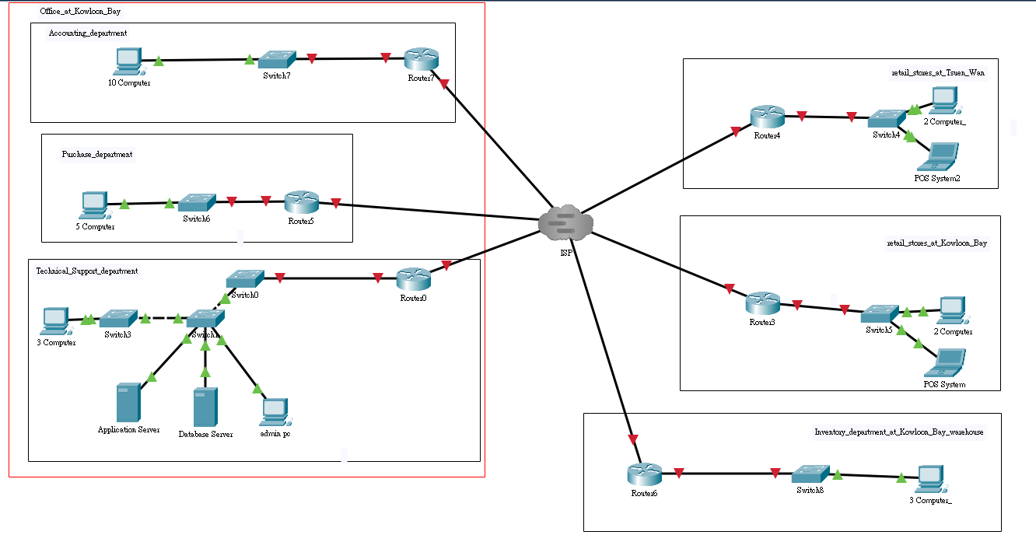

**6.** How can an organization get benefit from this central computerized management system?

With the central computerized management system[14], we can search, view, or edit a document easily just by moving our fingers in few step. The system supports simultaneous operation and share information of multiple users, the document can be uploaded to our management server, so that everyone can be used and download it, compare to the traditional manual processing, the central computerized management system is definitely more flexible and time efficient.

For instance, if a number of retail stores without computerizing its management system, they may face the problem of product management. The retail store needs to dealing with a massive amount of customers and orders every day, without a system that can easily centralized the product information or keep updating the latest price of product, it may waste a lot of time to have a communication with all the retails stores at the same time. For example, if we need to change the product price immediately, we just have to modify the price in the computer system, instead of noticing them one by one. Also, the central computerized management system can let us to know which product is almost sold out or had sold out already, so that we can repurchase the product from the supplier, or noticed which store still have the same kind of product left immediately.

In addition, if a company which requires a central computerized management system, I would recommend to set up the central computerized management system, since it allows the company to record all the employee's information and we can insert, update, delete and select the data by a central system. Also, the database system allows us to search for particular data with different search conditions. It can reduce manpower and space through computerized data storage. Also, it provides users with the information needed quickly and in real time.

Furthermore, the computerized management system storage all the data with our customers or sales number, so it can help us to analyse the sales figures in details, the digitization data is extremely helpful for inspecting whether the past turnover is in line with our expectation or not, it is also a decent system for us to anticipate and predict the sales growth of the future, which would be one of the key factor to decide the developing direction of the company.

**7.** Constraint and Limitations

**Availability of user interface:**

If the user thinks that the UI is hard to understand and use, we may need to spend a lot of time teaching them how to use the software. Therefore, the user interface with good design should be able to reach the goal of cost reduction, with a better UI design for users. Also, the expense of training our employees in how to use the system would be increased. For instance, some employees may not be very familiar with the new system, so a system with a user-friendly interface should be able to save a lot of time and money on staff training.

**Connection stability:**

A new store will be opened in Pearl River Delta Region soon, so we need to have network connection between Hong Kong and Pearl River Delta Region. Therefore, the connection quality may not be stable enough for the data transfer between two places. If we didn't deal with the problem of connection, the data may not be updated instantly, and it would eventually affect the operation of the whole system.

**System Extensibility:**

The finished system may not completely fulfil the needs of all users. Therefore, when we are designing the new system, we need to consider the extensibility of the whole system, the finished system should be able to extend with different function easily, instead of hard to implant a new function. Thus, if we need to add a function to the system, we just need to implant the function in the corresponding place, and reach the goal of time effective.

**8.** System Analysis and Design

**8.1** Actor Description

|  |
| --- |
| Actor Specification |
| Actor name: Sales Staff |
| Description: Sales staff is all staff in the sales department, but not sales manager. They don't have any modification permissions in store stock system. |

|  |
| --- |
| Actor Specification |
| Actor name: Sales Manager |
| Description: Sales manager is a manager in the sales department. He is responsible for managing sales staff. Sales manager has all permission in sales department. |

|  |
| --- |
| Actor Specification |
| Actor name: Inventory Staff |
| Description: Inventory staff includes inventory manager and staff, but not Goods Inwards Clerk. They are responsible for monitoring stock levels, checking delivery workers' availability, creating delivery services, recycling defective items, generating delivery notes, creating re-order requests and generating electronic goods received note. |

|  |
| --- |
| Actor Specification |
| Actor name: Delivery Worker |
| Description: Delivery worker is responsible for delivering goods. They need to upload delivery notes when they finish the work. |

|  |
| --- |
| Actor Specification |
| Actor name: Installation Worker |
| Description: Installation worker is responsible for installing goods in customer’s home. They need to upload installation notes when they finish the work. |

|  |
| --- |
| Actor Specification |
| Actor name: Technical Support Department Staff |
| Description: Technical Support Department Staff manage a staff account. Besides, they are responsible for check work and finish work. |

|  |
| --- |
| Actor Specification |
| Actor name: Technical Support Department Manager |
| Description: Technical Support Department manage an administration account. Besides, manager have all permission in technical support system |

|  |
| --- |
| Actor Specification |
| Actor name: Payment Gateway |
| Description: An external entity which handles the credit card and e-payment platform transaction. |

8.2 Use Case Design

Sale Department

1.Sales Order System

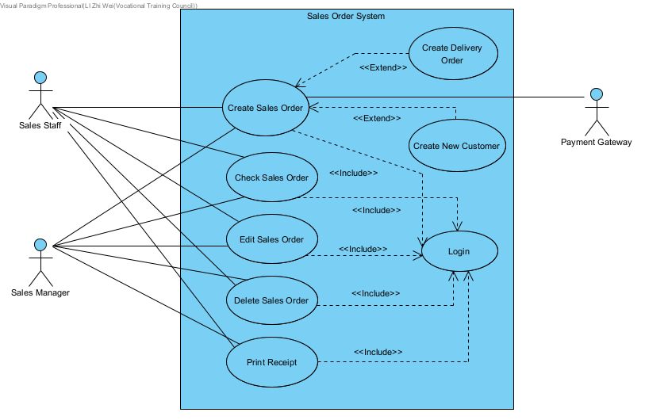

**Order Management System:**

1.Sales Order System

|  |  |
| --- | --- |
| **Use case name:** | Create Sales Order |
| **Use case ID:** | UC-10 |
| **Primary actor:** | Sales Manager, Sales Staff |
| **Secondary actor(s):** | Payment Gateway |
| **Brief description:** | Sales Manager or Sales Staff can create sales orders |
| **Pre-conditions:** | The employee has a valid account |
| **Flow of events:** | 1. Include (UC-01: Login)  2.Sales Manager or Sales Staff select “Create” in sales department to the create order page  3. Sales Manager or Sales Staff input information about the sale order that as order ID, select item, item quantity, store region and whether needs delivery service.  4. The sales select one of payment method include “Alipay”, “Credit Card”, “Alipay HK”, “Master Card”, “VISA” to send to payment gateway.  5. The sales select payment method is “Cash”, sales will receive cash  6. Extend (UC-02: Create Delivery Order)  7. Extend (UC-05: Create New Customer)  8. Click “Finish” |
| **Postconditions:** | A new sales order will be created |
| **Alternative flows and exceptions:** |  |
| **Non-behavior requirements:** | The stock quantity should be automatically reduced after the order is created. |
| **Issue:** |  |
| **Priority:** | High |
| **Source:** |  |

|  |  |
| --- | --- |
| **Use case name:** | Check Sales Order |
| **Use case ID:** | UC-20 |
| **Primary actor:** | Sales Manager, Sales Staff |
| **Secondary actor(s):** |  |
| **Brief description:** | Sales Manager or Sales Staff can view sales order |
| **Pre-conditions:** | The employee has a valid account |
| **Flow of events:** | 1. Include (UC-01: Login)  2. Sales Department display sales order lists  3. Sales Manager and Sales Staff input order ID in search box to search the order.  4. Sales Manager and Sales Staff click “Details” to check order details and items information. |
| **Postconditions:** |  |
| **Alternative flows and exceptions:** |  |
| **Non-behavior requirements:** | Traceability, the employee can check details of file |
| **Issue:** |  |
| **Priority:** | High |
| **Source:** |  |

|  |  |
| --- | --- |
| **Use case name:** | Edit Sales Order |
| **Use case ID:** | UC-30 |
| **Primary actor:** | Sales Manager, Sales Staff |
| **Secondary actor(s):** |  |
| **Brief description:** | Sales Manager or Sales Staff can update sales order |
| **Pre-conditions:** | The employee has a valid account |
| **Flow of events:** | 1. Include (UC-01: Login)  2. Sales Department display sales order lists  3. Sales Manager and Sales Staff input order ID in search box to search the order.  4. Sales Manager and Sales Staff click “Update” to update page  5. Sales Manager and Sales Staff modify information about the select order.  6. Sales Manager and Sales Staff click “Finish” |
| **Postconditions:** | Select order is updated. |
| **Alternative flows and exceptions:** |  |
| **Non-behavior requirements:** |  |
| **Issue:** |  |
| **Priority:** | High |
| **Source:** |  |

|  |  |
| --- | --- |
| **Use case name:** | Delete Sales Order |
| **Use case ID:** | UC-40 |
| **Primary actor:** | Sales Manager, Sales Staff |
| **Secondary actor(s):** |  |
| **Brief description:** | Sales Manager or Sales Staff can delete order |
| **Pre-conditions:** | The employee has a valid account |
| **Flow of events:** | 1. Include (UC-01: Login)  2. Sales Department display sales order lists  3. Sales Manager and Sales Staff input order ID in search box to search the order.  4. Sales Manager and Sales Staff click “Delete”  5. The system display a double confirms alert.  6. Sales Manager and Sales Staff click “Yes” |
| **Postconditions:** | Selected order is deleted |
| **Alternative flows and exceptions:** |  |
| **Non-behavior requirements:** |  |
| **Issue:** |  |
| **Priority:** | High |
| **Source:** |  |

|  |  |
| --- | --- |
| **Use case name:** | Print Receipt |
| **Use case ID:** | UC-50 |
| **Primary actor:** | Sales Manager, Sales Staff |
| **Secondary actor(s):** |  |
| **Brief description:** | Sales Manager or Sales Staff can print hardcopy to the customer |
| **Pre-conditions:** | The employee has a valid account |
| **Flow of events:** | 1. Include (UC-01: Login)  2. Sales Department display sales order lists  3. Sales Manager and Sales Staff input order ID in search box to search the order.  4. Sales Manager and Sales Staff click “Details” to check order details and items information.  5. Sales Manager and Sales Staff click “Generate Receipt”  6. System display print example  7. Sales Manager and Sales Staff click “Print” |
| **Postconditions:** | A hardcopy about selected order is printed |
| **Alternative flows and exceptions:** |  |
| **Non-behavior requirements:** |  |
| **Issue:** |  |
| **Priority:** | High |
| **Source:** |  |

**2.Sales Delivery Order System**

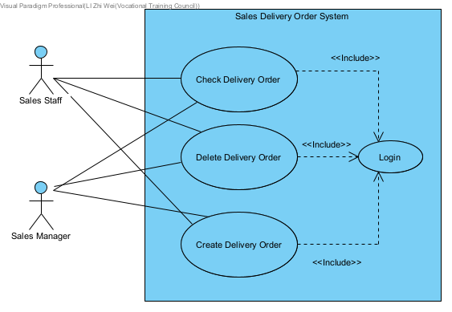

|  |  |
| --- | --- |
| **Use case name:** | Check Delivery Order |
| **Use case ID:** | UC-60 |
| **Primary actor:** | Sales Manager, Sales Staff |
| **Secondary actor(s):** |  |
| **Brief description:** | Sales Manager or Sales Staff can check delivery order |
| **Pre-conditions:** | The employee has a valid account |
| **Flow of events:** | 1. Include (UC-01: Login)  2. Sales Department display sales order lists  3. Sales Manager or Sales Staff click “Check Delivery Order”  4. The system display delivery order list  5. Sales Manager or Sales Staff input delivery order ID in search box to display the delivery order  6. Sales Manager or Sales Staff click “Details”  7. The system display delivery order details and delivery product information |
| **Postconditions:** |  |
| **Alternative flows and exceptions:** |  |
| **Non-behavior requirements:** | Traceability, the employee can check details of file |
| **Issue:** |  |
| **Priority:** | High |
| **Source:** |  |

|  |  |
| --- | --- |
| **Use case name:** | Delete Delivery Order |
| **Use case ID:** | UC-70 |
| **Primary actor:** | Sales Manager, Sales Staff |
| **Secondary actor(s):** |  |
| **Brief description:** | Sales Manager or Sales Staff can delete delivery order |
| **Pre-conditions:** | The employee has a valid account, and inventory department has no assign worker to the delivery order |
| **Flow of events:** | 1. Include (UC-01: Login)  2. Sales Department display sales order lists  3. Sales Manager or Sales Staff click “Check Delivery Order”  4. The system display delivery order list  5. Sales Manager or Sales Staff input delivery order ID in search box to display the delivery order  6. Sales Manager or Sales Staff click “Delete”  7. The system display a double confirms alert.  8. Sales Manager and Sales Staff click “Yes” |
| **Postconditions:** | A delivery order will be deleted |
| **Alternative flows and exceptions:** |  |
| **Non-behavior requirements:** |  |
| **Issue:** |  |
| **Priority:** | High |
| **Source:** |  |

|  |  |
| --- | --- |
| **Use case name:** | Create Delivery Order |
| **Use case ID:** | UC-80 |
| **Primary actor:** | Sales Manager, Sales Staff |
| **Secondary actor(s):** |  |
| **Brief description:** | Sales Manager or Sales Staff can create delivery order |
| **Pre-conditions:** | The employee has a valid account |
| **Flow of events:** | 1. Include (UC-01: Login)  2. Sales Department display sales order lists  3. Sales Manager or Sales Staff click “Check Delivery Order”  4. The system display delivery order list  5. Sales Manager or Sales Staff click “Create”  6. Sales staff or sales manager select expected delivery date, timeslot, customer ID and whether needs installation service.  7. Sales staff or sales manager click “Go to select item”  8. Sales staff or sales manager select delivery item list.  9. Sales staff or sales manager click “Finish” |
| **Postconditions:** | A delivery order will be created |
| **Alternative flows and exceptions:** |  |
| **Non-behavior requirements:** |  |
| **Issue:** |  |
| **Priority:** | High |
| **Source:** |  |

**3.Sales Defect Item System**

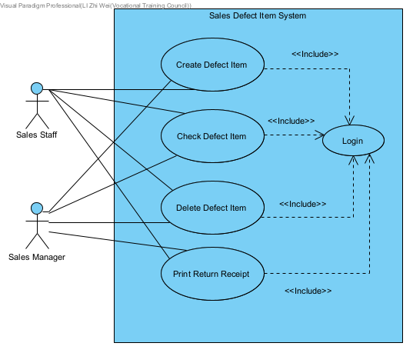

|  |  |
| --- | --- |
| **Use case name:** | Create Defect Item |
| **Use case ID:** | UC-90 |
| **Primary actor:** | Sales Manager, Sales Staff |
| **Secondary actor(s):** |  |
| **Brief description:** | Sales Manager or Sales Staff can create defect item |
| **Pre-conditions:** | The employee has a valid account |
| **Flow of events:** | 1. Include (UC-01: Login)  2. Sales Department display sales order lists  3. Sales Manager or Sales Staff click “Defect Item” to enter defect item page.  4. The system will list all defect item information  5. Sales Manager or Sales Staff click “Create” to enter create page  6. The system will list sales item list in sales department  7. Sales Manager or Sales Staff select item and input item quantity  8. Sales Manager or Sales Staff click “Finish” |
| **Postconditions:** | A new defect item will be created |
| **Alternative flows and exceptions:** | 1.In step 7, if defect item is old product that no products in existing products, sales staff or sales manager should input old product name, old item quantity and return price. |
| **Non-behavior requirements:** |  |
| **Issue:** |  |
| **Priority:** | Medium |
| **Source:** |  |

|  |  |
| --- | --- |
| **Use case name:** | Check Defect Item |
| **Use case ID:** | UC-100 |
| **Primary actor:** | Sales Manager, Sales Staff |
| **Secondary actor(s):** |  |
| **Brief description:** | Sales Manager or Sales Staff can check defect item |
| **Pre-conditions:** | The employee has a valid account |
| **Flow of events:** | 1. Include (UC-01: Login)  2. Sales Department display sales order lists  3. Sales Manager or Sales Staff click “Defect Item” to enter defect item page.  4. The system will list all defect item information |
| **Postconditions:** |  |
| **Alternative flows and exceptions:** |  |
| **Non-behavior requirements:** | Traceability, the employee can check details of file |
| **Issue:** |  |
| **Priority:** | Medium |
| **Source:** |  |

|  |  |
| --- | --- |
| **Use case name:** | Delete Defect Item |
| **Use case ID:** | UC-110 |
| **Primary actor:** | Sales Manager, Sales Staff |
| **Secondary actor(s):** |  |
| **Brief description:** | Sales Manager or Sales Staff can delete defect item |
| **Pre-conditions:** | The employee has a valid account |
| **Flow of events:** | 1. Include (UC-01: Login)  2. Sales Department display sales order lists  3. Sales Manager or Sales Staff click “Defect Item” to enter defect item page.  4. The system will list all defect item information  5. Sales staff or sales manager click “Delete”  6. The system display a double confirms alert.  7. Sales Manager and Sales Staff click “Yes” |
| **Postconditions:** | Defect item will be deleted |
| **Alternative flows and exceptions:** |  |
| **Non-behavior requirements:** |  |
| **Issue:** |  |
| **Priority:** | Medium |
| **Source:** |  |

|  |  |
| --- | --- |
| **Use case name:** | Print Return Receipt |
| **Use case ID:** | UC-120 |
| **Primary actor:** | Sales Manager, Sales Staff |
| **Secondary actor(s):** |  |
| **Brief description:** | Sales Manager or Sales Staff can print hardcopy to customer |
| **Pre-conditions:** | The employee has a valid account |
| **Flow of events:** | 1. Include (UC-01: Login)  2. Sales Department display sales order lists  3. Sales Manager or Sales Staff click “Defect Item” to enter defect item page.  4. The system will list all defect item information  5. Sales Manager and Sales Staff select print of defect item  6. Sales Manager and Sales Staff click “Print”  7. The system display return receipt example  8. Sales Manager and Sales Staff click “Print” |
| **Postconditions:** | Sales Manager and Sales Staff print a return receipt hardcopy to customer |
| **Alternative flows and exceptions:** |  |
| **Non-behavior requirements:** |  |
| **Issue:** |  |
| **Priority:** | Medium |
| **Source:** |  |

**4.Sales Customer System**

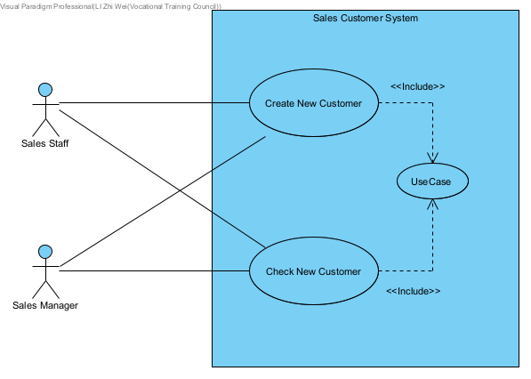

|  |  |
| --- | --- |
| **Use case name:** | Create New Customer |
| **Use case ID:** | UC-130 |
| **Primary actor:** | Sales Manager, Sales Staff |
| **Secondary actor(s):** |  |
| **Brief description:** | Sales Manager can create a new customer |
| **Pre-conditions:** | The employee has a valid account |
| **Flow of events:** | 1. Include (UC-01: Login)  2.Sales Manager or Sales Staff select “Create” in sales department to the create order page  3. Sales Manager or Sales Staff input information about the sale order that as order ID, select item, item quantity, store region and whether needs delivery service.  4. The sales select one of payment method include “Alipay”, “Credit Card”, “Alipay HK”, “Master Card”, “VISA” to send to payment gateway.  5. The sales select payment method is “Cash”, sales will receive cash  6. Sales Staff or Sales manager click “Add Customer” go to the customer page.  7.Customer page display list of customer information.  8.Sales Staff or Sales manager input information that as customer name, customer address, phone number and district  9.Sales Staff or sales manager click “Finish” |
| **Postconditions:** | A new customer will be created |
| **Alternative flows and exceptions:** |  |
| **Non-behavior requirements:** |  |
| **Issue:** |  |
| **Priority:** | High |
| **Source:** |  |

|  |  |
| --- | --- |
| **Use case name:** | Check New Customer |
| **Use case ID:** | UC-140 |
| **Primary actor:** | Sales Manager |
| **Secondary actor(s):** |  |
| **Brief description:** | Sales Manager can modify a replenishment request |
| **Pre-conditions:** | The employee has a valid account |
| **Flow of events:** | 1. Include (UC-01: Login)  2.Sales Manager or Sales Staff select “Create” in sales department to the create order page  3. Sales Manager or Sales Staff input information about the sale order that as order ID, select item, item quantity, store region and whether needs delivery service.  4. The sales select one of payment method include “Alipay”, “Credit Card”, “Alipay HK”, “Master Card”, “VISA” to send to payment gateway.  5. The sales select payment method is “Cash”, sales will receive cash  6. Sales Staff or Sales manager click “Add Customer” go to the customer page.  7.The system display list of customers |
| **Postconditions:** |  |
| **Alternative flows and exceptions:** |  |
| **Non-behavior requirements:** | Traceability, the employee can check details of file |
| **Issue:** |  |
| **Priority:** | High |
| **Source:** |  |

**5.Sales Stock System**

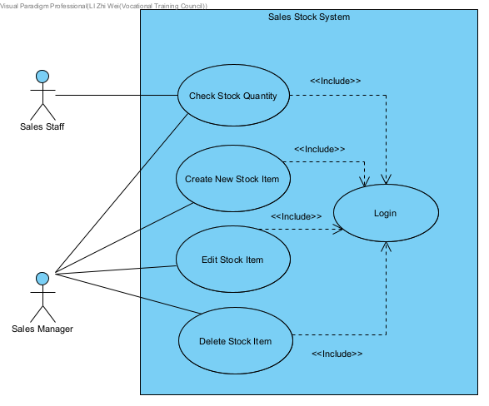

|  |  |
| --- | --- |
| **Use case name:** | Check Stock Quantity |
| **Use case ID:** | UC-150 |
| **Primary actor:** | Sales Manager, Sales Staff |
| **Secondary actor(s):** |  |
| **Brief description:** | Sales Manager and sales staff can check stock quantity |
| **Pre-conditions:** | The employee has a valid account |
| **Flow of events:** | 1. Include (UC-01: Login)  2. Sales Department display sales order lists  3. Sales Staff or Sales Manager click “Stock Quantity” go to stock page  4. The system display out of stock ID alert information.  5. Sales Staff or Sales Manager click “confirm”  6. The system display stock quantity list |
| **Postconditions:** |  |
| **Alternative flows and exceptions:** |  |
| **Non-behavior requirements:** | Traceability, the employee can check details of file |
| **Issue:** |  |
| **Priority:** | High |
| **Source:** |  |

|  |  |
| --- | --- |
| **Use case name:** | Create New Stock Item |
| **Use case ID:** | UC-160 |
| **Primary actor:** | Sales Manager |
| **Secondary actor(s):** |  |
| **Brief description:** | Sales Manager can create new stock item |
| **Pre-conditions:** | The employee has a valid account |
| **Flow of events:** | 1. Include (UC-01: Login)  2. Sales Department display sales order lists  3. Sales Staff or Sales Manager click “Stock Quantity” go to stock page  4. The system display out of stock ID alert information.  5. Sales Staff or Sales Manager click “confirm”  6. The system display stock quantity list  7. Sales Manager click “Create” to create page  8. Sales Manager input information that as product name, product quantity, max stock quantity, product weight, product brand, product type and product price.  9. Sales Manager click "Finish" |
| **Postconditions:** | A new stock item will be created |
| **Alternative flows and exceptions:** | If employee is sales staff, the system will display no permission alert information. |
| **Non-behavior requirements:** | Permission |
| **Issue:** |  |
| **Priority:** | High |
| **Source:** |  |

|  |  |
| --- | --- |
| **Use case name:** | Edit Stock Item |
| **Use case ID:** | UC-170 |
| **Primary actor:** | Sales Manager, Sales Staff |
| **Secondary actor(s):** |  |
| **Brief description:** | Sales Manager and sales staff can check stock quantity |
| **Pre-conditions:** | The employee has a valid account |
| **Flow of events:** | 1. Include (UC-01: Login)  2. Sales Department display sales order lists  3. Sales Staff or Sales Manager click “Stock Quantity” go to stock page  4. The system display out of stock ID alert information.  5. Sales Staff or Sales Manager click “confirm”  6. The system display stock quantity list  7. Sales Manager click “Edit” go to edit page  8. Sales Manager select product and modify stock quantity information  9. Sales Manager click “Finish” |
| **Postconditions:** | Stock quantity will be updated |
| **Alternative flows and exceptions:** | If employee is sales staff, the system will display no permission alert information. |
| **Non-behavior requirements:** | Access Control |
| **Issue:** |  |
| **Priority:** | High |
| **Source:** |  |

|  |  |
| --- | --- |
| **Use case name:** | Delete Stock Item |
| **Use case ID:** | UC-180 |
| **Primary actor:** | Sales Manager, Sales Staff |
| **Secondary actor(s):** |  |
| **Brief description:** | Sales Manager and sales staff can check stock quantity |
| **Pre-conditions:** | The employee has a valid account |
| **Flow of events:** | 1. Include (UC-01: Login)  2. Sales Department display sales order lists  3. Sales Staff or Sales Manager click “Stock Quantity” go to stock page  4. The system display out of stock ID alert information.  5. Sales Staff or Sales Manager click “confirm”  6. The system display stock quantity list  7. Sales Manager click “Delete”  8. The system display a double confirms alert.  9. Sales Manager and Sales Staff click “Yes” |
| **Postconditions:** | Stock quantity will be deleted |
| **Alternative flows and exceptions:** | If employee is sales staff, the system will display no permission alert information. |
| **Non-behavior requirements:** | Access Control |
| **Issue:** |  |
| **Priority:** | High |
| **Source:** |  |

**Inventory System:**

**1. Inventory Delivery Service System**

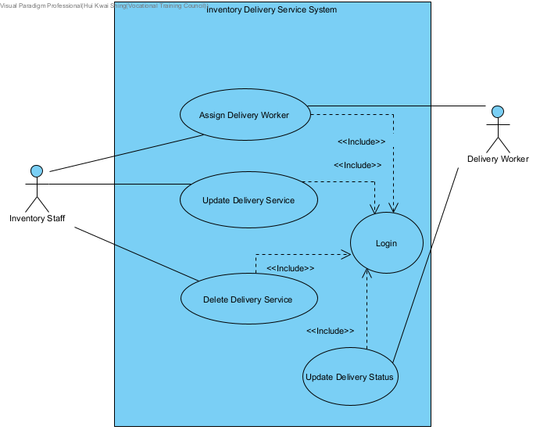

|  |  |
| --- | --- |
| **Use case name:** | Assign Delivery Worker |
| **Use case ID:** | UC-190 |
| **Primary actor:** | Inventory Staff |
| **Secondary actor(s):** | Delivery Worker |
| **Brief description:** | Inventory Staff can assign worker for delivery service |
| **Pre-conditions:** | The employee has a valid account |
| **Flow of events:** | 1. Include (UC-01: Login) 2. Inventory Staff select delivery order 3. Inventory Staff select available worker / click automatic assign worker 4. Click save |
| **Postconditions:** | Assign worker for the delivery order |
| **Alternative flows and exceptions:** |  |
| **Non-behavior requirements:** |  |
| **Issue:** |  |
| **Priority:** | Low |
| **Source:** |  |

|  |  |
| --- | --- |
| **Use case name:** | Update Delivery Service |
| **Use case ID:** | UC-200 |
| **Primary actor:** | Inventory Staff |
| **Secondary actor(s):** |  |
| **Brief description:** | Inventory Staff can update the delivery service |
| **Pre-conditions:** | The employee has a valid account and a delivery service is created |
| **Flow of events:** | 1. Include (UC-01: Login) 2. Inventory Staff search the order by order number or select the suitable date 3. Inventory Staff click the delivery order, the system display the order detail 4. Inventory Staff update the detail of the order 5. Inventory Staff click save, the system display success message |
| **Postconditions:** | A delivery service will be modified. |
| **Alternative flows and exceptions:** |  |
| **Non-behavior requirements:** |  |
| **Issue:** |  |
| **Priority:** | Low |
| **Source:** |  |

|  |  |
| --- | --- |
| **Use case name:** | Update Delivery Status |
| **Use case ID:** | UC-210 |
| **Primary actor:** | Delivery Worker |
| **Secondary actor(s):** |  |
| **Brief description:** | Delivery Worker can update the delivery order status to delivered |
| **Pre-conditions:** | The employee has a valid account and a delivery status is procssing |
| **Flow of events:** | 1. Include (UC-01: Login)  2. Delivery worker click task button, the system display the available task for delivery worker  3.Delivey worker click delivered, the system update the complete time and status and send the installation order to intallation worker |
| **Postconditions:** | Delivery order status will be update to delivered |
| **Alternative flows and exceptions:** |  |
| **Non-behavior requirements:** |  |
| **Issue:** |  |
| **Priority:** | Low |
| **Source:** |  |

|  |  |
| --- | --- |
| **Use case name:** | Delete Delivery Service |
| **Use case ID:** | UC-220 |
| **Primary actor:** | Inventory Staff |
| **Secondary actor(s):** |  |
| **Brief description:** | Inventory Staff can delete the delivery service |
| **Pre-conditions:** | The employee has a valid account and a delivery service is created |
| **Flow of events:** | 1. Include (UC-01: Login)  2. Inventory Staff search the order by order number or select the suitable date  3.Inventory Staff click the delivery order, the system display the order detail  4.Inventory Staff click delete, the system display success message |
| **Postconditions:** | A delivery service will be deleted |
| **Alternative flows and exceptions:** |  |
| **Non-behavior requirements:** |  |
| **Issue:** |  |
| **Priority:** | Low |
| **Source:** |  |

**2. Inventory Re-order System**

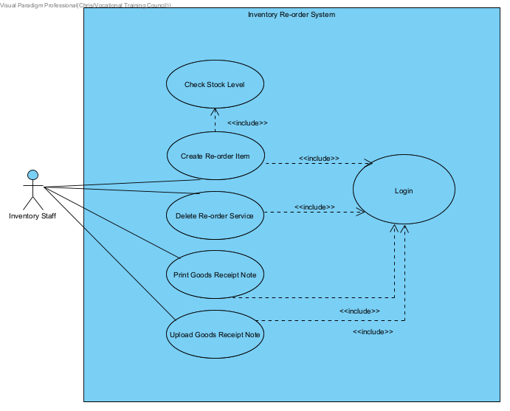

|  |  |
| --- | --- |
| **Use case name:** | Create Re-order Item Request |
| **Use case ID:** | UC-230 |
| **Primary actor:** | Inventory Staff |
| **Secondary actor(s):** |  |
| **Brief description:** | The inventory staff can create re-order requests |
| **Pre-conditions:** | The employee has a valid account |
| **Flow of events:** | 1. Include (UC-01: Login)  2. Inventory Staff select the Reorder Item menu to enter Reorder Item page.  3. The system lists all re-order requests that below certain level (StockQuantity < ReorderLevel).   1. Full in item information (You can select the cell in the grid view to fill in the form quicker.) 2. Select the Confirm button, the system will show the successful message. 3. Click the “View Ordering Item” button, and the reorder item that we just insert will show on the “Ordering list”. |
| **Postconditions:** | The Re-order Item request save in the Purchase Department database. |
| **Alternative flows and exceptions:** |  |
| **Non-behavior requirements:** |  |
| **Issue:** |  |
| **Priority:** | High |
| **Source:** |  |

|  |  |
| --- | --- |
| **Use case name:** | Delete Re-order Item Request |
| **Use case ID:** | UC-240 |
| **Primary actor:** | Inventory Staff |
| **Secondary actor(s):** |  |
| **Brief description:** | The inventory staff can delete re-order item requests |
| **Pre-conditions:** | The employee has a valid account and the request has not yet been approved |
| **Flow of events:** | 1. Include (UC-01: Login)  2. Inventory Staff select the Reorder Item menu to enter Reorder Item page.  3. The system lists all re-order requests that below certain level (StockQuantity < ReorderLevel).  4. Input the Re-order Item ID.  5. Click “Delete Order” button. |
| **Postconditions:** | The Reorder Item is deleted from the system successfully. |
| **Alternative flows and exceptions:** | If step 5 selects goods are approved, the system will send an error message. |
| **Non-behavior requirements:** |  |
| **Issue:** |  |
| **Priority:** | High |
| **Source:** |  |

|  |  |
| --- | --- |
| **Use case name:** | Print Electronic Goods Received Note |
| **Use case ID:** | UC-250 |
| **Primary actor:** | Inventory Staff |
| **Secondary actor(s):** |  |
| **Brief description:** | The Inventory Staff created a goods received note to the supplier |
| **Pre-conditions:** | The employee has a valid account |
| **Flow of events:** | 1. Include (UC-01: Login) 2. Inventory Staff select the Reorder Item menu to enter Reorder Item page. 3. Inventory Staff click the “View Ordering Item” button, the system shows the “Ordering list”. 4. Choose the Stock ID that is return inwards items. 5. Click the “Pre-print” button. 6. The system shows the “Pre-print” of Goods Receive Note. 7. Click the “Print” button. 8. The system prompts a print screen properties box. 9. Select “Microsoft Print to PDF” and click “OK” button. 10. Choose the save location path in the computer and click “Save” button. 11. The PDF is saved on the computer. 12. 10. A received note will be created and printed by PDF. |
| **Postconditions:** | An Electronic Goods Received Note will be created and printed. |
| **Alternative flows and exceptions:** |  |
| **Non-behavior requirements:** |  |
| **Issue:** |  |
| **Priority:** | High |
| **Source:** |  |

|  |  |
| --- | --- |
| **Use case name:** | Upload Goods Received Note |
| **Use case ID:** | UC-260 |
| **Primary actor:** | Inventory Staff |
| **Secondary actor(s):** |  |
| **Brief description:** | The Inventory Staff created a goods received note to the supplier |
| **Pre-conditions:** | The employee has a valid account |
| **Flow of events:** | 1. Include (UC-01: Login) 2. Inventory Staff select the Reorder Item menu to enter Reorder Item page. 3. Inventory Staff click the “View Ordering Item” button, the system shows the “Ordering list”. 4. Click the “Upload Receipt” button. 5. Choose the receipt that the supplier just signed. 6. Click “OK” button. |
| **Postconditions:** | An Electronic Goods Received Note will be uploaded. |
| **Alternative flows and exceptions:** |  |
| **Non-behavior requirements:** |  |
| **Issue:** |  |
| **Priority:** | High |
| **Source:** |  |

|  |  |
| --- | --- |
| **Use case name:** | Create Supplier |
| **Use case ID:** | UC-270 |
| **Primary actor:** | Inventory Staff |
| **Secondary actor(s):** |  |
| **Brief description:** | The Inventory Staff created a goods received note to the supplier |
| **Pre-conditions:** | The employee has a valid account |
| **Flow of events:** | 1. Include (UC-01: Login) 2. Inventory Staff select the Supplier menu to enter Supplier page. 3. Select the Supplier items menu. 4. Full in Supplier information (Click the cell text in the grid view.) 5. Select the “Update” button. 6. After submitted the form, the system will show the successful message. |
| **Postconditions:** | An Electronic Goods Received Note will be uploaded. |
| **Alternative flows and exceptions:** |  |
| **Non-behavior requirements:** |  |
| **Issue:** |  |
| **Priority:** | High |
| **Source:** |  |

**3.Inventory Manage Goods System**

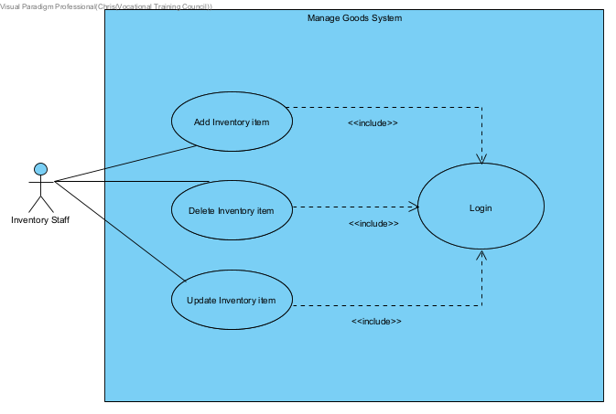

|  |  |
| --- | --- |
| **Use case name:** | Add Inventory Items |
| **Use case ID:** | UC-280 |
| **Primary actor:** | Inventory Staff |
| **Secondary actor(s):** |  |
| **Brief description:** | The inventory staff can create add new inventory item. |
| **Pre-conditions:** | The employee has a valid account |
| **Flow of events:** | 1. Include (UC-01: Login)  2. Inventory Staff select the “Add Item” menu to enter add item page.   1. Full in item information (Click the cell in the grid view and edit the info.) 2. Choose the item type. 3. Select the “Add Item” button. 4. The system checks whether the item information is all filled in and show successful message. |
| **Postconditions:** | The new inventory item saves in the inventory system. |
| **Alternative flows and exceptions:** |  |
| **Non-behavior requirements:** |  |
| **Issue:** |  |
| **Priority:** | High |
| **Source:** |  |

|  |  |
| --- | --- |
| **Use case name:** | Delete Inventory Items |
| **Use case ID:** | UC-290 |
| **Primary actor:** | Inventory Staff |
| **Secondary actor(s):** |  |
| **Brief description:** | The inventory staff can delete inventory item. |
| **Pre-conditions:** | The employee has a valid account |
| **Flow of events:** | 1. Include (UC-01: Login) 2. Inventory Staff select the “Delete Item” menu to enter delete item page. 3. Full in item information. (Click the cell in the grid view) 4. Choose the item type. 5. Select the “Delete Item” button. 6. The system checks whether the item information is all filled in and show successful message. |
| **Postconditions:** | The inventory item is deleted from the inventory system. |
| **Alternative flows and exceptions:** |  |
| **Non-behavior requirements:** |  |
| **Issue:** |  |
| **Priority:** | High |
| **Source:** |  |

|  |  |
| --- | --- |
| **Use case name:** | Update Inventory Items |
| **Use case ID:** | UC-300 |
| **Primary actor:** | Inventory Staff |
| **Secondary actor(s):** |  |
| **Brief description:** | The inventory staff can update inventory item. |
| **Pre-conditions:** | The employee has a valid account |
| **Flow of events:** | 1. Include (UC-01: Login) 2. Inventory Staff select the “Update Item” menu to enter update item page. 3. Full in item information. (Click the cell in the grid view and edit the info) 4. Choose the item type. 5. Select the “Update Item” button. 6. The system checks whether the item information is all filled in and show successful message. |
| **Postconditions:** | The inventory item is updated from the inventory system. |
| **Alternative flows and exceptions:** |  |
| **Non-behavior requirements:** |  |
| **Issue:** |  |
| **Priority:** | High |
| **Source:** |  |

**4.Inventory Manage Goods System**

|  |  |
| --- | --- |
| **Use case name:** | Add Inventory Items |
| **Use case ID:** | UC-310 |
| **Primary actor:** | Inventory Staff |
| **Secondary actor(s):** |  |
| **Brief description:** | The inventory staff can create add new inventory item. |
| **Pre-conditions:** | The employee has a valid account |
| **Flow of events:** | 1. Include (UC-01: Login)  2. Inventory Staff select the “Add Item” menu to enter add item page.   1. Full in item information (Click the cell in the grid view and edit the info.) 2. Choose the item type. 3. Select the “Add Item” button. 4. The system checks whether the item information is all filled in and show successful message. |
| **Postconditions:** | The new inventory item saves in the inventory system. |
| **Alternative flows and exceptions:** |  |
| **Non-behavior requirements:** |  |
| **Issue:** |  |
| **Priority:** | High |
| **Source:** |  |

|  |  |
| --- | --- |
| **Use case name:** | Delete Inventory Items |
| **Use case ID:** | UC-320 |
| **Primary actor:** | Inventory Staff |
| **Secondary actor(s):** |  |
| **Brief description:** | The inventory staff can delete inventory item. |
| **Pre-conditions:** | The employee has a valid account |
| **Flow of events:** | 1. Include (UC-01: Login) 2. Inventory Staff select the “Delete Item” menu to enter delete item page. 3. Full in item information. (Click the cell in the grid view) 4. Choose the item type. 5. Select the “Delete Item” button. 6. The system checks whether the item information is all filled in and show successful message. |
| **Postconditions:** | The inventory item is deleted from the inventory system. |
| **Alternative flows and exceptions:** |  |
| **Non-behavior requirements:** |  |
| **Issue:** |  |
| **Priority:** | High |
| **Source:** |  |

|  |  |
| --- | --- |
| **Use case name:** | Update Inventory Items |
| **Use case ID:** | UC-320 |
| **Primary actor:** | Inventory Staff |
| **Secondary actor(s):** |  |
| **Brief description:** | The inventory staff can update inventory item. |
| **Pre-conditions:** | The employee has a valid account |
| **Flow of events:** | 1. Include (UC-01: Login) 2. Inventory Staff select the “Update Item” menu to enter update item page. 3. Full in item information. (Click the cell in the grid view and edit the info) 4. Choose the item type. 5. Select the “Update Item” button. 6. The system checks whether the item information is all filled in and show successful message. |
| **Postconditions:** | The inventory item is updated from the inventory system. |
| **Alternative flows and exceptions:** |  |
| **Non-behavior requirements:** |  |
| **Issue:** |  |
| **Priority:** | High |
| **Source:** |  |

**5.Inventory Supplier System**

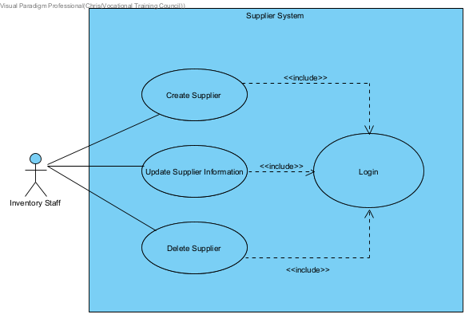

|  |  |
| --- | --- |
| **Use case name:** | Create Supplier |
| **Use case ID:** | UC-330 |
| **Primary actor:** | Inventory Staff |
| **Secondary actor(s):** |  |
| **Brief description:** | The inventory staff can create new supplier. |
| **Pre-conditions:** | The employee has a valid account |
| **Flow of events:** | 1. Include (UC-01: Login)  2. Inventory Staff select the “Supplier” menu to enter Supplier page.   1. Full in Supplier information. (Click the cell in the grid view and edit the info) 2. Select the “Add” button. 3. Before insert the form information into the system, the system will check whether the item information is all filled in. 4. After submitted the form, the system will show the successful message. |
| **Postconditions:** | The new supplier information will store in the inventory system. |
| **Alternative flows and exceptions:** |  |
| **Non-behavior requirements:** |  |
| **Issue:** |  |
| **Priority:** | High |
| **Source:** |  |

|  |  |
| --- | --- |
| **Use case name:** | Update Supplier information |
| **Use case ID:** | UC-340 |
| **Primary actor:** | Inventory Staff |
| **Secondary actor(s):** |  |
| **Brief description:** | The inventory staff can delete supplier. |
| **Pre-conditions:** | The employee has a valid account |
| **Flow of events:** | 1. Include (UC-01: Login) 2. Inventory Staff select the “Supplier” menu to enter Supplier page. 3. Full in Supplier information. (Click the cell in the grid view and edit the info) 4. Select the “Update” button. 5. Before insert the form information into the system, the system will check whether the item information is all filled in. 6. After submitted the form, the system will show the successful message. |
| **Postconditions:** | The new supplier information will update to the inventory system. |
| **Alternative flows and exceptions:** |  |
| **Non-behavior requirements:** |  |
| **Issue:** |  |
| **Priority:** | High |
| **Source:** |  |

|  |  |
| --- | --- |
| **Use case name:** | Delete Supplier |
| **Use case ID:** | UC-350 |
| **Primary actor:** | Inventory Staff |
| **Secondary actor(s):** |  |
| **Brief description:** | The inventory staff can delete supplier. |
| **Pre-conditions:** | The employee has a valid account |
| **Flow of events:** | 1. Include (UC-01: Login) 2. Inventory Staff select the “Supplier” menu to enter Supplier page. 3. Full in Supplier information. (Click the cell in the grid view and edit the info) 4. Select the “Delete” button. 5. Before insert the form information into the system, the system will check whether the item information is all filled in. 6. After submitted the form, the system will show the successful message. |
| **Postconditions:** | The new supplier information will delete from the inventory system. |
| **Alternative flows and exceptions:** |  |
| **Non-behavior requirements:** |  |
| **Issue:** |  |
| **Priority:** | High |
| **Source:** |  |

**Technical Support Department System**

**1. Technical Support Department Installation Service System**

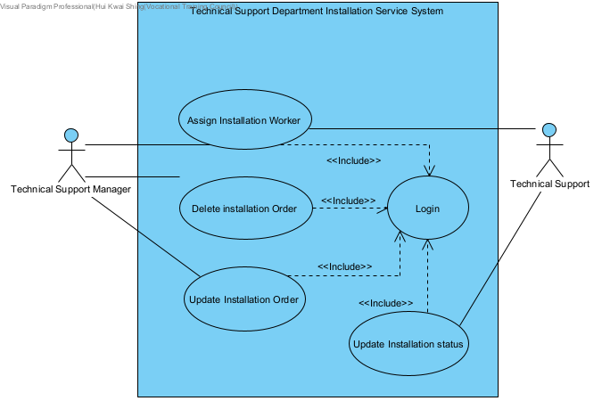

|  |  |
| --- | --- |
| **Use case name:** | Assign Installation Worker |
| **Use case ID:** | UC-360 |
| **Primary actor:** | Technical Support Manager |
| **Secondary actor(s):** |  |
| **Brief description:** | Technical Support Manager can assign a worker for installation order |
| **Pre-conditions:** | User have vaild account |
| **Flow of events:** | 1. Include (UC-01: Login) 2. Technical Manager select installation order 3. Technical Manager select available worker / click automatic assign worker 4. Click save |
| **Postconditions:** | Worker will be assigned |
| **Alternative flows and exceptions:** |  |
| **Non-behavior requirements:** |  |
| **Issue:** |  |
| **Priority:** | low |
| **Source:** |  |

|  |  |
| --- | --- |
| **Use case name:** | Update Installation Service |
| **Use case ID:** | UC-370 |
| **Primary actor:** | Technical Support Manager |
| **Secondary actor(s):** |  |
| **Brief description:** | Technical Support Manager can update the installation service |
| **Pre-conditions:** | The employee has a valid account, and an installation service status is processing |
| **Flow of events:** | 1. Include (UC-01: Login) 2. Technical Support Manager search the order by order number or select the suitable date 3. Technical Support Manager click the installation order, the system display the order detail 4. Technical Support update the detail of the order 5. Technical Support click save, the system display success message |
| **Postconditions:** | An installation service will be modified |
| **Alternative flows and exceptions:** |  |
| **Non-behavior requirements:** |  |
| **Issue:** |  |
| **Priority:** | Low |
| **Source:** |  |

|  |  |
| --- | --- |
| **Use case name:** | Update Installation Status |
| **Use case ID:** | UC-380 |
| **Primary actor:** | Delivery Worker |
| **Secondary actor(s):** |  |
| **Brief description:** | Technical support can update the Installation order status to completed |
| **Pre-conditions:** | The employee has a valid account and the installation order status is procssing |
| **Flow of events:** | 1. Include (UC-01: Login)  2. Technical support click task button, the system display the available task for delivery worker  3. Technical support click Completed, the system update the completed time and status. |
| **Postconditions:** | Installation order status will be update to Completed |
| **Alternative flows and exceptions:** |  |
| **Non-behavior requirements:** |  |
| **Issue:** |  |
| **Priority:** | Low |
| **Source:** |  |

|  |  |
| --- | --- |
| **Use case name:** | Delete Installation Service |
| **Use case ID:** | UC-390 |
| **Primary actor:** | Technical Support Manager |
| **Secondary actor(s):** |  |
| **Brief description:** | Technical Support Manager can delete the installation service |
| **Pre-conditions:** | The employee has a valid account and an installation service is created |
| **Flow of events:** | 1. Include (UC-01: Login)  2. Technical Support Manager search the order by order number or select the suitable date  3 Technical Support Manager click the installation order, the system display the order detail  4. Technical Support Manager click delete, the system display success message |
| **Postconditions:** | An installation service will be deleted |
| **Alternative flows and exceptions:** |  |
| **Non-behavior requirements:** |  |
| **Issue:** |  |
| **Priority:** | Low |
| **Source:** |  |

**Admin System**

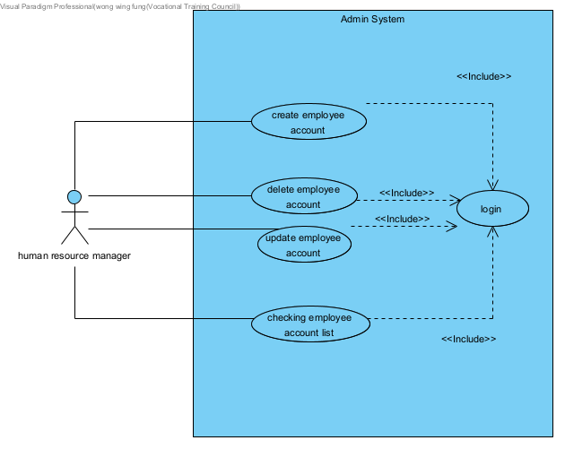

|  |  |
| --- | --- |
| Use case name: | Create employee account |
| Use case ID: | UC-400 |
| Brief description: | Staff can create a new employee account |
| Pre-conditions: | The employee has a valid admin account |
| Flow of events: | 1. Include (UC-01: Login)  2.Staff input all information about the account, include EmpID, EmpName, Empdepartment ,account number, password,  security question answer.  4. Staff click “Create” to Create employee account |
| Postconditions: |  |
| Alternative flows and exceptions: |  |

|  |  |
| --- | --- |
| Use case name: | Delete employee account |
| Use case ID: | UC-400 |
| Brief description: | Staff can delete a employee account |
| Pre-conditions: | The employee has a valid admin account |
| Flow of events: | 1. Include (UC-01: Login)  2.Staff input all information about the account, include EmpID, EmpName, Empdepartment ,account number, password,  security question answer.  4. Staff click “delete” to delete employee account |
| Postconditions: |  |
| Alternative flows and exceptions: |  |

|  |  |
| --- | --- |
| Use case name: | update employee account |
| Use case ID: | UC-410 |
| Brief description: | Staff can update the employee account information |
| Pre-conditions: | The employee has a valid admin account |
| Flow of events: | 1. Include (UC-01: Login)  2.Staff input all information about the account, include EmpID, EmpName, Empdepartment ,account number, password,  security question answer.  3. Enter the information you want to change.  4. Staff click “update” to delete employee account |
| Postconditions: |  |
| Alternative flows and exceptions: |  |

|  |  |
| --- | --- |
| Use case name: | checking employee account list |
| Use case ID: | UC-420 |
| Brief description: | Staff can checking employee account information in a list |
| Pre-conditions: | The employee has a valid admin account |
| Flow of events: | 1. Include (UC-01: Login)  4. Staff click “employee account list” to show all employee account information |
| Postconditions: |  |
| Alternative flows and exceptions: |  |

|  |  |
| --- | --- |
| **Use case name:** | Login |
| **Use case ID:** | UC-01 |
| **Brief description:** | The employee logs in the account |
| **Pre-conditions:** | The employee account number and password are correctly |
| **Flow of events:** | 1. The employee inputs his account number  2. The employee inputs his password that matches the account number  3. The employee select a language in English and Simplified Chinese |
| **Postconditions:** | The employee is successful to log in the account |
| **Alternative flows and exceptions:** | In step2, if the password is not correct, the system will notification the customer to input password again |

|  |  |
| --- | --- |
| **Use case name:** | Create Delivery Order |
| **Use case ID:** | UC-02 |
| **Brief description:** | If sales staff or sales manager select needs delivery service in creating sales order, they will create delivery order. |
| **Pre-conditions:** | The sales staff or sales manager select needs delivery service in creating sales order. |
| **Flow of events:** | 1. Sales staff or sales manager select expected delivery date, timeslot, customer ID and whether needs installation service.  2. Sales staff or sales manager click “Go to select item”  3. Sales staff or sales manager select delivery item list. |
| **Postconditions:** | A delivery order will be created. |
| **Alternative flows and exceptions:** | In step2, if select timeslot has no delivery position, system will send alert information, sales staff or sales manager should re-select another timeslot. |

|  |  |
| --- | --- |
| **Use case name:** | Check Stock Level |
| **Use case ID:** | UC-03 |
| **Brief description:** | Some sales orders need to pay all amounts or pay deposits |
| **Pre-conditions:** | The sales staff creates a sales order |
| **Flow of events:** | 1. The sales staff click “Stock level” to enter the stock page  2. The system will display a list of stock status |
| **Postconditions:** | If status is insufficient or storage, the system will agree to staff to create replenishment requests and re-order requests. If the status is full, the system will agree to staff to create delivery requests and installation requests. |
| **Alternative flows and exceptions:** | If goods unavailable in-store or stock level at stock is close to or below re-order level, deposit amount can input 0 |

|  |  |
| --- | --- |
| **Use case name:** | Check Delivery Time |
| **Use case ID:** | UC-04 |
| **Brief description:** | Technical Support Department Staff can view delivery finish time |
| **Pre-conditions:** | The employee has a valid account |
| **Flow of events:** | 1. Include (UC-01: Login)  2. Technical Support Department Staff click “Technical Support Department” to enter the technical support department  3. Technical Support Department Staff click “Delivery Worker” to enter delivery worker page  4. Technical Support Department Staff click “Finish time” to enter delivery finish page  5. The system list finish delivery service and finish time |
| **Postconditions:** | The system will agree technical support department staff after two hours of delivery time |
| **Alternative flows and exceptions:** | If delivery time is not after two hours, they can’t create installation service |

|  |  |
| --- | --- |
| **Use case name:** | Create New Customer |
| **Use case ID:** | UC-05 |
| **Brief description:** | Sales Staff or Sales manager create a new customer in the system |
| **Pre-conditions:** | Payment Type is deposit receipt in creating sales order or needs delivery service |
| **Flow of events:** | 1. Sales Staff or Sales manager click “Add Customer” go to the customer page. 2. Customer page display list of customer information. 3. Sales Staff or Sales manager input information that as customer name, customer address, phone number and district |
| **Postconditions:** | A new customer information will store in system |
| **Alternative flows and exceptions:** | Sales Staff or Sales manager can input phone number to search customer information to get customer ID. |

**9. Class Diagram**

**9.1 Data Dictionary**

|  |  |
| --- | --- |
| Class Name | Definition |
| Sales Staff | Sales are the internal user accounts of the system. They are responsible for creating orders for customers. After login, they can create/ retrieve orders, create/update/delete delivery request, check stock level. |
| Sales Manager | Sales manager is type of sales with more permission. Sales managers are allowed to manage the replenishment request. after login, they can create/update/delete/retrieve replenishment request |
| Inventory Level | Inventory Level is stock level in inventory department. |
| Sales Order | The sales team can create a sales order for customers to buy appliances in retail stores. A sales order contains payment option, shipping option and have a deposit agreement when customer request an unavailable item. |
| Payment Order | Payment Order is a type of sales order. Customer don’t need to provide their personal information and deposit. |
| Deposit Order | Deposit Order is a type of salesorder. Customer need to provide their personal information and pay 20% unavailable item deposit. |
| Installation Request | Sales department create a new sales order, order item can choose delivery request and installation request |
| Delivery Order | When sales select delivery service in creating sales order, delivery order will be created. |
| Delivery Worker | Internal user account of the Inventory delivery management system. They are responsible for handling the delivery request created by the sales team. After login, they can check delivery request content and timetable. Also, they can send a completion message when the delivery request is completed. |
| Store Stock | It holds the details of retail stores and list of item detail information |
| Item | It holds the details of appliances such as name, type, price, qty etc. |
| Stock item | Stock item in sales store |
| Delivery Item | It holds the details of need delivery service of items |
| Defect Item | It holds the id number of the defect item |
| Old Item | Defect Item but no existing in item list |
| Payment Receipt | Payment receipt is a type of receipt. It holds the detailed total amount of the sales order. |
| Deposit Receipt | Deposit receipt is a type of receipt. It holds the details of the deposit agreement |
| Payment | Payment includes three types of payment method, they are credit card, E-payment and Cash |
| Credit Card | It holds the details of the credit card from customer, such as credit card number, type, expiry date. |
| E-payment | It holds the details of the E-payment from customers, such as type and balance. |
| Cash | Customer will pay cash to the sales representative |
| Payment Gateway | External payment gateway verifies the credit card payment and sends back the approval code when the transaction is approved. |
| Supplier | It holds the details of supplier. Such as supplier's name and their location. |
| Technical Support | Technical Support can handle installation service, assign installation work and finish work. |
| Technical Manager | Technical Manager can assign delivery work and installation work. Besides, they can manager all delivery order |
| Employee | Employee includes all department employee, they have employee id and password |
| Inventory Staff | Inventory Staff is staff and manager in the inventory department |
| Delivery Note | Delivery Note is hardcopy of the delivery order and requires the customer’s signature |
| Purchase Order Detail | If inventory stock is shortage, inventory should create a purchase order to purchase shortage items to supplier, purchase order details is details of items in purchase order |
| Electronic purchase order | If inventory stock is shortage, inventory should create a purchase order to purchase shortage items to supplier |
| Reordering Item | Reordering item is supplier can supply items |
| Public User | No company account’s people |
| Login | System Login System |

**9.2 Order Management System**

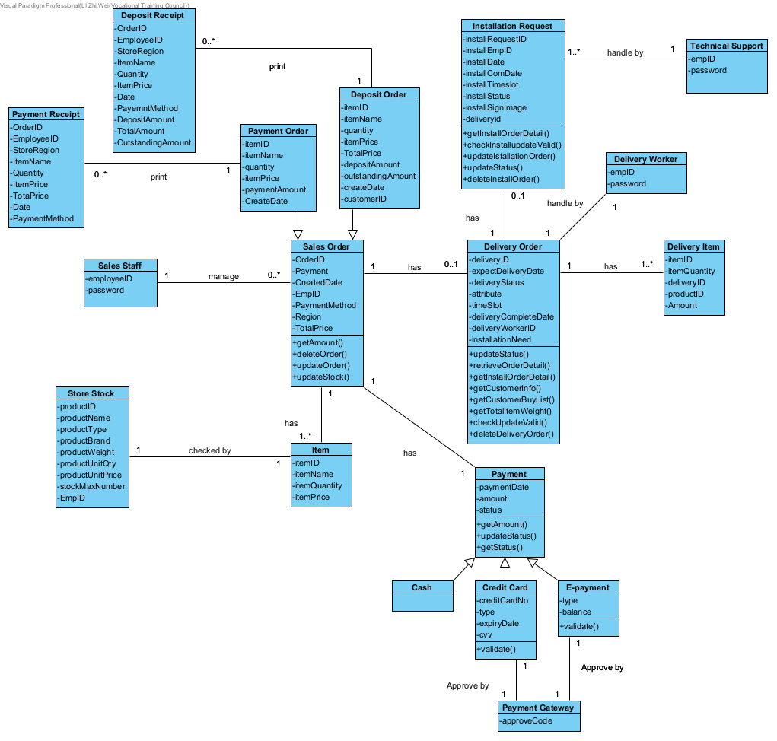

**9.3 Sales Defect Item**

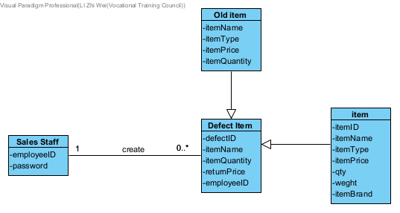

**9.4 Sales Stock Item System**

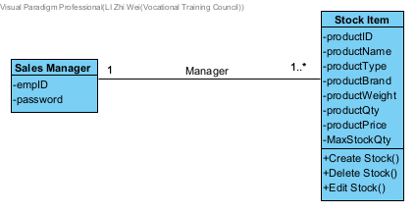

**9.5 Delivery and Installation**

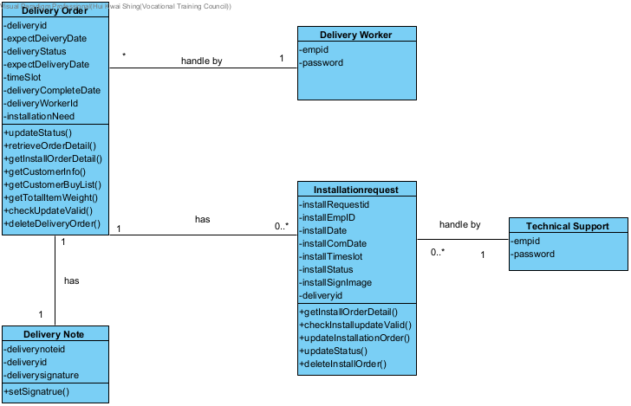

**9.6 Inventory System**

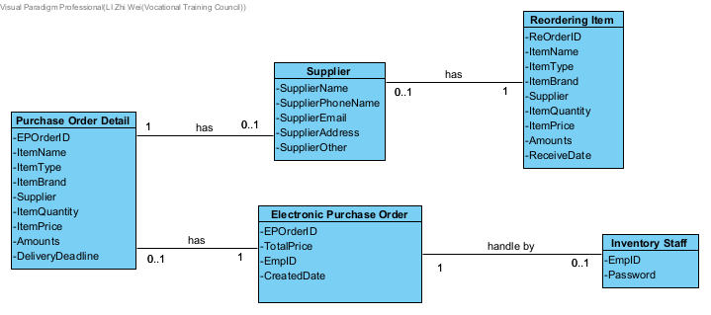

**9.7 Inventory Good Management System**

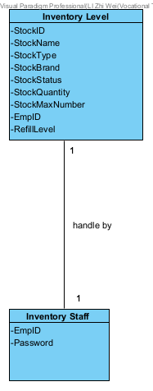

**9.8 Inventory Supplier System**

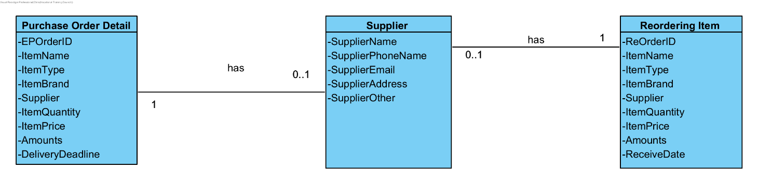

**9.9 Technical Support System**

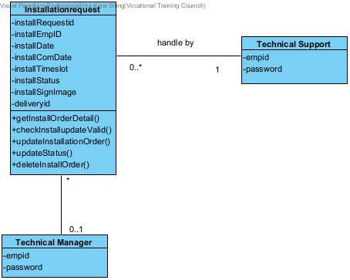

**9.10 Login System**

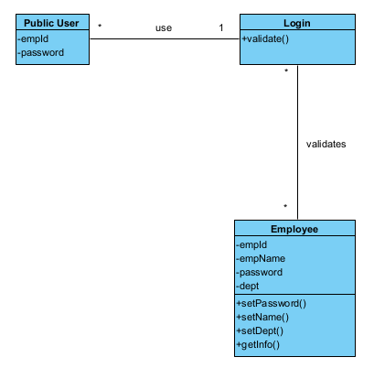

**9.11 Payment System**

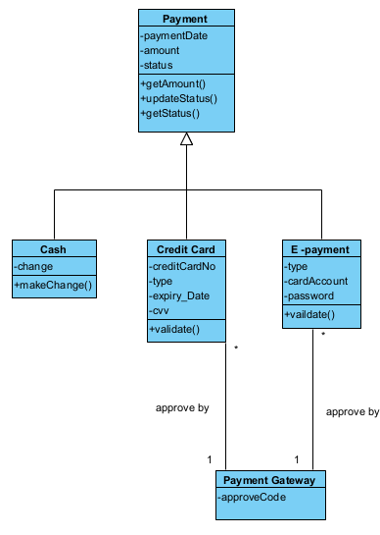

**10. Sequence Diagram (3-Tier with MVC model)**

**10.1 Login System**

Scenario 1: Login success

|  |  |
| --- | --- |
| Employee | System |
|  | Asks the sales to login |
| Enter the employee id and password |  |
|  | Display login success |

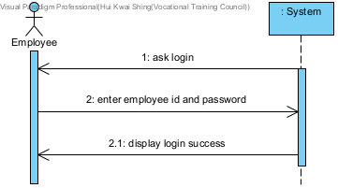

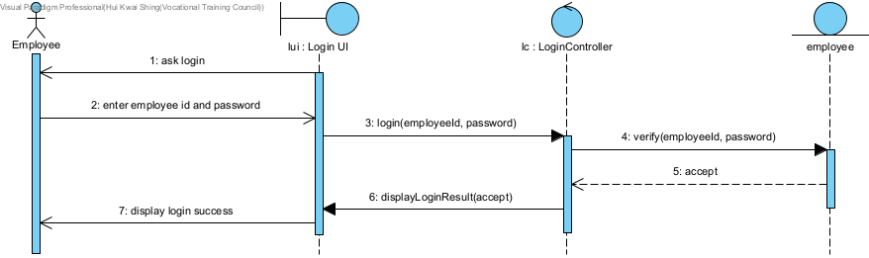

Scenario 2: Login Fail

|  |  |
| --- | --- |
| Employee | System |
|  | Asks the sales to login |
| Enter the employee id and password |  |
|  | Ask to re-enter |

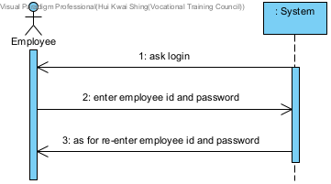

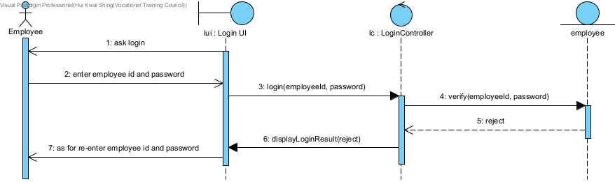

**10.2 Sales Order System**

Scenario 1: Create Sales Order (Select Credit card payment)

|  |  |  |
| --- | --- | --- |
| Sales | System | Payment Gateway |
|  | Asks the sales to login |  |
| Enter the employee id and password |  |  |
| Sales select good page list |  |  |
|  | Display the list of items |  |
| Select the item |  |  |
|  | Display the details information of item |  |
| Add an item into the shopping cart |  |  |
|  | Display the item in the shopping cart |  |
| Check out item |  |  |
|  | Display total |  |
| Select credit card payment |  |  |
|  | Ask for credit card information |  |
| Enter Credit card info |  |  |
|  | Sends credit card transaction request |  |
|  |  | Approval code |
|  | Display order confirmation |  |

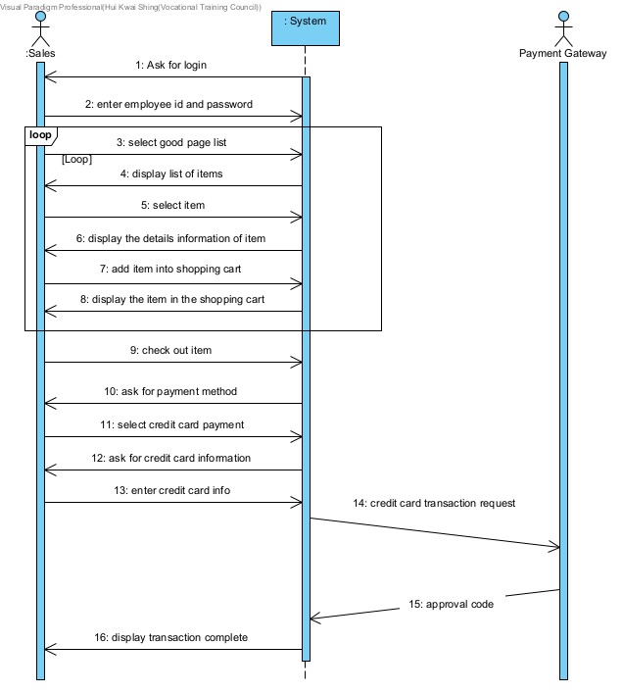

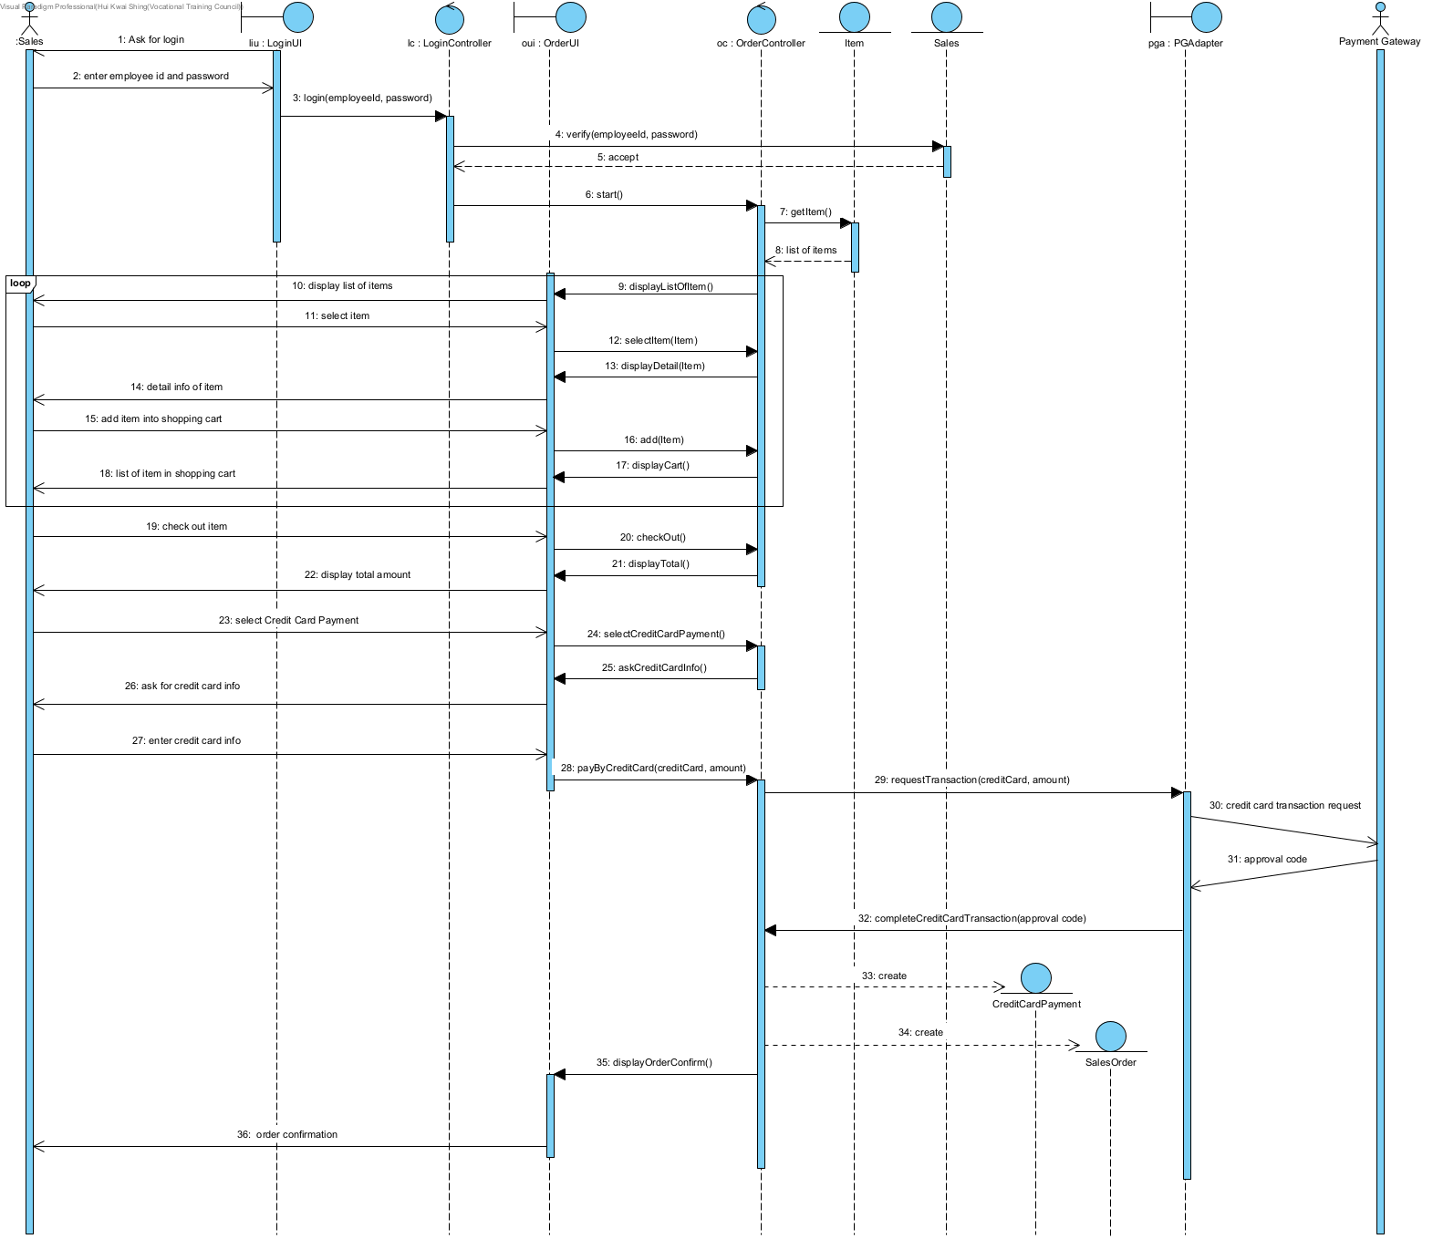

Scenario 2: Create Sales Order (Select E-payment)

|  |  |  |
| --- | --- | --- |
| Sales | System | Payment Gateway |
|  | Asks the sales to login |  |
| Enter the employee id and password |  |  |
| Sales select good page list |  |  |
|  | Display the list of items |  |
| Select the item |  |  |
|  | Display the details information of item |  |
| Add an item into the shopping cart |  |  |
|  | Display the item in the shopping cart |  |
| Check out item |  |  |
|  | Display total |  |
| Select E-payment |  |  |
|  | Ask for scan QR code |  |
| Scan E-payment QR code |  |  |
|  | Sends E-payment transaction request |  |
|  |  | Approval message |
|  | Display order confirmation |  |

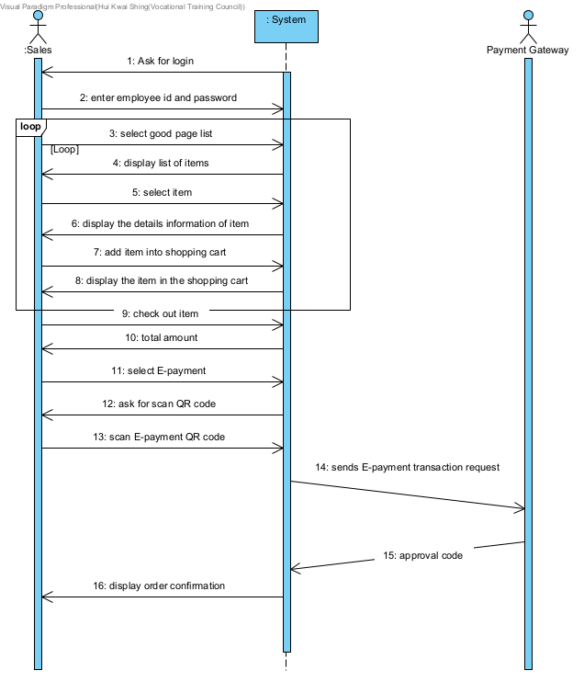

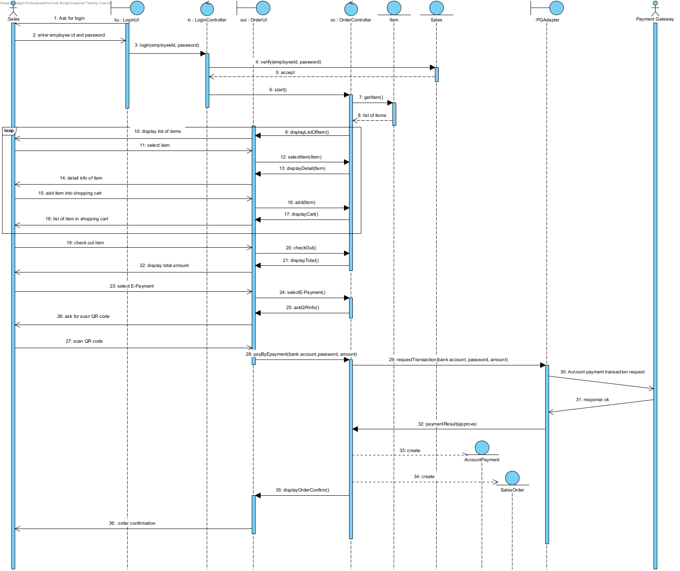

Scenario 3: Create Sales Order (Select Cash payment)

|  |  |  |
| --- | --- | --- |
| Sales | System | Payment Gateway |
|  | Asks the sales to login |  |
| Enter the employee id and password |  |  |
| Sales select good page list |  |  |
|  | Display the list of items |  |
| Select the item |  |  |
|  | Display the details information of item |  |
| Add an item into the shopping cart |  |  |
|  | Display the item in the shopping cart |  |
| Check out item |  |  |
|  | Display total |  |
| Select Cash payment |  |  |
|  | Ask for enter amount |  |
| Enter amount |  |  |
|  | Display change |  |
| ok |  |  |
|  | Display order confirmation |  |

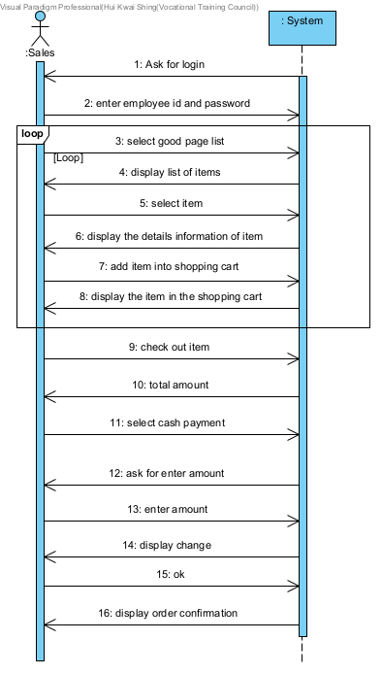

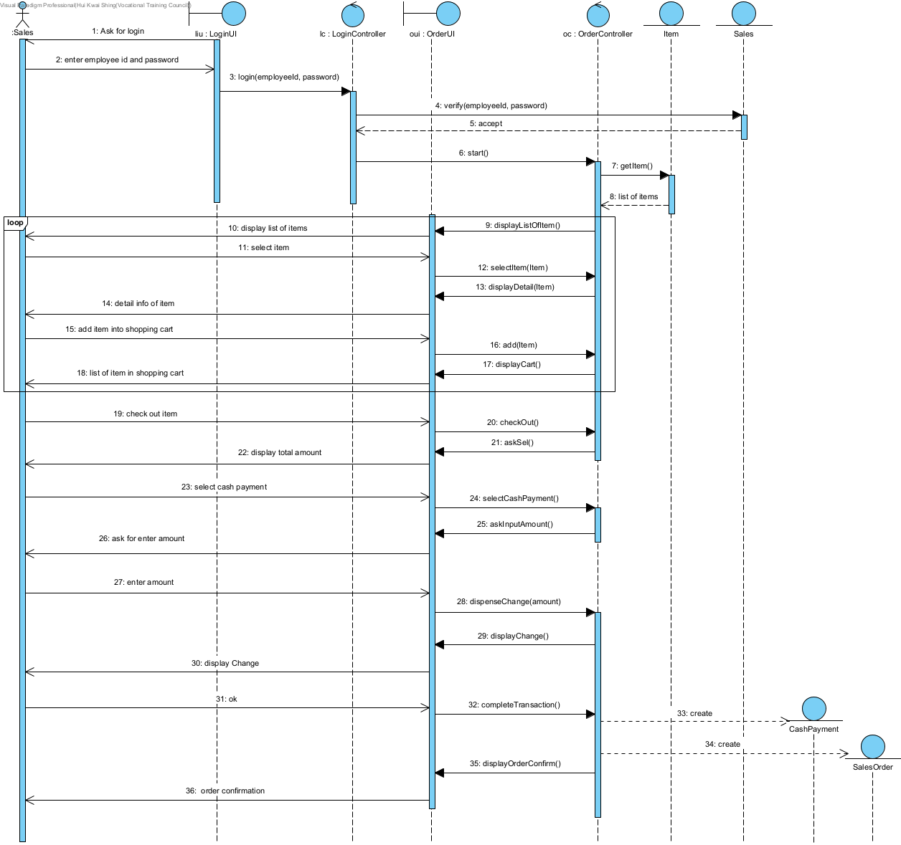

Scenario 4: Create Sales Order (Delivery service)

|  |  |  |
| --- | --- | --- |
| Sales | System | Inventory Department |
|  | Asks the sales to login |  |
| Enter the employee id and password |  |  |
| Sales select good page list |  |  |
|  | Display the list of items |  |
| Select the item |  |  |
|  | Display the details information of item |  |
| Add an item into the shopping cart |  |  |
|  | Display the item in the shopping cart |  |
| Check out item |  |  |
|  | Display total |  |
| Select Delivery |  |  |
|  | Ask for delivery date and time |  |
| Select delivery date and time |  |  |
|  | Ask for customer info |  |
| Enter customer name, address, phone |  |  |
|  | Display total |  |
| Select cash payment |  |  |
|  | Ask for enter amount |  |
| Enter amount |  |  |
|  | Display change |  |
| Receive change |  |  |
|  | sends the delivery request |  |
|  | Display order confirmation |  |

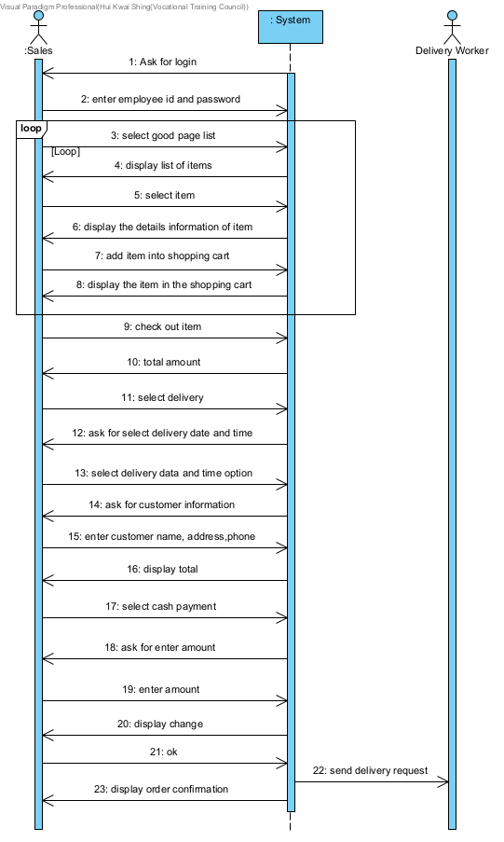

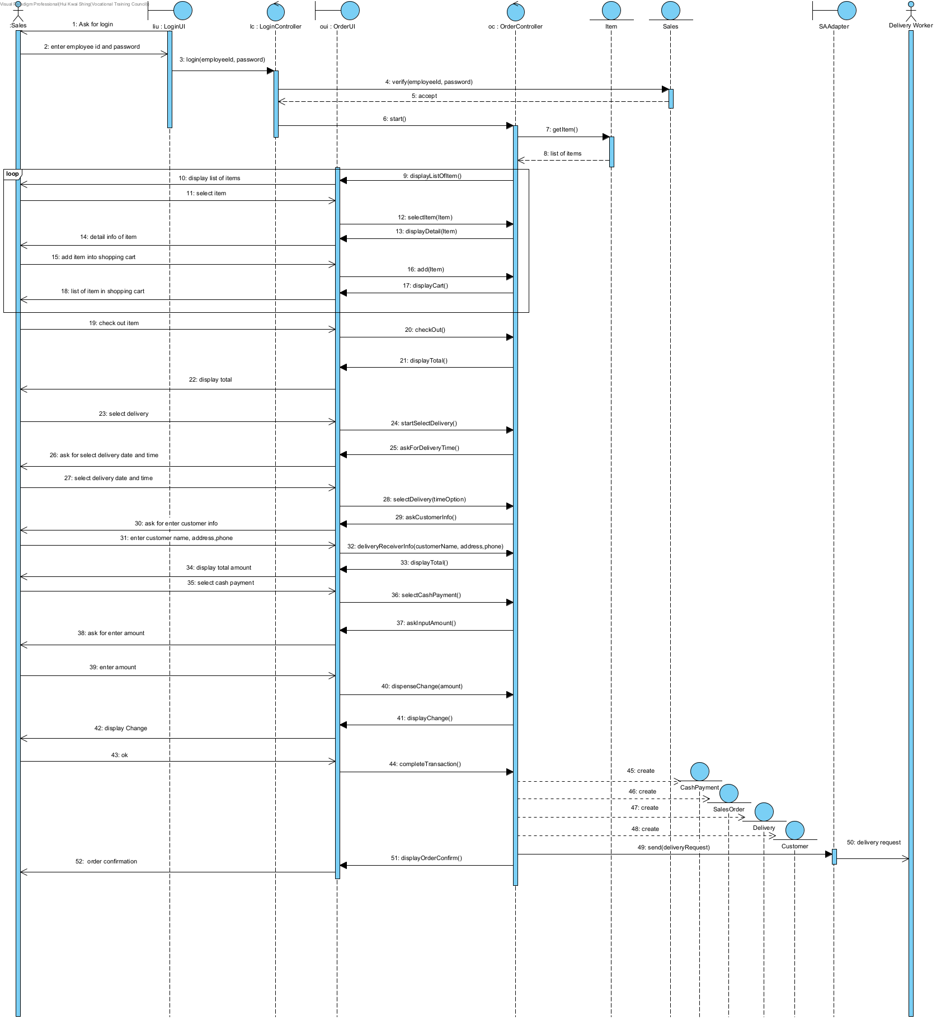

Scenario 5: Create Sales Order (Installation Service)

|  |  |  |  |
| --- | --- | --- | --- |
| Sales | System | Delivery Worker | Installation Worker |
|  | Asks the sales to login |  |  |
| Enter the employee id and password |  |  |  |
| Sales select good page list |  |  |  |
|  | Display the list of items |  |  |
| Select the item |  |  |  |
|  | Display the details information of item |  |  |
| Add an item into the shopping cart |  |  |  |
|  | Display the item in the shopping cart |  |  |
| Check out item |  |  |  |
| Select Delivery |  |  |  |
|  | Ask for select delivery time option |  |  |
| Select delivery time option |  |  |  |
|  | Ask for customer info |  |  |
| Enter customer name, address, phone |  |  |  |
|  | Ask for installation option |  |  |
| Select installation |  |  |  |
|  | Display installation time option |  |  |
| Select installation time option |  |  |  |
|  | Display total |  |  |
| Select cash payment |  |  |  |
|  | Ask for enter amount |  |  |
| Enter amount |  |  |  |
|  | Display change |  |  |
| Receive change |  |  |  |
|  | sends the delivery request |  |  |
|  | sends the installation request |  |  |
|  | Display order confirmation |  |  |

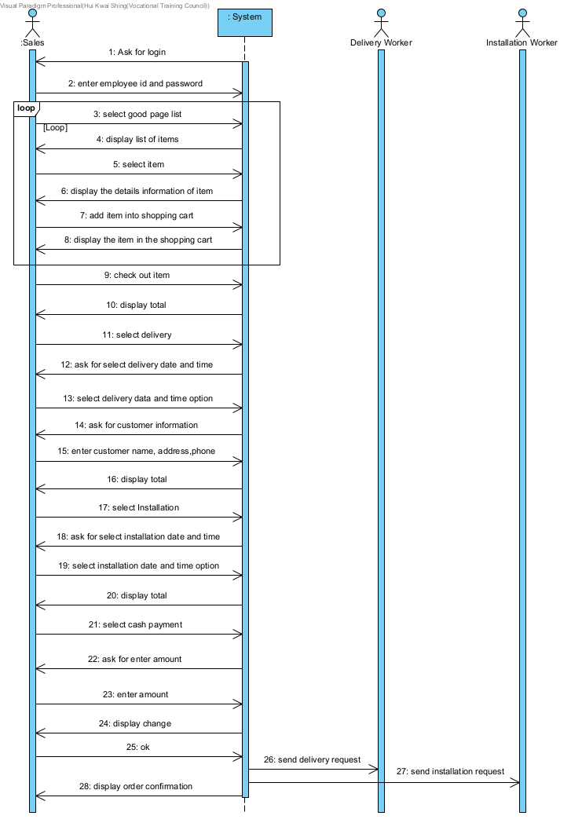

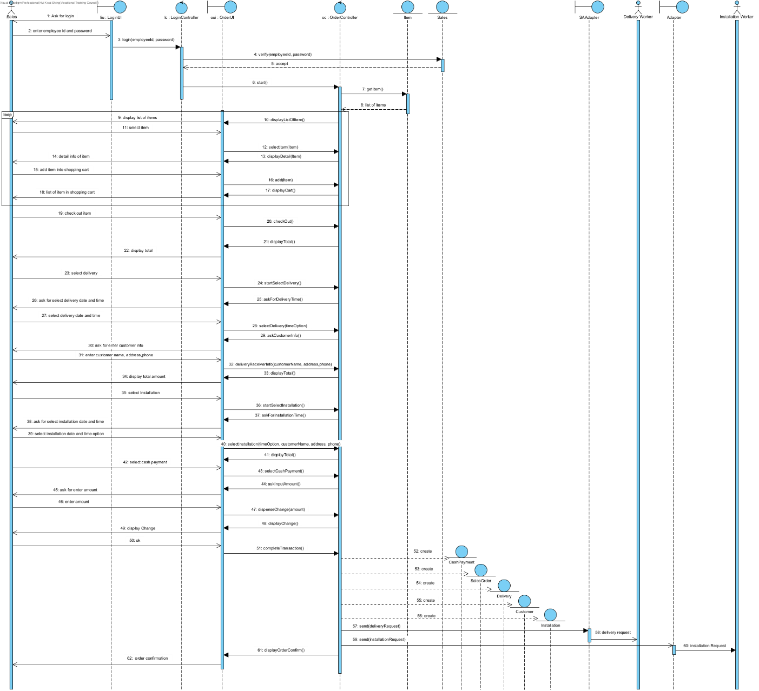

Scenario 6: Create Sales Order (Unavailable item)

|  |  |  |
| --- | --- | --- |
| Sales | System | Delivery Worker |
|  | Ask the sales to login |  |
| Enter the employee id and password |  |  |
| Sales select good page list |  |  |
|  | Display the list of items |  |
| Select the unavailable item |  |  |
|  | Display the details information of item |  |
| Add an item into the shopping cart |  |  |
|  | display unavailable item message |  |
| accept |  |  |
|  | Display the item in the shopping cart |  |
| Check out item |  |  |
|  | Ask for select delivery time option |  |
| Select delivery time option |  |  |
|  | Ask for customer info |  |
| Enter customer name, address, phone |  |  |
|  | Display total |  |
| Select cash payment |  |  |
|  | Ask for enter amount |  |
| Enter amount |  |  |
|  | Display change |  |
| ok |  |  |
|  | sends the delivery request |  |
|  | Display order confirmation |  |

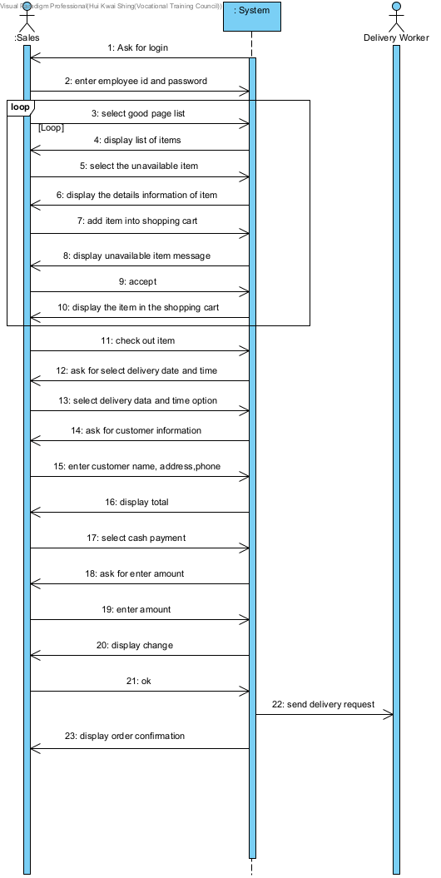

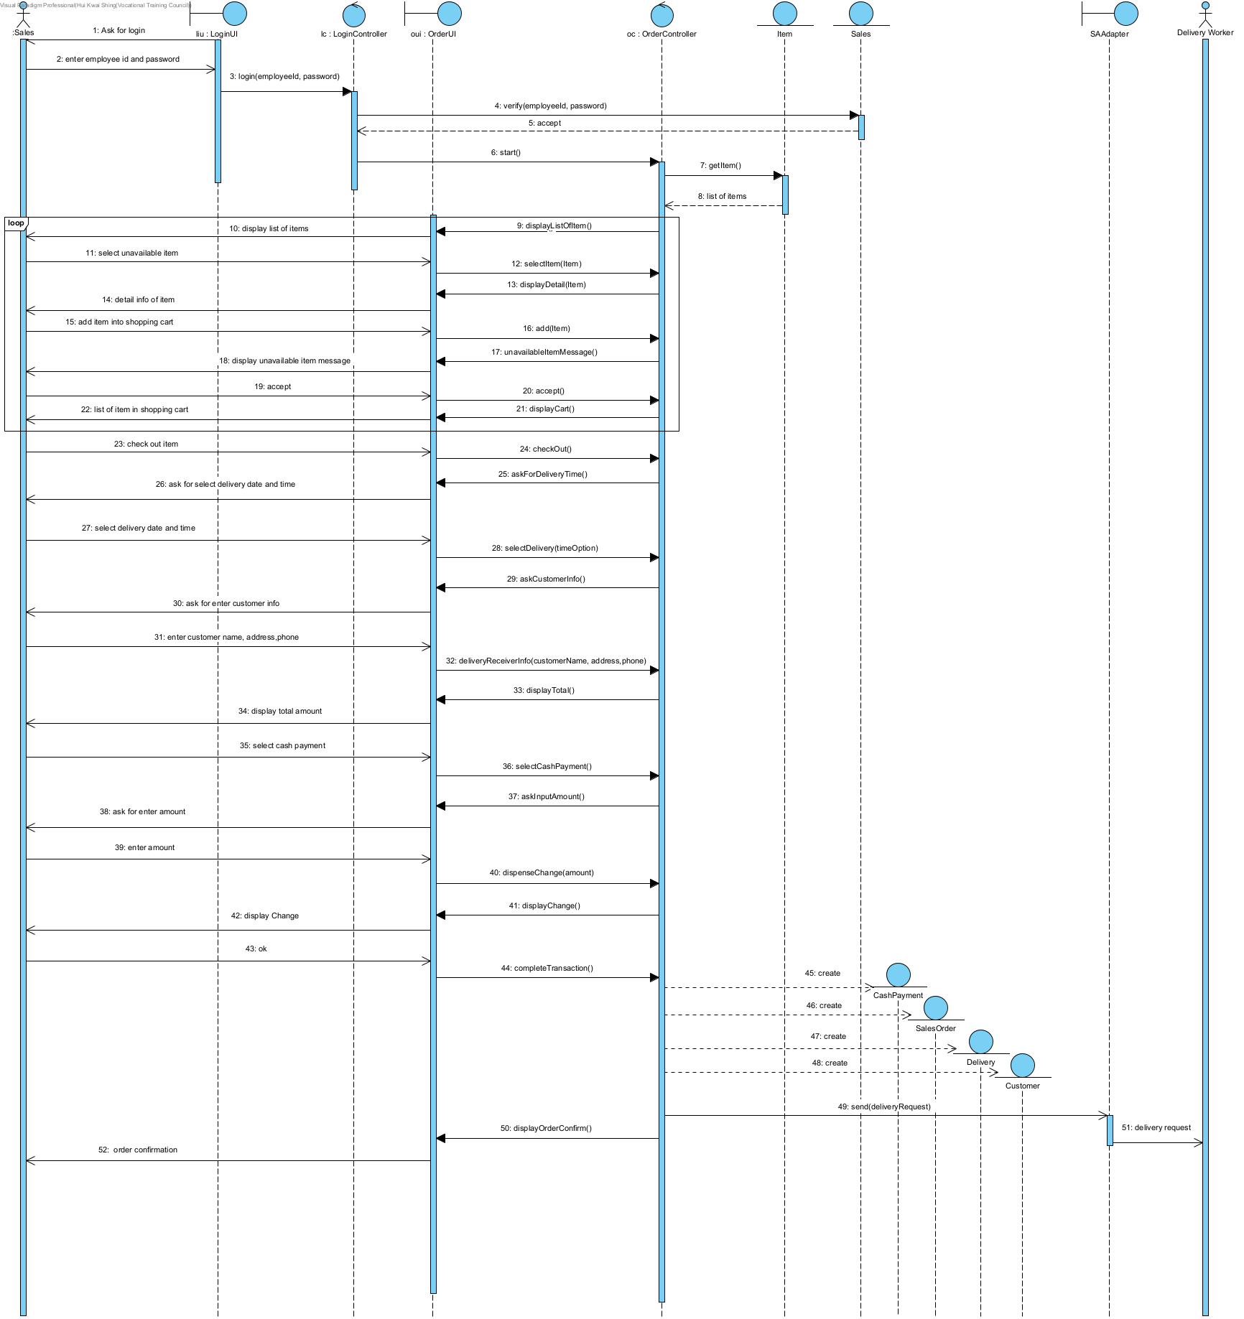

Scenario 7: Create Sales Order (Unavailable item over $5000)

|  |  |  |  |
| --- | --- | --- | --- |
| Sales | System | Delivery Worker | Installation Worker |
|  | Asks the sales to login |  |  |
| Enter the employee id and password |  |  |  |
| Sales select good page list |  |  |  |
|  | Display the list of items |  |  |
| Select the unavailable item |  |  |  |
|  | Display the details information of item |  |  |
| Add an item into the shopping cart |  |  |  |
|  | display 20% deposit message |  |  |
| accept |  |  |  |
|  | Display the item in the shopping cart |  |  |
| Check out item |  |  |  |
|  | Ask for select delivery time option |  |  |
| Select delivery time option |  |  |  |
|  | Ask for customer info |  |  |
| Enter customer name, address, phone |  |  |  |
|  | Display total |  |  |
| Select cash payment |  |  |  |
|  | Ask for enter amount |  |  |
| Enter amount |  |  |  |
|  | Display change |  |  |
| ok |  |  |  |
|  | Display deposit agreement |  |  |
| Select print deposit agreement |  |  |  |
|  | display deposit agreement |  |  |
| Select print deposit agreement |  |  |  |
|  | print deposit agreement |  |  |
| ok |  |  |  |
|  | sends the delivery request |  |  |
|  | Display order confirmation |  |  |

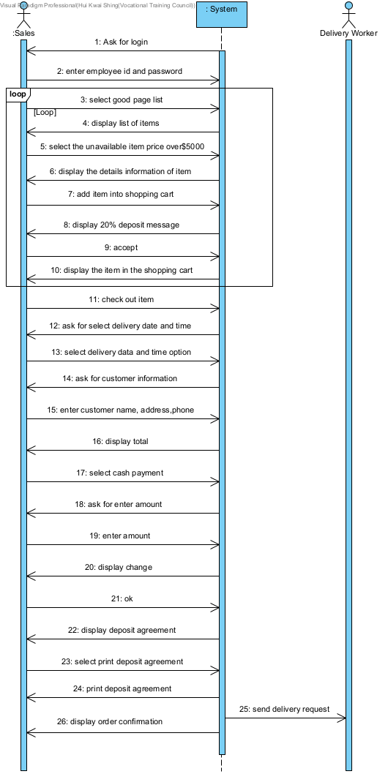

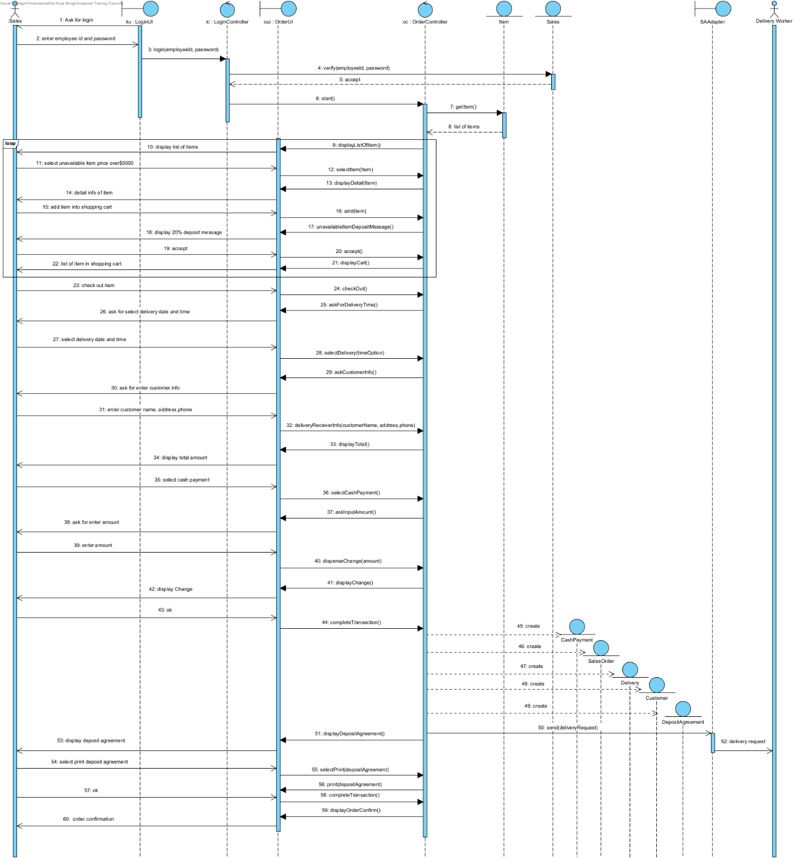

Inventory System

Scenario1 : Create delivery request (with sufficient delivery worker)

|  |  |  |
| --- | --- | --- |
| Inventory Staff | System | Delivery Staff |
|  | Asks the Inventory Staff to login |  |
| Enter the employee id and password |  |  |
|  | Display the Inventory Department Page |  |
| Select the “Delivery” button |  |  |
|  | Display the delivery service page |  |
| Select the “Create delivery service” button |  |  |
|  | Display the create page of delivery |  |
| Enter the Delivery information |  |  |
|  | Ask for select delivery time option |  |
| Select delivery time option |  |  |
|  | Sends the delivery request to Delivery Staff |  |
|  | Display delivery order confirmation |  |

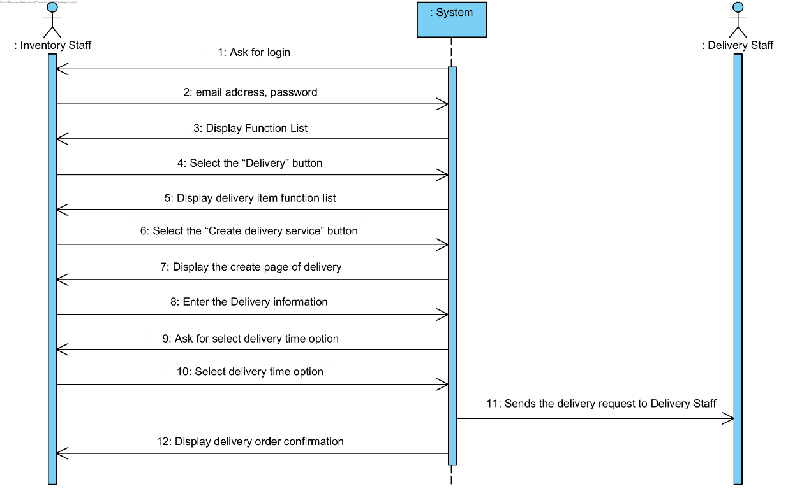

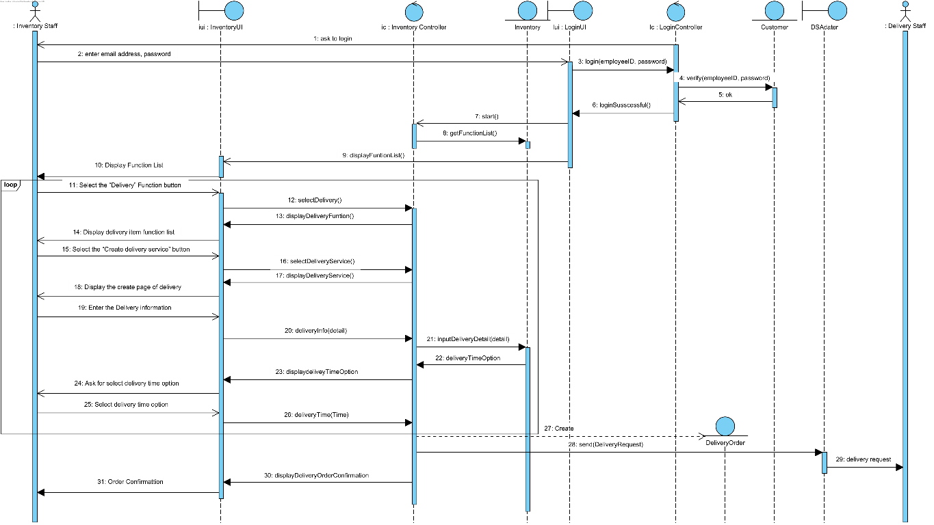

Scenario2 : Create delivery request (with insufficient delivery worker)

|  |  |  |
| --- | --- | --- |
| Inventory Staff | System | Delivery Staff |
|  | Asks the Inventory Staff to login |  |
| Enter the employee id and password |  |  |
|  | Display the Inventory Department Page |  |
| Select the “Delivery” button |  |  |
|  | Display the delivery service page |  |
| Select the “Create delivery service” button |  |  |
|  | Display the create page of delivery |  |
| Enter the Delivery information |  |  |
|  | Ask for select delivery time option |  |
| Select delivery time option |  |  |
|  | Ask for reselect delivery time option |  |

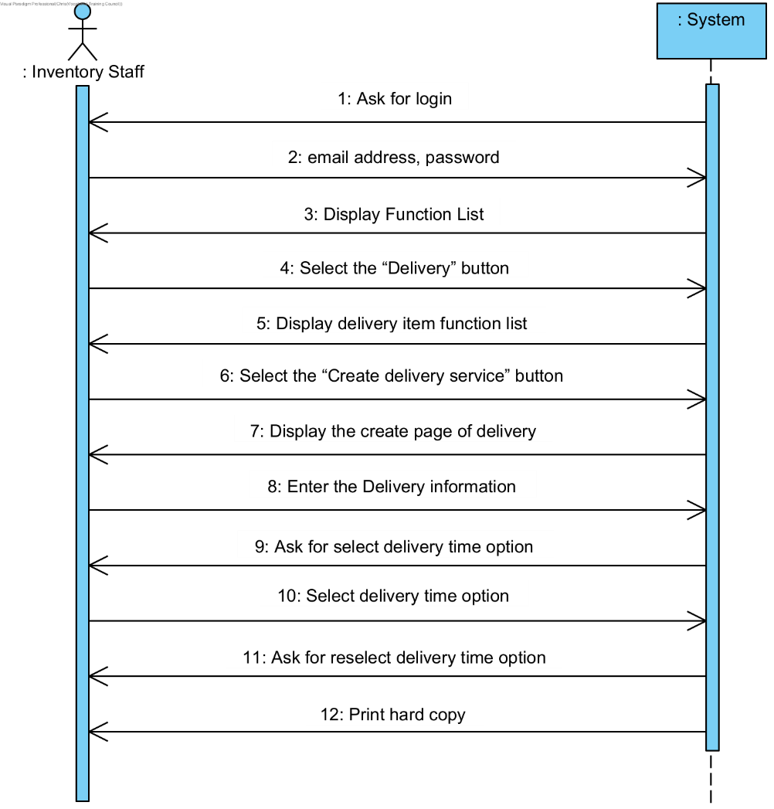

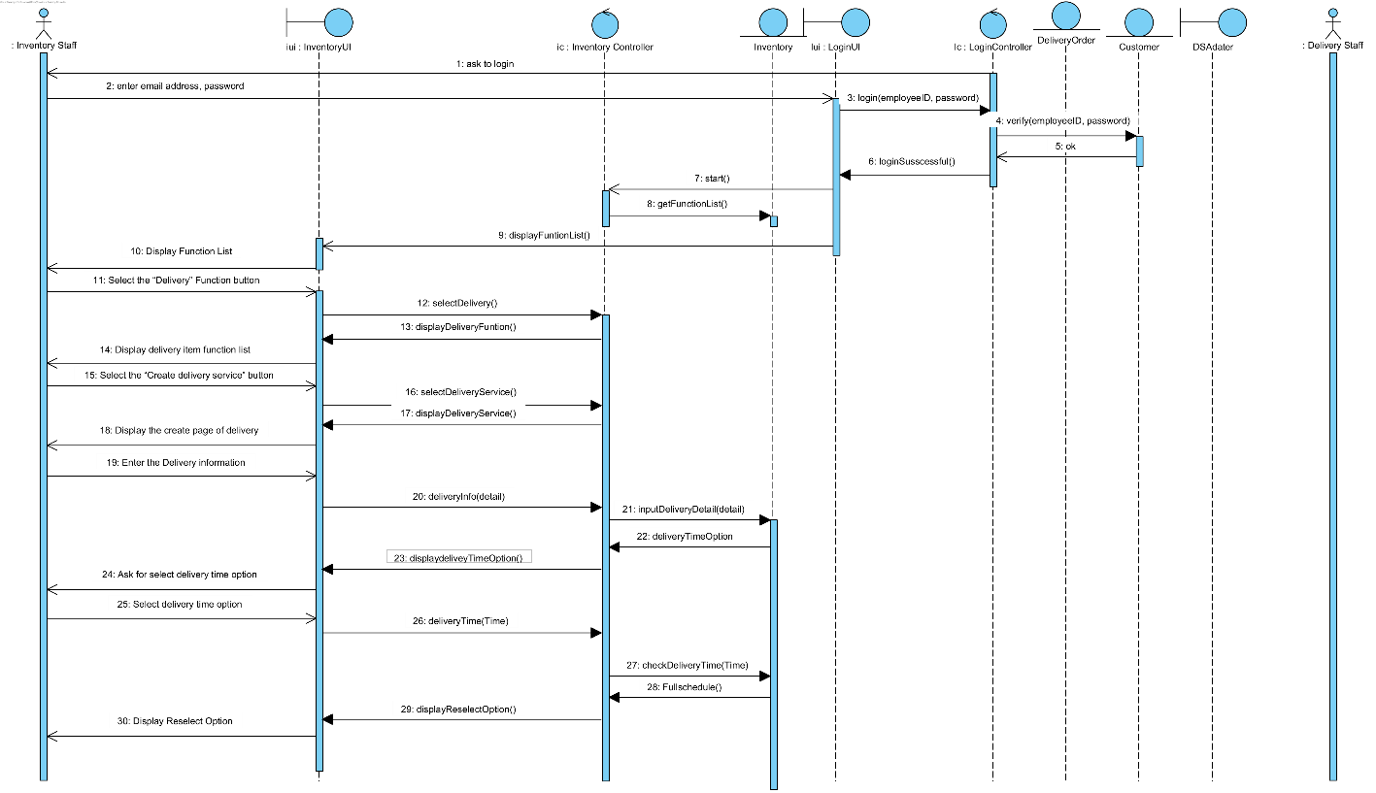

Scenario3 : Create installation request (with sufficient worker)

|  |  |  |
| --- | --- | --- |
| Inventory Staff | System | Delivery Staff |
|  | Asks the Inventory Staff to login |  |
| Enter the employee id and password |  |  |
|  | asks for select department |  |
| select Technical support department |  |  |
| select installation |  |  |
| Select the “Create installation service” button |  |  |
|  | Display all installation |  |
| Select the “Create” button |  |  |
|  | Display creates delivery page |  |
| input delivery order number |  |  |
|  | Check delivery time is after 2 hours |  |
|  | ask for select installation items |  |
| select installation items |  |  |
| Enter installation information |  |  |
|  | Sends the installation request to Installation Worker |  |
|  | Display installation service confirmation |  |
|  | Print hard copy |  |

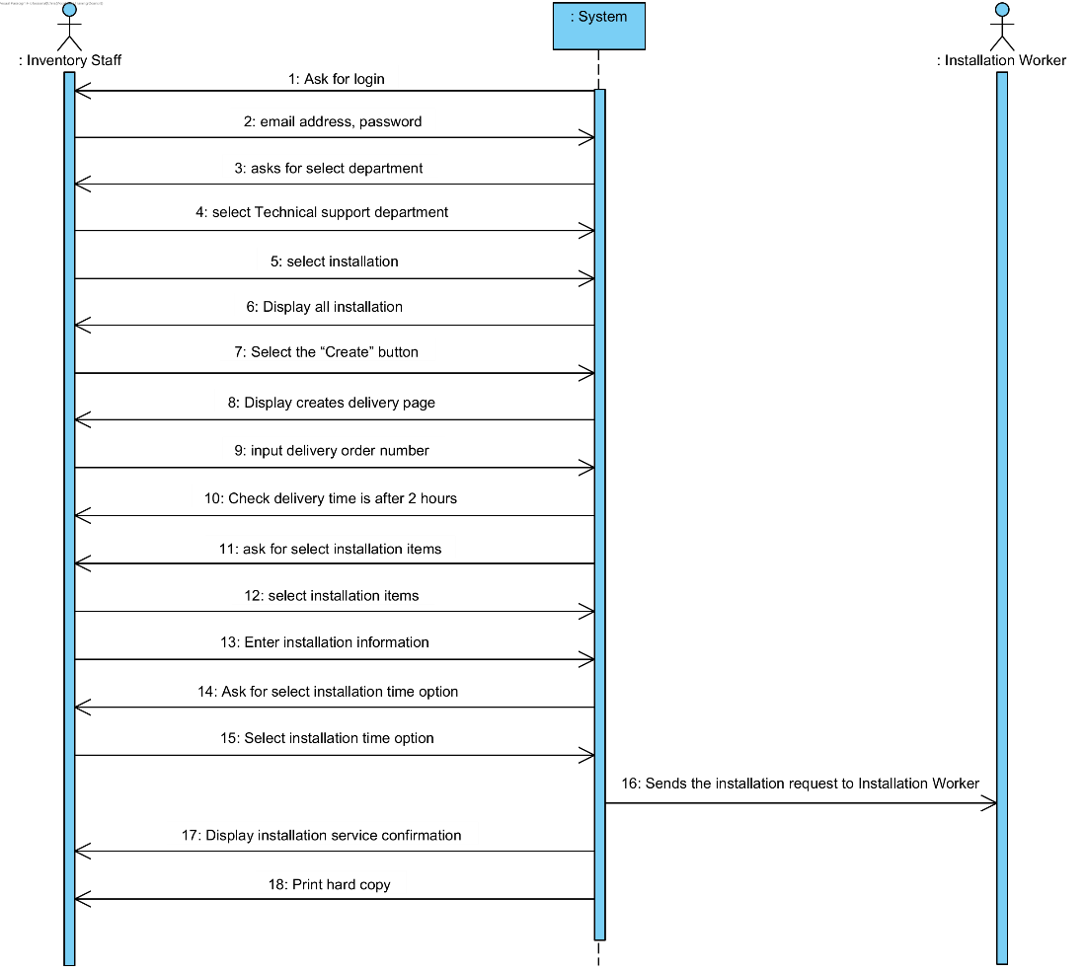

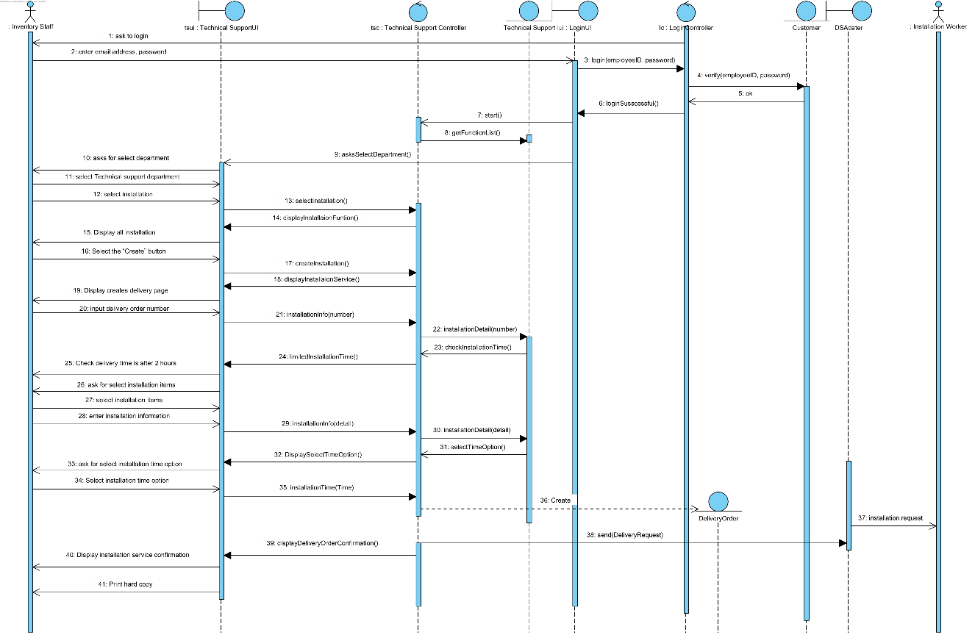

Scenario 4: Create installation request (with insufficient worker)

|  |  |  |
| --- | --- | --- |
| Inventory Staff | System | Delivery Staff |
|  | Asks the Inventory Staff to login |  |
| Enter the employee id and password |  |  |
|  | asks for select department |  |
| select Technical support department |  |  |
| select installation |  |  |
| Select the “Create installation service” button |  |  |
|  | Display all installation |  |
| Select the “Create” button |  |  |
|  | Display creates delivery page |  |
| input delivery order number |  |  |
|  | Check delivery time is after 2 hours |  |
|  | ask for select installation items |  |
| select installation items |  |  |
| Enter installation information |  |  |
|  | ask for reselect installation items |  |

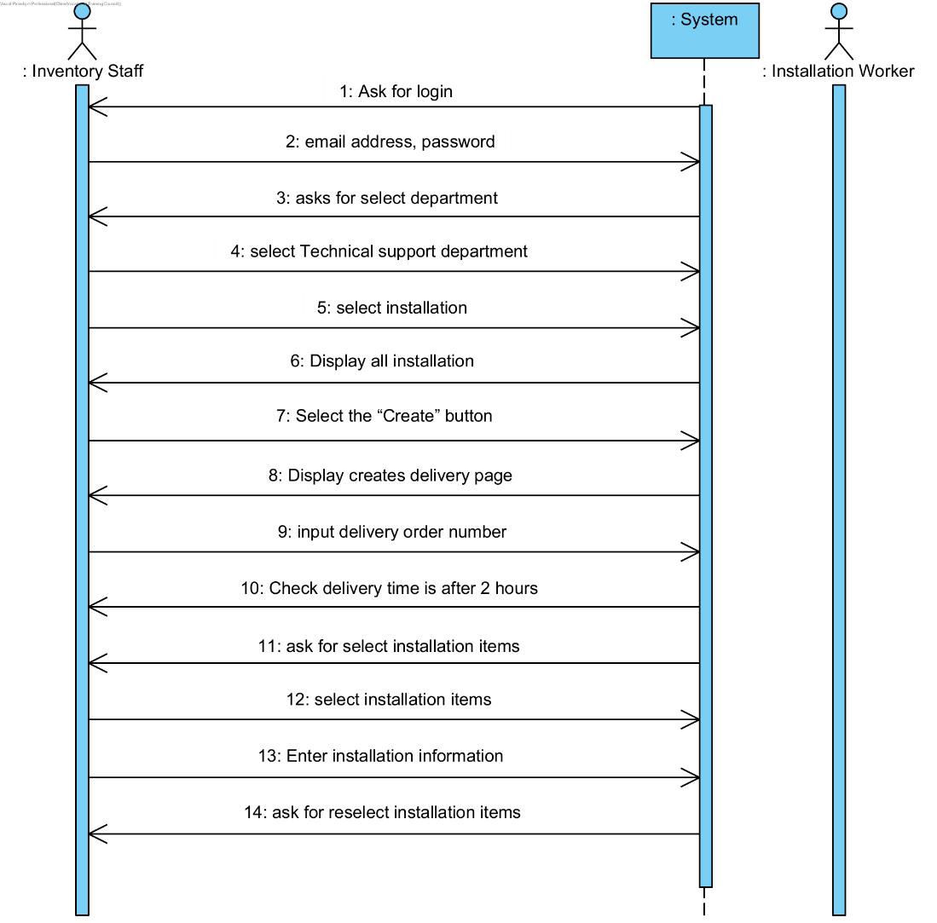

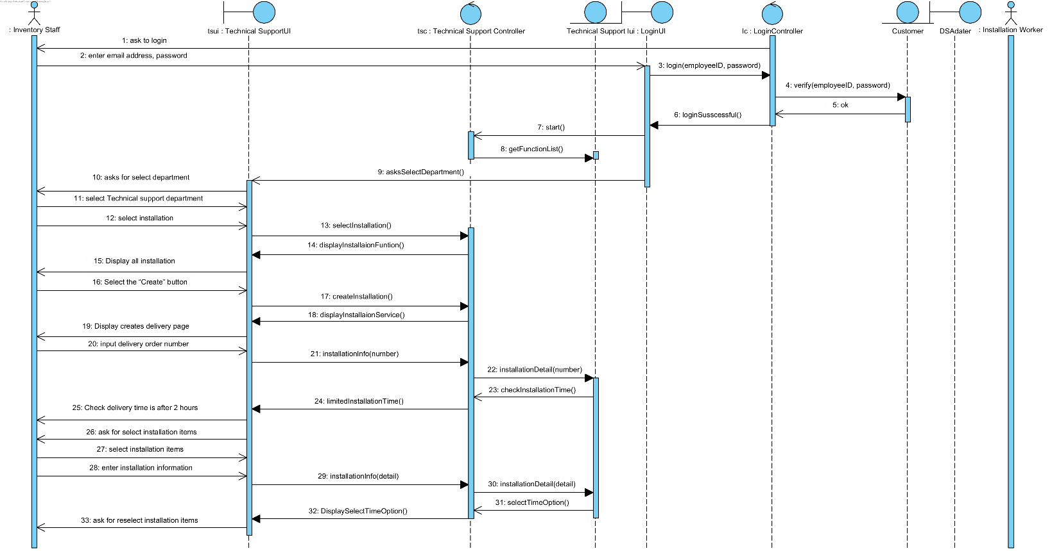

Scenario 5: Create new Item (inventory)

|  |  |  |
| --- | --- | --- |
| Inventory Staff | System | Delivery Staff |
|  | Ask for login |  |
| Enter the employee id and password |  |  |
|  | Display Department List |  |
| Select the “Purchase Department” button |  |  |
|  | Display Inventory item list |  |
| Select the “Create item” button |  |  |
|  | Select the “Create item” button |  |
| Enter installation information |  |  |
|  | confirm create successful message |  |

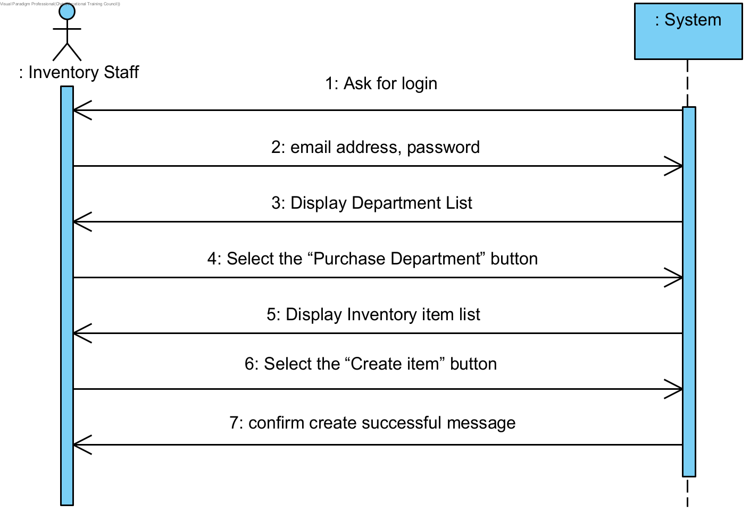

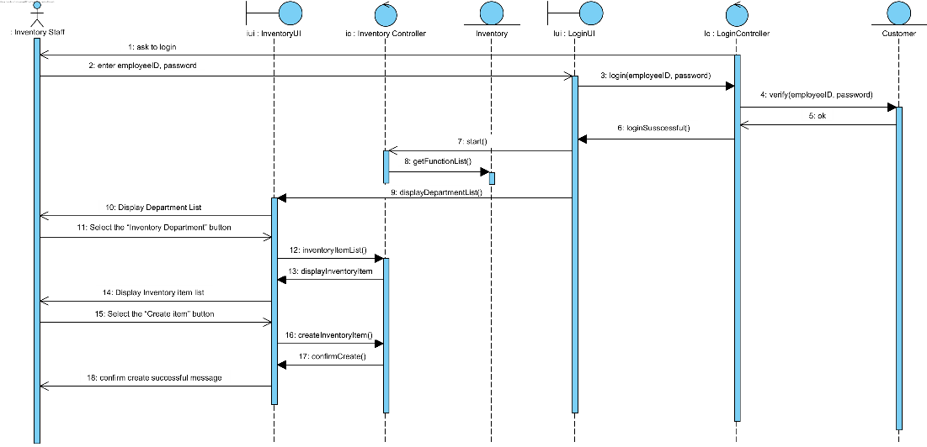

Scenario 6: Update Price (Sales Department)

|  |  |  |
| --- | --- | --- |
| Inventory Staff | System | Delivery Staff |
|  | Ask for login |  |
| Enter the employee id and password |  |  |
|  | Display Department List |  |
| Select the “Sales Department” button |  |  |
|  | Display Sales item list |  |
| Select the “Edit” button |  |  |
|  | confirm edit successful message |  |

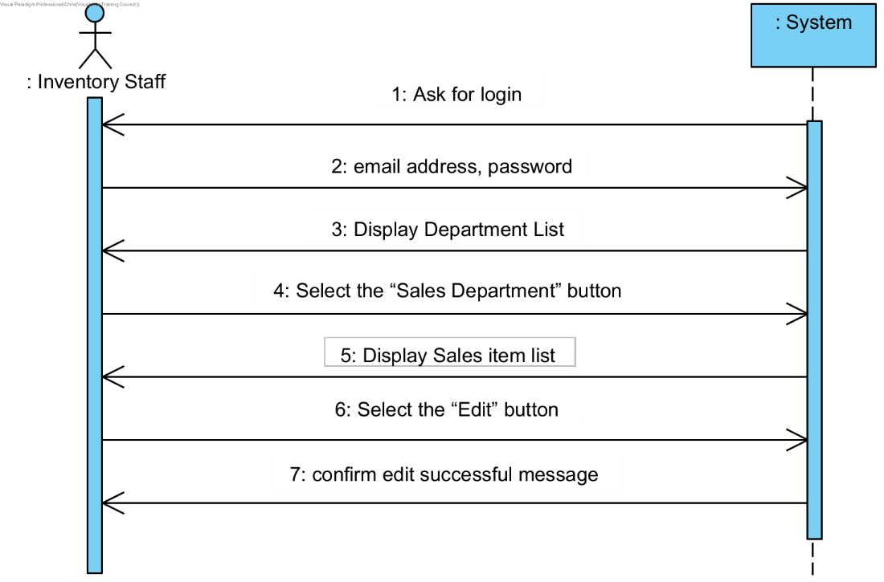

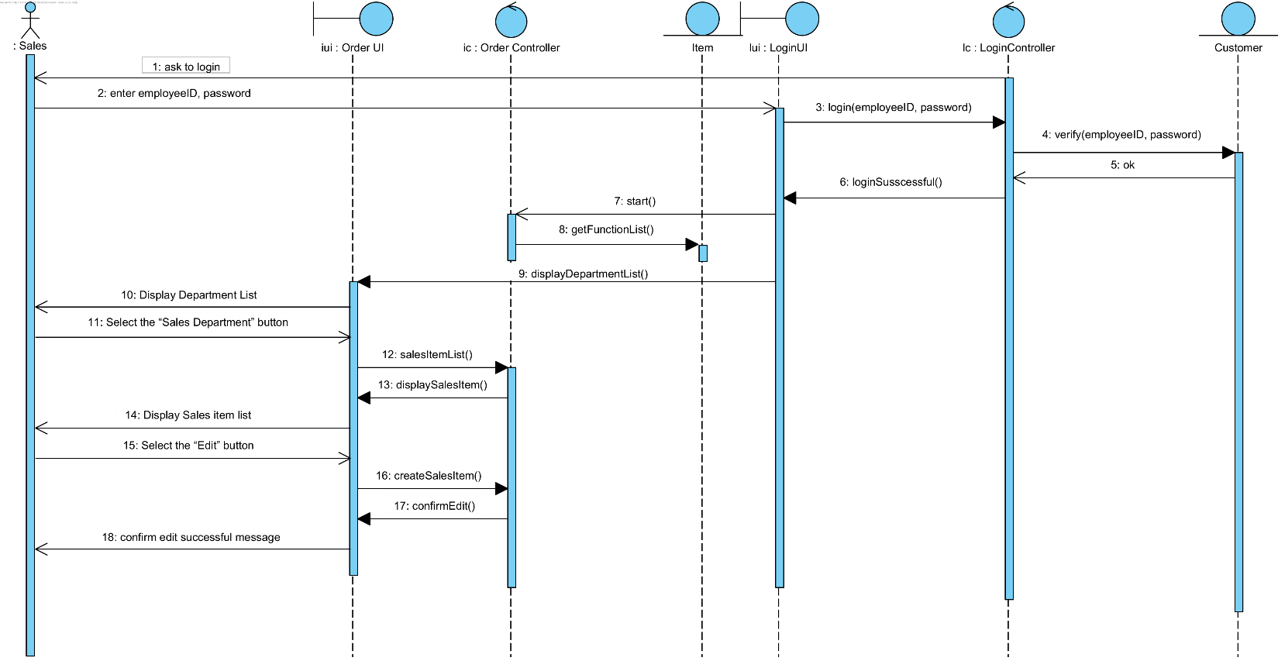

Scenario 7: Create Replenishment Request (stock level low and inventory department is approval)

|  |  |  |
| --- | --- | --- |
| Sales Manager | System | Inventory Staff |
|  | Asks for login |  |
| Enter the employee id and password |  |  |
|  | Asks for select department |  |
| Select sales department |  |  |
| Select replenishment request |  |  |
|  | Display all replenishment requests |  |
| Click Create |  |  |
|  | Display creates request page |  |
| Input items’ name and quantity |  |  |
|  | Display details of replenishment |  |
| Select send to inventory department |  |  |
|  | send approve request |  |
|  |  | Approve |
|  | A replenishment request approves |  |

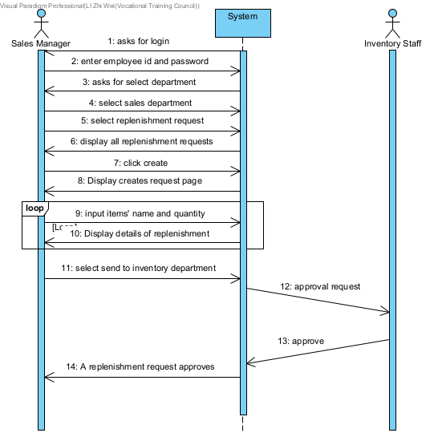

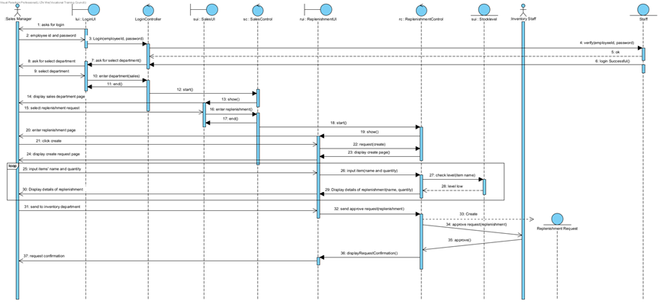

Scenario 8: Create Replenishment Request (stock level high)

|  |  |  |
| --- | --- | --- |
| Sales Manager | System | Inventory Staff |
|  | Asks for login |  |
| Enter the employee id and password |  |  |
|  | Asks for select department |  |
| Select sales department |  |  |
| Select replenishment request |  |  |
|  | Display all replenishment requests |  |
| Click Create |  |  |
|  | Display creates request page |  |
| Input items’ name and quantity |  |  |
|  | Ask for re-select items |  |

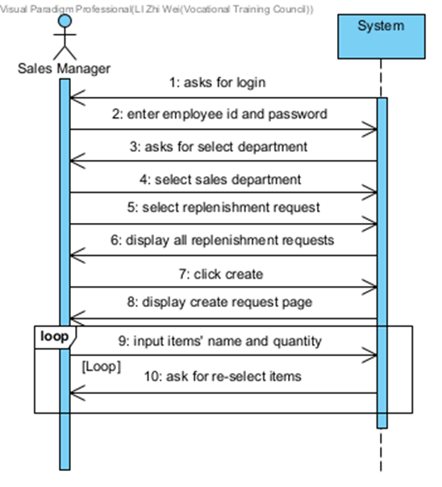

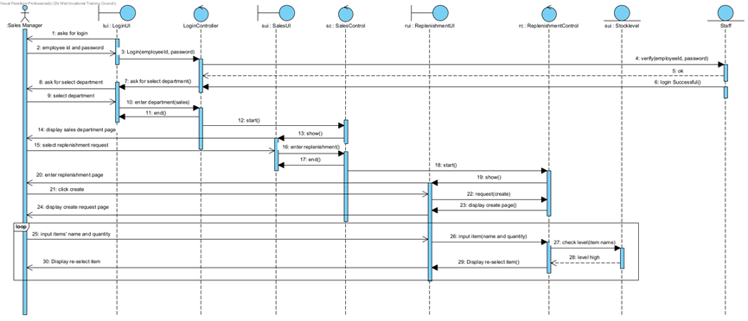

Scenario 9: Create Replenishment Request (stock level low and inventory department is not approval)

|  |  |  |
| --- | --- | --- |
| Sales Manager | System | Inventory Staff |
|  | Asks for login |  |
| Enter the employee id and password |  |  |
|  | Asks for select department |  |
| Select sales department |  |  |
| Select replenishment request |  |  |
|  | Display all replenishment requests |  |
| Click Create |  |  |
|  | Display creates request page |  |
| Input items’ name and quantity |  |  |
|  | Display details of replenishment |  |
| Select send to inventory department |  |  |
|  | Send approve request |  |
|  |  | Reject |
|  | A replenishment request reject |  |

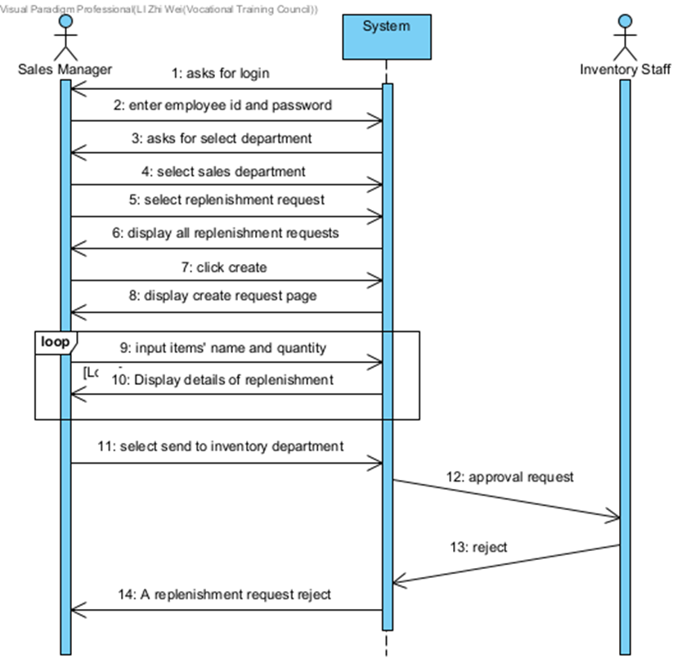

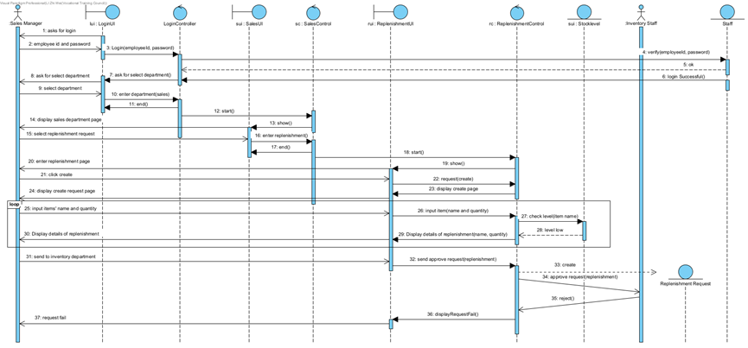

Scenario 10: Create Re-order Request (stock level low and purchase department is approved)

|  |  |  |
| --- | --- | --- |
| Inventory Staff | System | Purchase Staff |
|  | Asks for login |  |
| Enter the employee id and password |  |  |
|  | Asks for select department |  |
| Select inventory department |  |  |
| Select re-order request |  |  |
|  | Display all re-order requests |  |
| Click Create |  |  |
|  | Display creates request page |  |
| Input items’ name and quantity |  |  |
|  | Display details of re-order |  |
| Select send to purchase department |  |  |
|  | Send approve request |  |
|  |  | Approve |
|  | A re-order request approves |  |

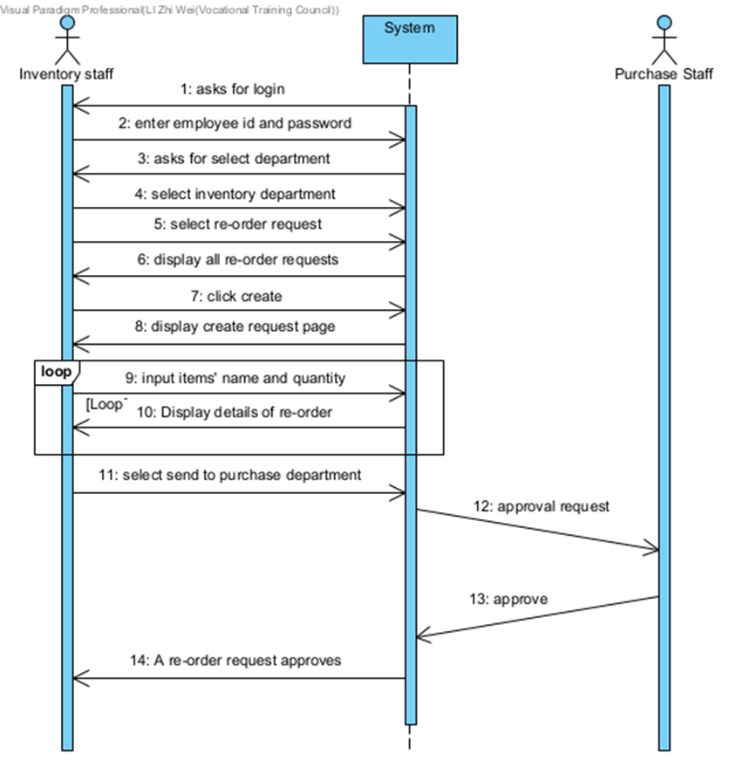

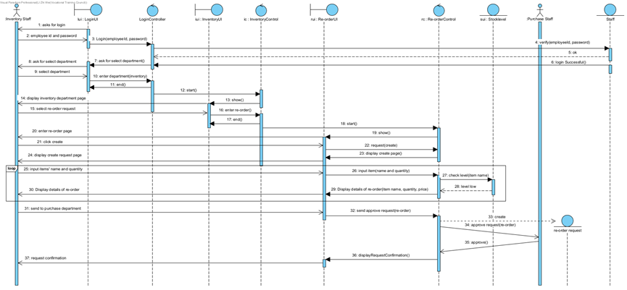

Scenario 11: Create Re-order Request (stock level high)

|  |  |  |
| --- | --- | --- |
| Inventory Staff | System | Purchase Staff |
|  | Asks for login |  |
| Enter the employee id and password |  |  |
|  | Asks for select department |  |
| Select inventory department |  |  |
| Select re-order request |  |  |
|  | Display all re-order requests |  |
| Click Create |  |  |
|  | Display creates request page |  |
| Input items’ name and quantity |  |  |
|  | Asks for re-select items |  |

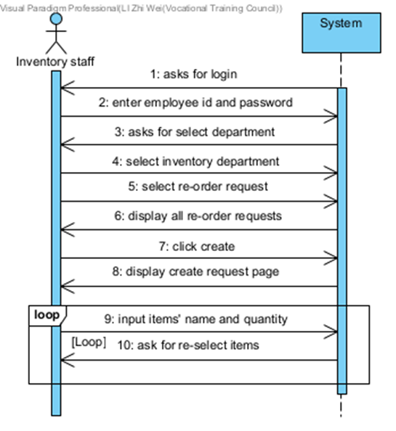

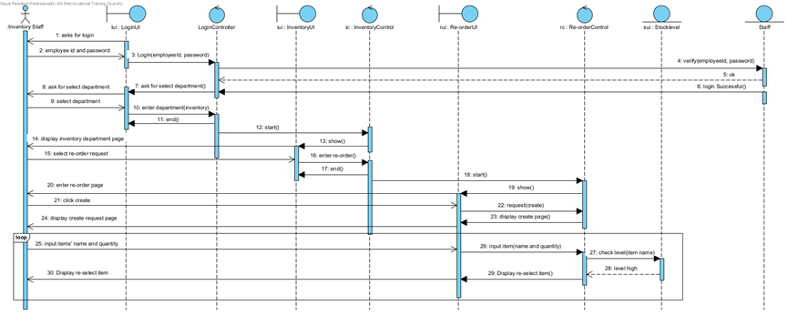

Scenario 12: Create Re-order Request (stock level low and purchase department is not approved)

|  |  |  |
| --- | --- | --- |
| Inventory Staff | System | Purchase Staff |
|  | Asks for login |  |
| Enter the employee id and password |  |  |
|  | Asks for select department |  |
| Select inventory department |  |  |
| Select re-order request |  |  |
|  | Display all re-order requests |  |
| Click Create |  |  |
|  | Display creates request page |  |
| Input items’ name and quantity |  |  |
|  | Display details of re-order |  |
| Select send to purchase department |  |  |
|  | Send approve request |  |
|  |  | Reject |
|  | A re-order request reject |  |

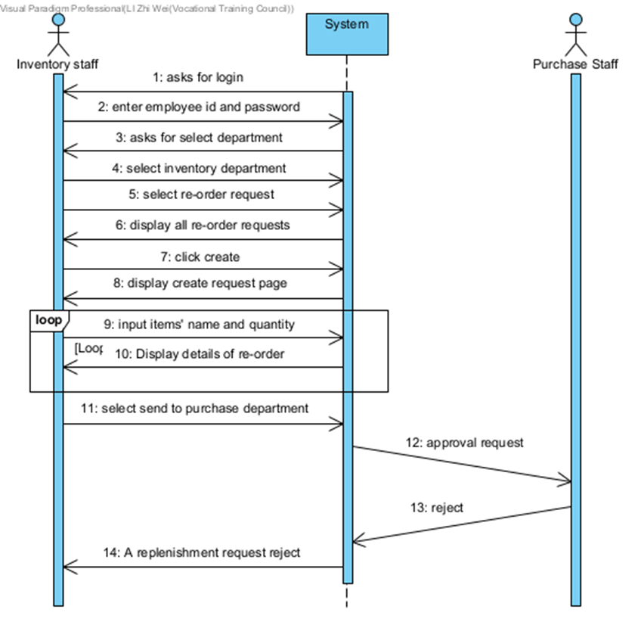

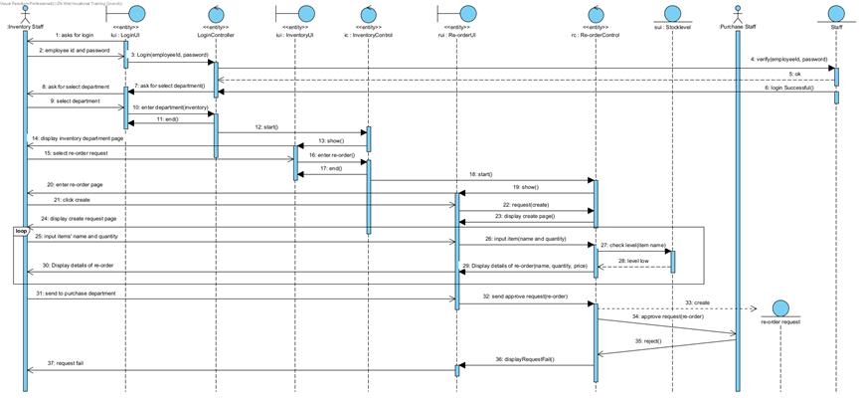

Scenario 13: Create Purchase Order

|  |  |
| --- | --- |
| Purchase Staff | System |
|  | Asks for login |
| Enter the employee id and password |  |
|  | Asks for select department |
| Select purchase department |  |
| Select purchase order |  |
|  | Display all purchase orders |
| Click Create |  |
|  | Display creates request page |
| Input items number |  |
|  | Ask for input items quantity |
| Input items quantity |  |
|  | Ask for select supplier |
| Select supplier |  |
| Click create |  |
|  | Display order content |
| Click finish |  |
|  | A purchase order will be created |

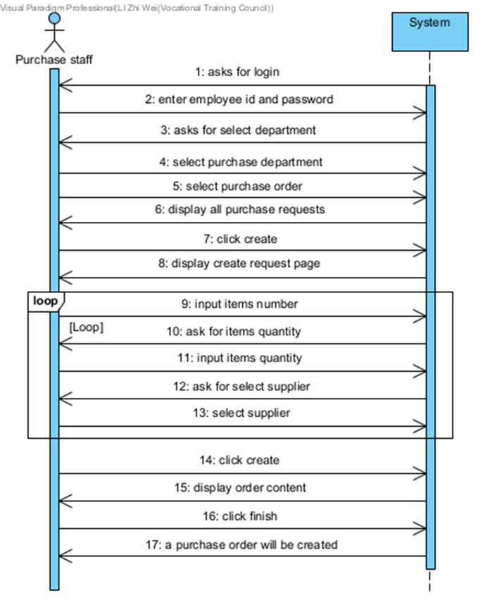

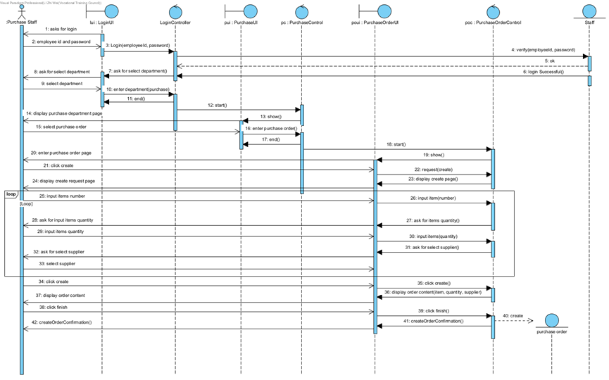

Scenario 14: Create Goods Returned Note

|  |  |
| --- | --- |
| Goods Inwards Clerk | System |
|  | Asks for login |
| Enter the employee id and password |  |
|  | Asks for select department |
| Select inventory department |  |
| Select goods returned note |  |
|  | Display all goods returned note |
| Click Create |  |
|  | Display creates note page |
| Input items number |  |
|  | Ask for input items quantity |
| Input items quantity |  |
|  | Ask for returned money |
| Input returned money |  |
| Click create |  |
|  | Display goods returned note content |
| Click finish |  |
|  | A goods returned note will be created |
|  | Ask for select print hard copy |
| Select print hard copy |  |
|  | Print a hard copy |

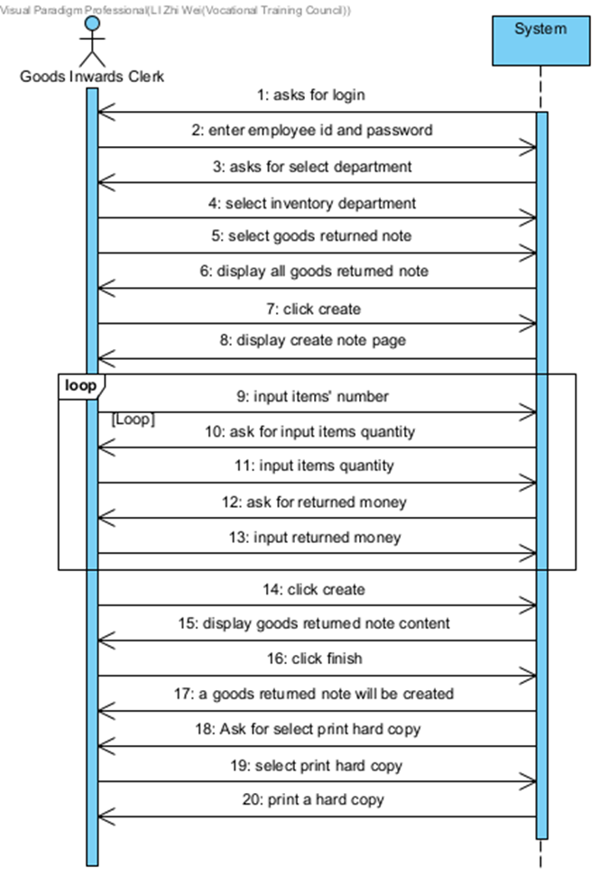

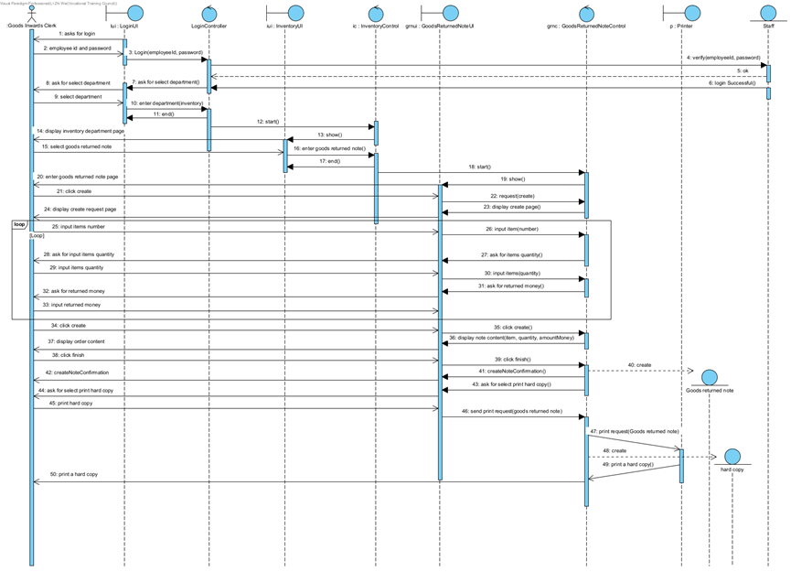

**11 .State Machine Diagram**

**11.1 Sales Order Creation**

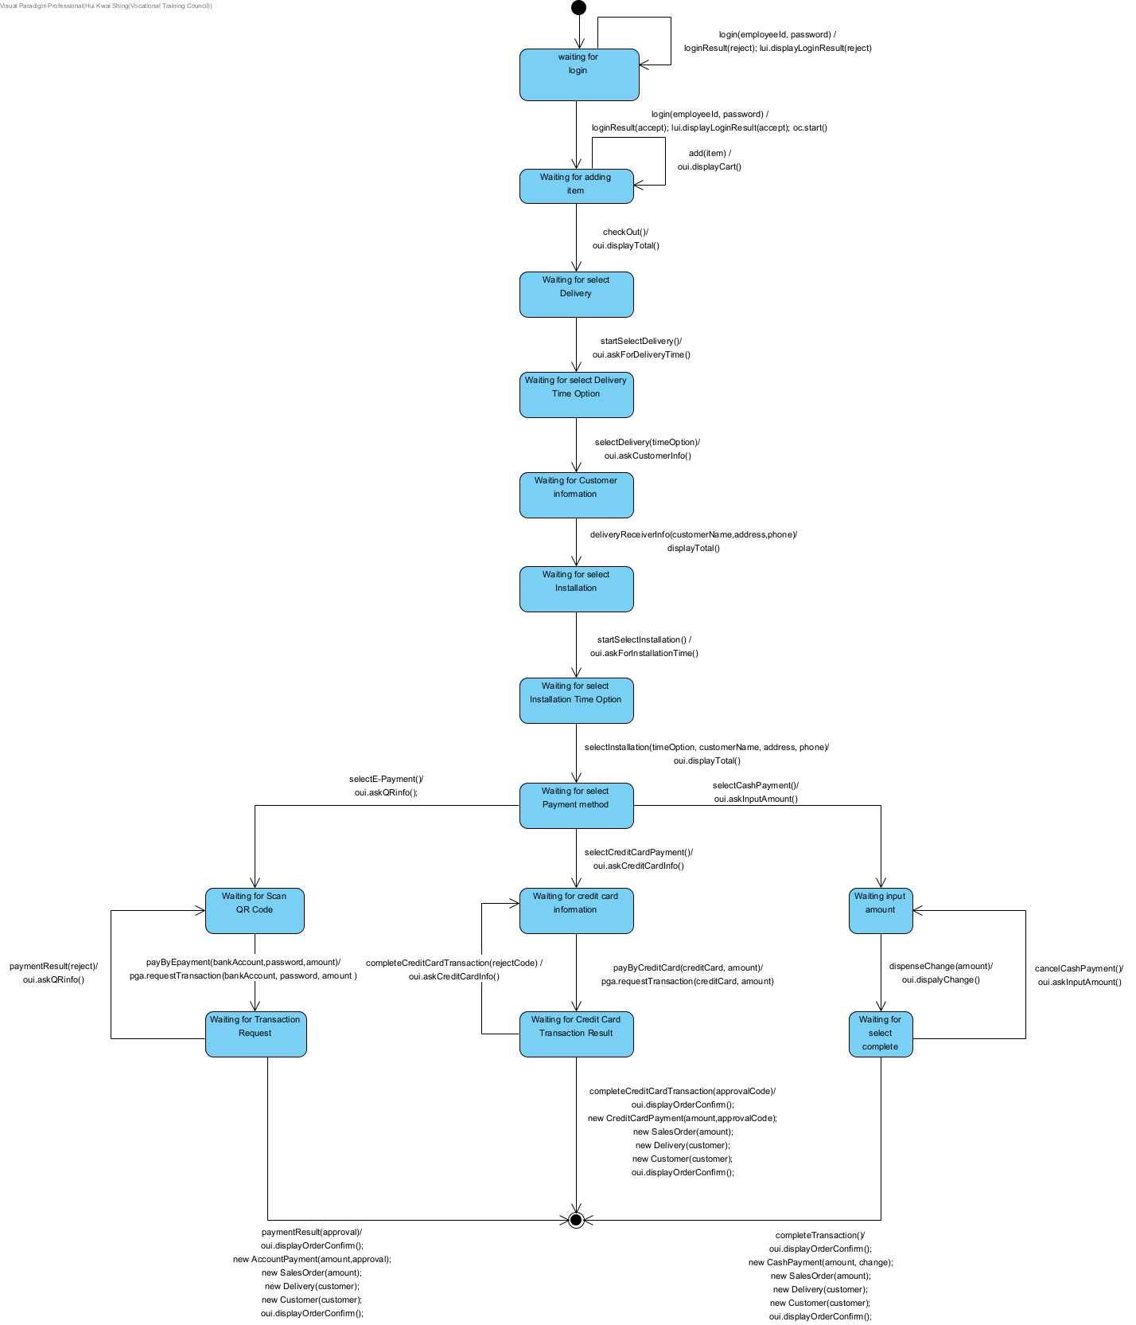

**11.2 Create replenishment request**

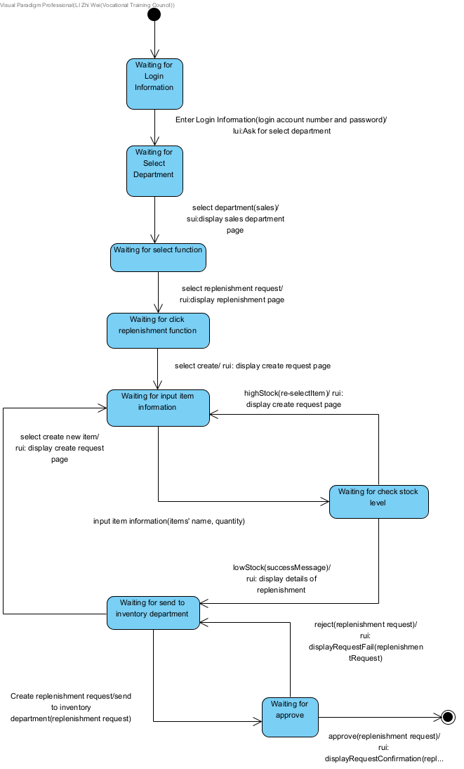

**11.3 Create Re-order Request**

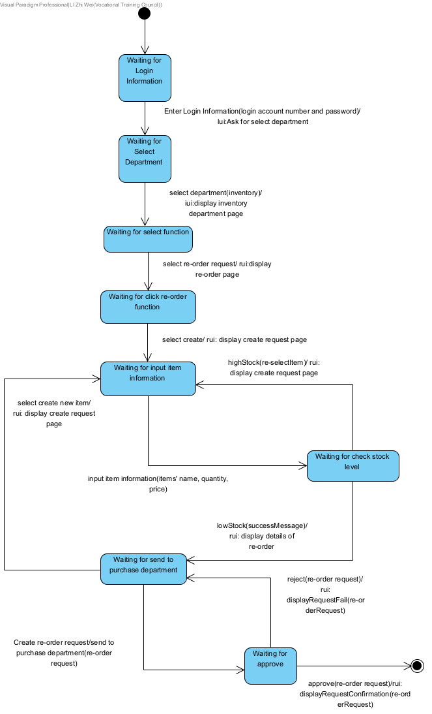

**11.4 Create Purchase Order**

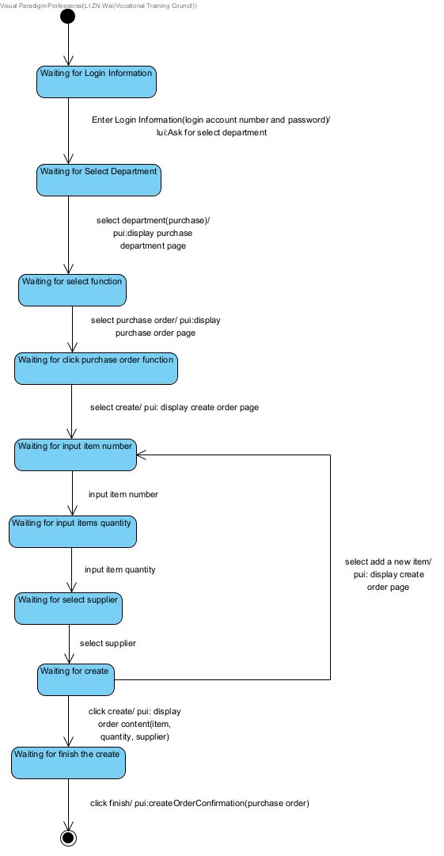

**11.5 Create Goods Returned Note**

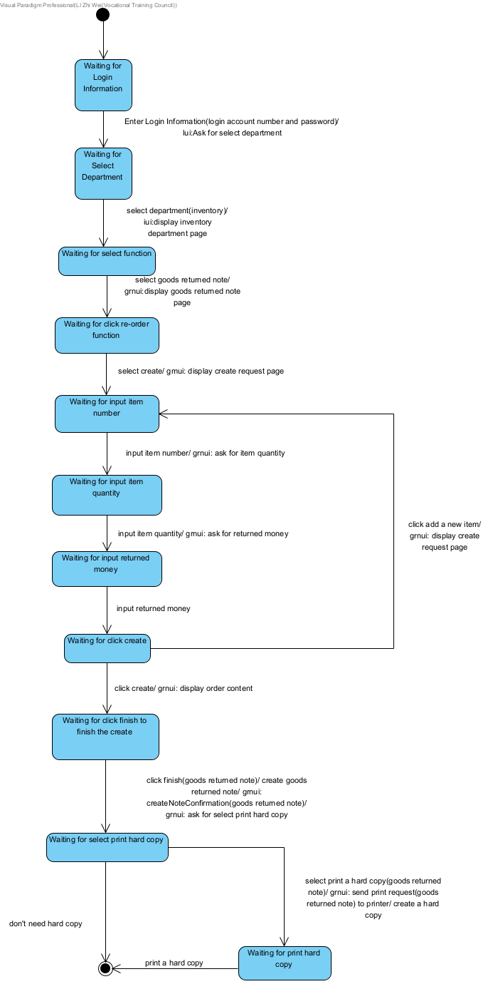

**12. Entity Relation Diagram**

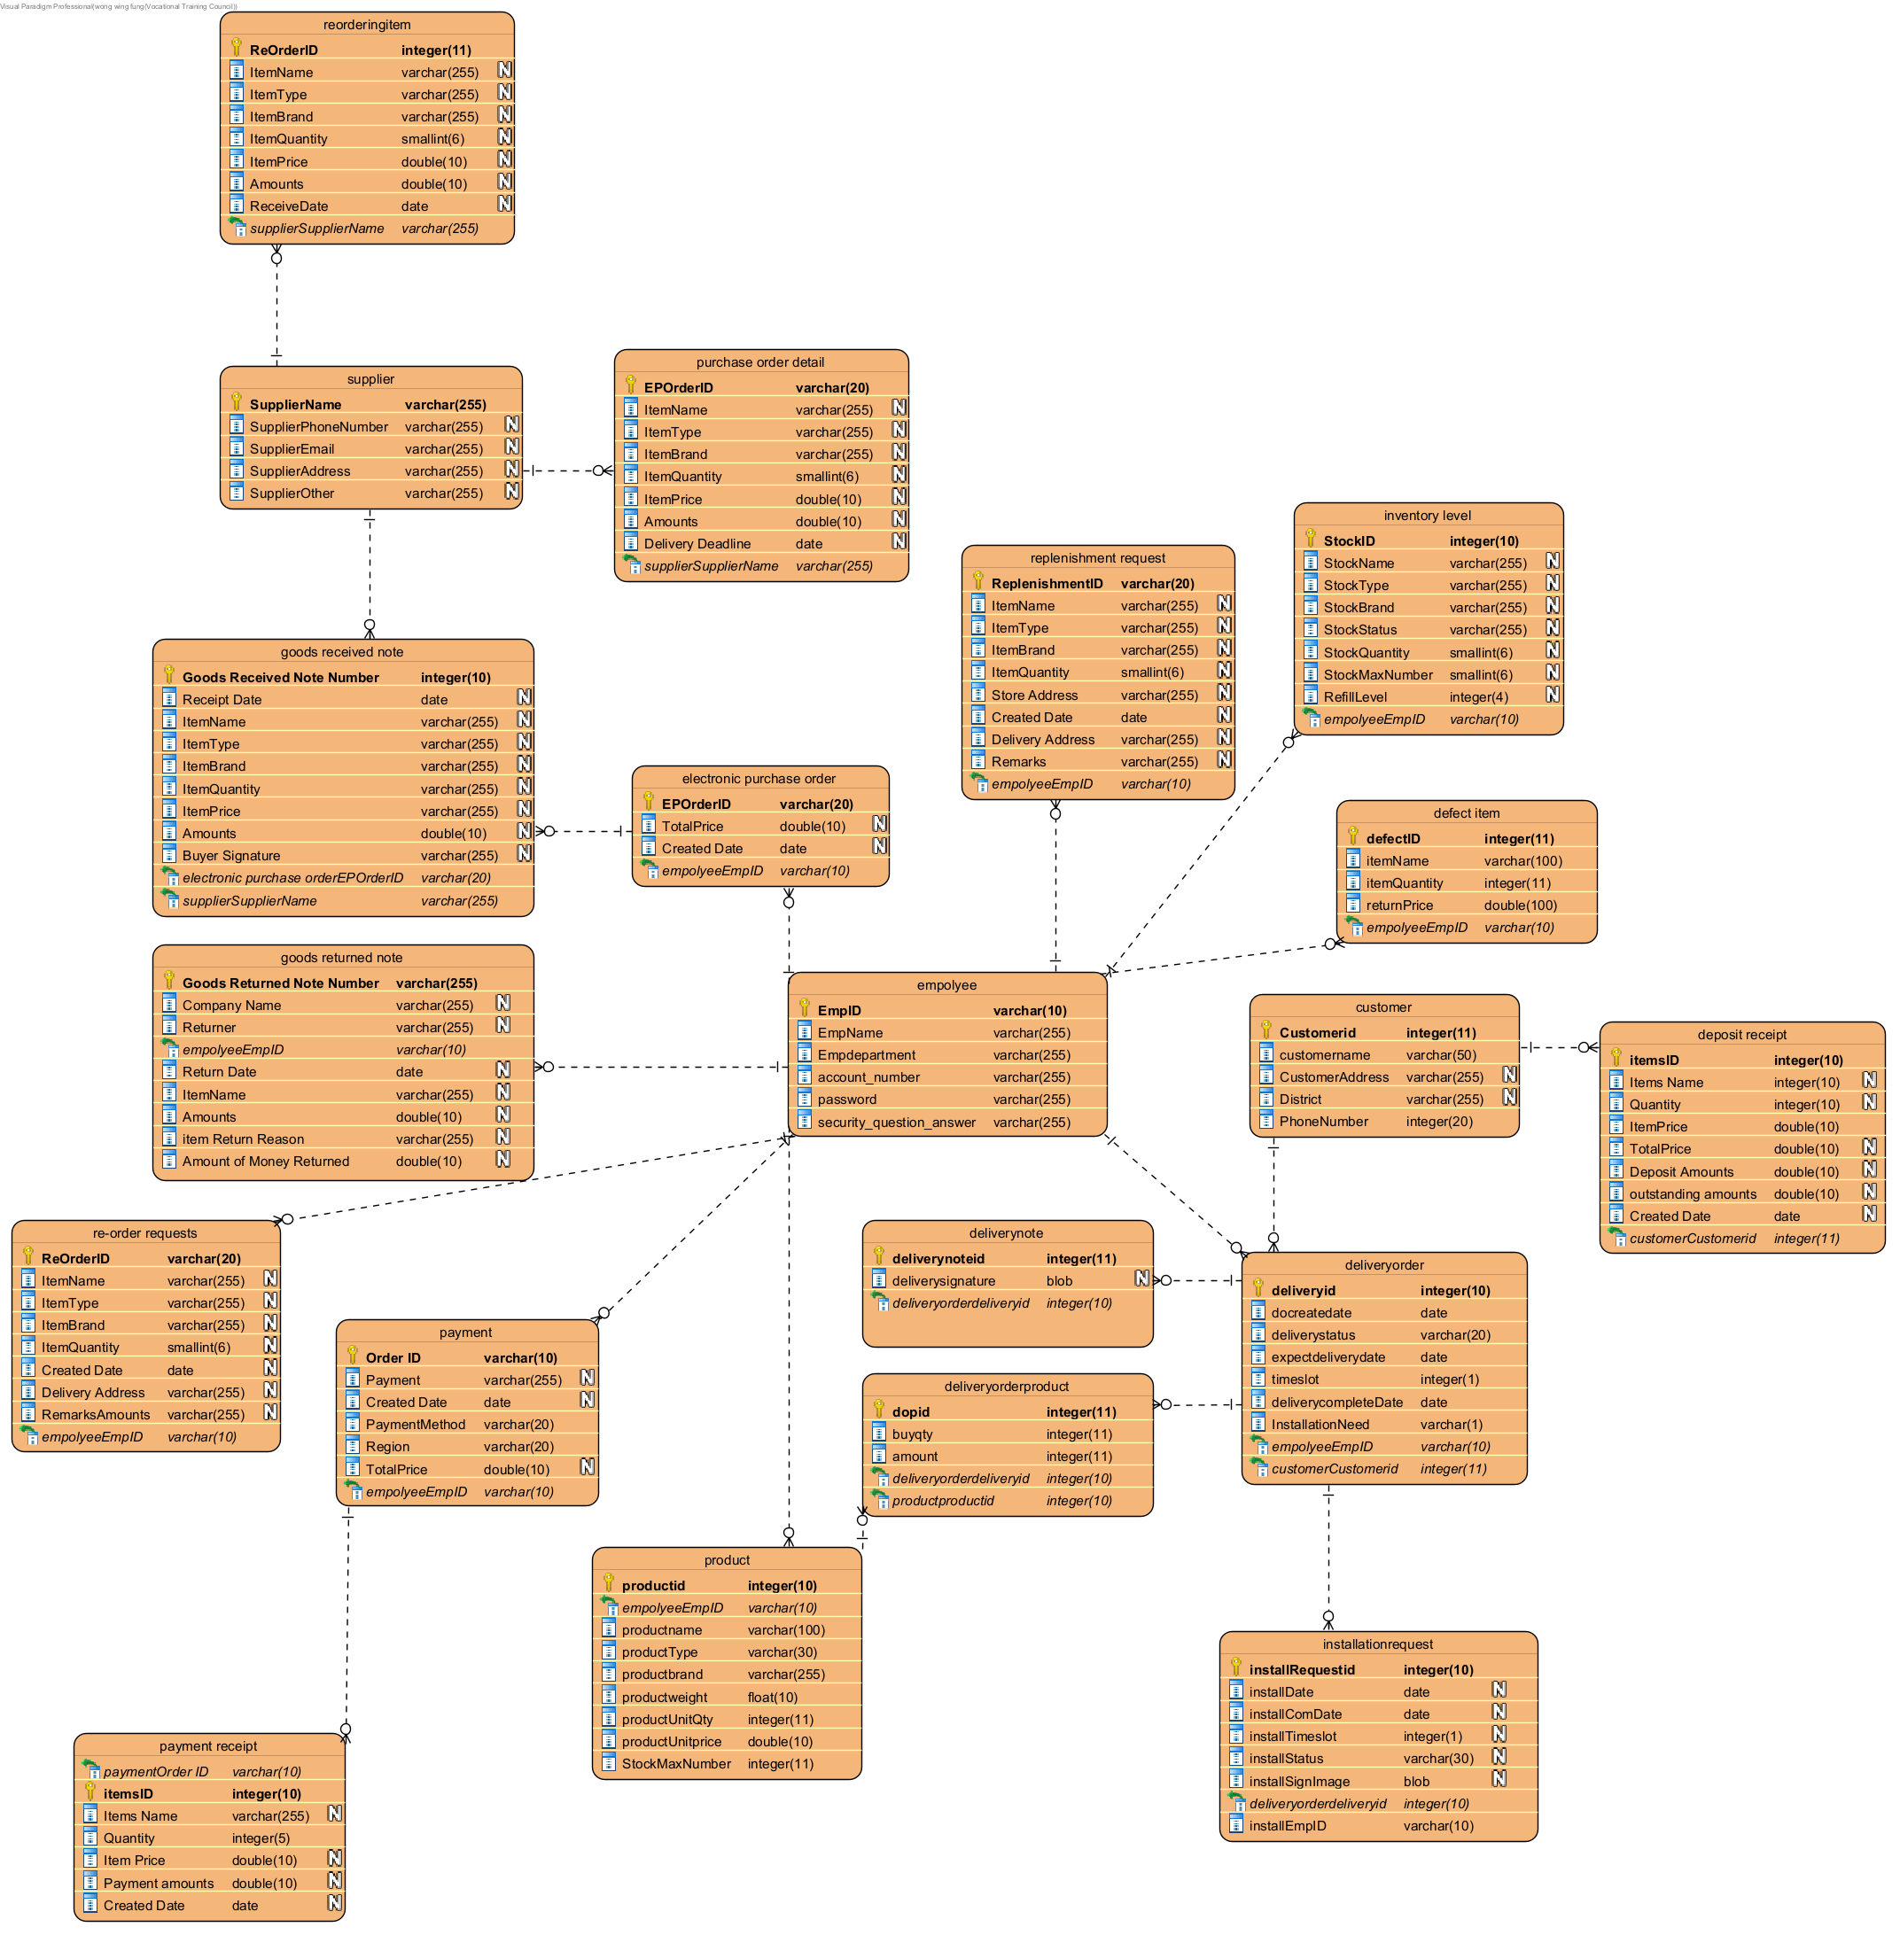

Table: customer

Entity Description: Customer Information

|  |  |  |  |  |
| --- | --- | --- | --- | --- |
| Column Name | Data type | Key? | Null? | Description |
| CustomerAddress | varchar(255) |  | Null | Customer Address |
| CustomerName | varchar(255) |  |  | Customer Name |
| PhoneNumber | integer(100) |  | Null | Customer Phone Number |
| Customerid | integer(11) | PK |  | Customer ID |
| District | varchar(255) |  |  |  |

Table: deliveryorder

|  |  |  |  |  |
| --- | --- | --- | --- | --- |
| Column Name | Data type | Key? | Null? | Description |
| DeliveryDate | date |  | Null | Delivery order Date |
| DeliveryID | integer(10) | PK |  | Delivery order id |
| DeliveryStatus | varchar(255) |  | Null | Delivery order status is complete or not |
| EmpolyeeEmpID | varchar(10) | FK | Null | Editor's employee ID |
| Expect delivery date | date |  | Null |  |
| timeslot | integer(1) |  | Null |  |
| Delivery complete Date | date |  | Null |  |
| Installation Need | varchar(1) |  | Null |  |
| Customerid | integer(11) | FK |  |  |

Table: Delivery Note

Entity Description: When a delivery service is created, the system will generate and print delivery notes. Two hardcopy delivery notes will be delivered together with items.

|  |  |  |  |  |
| --- | --- | --- | --- | --- |
| Column Name | Data type | Key? | Null? | Description |
| Delivery note id | integer(11) | PK |  |  |
| Delivery signature | blob |  | Null |  |
| Delivery order delivery id | integer(10) | FK |  |  |

Table: delivery order product

Entity Description: product in delivery order

|  |  |  |  |  |
| --- | --- | --- | --- | --- |
| Column Name | Data type | Key? | Null? | Description |
| dopid | integer(11) | PK |  | delivery order product id |
| Buy qty | integer(11) |  |  |  |
| amount | integer(11) |  | Null |  |
| Delivery order delivery id | integer(10) | FK |  |  |
| Product product id | integer(10) | FK |  |  |

Table: Deposit Receipt

Entity Description: The system will generate a deposit receipt in the deposit folder when unavailable items over $5000 and the customer pay 20% or more deposit is finished

|  |  |  |  |  |
| --- | --- | --- | --- | --- |
| Column Name | Data type | Key? | Null? | Description |
| Order ID | varchar(10) | PK,FK |  |  |
| itemsID | integer(11) | PK |  |  |
| Items Name | varchar(255) |  | Null |  |
| ItemPrice | integer(10) |  |  |  |
| TotalPrice | double |  | Null |  |
| Deposit Amounts | double |  | Null |  |
| outstanding amounts | double |  | Null |  |
| Created Date | datetime |  | Null |  |
| customerID | int(11) | FK | Null |  |

Table: Electronic Purchase Order

Entity Description: If a re-order request is approved, a total purchase order will be generated. The total purchase order will be sent to The Accounting Department.

|  |  |  |  |  |
| --- | --- | --- | --- | --- |
| Column Name | Data type | Key? | Null? | Description |
| Created Date | DATETIME |  | Null | Created order Date |
| EmpolyeeEmpID | varchar(255) | FK | Null | Editor's employee ID |
| EPOrderID | varchar(20) | PK |  | Purchase Order ID |
| TotalPrice | datetime |  | Null | Purchase Total Price |

Table: Empolyee

Entity Description: information of employees

|  |  |  |  |  |
| --- | --- | --- | --- | --- |
| Column Name | Data type | Key? | Null? | Description |
| account_number | varchar(255) |  |  | employee account number |
| Empdepartment | varchar(255) |  |  | Every employee has a department to which they belong |
| EmpID | varchar(10) | PK |  | the employee ID, each employee has their own unique id |
| EmpName | varchar(255) |  |  | employee name |
| password | varchar(255) |  |  | employee password create by himself |
| security_question_answer | varchar(255) |  |  | employee has their own security question and answer |

Table: Goods Received Note

Entity Description: When the Good Inward Clerk confirms that the received quantity is the same as the delivery note and the purchase order, The Inventory Department can generate a goods received note.

|  |  |  |  |  |
| --- | --- | --- | --- | --- |
| Column Name | Data type | Key? | Null? | Description |
| Amount | double |  | Null | need purchase Item total Amount |
| Buyer Signature | varchar(255) |  | Null | the management Signature |
| Electronic Purchase Order-EPOrderID | varchar(255) | FK | Null | Purchase Order ID |
| Goods Returned Note Number | integer(10) | PK |  | Goods Returned Note id |
| ItemBrand | varchar(255) |  | Null | need purchase Item Brand |
| ItemName | varchar(255) |  | Null | need purchase Item Name |
| ItemPrice | integer(100) |  | Null | need purchase Item Price |
| ItemQuantity | integer(100) |  | Null | need purchase Item Quantity |
| ItemType | varchar(255) |  | Null | need purchase Item Type |
| Receipt Date | date time |  | Null | Receipt Date |
| SupplierName | varchar(255) | FK | Null | purchase Item Supplier name |

Table: Goods Returned Note

Entity Description: When defective items from the customers are returned to The Inventory Department, the goods returned note will generate.

|  |  |  |  |  |
| --- | --- | --- | --- | --- |
| Column Name | Data type | Key? | Null? | Description |
| Amount | integer(100) |  | Null | Return Item Amount |
| Amount of Money Returned | double |  | Null | Amount of Money Returned |
| Company Name | varchar(255) |  | Null | Company Name |
| Goods Returned Note Number | integer(10) | PK |  | Goods Returned Note id |
| ItemName | varchar(255) |  | Null | Return Item Name |
| item Return Reason | varchar(255) |  | Null | item Return Reason |
| Return Date | DATE |  | Null | Return Date |
| Returner | varchar(255) |  | Null | Returner id |
| EmpID | double | FK | Null |  |

Table: Inventory Level

Entity Description: Sales employees and inventory employees can view inventory levels in all stores and The Inventory Departments.

|  |  |  |  |  |
| --- | --- | --- | --- | --- |
| Column Name | Data type | Key? | Null? | Description |
| EmpolyeeEmpID | varchar(10) | FK | Null | Editor's employee ID |
| StockBrand | varchar(255) |  | Null | Stock item brand |
| StockID | varchar(255) | PK |  | Stock item ID |
| StockMaxNumber | integer(100) |  | Null | Stock item max quantity have how many |
| StockName | varchar(255) |  | Null | Stock item name |
| StockQuantity | integer(100) |  | Null | Stock item Quantity |
| StockStatus | varchar(255) |  | Null | Stock item status adequate generally out of stock |
| StockType | varchar(255) |  | Null | Stock item type |
| RefillLevel | integer(4) |  | Null |  |

Table: payment

Entity Description: payment

|  |  |  |  |  |
| --- | --- | --- | --- | --- |
| Column Name | Data type | Key? | Null? | Description |
| Order ID | varchar(10) | PK,FK |  |  |
| Payment | varchar(255) |  | Null |  |
| Created Date | datetime |  | Null |  |
| EmpID | integer(10) | FK | Null |  |
| PaymentMethod | integer(20) |  |  |  |
| Region | integer(20) |  |  |  |
| TotalPrice |  |  | Null |  |

Table: Payment Receipt

Entity Description: generate when item is available in-store and the customer’s payment is finished.

|  |  |  |  |  |
| --- | --- | --- | --- | --- |
| Column Name | Data type | Key? | Null? | Description |
| Order ID | varchar(10) | PK,FK |  |  |
| Created Date | Datetime |  | Null | the receipt create date |
| itemsID | varchar(255) | PK |  | The ID of the buying item |
| Items Name | varchar(255) |  | Null | The name of the buying item |
| Payment amount | double |  | Null | the Payment amount |
| Quantity | integer(5) |  |  |  |
| Item Price | double |  | Null | item Price |

Table: Purchase Order Detail

Entity Description: Purchase Order Detail

|  |  |  |  |  |
| --- | --- | --- | --- | --- |
| Column Name | Data type | Key? | Null? | Description |
| Amount | double |  | Null | need purchase Item total Amount |
| Delivery Deadline | datetime |  | Null | Delivery Deadline |
| EPOrderID | varchar(20) | PK |  | Purchase Order ID |
| ItemBrand | varchar(255) |  | Null | need purchase Item Brand |
| ItemName | varchar(255) |  | Null | need purchase Item Name |
| ItemPrice | double |  | Null | need purchase Item Price |
| ItemQuantity | smallint(6) |  | Null | need purchase Item Quantity |
| ItemType | varchar(255) |  | Null | need purchase Item Type |
| Supplier | varchar(255) | FK | Null | purchase Item Supplier |

Table: Re-order Requests

Entity Description: The system allows the sales manager to create replenishment requests with

|  |  |  |  |  |
| --- | --- | --- | --- | --- |
| Column Name | Data type | Key? | Null? | Description |
| Amount | integer(100) |  | Null | Re-order item Amount |
| Created Date | DATE |  | Null | the receipt create date |
| Delivery Address | varchar(255) |  | Null | Re-order Delivery Address |
| Empolyee-EmpID | integer(10) | FK | Null | Inventory Employee's id |
| ItemBrand | varchar(255) |  | Null | Re-order Item Brand |
| ItemName | varchar(255) |  | Null | Re-order Item Name |
| ItemQuantity | integer(100) |  | Null | Re-order Item Quantity |
| ItemType | varchar(255) |  | Null | Re-order Item Type |
| Remarks | varchar(255) |  | Null | Remarks |
| ReOrderID | varchar(255) | PK |  | Re-Order ID |

Table: Replenishment Reques

Entity Description: The system allows the sales manager to create replenishment requests with the permissions of the inventory department when the item inventory level in store inventory is near or below the reorder level

|  |  |  |  |  |
| --- | --- | --- | --- | --- |
| Column Name | Data type | Key? | Null? | Description |
| Created Date | DATE |  | Null | the receipt create date |
| Delivery Address | varchar(255) |  | Null | Delivery Address |
| Empolyee-EmpID | varchar(255) | FK | Null | Editor's employee ID |
| ItemBrand | varchar(255) |  | Null | need replenishment Item |
| ItemName | varchar(255) |  | Null | need replenishment Item Name |
| ItemQuantity | integer(100) |  | Null | need replenishment Item |
| ItemType | varchar(255) |  | Null | need replenishment Item Type |
| Remarks | varchar(255) |  | Null | store remarks |
| ReplenishmentID | varchar(20) | PK |  | Replenishment Re-Order ID |
| Store Address | varchar(255) |  | Null | Re-Order Store Address |

Table: Supplier

Entity Description: Purchase Supplier Detail

|  |  |  |  |  |
| --- | --- | --- | --- | --- |
| Column Name | Data type | Key? | Null? | Description |
| SupplierAddress | varchar (255) |  | Null | Supplier Address |
| SupplierEmail | varchar (255) |  | Null | Supplier Email |
| SupplierName | varchar (255) | PK |  | Supplier Name |
| SupplierOther | varchar (255) |  | Null | Supplier Other Detail |
| SupplierPhoneNumber | varchar (255) |  | Null | Supplier Phone Number |

Table: defect item

Entity Description: the defect item

|  |  |  |  |  |
| --- | --- | --- | --- | --- |
| Column Name | Data type | Key? | Null? | Description |
| Return Price | double |  | Null | defect item return Price |
| itemQuantity | int(11) |  | Null | Item Quantity |
| itemName | varchar (100) |  | Null | Item Name |
| empID | varchar (10) | FK | Null | Employee ID |
| defectID | int(11) | PK |  |  |

Table: installationrequest

Entity Description: installation request

|  |  |  |  |  |
| --- | --- | --- | --- | --- |
| Column Name | Data type | Key? | Null? | Description |
| installRequestid | int(11) | PK |  |  |
| EmpID | varchar (10) | FK | Null | Employee ID |
| installDate | Date |  | Null | installation date |
| installComDate | date |  | Null | complete date |
| installTimeslot | int(1) |  | Null | Time slot |
| installStatus | varchar (30) |  | Null | Status |
| installSignImage | Blob |  | Null |  |
| deliveryid | Int(11) | FK |  |  |

Table: product

Entity Description: shop products

|  |  |  |  |  |
| --- | --- | --- | --- | --- |
| Column Name | Data type | Key? | Null? | Description |
| productid | int(11) | PK |  | shop products id |
| productname | varchar (100) |  |  | shop products name |
| productType | varchar (30) |  |  | shop products type |
| productbrand | varchar (255) |  |  |  |
| productweight | Float |  |  | weight |
| productUnitQty | Int(11) |  |  | product Unit Qty |
| productUnitprice | double |  |  | price |
| StockMaxNumber | Int(11) |  |  |  |
| EmpID | varchar (10) | FK |  | Employee ID |

Table: reorderingitem

Entity Description: re-ordering item

|  |  |  |  |  |
| --- | --- | --- | --- | --- |
| Column Name | Data type | Key? | Null? | Description |
| ReOrderID | int(11) | PK |  |  |
| ItemName | varchar (255) |  | Null |  |
| ItemType | varchar (255) |  | Null |  |
| ItemBrand | varchar (255) |  | Null |  |
| Supplier | varchar (255) | FK | Null |  |
| ItemQuantity | smallint(6) |  | Null |  |
| ItemPrice | double |  | Null |  |
| Amounts | double |  | Null |  |
| ReceiveDate | date |  | Null |  |

**13. Project Schedule**

Planning schedule: Waterfall Development

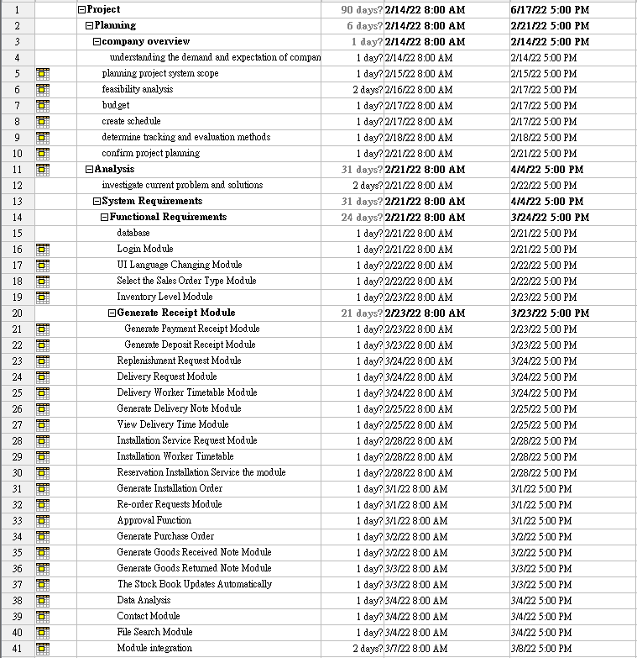

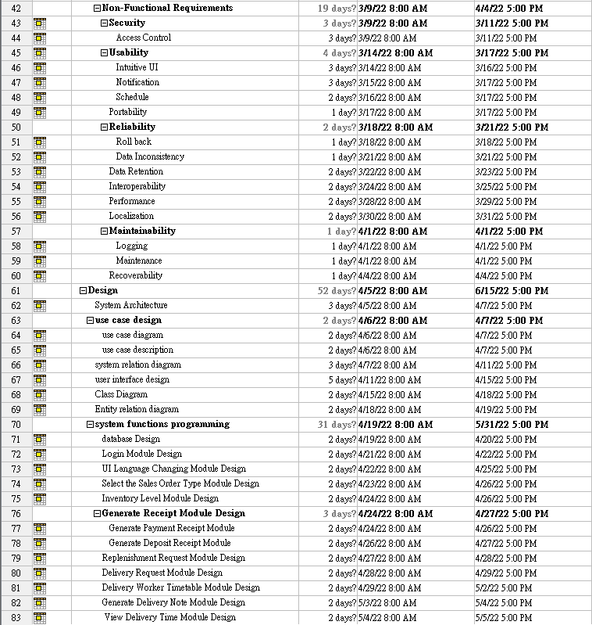

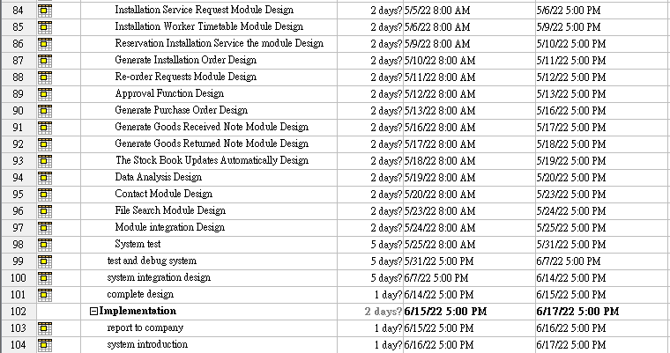

**14.UI design**

**1. Login System**

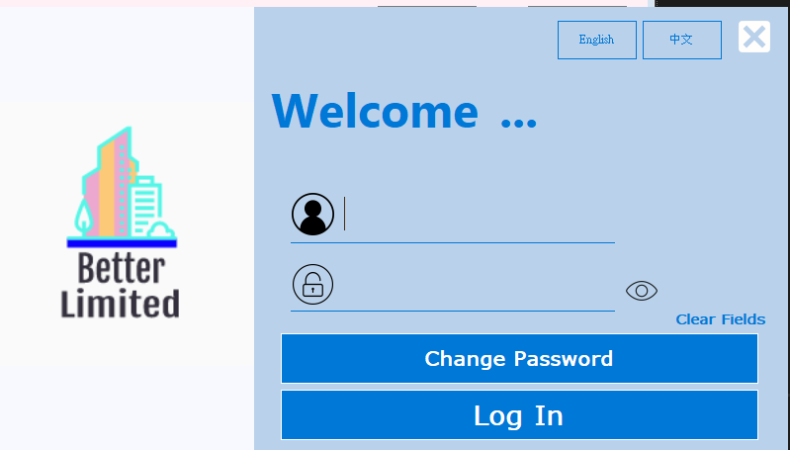

**1.1 Input user name**

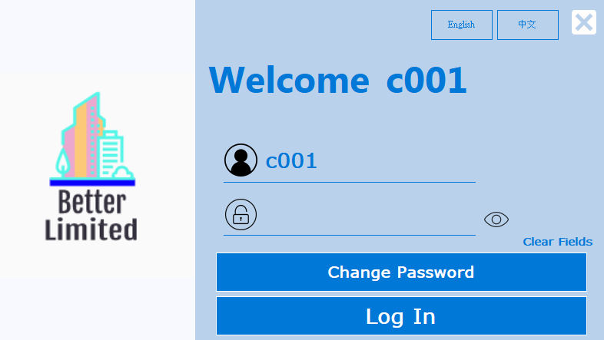

**1.2 display password**

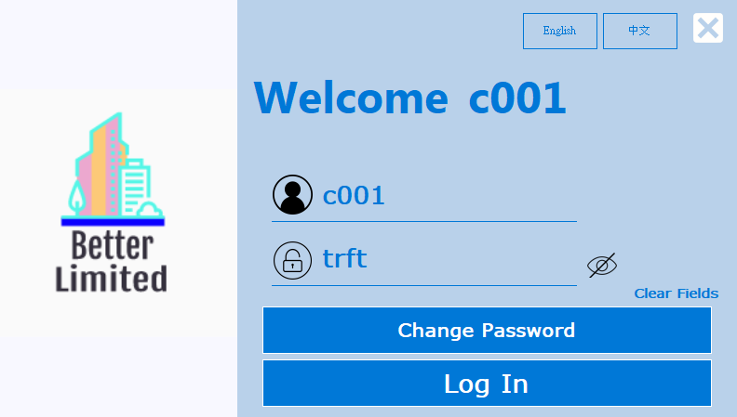

**1.3 hide password**

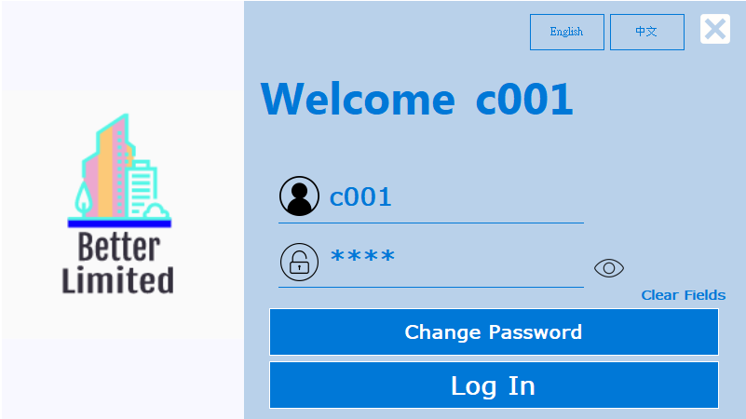

**1.4 username or password incorrect**

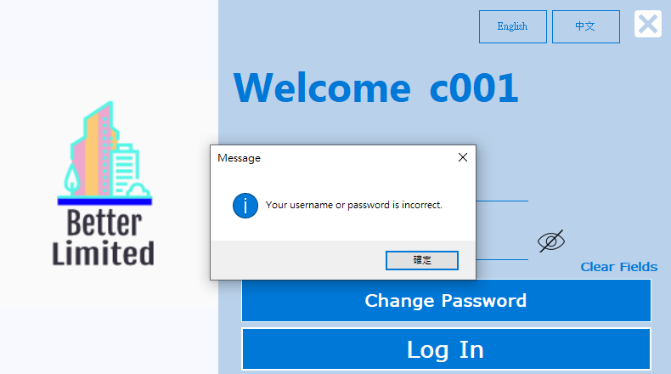

**1.5 null value**

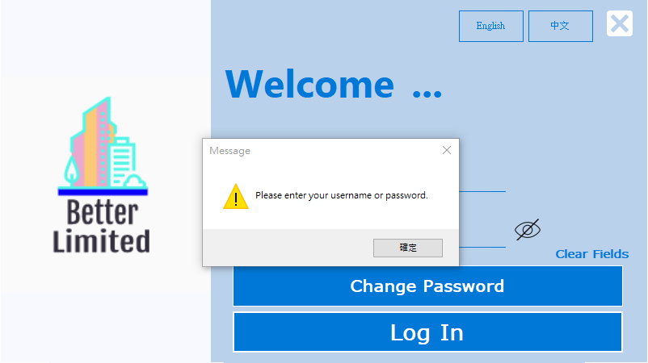

**1.6 Click “中文” button**

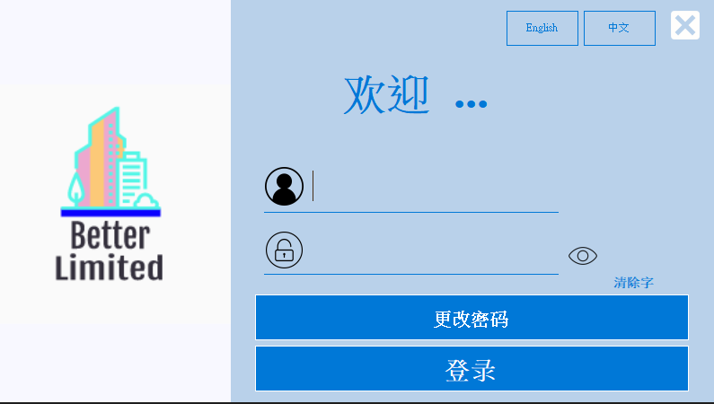

**1.7 Change password**

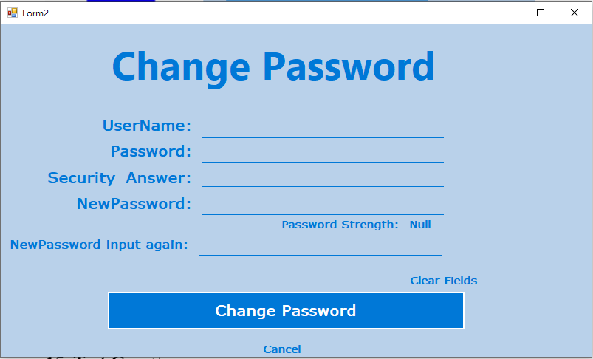

**1.8 Change password - input new password**

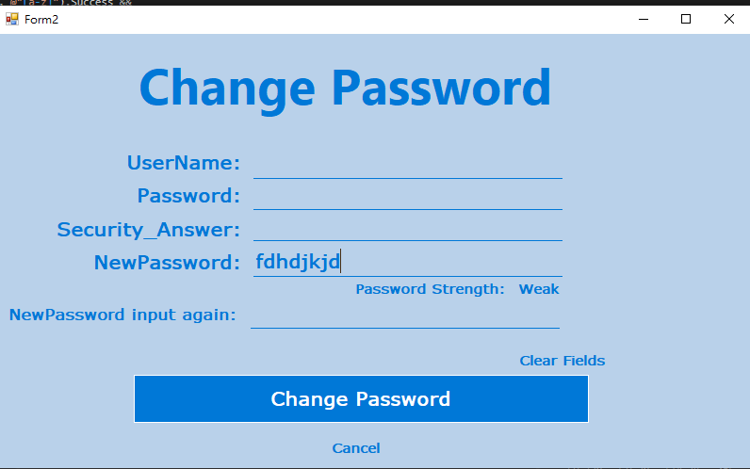

**1.8 Change password – null input**

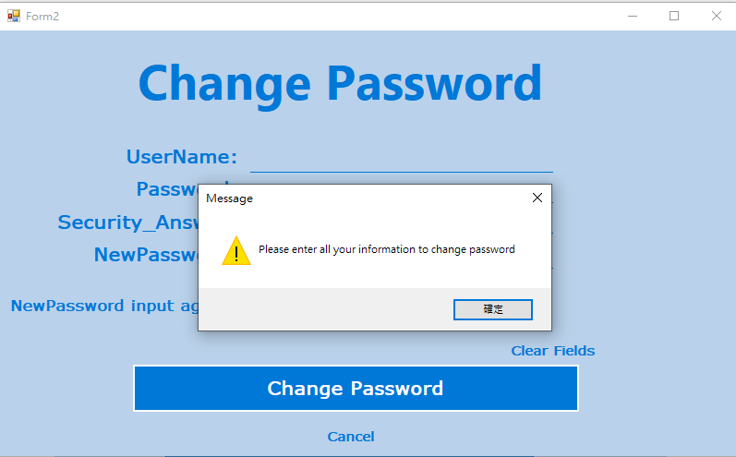

**1.9 Change password – information incorrect**

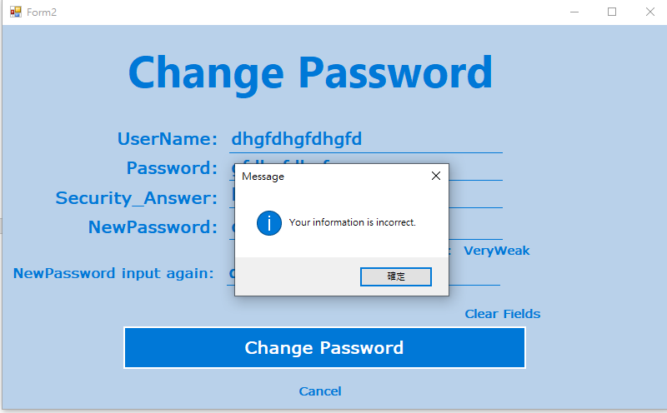

**1.10 Change password – Different new passwords**

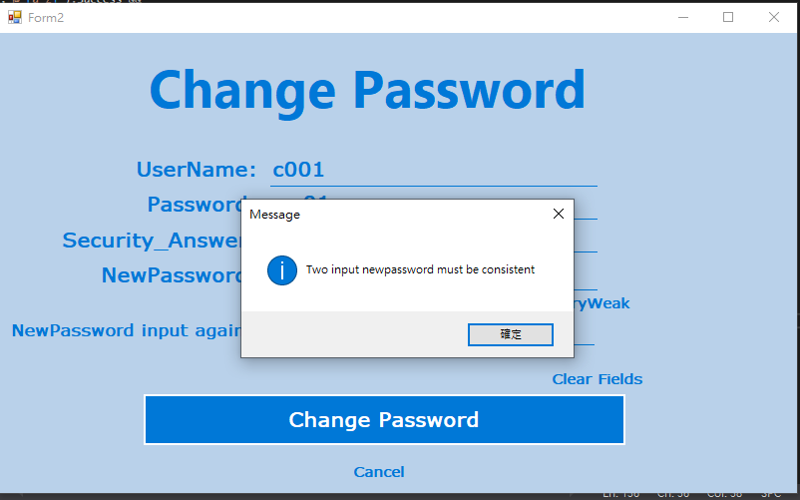

**1.11 Change password – Change password successful**

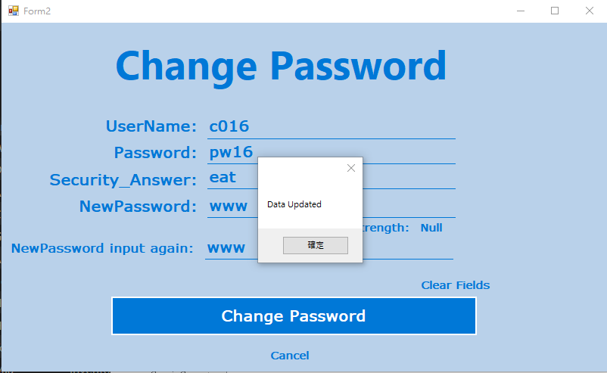

**1.12 Change password (include Click “中文” button)**

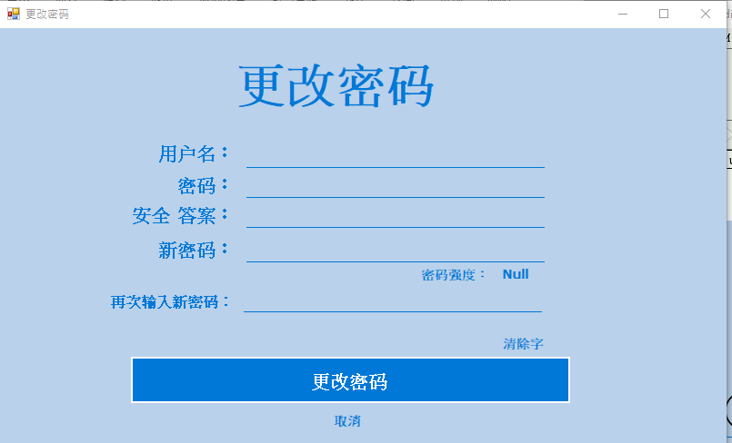

**2.Admin system**

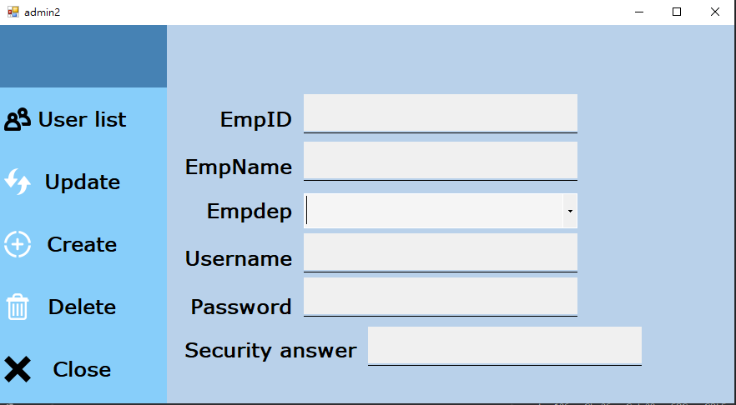

**2.1 Null input**

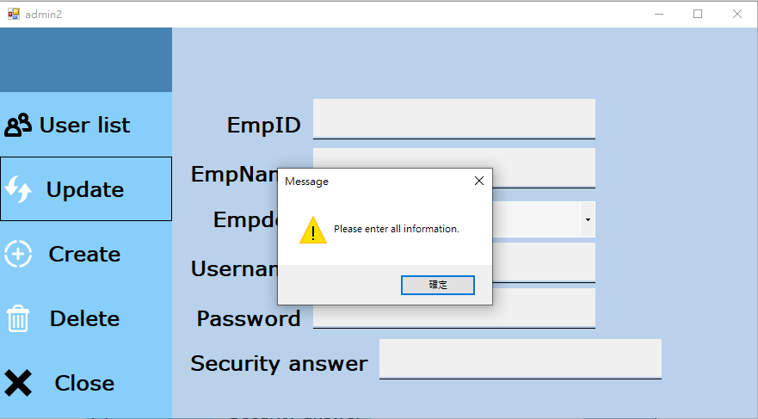

**2.2 EmpID incorrect**

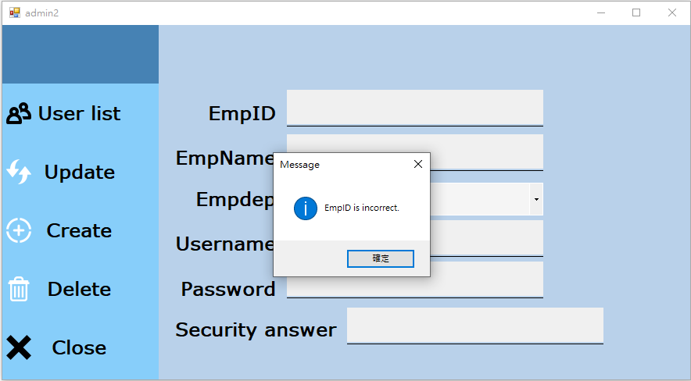

**2.3 Create successful**

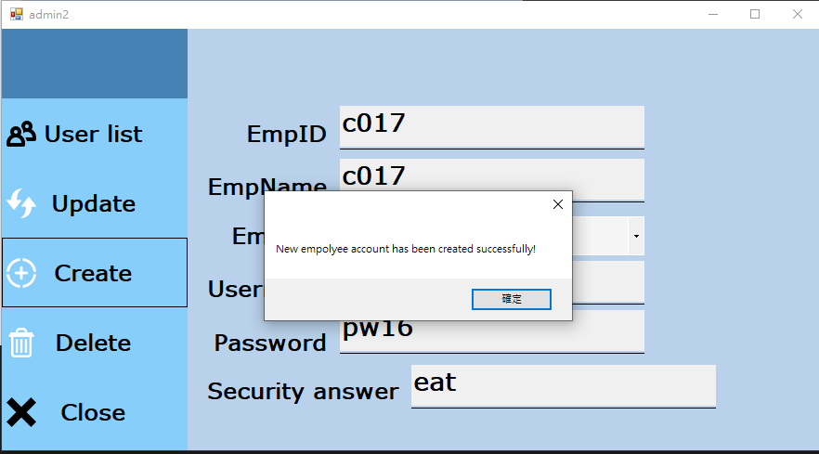

**2.4 Update successful**

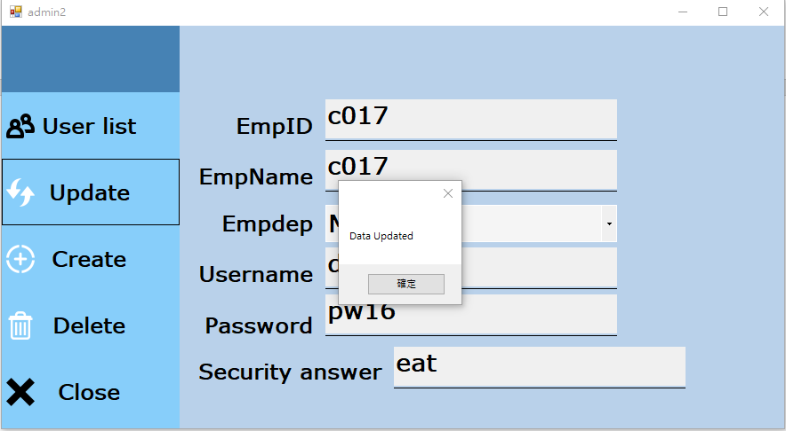

**2.4 Delete successful**

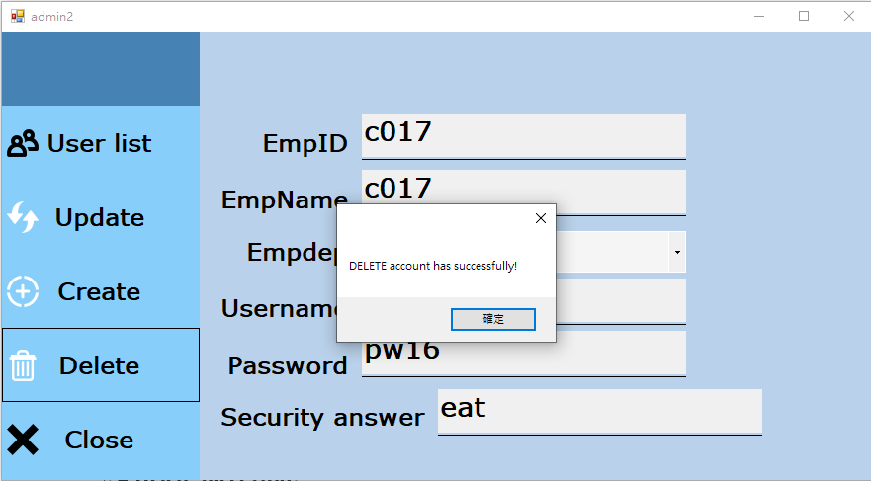

**2.5 Users list**

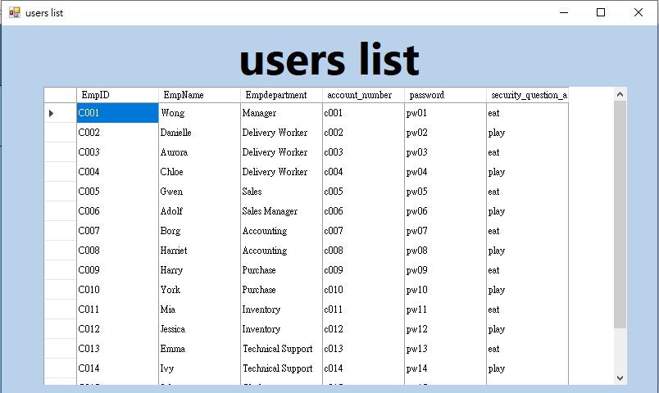

**3.Sales Order System**

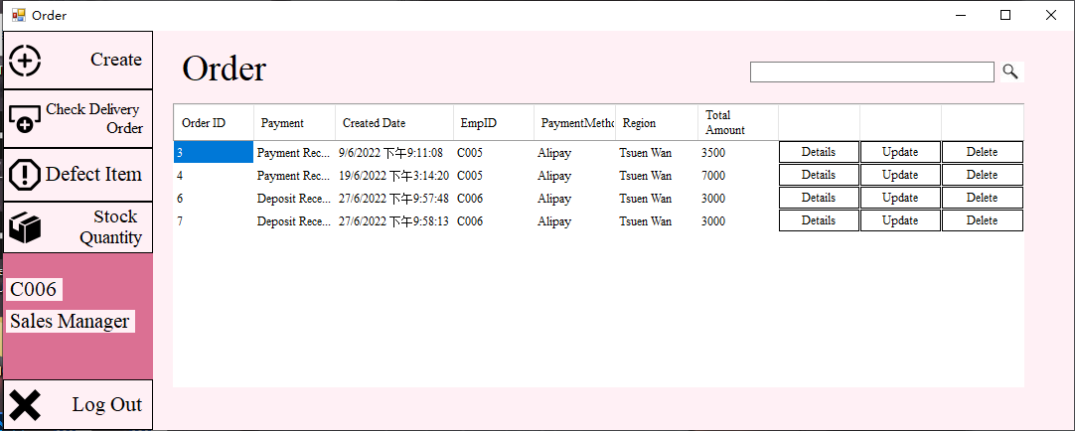

**3.1 Delete Order2.Admin system**

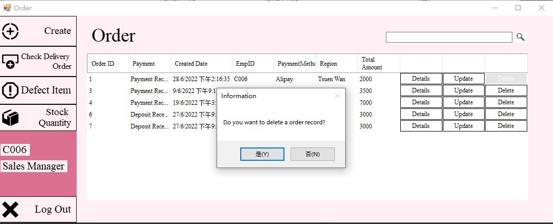

**3.2 Payment Order Details**

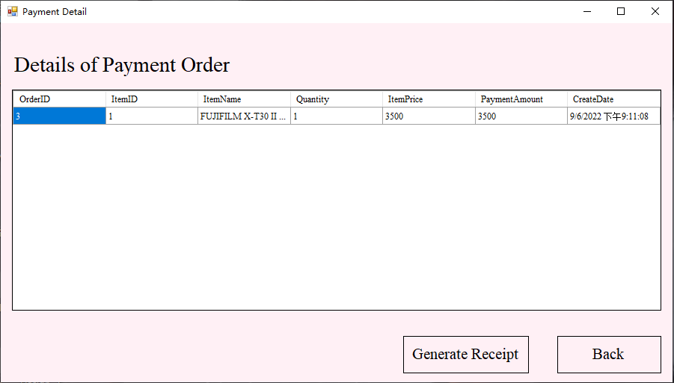

**3.3 Deposit Order Details**

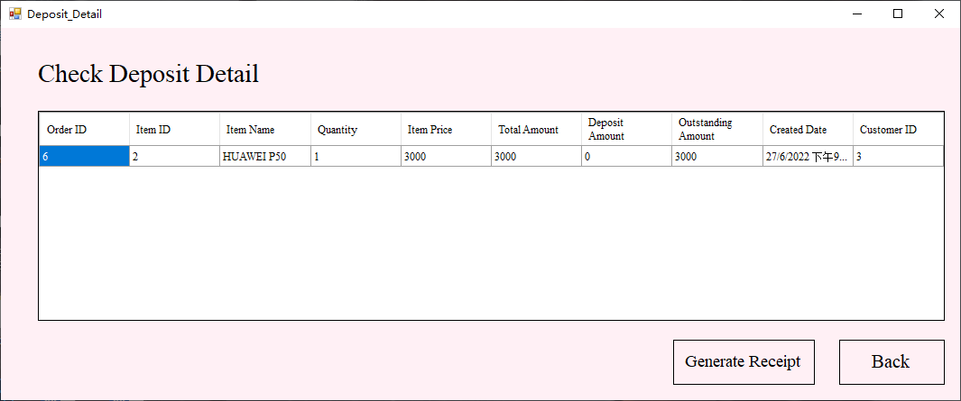

**3.4 Payment Receipt**

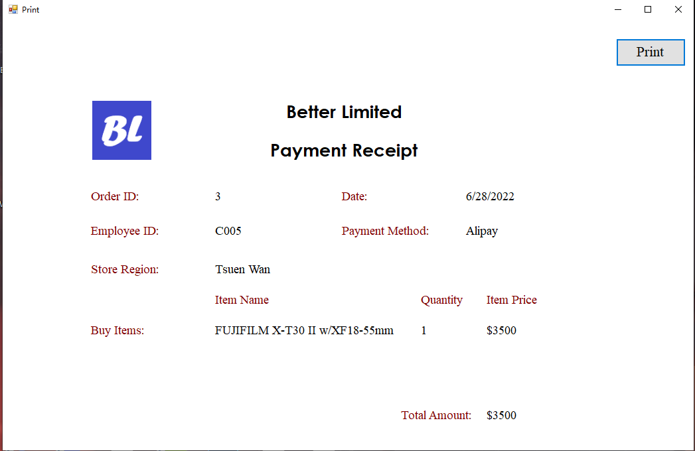

**3.5 Deposit Receipt**

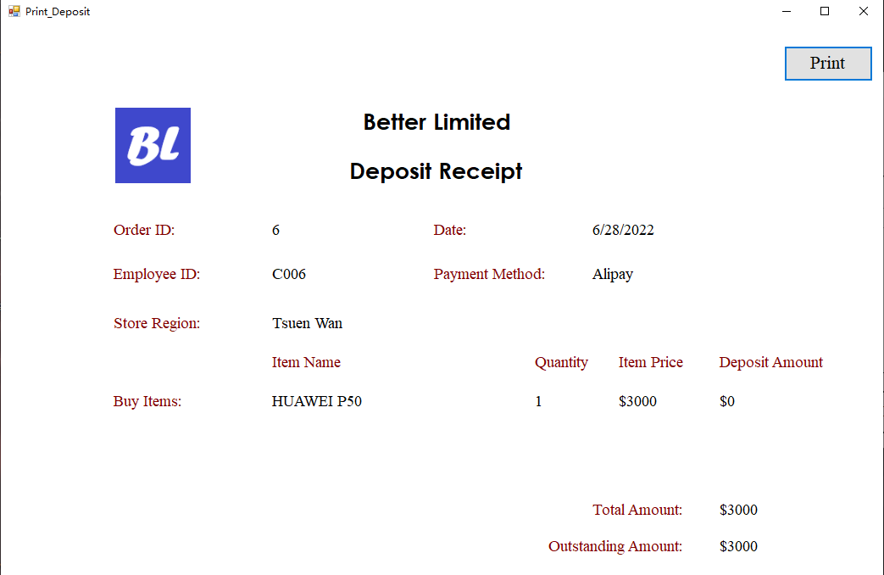

**3.6 Print Payment Receipt**

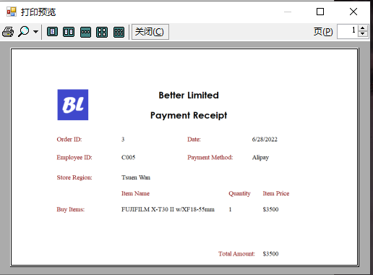

**3.7 Print Deposit Receipt**

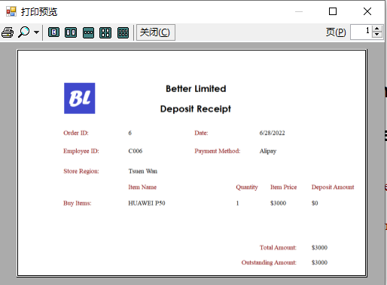

**3.8 Create Order (Payment Order)**

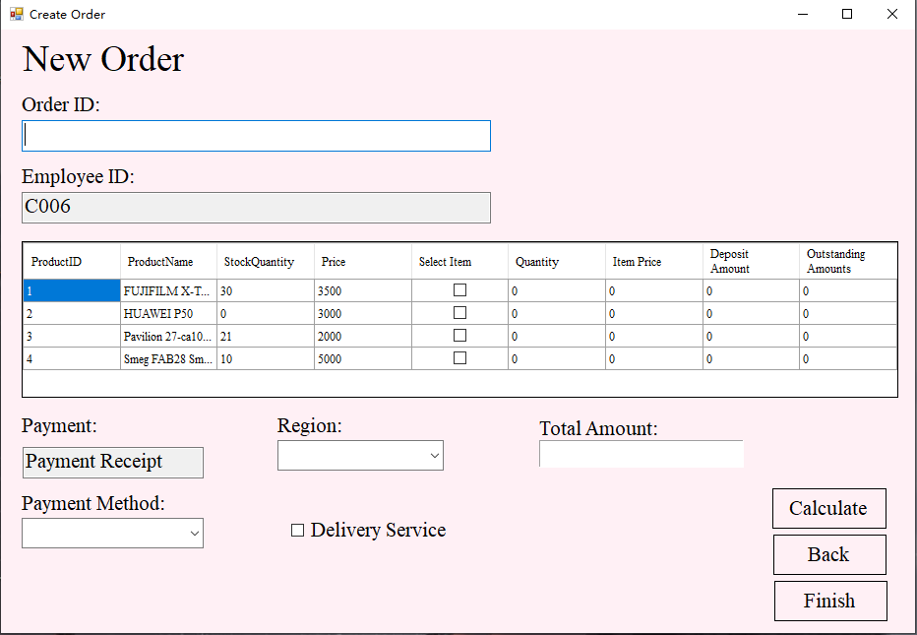

**3.9 Create Order (Deposit Order)**

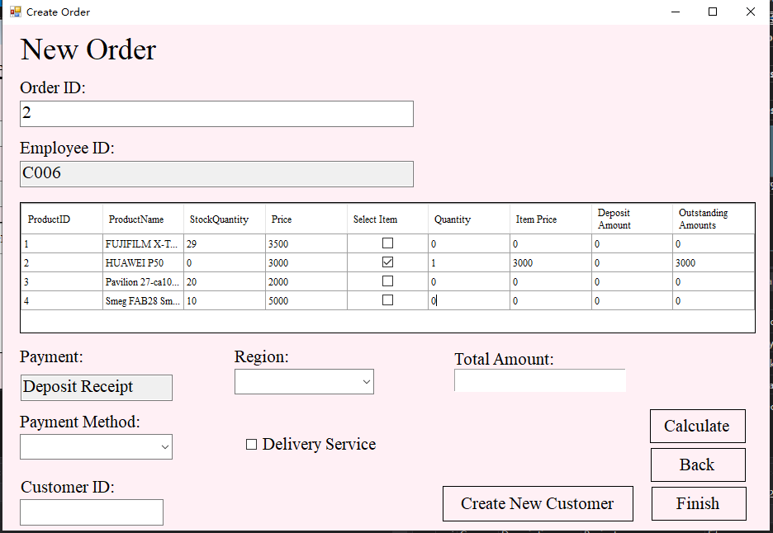

**3.10 Create Delivery Order**

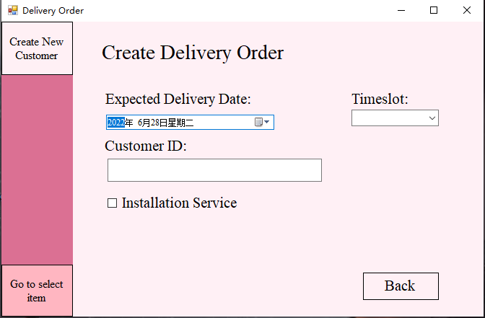

**3.11 Create Customer**

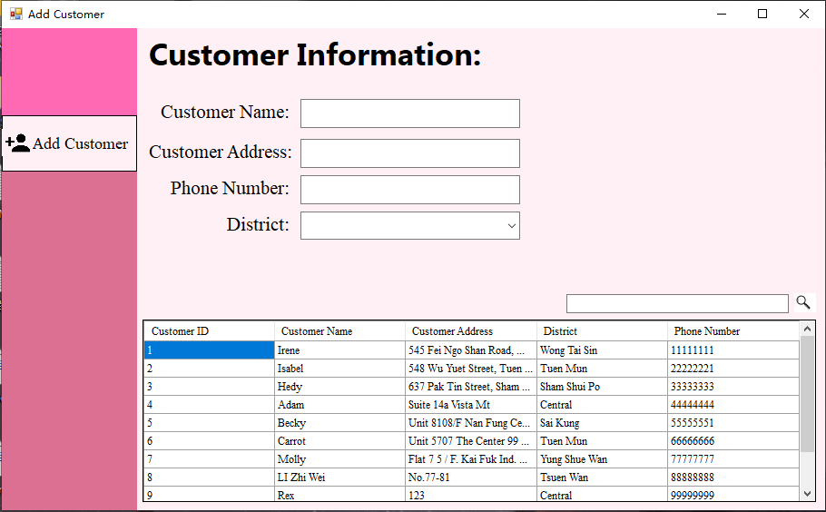

**3.12 Select Delivery Item**



**3.13 Update Payment Order**

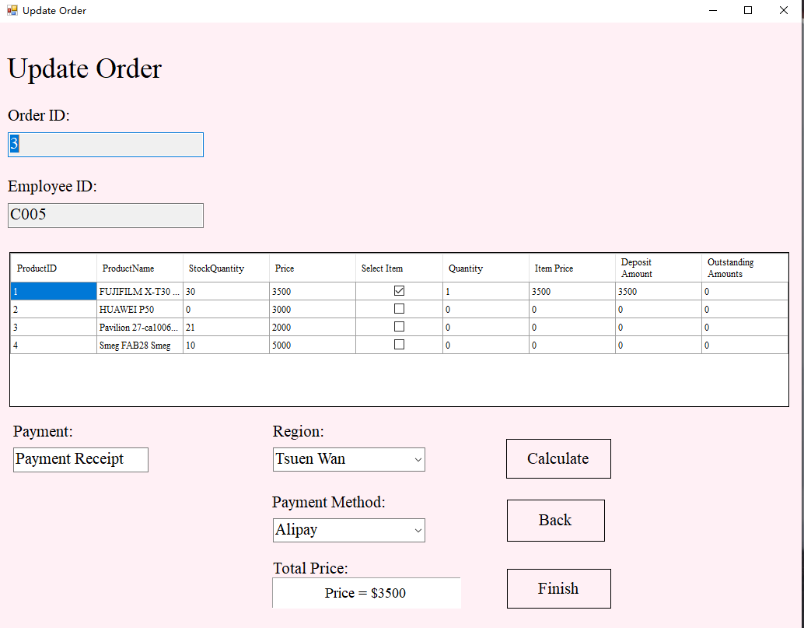

**3.14 Update Deposit Order**

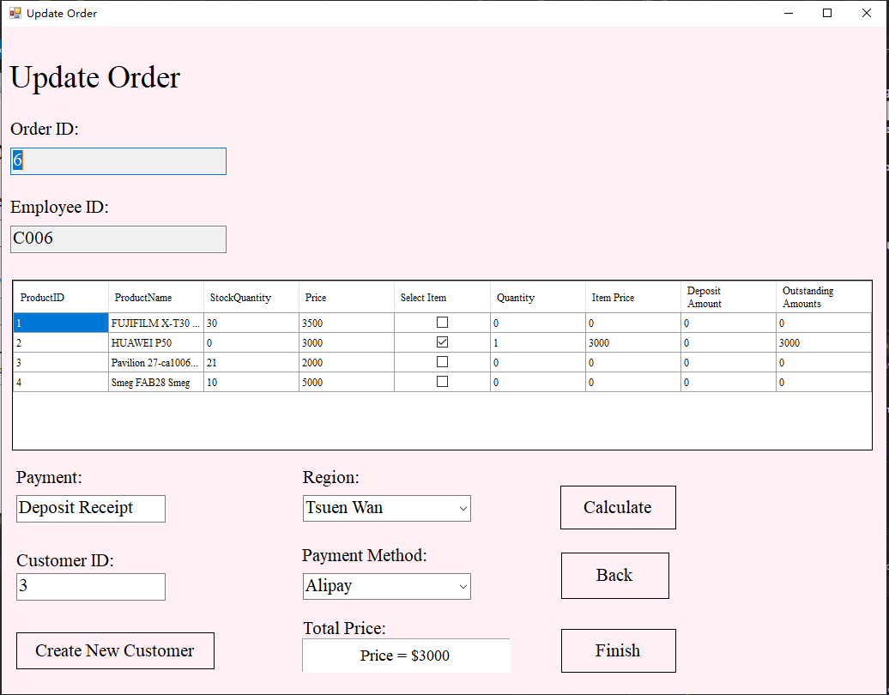

**4. Sales Delivery Order System**

**4.1 Check Delivery Order**

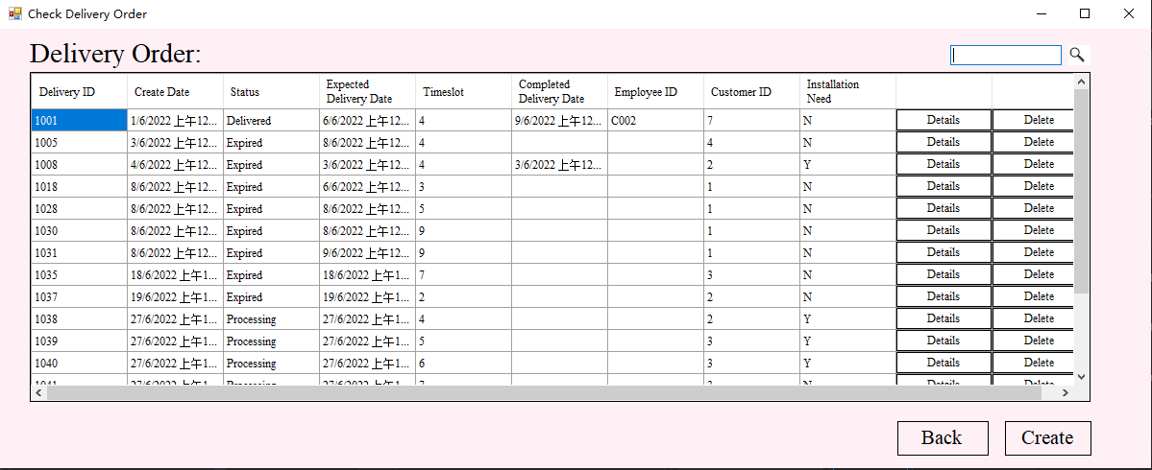

**4.2 Check Order Details**

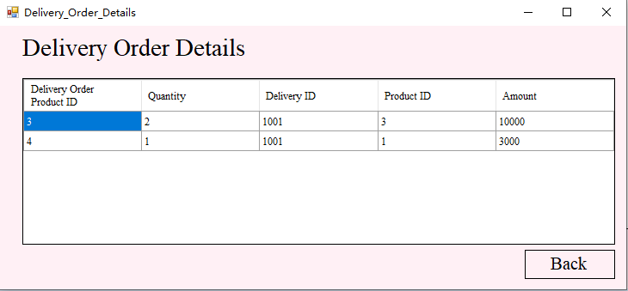

**4.3 Delete Delivery Order**

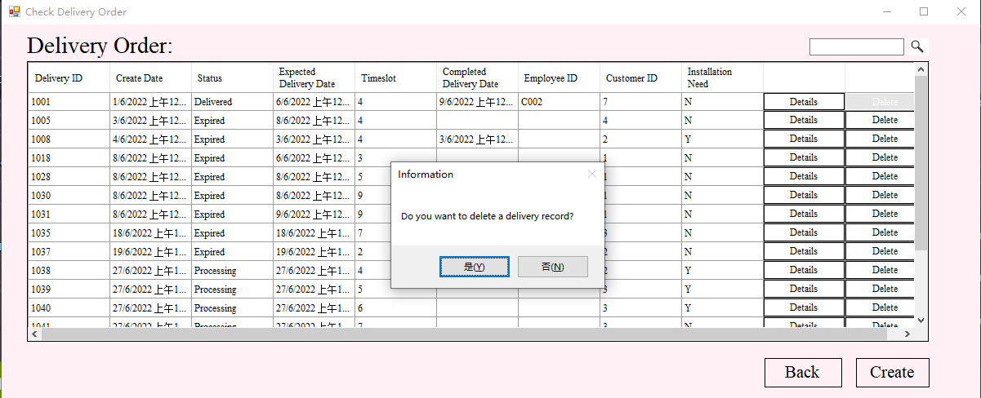

**5. Sales Defect Item System**

**5.1 Check Defect Item**

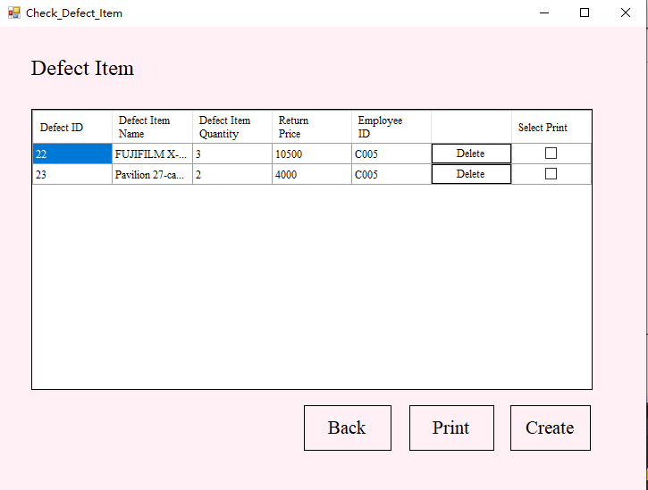

**5.2 Delete Defect Item**

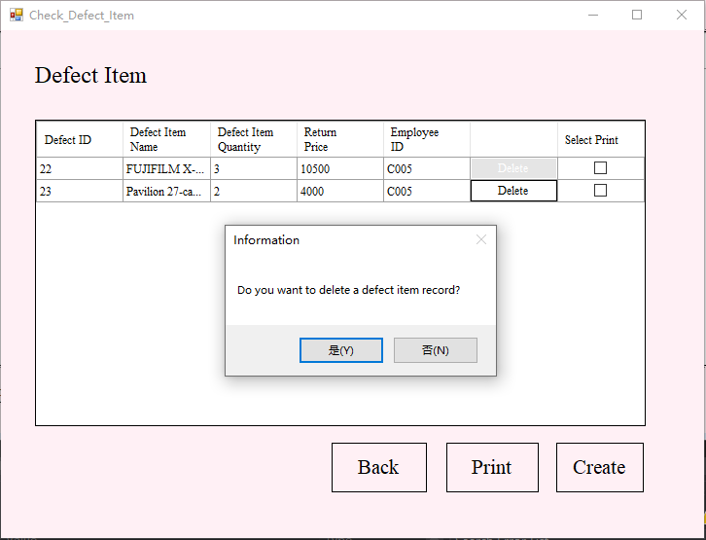**5.3 Create New Defect Item**

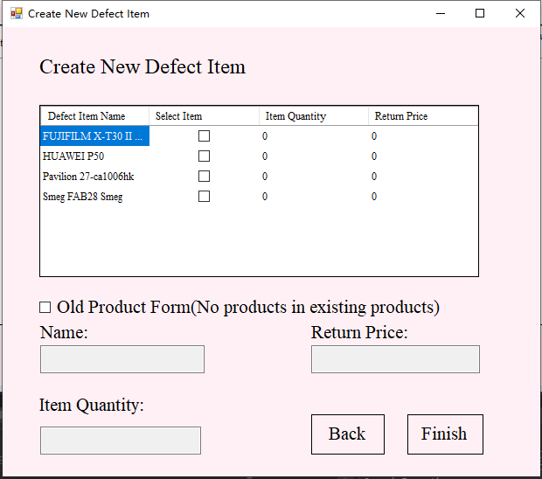

**5.4 Return Receipt**

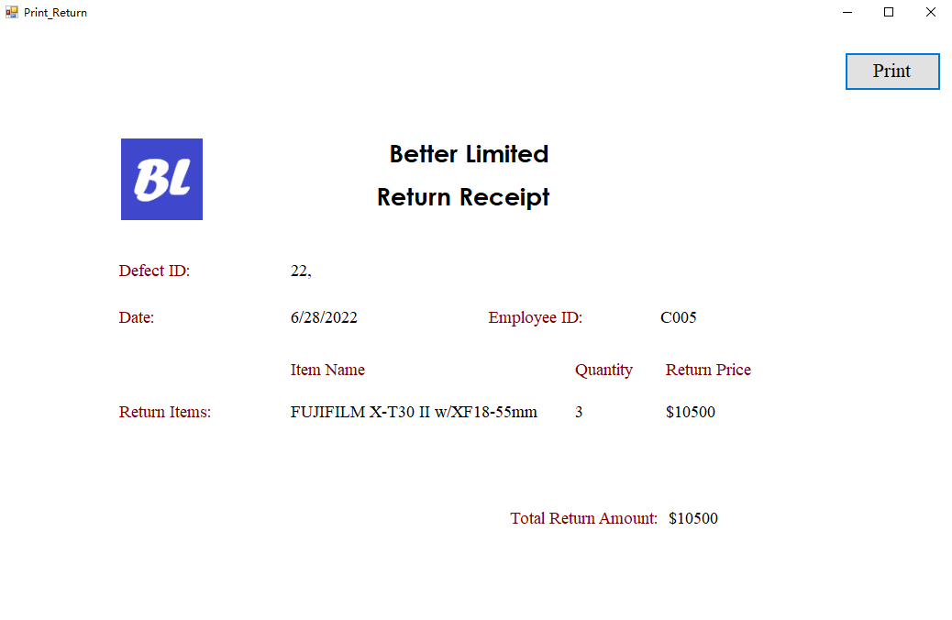

**5.5 Print Return Receipt**

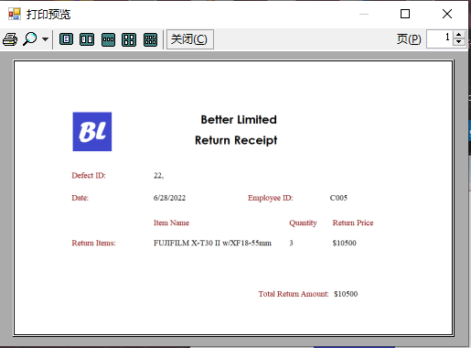

**6. Sales Stock Item System**

**6.1 Check Stock Quantity**

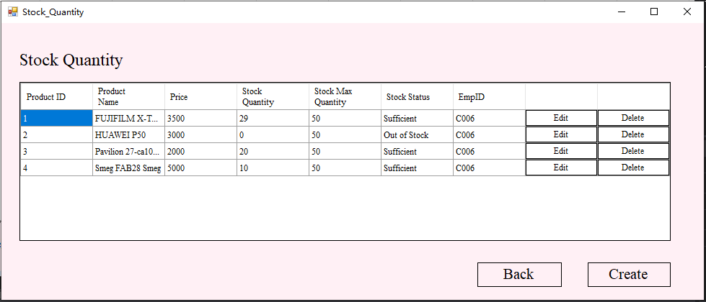

**6.2 Out of Stock Alert**

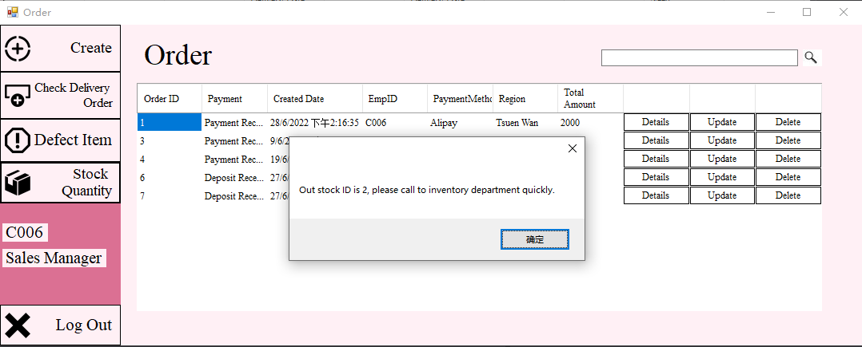

**6.3 Delete Stock Quantity**

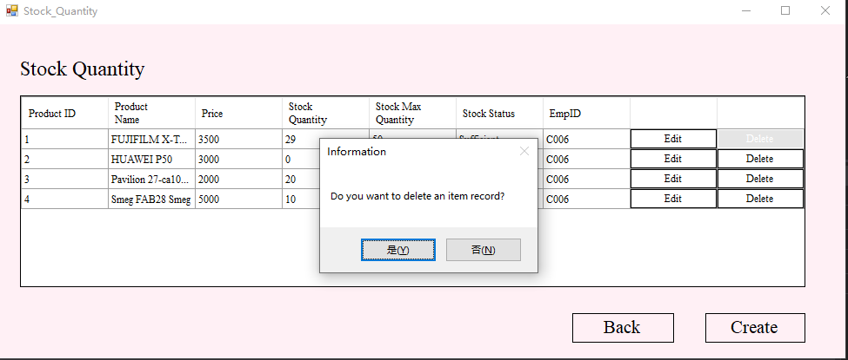

**6.4 Edit Stock Quantity**

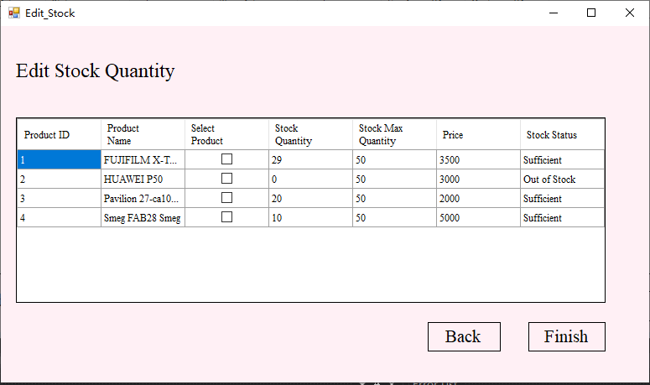

**6.5 Create Stock Quantity**

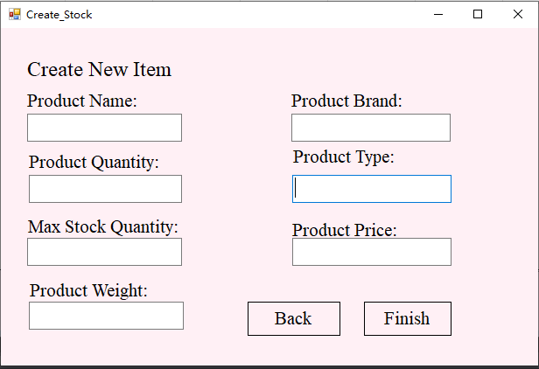

**7.Low level product alert**

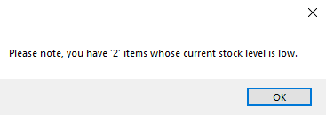

**8.Add new inventory item**

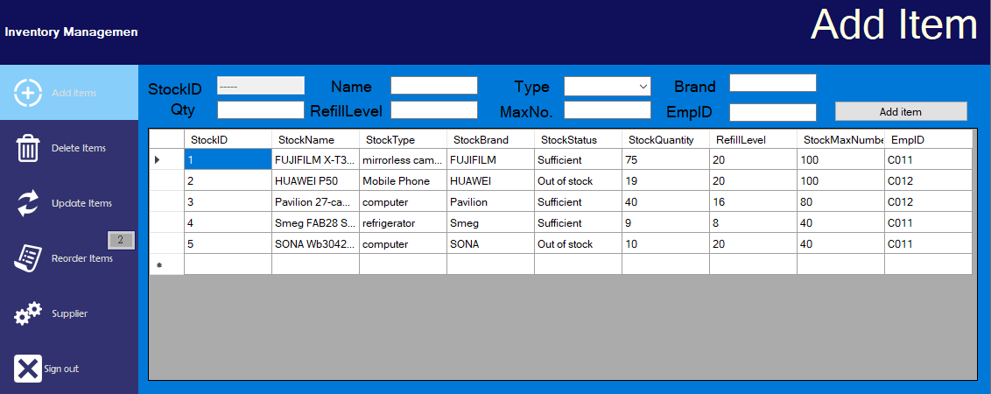

**8.1Add new inventory item- successful**

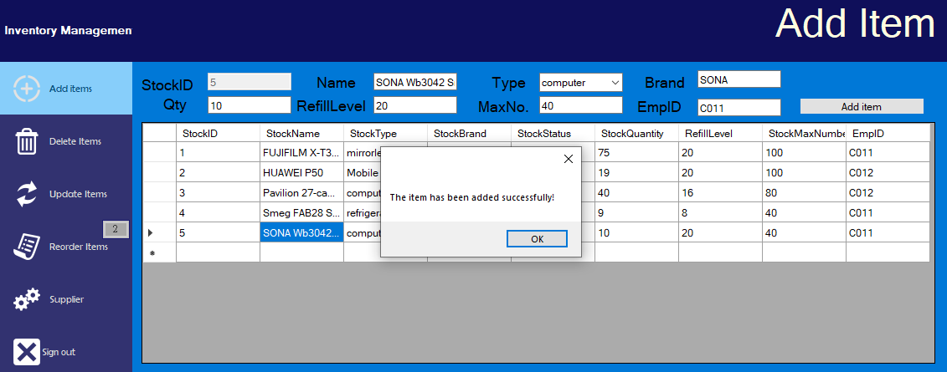

**8.2Add new inventory item- error**

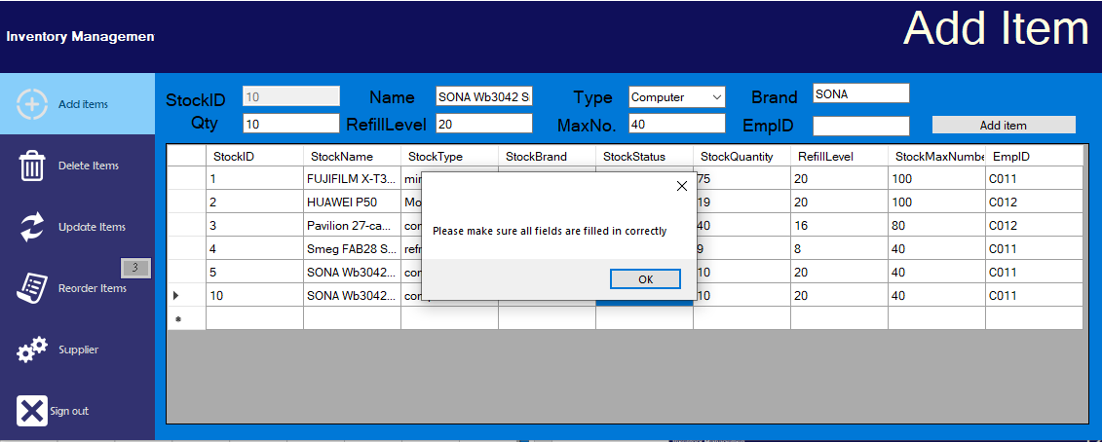

1. **Delete inventory item**

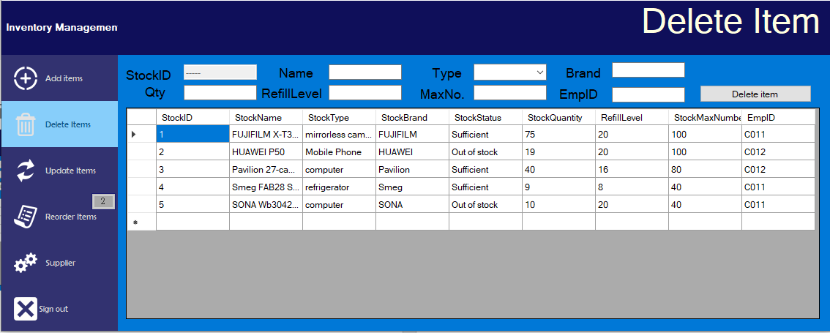

**9.1Delete inventory item- successful**

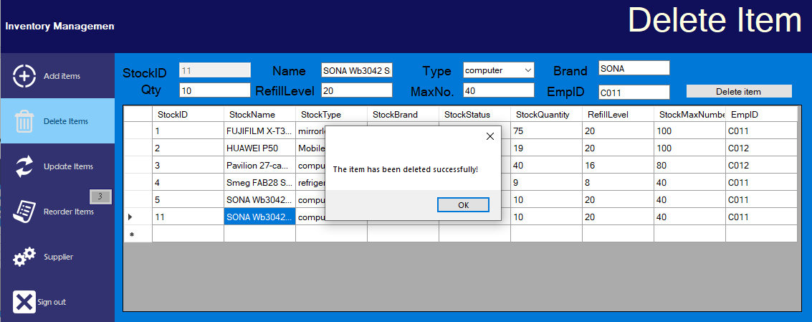

**9.2Update inventory item**

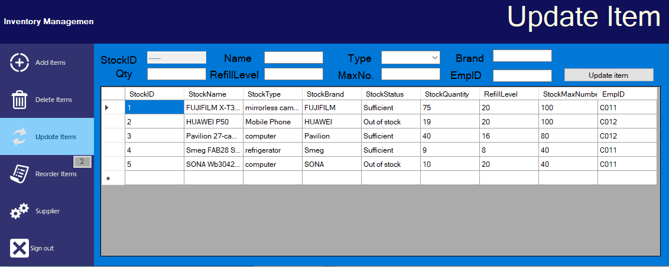

**10.1Update inventory item- successful**

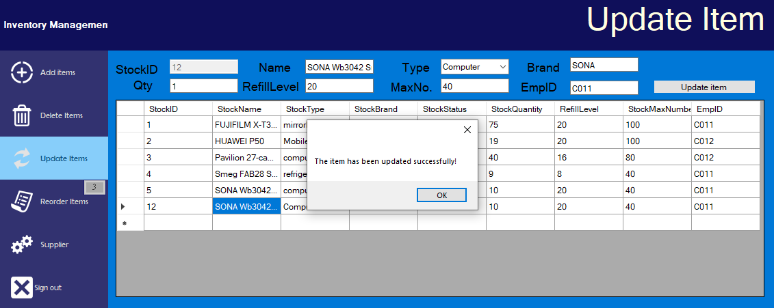

**10.2Update inventory item- error**

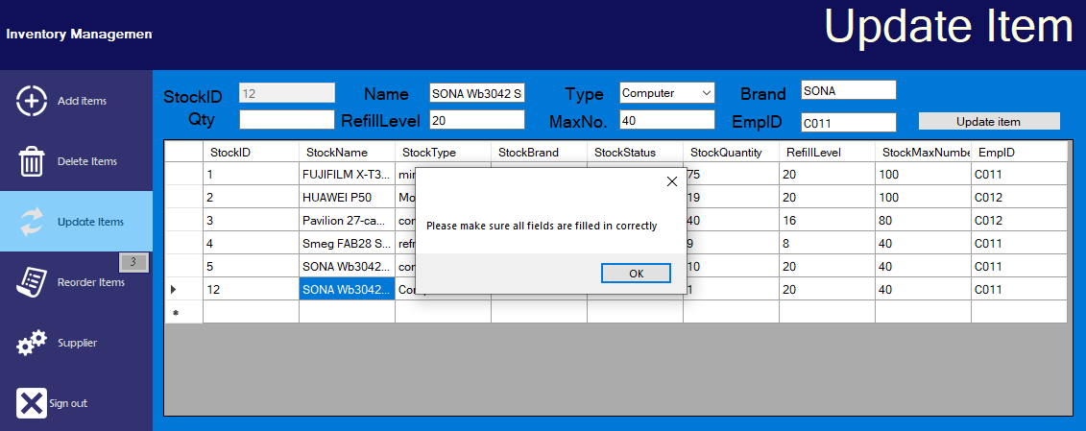

**11.Reorder inventory item from supplier**

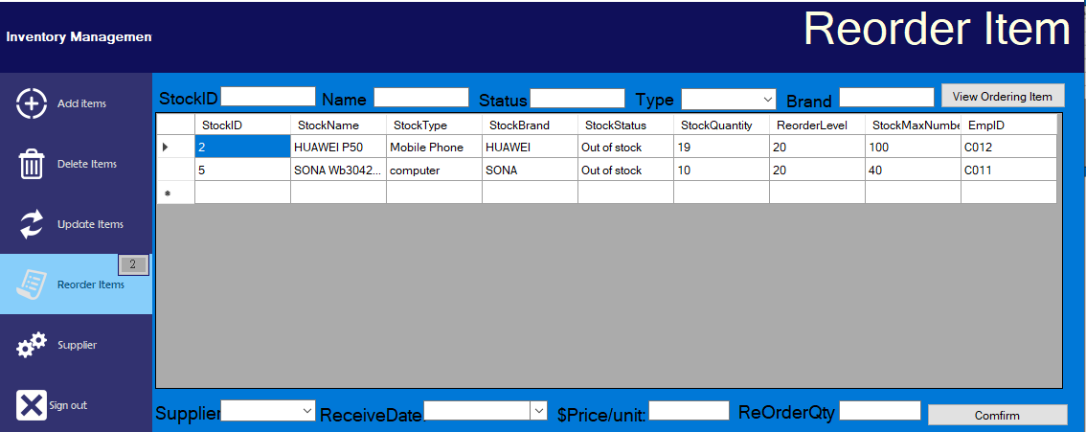

**11.1Reorder inventory item from supplier- successful**

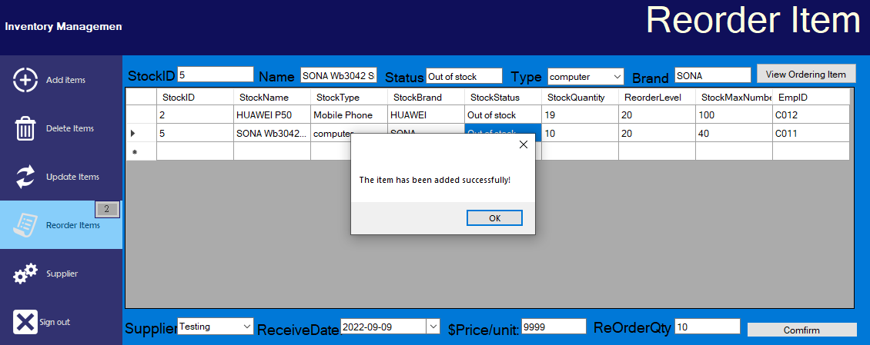

**11.2Reorder inventory item from supplier- error**

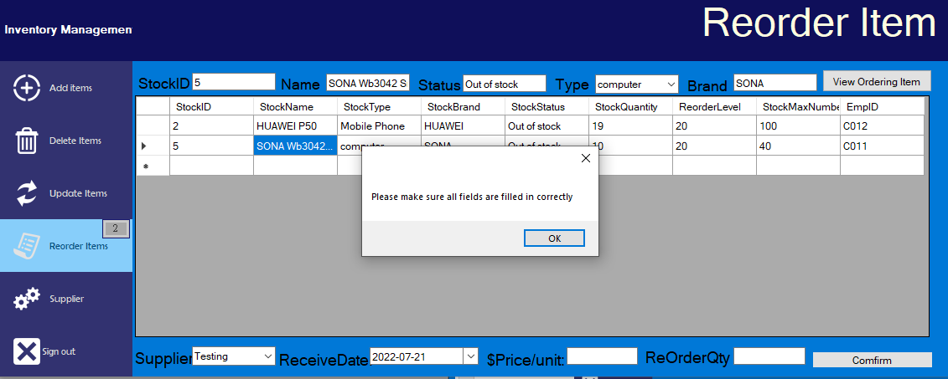

**12.Ordering Item List**

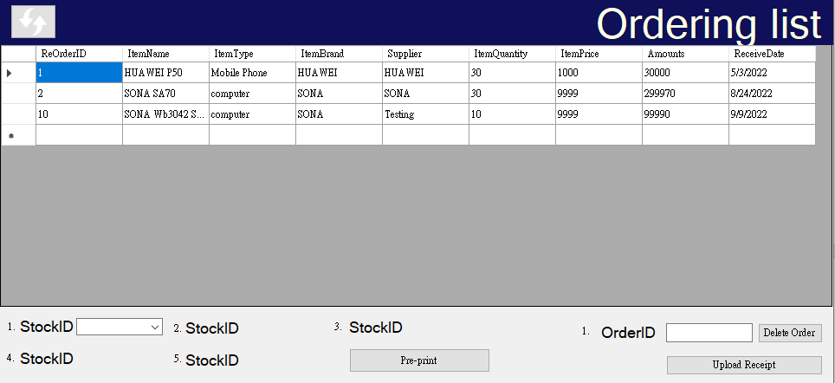

**12.1Pre-print Goods Receive Note**

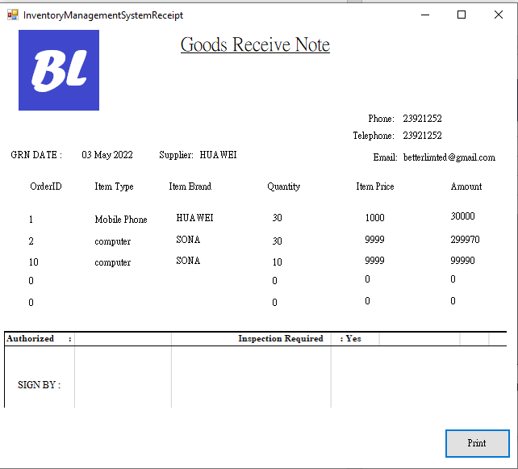

**12.2Print Goods Receive Note**

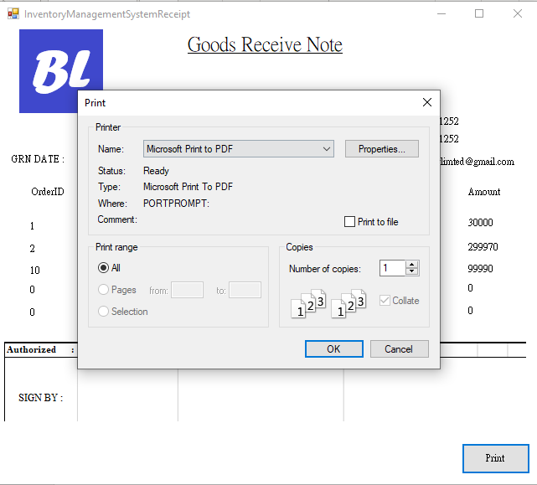

**12.3Add/Delete/Update supplier**

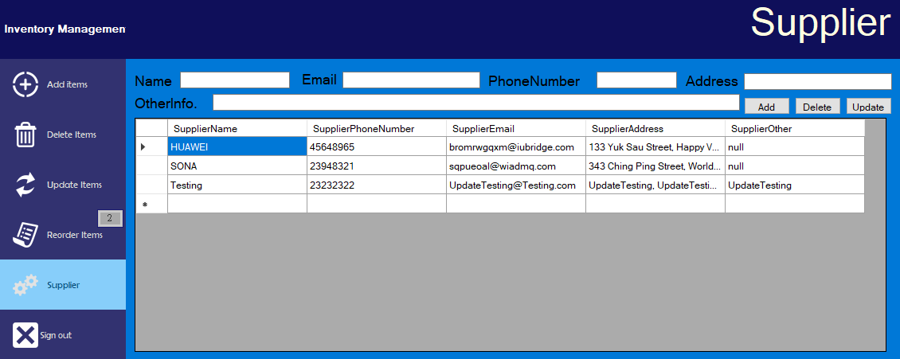

**13.1 Delivery Order Management System & Time Table**

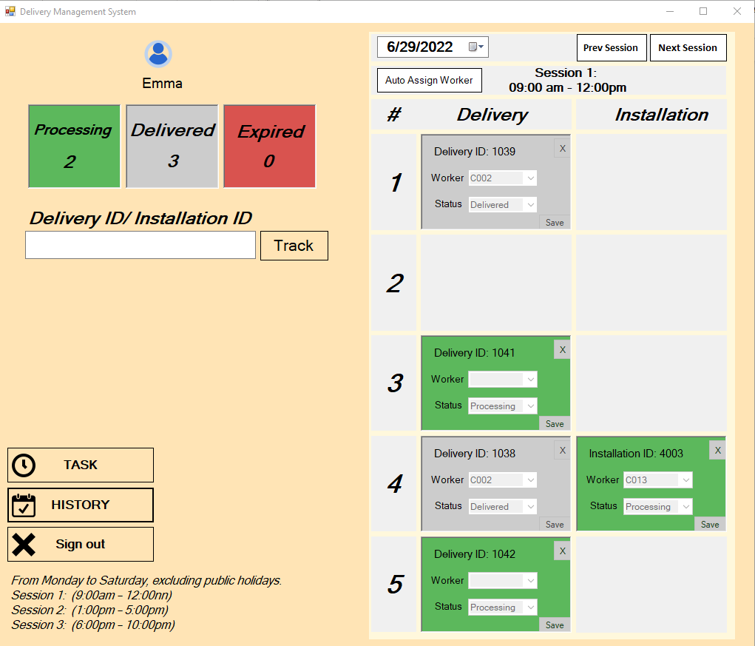

**13.2 Order Detail – Delivery Order**

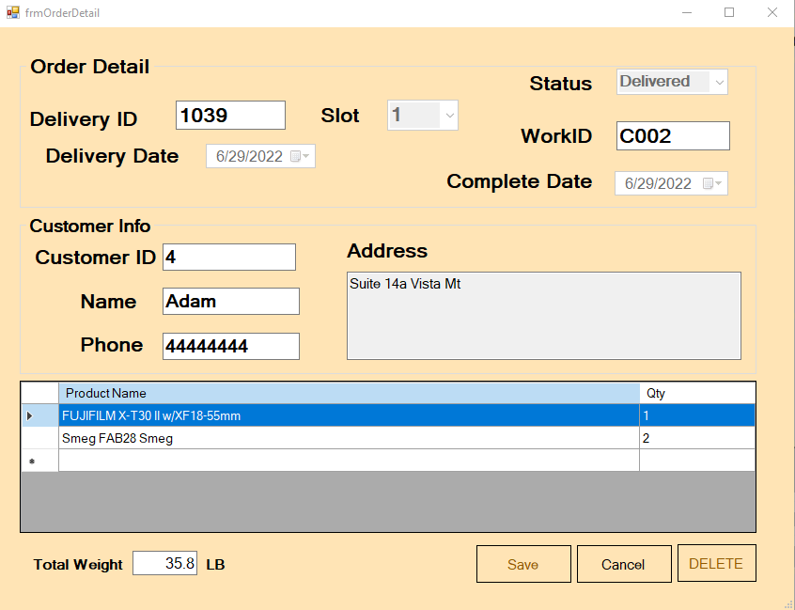

**13.3 Order Detail – Installation Order**

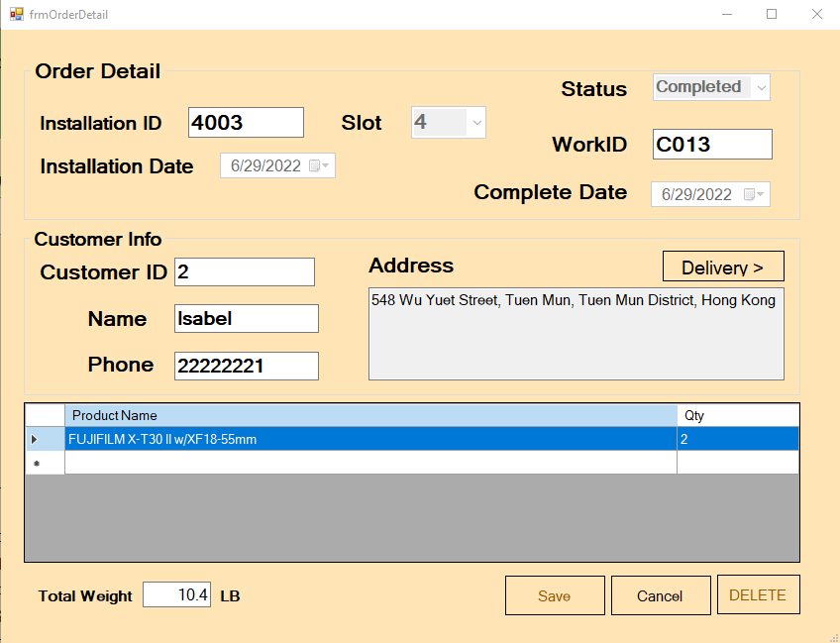

**13.4 Worker Task Manager – Delivery**

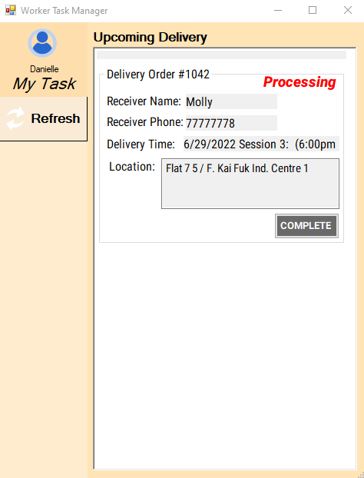

**13.5 Worker Task Manager – Installation**

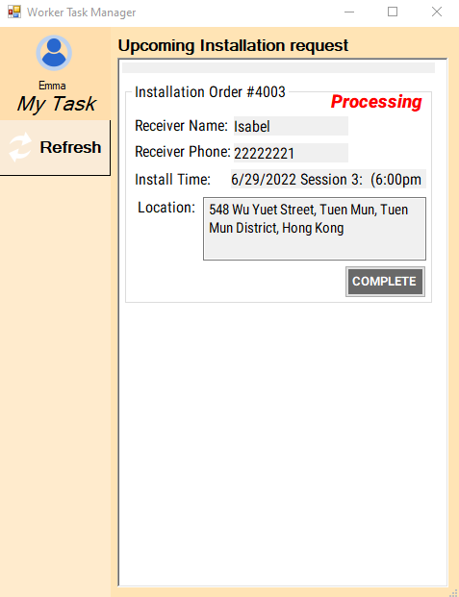

**13.6 Order History**

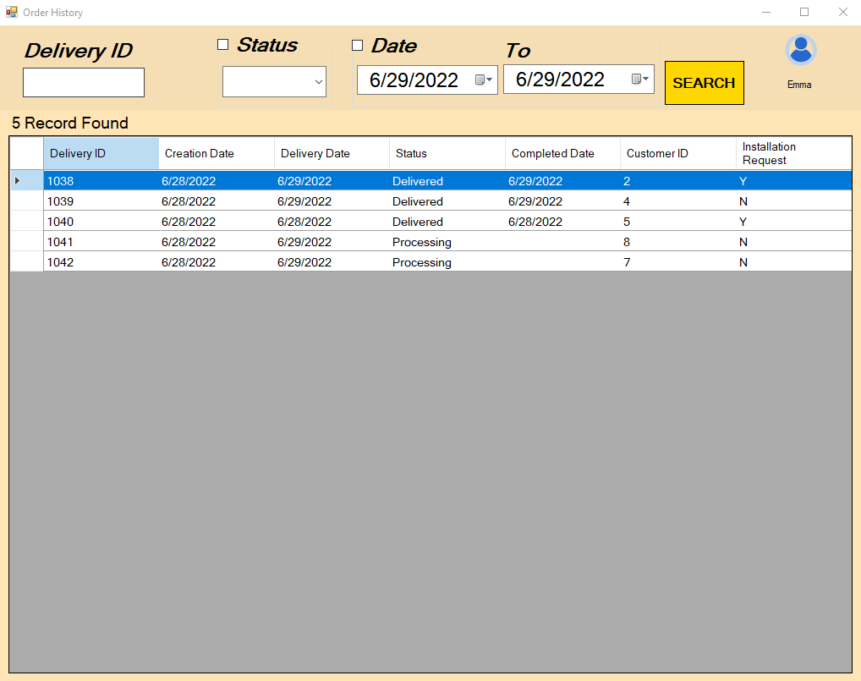

**15. Test Case**

**1.Login System**

|  |  |  |  |  |
| --- | --- | --- | --- | --- |
| Test series: Test Script:OR-1 | | | | |
| Test Title: login with incorrect password | | | | |
| Test author: staff | | | | |
| Pre-condition: null | | | | |
| Description | Test steps | Expect result | Actual result | Pass/Fail |
| try to use incorrect password to login, then see the system will happen | 1. input account number 2. input a incorrect password 3. click the login button | the system will not let me go in and send the error message. | the system not let me go in and send the error message. | Pass |

|  |  |  |  |  |
| --- | --- | --- | --- | --- |
| Test series: Test Script:OR-2 | | | | |
| Test Title: login to staff account | | | | |
| Test author: staff | | | | |
| Pre-condition: null | | | | |
| Description | Test steps | Expect result | Actual result | Pass/Fail |
| try to use correct password to login, then see the system will happen | 1. input account number 2. input a correct password 3. click the login button | the system will let me go to the staff department system | the system will let me go to the staff department system | Pass |

|  |  |  |  |  |
| --- | --- | --- | --- | --- |
| Test series: Test Script:OR-3 | | | | |
| Test Title: login to account is null department | | | | |
| Test author: staff | | | | |
| Pre-condition: null | | | | |
| Description | Test steps | Expect result | Actual result | Pass/Fail |
| Create a null department account in SQL, and  try to use it to login, then see the system will happen. | 1. input account number 2. input a correct password 3. click the login button | the system will not let me go in any system | the system not let me go in any system. | Pass |

|  |  |  |  |  |
| --- | --- | --- | --- | --- |
| Test series: Test Script:OR-4 | | | | |
| Test Title: change password in using Chinese password | | | | |
| Test author: staff | | | | |
| Pre-condition: null | | | | |
| Description | Test steps | Expect result | Actual result | Pass/Fail |
| change password  in use Chinese password  ,then see the system will happen. | 1. input account all information 2. input a Chinese password 3. click the change button | the system will create successful | the system create unsuccessful the Chinese password  is change to “???” | Fail |

**2.Admin System**

|  |  |  |  |  |
| --- | --- | --- | --- | --- |
| Test series: Test Script:AS-1 | | | | |
| Test Title: create account in using Chinese | | | | |
| Test author: staff | | | | |
| Pre-condition: login admin system | | | | |
| Description | Test steps | Expect result | Actual result | Pass/Fail |
| using Chinese to create account,then see the system will happen. | 1. input account all information in Chinese 2. click the create button | the system will create successful,  show Chinese. | the system create unsuccessful the Chinese password  is change to “???” | Fail |

**3.Inventory system: (add item)**

|  |  |  |  |  |
| --- | --- | --- | --- | --- |
| Test Script: IS-001 | | | | |
| Test Title: Add item in the inventory system successfully. | | | | |
| Test author: Inventory Staff | | | | |
| Pre-condition: Inventory Staff has been logged in. | | | | |
| Description | Test steps | Expect result | Actual result | Pass/fail |
| Add new inventory items into the system. | 1. Login to the Inventory system. 2. Select the Add items menu. 3. Fill in the information of the new item. (Can select the cell in the grid view to fill in the form quicker.) 4. Click the “Add item” button. | The item info is added to the system successfully, and the new record will immediately show on the grid view. | As the expected result. | Pass |

|  |  |  |  |  |
| --- | --- | --- | --- | --- |
| Test Script: IS-002 | | | | |
| Test Title: Show “StockStatus” in the “Add item” field. | | | | |
| Test author: Inventory Staff | | | | |
| Pre-condition: Inventory Staff has been login. | | | | |
| Description | Test steps | Expect result | Actual result | Pass/fail |
| Show “Sufficient”  (StockQuantity > RefillLevel) or “Insufficient” (StockQuantity < RefillLevel) Stock Status in the Add item grid view. | 1. Login to the Inventory system. 2. Select the Add items menu. 3. Fill in the information of the new item. (Can select the cell in the grid view to fill in the form quicker.) 4. Click the “Add item” button. 5. The item info is added to the system successfully, and the new record will immediately show on the grid view. 6. The “StockStatus” show in the Grid view correctly. | The item info is added to the system successfully, and the new record will immediately show on the grid view. | As the expect result. | Pass |

|  |  |  |  |  |
| --- | --- | --- | --- | --- |
| Test Script: IS-003 | | | | |
| Test Title: Fill in the Add item form incorrectly. | | | | |
| Test author: Inventory Staff | | | | |
| Pre-condition: Inventory Staff has been login. | | | | |
| Description | Test steps | Expect result | Actual result | Pass/fail |
| If the staff didn’t input, all the field in the Add Item form. The error message will be prompt. | 1. Login to the Inventory system. 2. Select the Add items menu. 3. Fill in the information of the new item. (Can select the cell in the grid view to fill in the form quicker.) 4. Click the “Add item” button. | The Add Item form will prompt the remind message of “Please make sure all fields are filled in correctly”. | As the expect result. | Pass |

**Delete item**

|  |  |  |  |  |
| --- | --- | --- | --- | --- |
| Test Script: IS-004 | | | | |
| Test Title: Delete item in the inventory system successfully. | | | | |
| Test author: Inventory Staff | | | | |
| Pre-condition: Inventory Staff has been login. | | | | |
| Description | Test steps | Expect result | Actual result | Pass/fail |
| Delete inventory item into the system. | 1. Login to the Inventory system. 2. Select the Delete items menu. 3. Select the cell in the grid view of Delete item. 4. Click the “Delete dd item” button. | The item info is deleted from the system successfully, and the new record will immediately show on the grid view. | As the expect result. | Pass |

|  |  |  |  |  |
| --- | --- | --- | --- | --- |
| Test Script: IS-005 | | | | |
| Test Title: Fill in the Add item form incorrectly. | | | | |
| Test author: Inventory Staff | | | | |
| Pre-condition: Inventory Staff has been login. | | | | |
| Description | Test steps | Expect result | Actual result | Pass/fail |
| If the staff didn’t input, all the field in the Delete Item form. The error message will be prompt. | 1. Login to the Inventory system. 2. Select the Delete items menu. 3. Fill in the information of the new item. 4. Click the “Delete item” button. | The Delete Item form will prompt the remind message of “Please make sure all fields are filled in correctly”. | As the expect result. | Pass |

**Update item**

|  |  |  |  |  |
| --- | --- | --- | --- | --- |
| Test Script: IS-006 | | | | |
| Test Title: Update item in the inventory system successfully. | | | | |
| Test author: Inventory Staff | | | | |
| Pre-condition: Inventory Staff has been login. | | | | |
| Description | Test steps | Expect result | Actual result | Pass/fail |
| Update new inventory item into the system. | 1. Login to the Inventory system. 2. Select the Update items menu. 3. Fill in the information of the update item. (Can select the cell in the grid view to fill in the form quicker.) 4. Click the “Update item” button. | The item info is updated to the system successfully, and the new record will immediately show on the grid view. | As the expect result. | Pass |

|  |  |  |  |  |
| --- | --- | --- | --- | --- |
| Test Script: IS-007 | | | | |
| Test Title: Show “StockStatus” in the “Update item” field. | | | | |
| Test author: Inventory Staff | | | | |
| Pre-condition: Inventory Staff has been login. | | | | |
| Description | Test steps | Expect result | Actual result | Pass/fail |
| Show “Sufficient”  (StockQuantity > RefillLevel) or “Insufficient” (StockQuantity < RefillLevel) Stock Status in the Add item grid view, after the staff has updated the item information. | 1. Login to the Inventory system. 2. Select the Update items menu. 3. Fill in the information of the new item. (Can select the cell in the grid view to fill in the form quicker.) 4. Click the “Add item” button. 5. The item info is added to the system successfully, and the new record will immediately show on the grid view. 6. The “StockStatus” show in the Grid view correctly. | The item info is added to the system successfully, and the new record will immediately show on the grid view. | As the expect result. | Pass |

|  |  |  |  |  |
| --- | --- | --- | --- | --- |
| Test Script: IS-008 | | | | |
| Test Title: Fill in the Add item form incorrectly. | | | | |
| Test author: Inventory Staff | | | | |
| Pre-condition: Inventory Staff has been login. | | | | |
| Description | Test steps | Expect result | Actual result | Pass/fail |
| If the staff didn’t input, all the field in the Update Item form. The error message will be prompt. | 1. Login to the Inventory system. 2. Select the Update items menu. 3. Fill in the information of the new item. (Can select the cell in the grid view to fill in the form quicker.) 4. Click the “Add item” button. | The Add Item form will prompt the remind message of “Please make sure all fields are filled in correctly”. | As the expect result. | Pass |

**Reorder item**

|  |  |  |  |  |
| --- | --- | --- | --- | --- |
| Test Script: IS-009 | | | | |
| Test Title: Reorder item in the inventory system successfully. | | | | |
| Test author: Inventory Staff | | | | |
| Pre-condition: Inventory Staff has been login. | | | | |
| Description | Test steps | Expect result | Actual result | Pass/fail |
| Reorder item in the inventory system successfully. | 1. Login to the Inventory system. 2. Select the Reorder items menu. 3. Select the cell in the grid view of Reorder item, and the textbox of Reorder information is filled automatically. 4. Click the “View Ordering” button, and the system will display the Ordering list. 5. Input the information of reorder item. 6. Click the “Confirm” button in the Reorder Item list. 7. Click the refresh button on the Ordering list. | The new reorder item is added to the system successfully, and the new record will show on the Ordering list grid view. | As the expect result. | Pass |

|  |  |  |  |  |
| --- | --- | --- | --- | --- |
| Test Script: IS-010 | | | | |
| Test Title: Fill in reorder item in the inventory system incorrectly. | | | | |
| Test author: Inventory Staff | | | | |
| Pre-condition: Inventory Staff has been login. | | | | |
| Description | Test steps | Expect result | Actual result | Pass/fail |
| If the staff didn’t input, all the field in the Reorder Item form. The error message will be prompt. | 1. Login to the Inventory system. 2. Select the Reorder items menu. 3. Select the cell in the grid view of Reorder item, and the textbox of Reorder information is filled automatically. 4. Click the “View Ordering” button, and the system will display the Ordering list. 5. Input the information of reorder item. 6. Click the “Confirm” button in the Reorder Item list. | The reorder Item form will prompt the remind message of “Please make sure all fields are filled in correctly”. | As the expect result. | Pass |

**Return inwards**

|  |  |  |  |  |
| --- | --- | --- | --- | --- |
| Test Script: IS-010 | | | | |
| Test Title: Print the Goods Receive Note | | | | |
| Test author: Inventory Staff | | | | |
| Pre-condition: Inventory Staff has been login. | | | | |
| Description | Test steps | Expect result | Actual result | Pass/fail |
| Print the Goods Receive Note. | 1. Login to the Inventory system. 2. Select the Reorder items menu. 3. Click the “View Ordering Item” button, the system shows the Ordering List. 4. Select the Stock ID. 5. Click the “Pre-print” button, and the Goods Receive Note will show. 6. Click the “Print” button. 7. Select the properties of the print. 8. Click the “OK” button. 9. Choose the file location. | The Goods Receive Note can now print out. | As the expect result. | Pass |

|  |  |  |  |  |
| --- | --- | --- | --- | --- |
| Test Script: IS-010 | | | | |
| Test Title: Upload the Goods Receive Note | | | | |
| Test author: Inventory Staff | | | | |
| Pre-condition: Inventory Staff has been login. | | | | |
| Description | Test steps | Expect result | Actual result | Pass/fail |
| Upload the Goods Receive Note. | 1. Login to the Inventory system. 2. Select the Reorder items menu. 3. Click the “View Ordering Item” button, the system shows the Ordering List. 4. Click the “Upload Receipt” button. | The Goods Receive Note is uploaded. | As the expect result. | Pass |

**4.Delivery System:**

|  |  |  |  |  |
| --- | --- | --- | --- | --- |
| Test series: Test Script:DS-01 | | | | |
| Test Title: Search Delivery order using front page search field | | | | |
| Test author: Inventory staff, technical support | | | | |
| Pre-condition: valid Manager, Delivery worker and Technical Support account | | | | |
| Description | Test steps | Expect result | Actual result | Pass/Fail |
| Search the existing delivery order and installation order to see the searching result is match or not | 1. Login as manager search Delivery order ‘1038’ 2. Login as Worker search delivery order ‘1038’ 3. Login as Technical Support, search delivery order ‘1038’ | Timetable display correct response result | Display delivery order 1038 | Pass |

|  |  |  |  |  |
| --- | --- | --- | --- | --- |
| Test series: Test Script:DS-02 | | | | |
| Test Title: Search a non-existing delivery order using front page search field | | | | |
| Test author: Inventory staff, technical support | | | | |
| Pre-condition: valid Manager, Delivery worker and Technical Support account | | | | |
| Description | Test steps | Expect result | Actual result | Pass/Fail |
| Search the non-existing delivery order and installation order to see the searching result is match or not | 1. Login as manager search Delivery order ‘1001’ and Installation order ‘4001’ 2. Login as Worker search delivery order ‘1001’ and Installation order ‘4001’ 3. Login as Technical Support , search delivery order ‘1001’ and Installation order ‘4001’ | Timetable display No Record Found | Display No record Found | Pass |

|  |  |  |  |  |
| --- | --- | --- | --- | --- |
| Test series: Test Script:DS-03 | | | | |
| Test Title: Display order by using datetime picker | | | | |
| Test author: inventory staff, Manager and Technical Support | | | | |
| Pre-condition: valid inventory staff account | | | | |
| Description | Test steps | Expect result | Actual result | Pass/Fail |
| Select 28-6-2022 using datetimepicker | 1. Login in as delivery worker, select 28-6-2022 using datetimepicker 2. Login in as Manager, select 28-6-2022 using datetimepicker 3. Login in as Technical Support, select 28-6-2022 using datetimepicker | Display 28-6-2022, delivery order and installation order in session 1 | Display 28-6-2022, delivery order and installation order in session 1 | Pass |

|  |  |  |  |  |
| --- | --- | --- | --- | --- |
| Test series: Test Script:DS-03-2 | | | | |
| Test Title: Using datetimepicker to Choose 5-6-2022(Sunday) | | | | |
| Test author: inventory staff, Manager and Technical Support | | | | |
| Pre-condition: valid inventory staff acount | | | | |
| Description | Test steps | Expect result | Actual result | Pass/Fail |
| Using datetimepicker to Choose 5-6-2022(Sunday) | 1. Login in as delivery worker, using datetimepicker to Choose 5-6-2022(Sunday)datetimepicker 2. Login in as Manager, using datetimepicker to Choose 5-6-2022(Sunday)datetimepicker 3. Login in as Technical Support, using datetimepicker to Choose 5-6-2022(Sunday) | TimeTable will jump to 6-6-2022(Mon) | TimeTable will jump to 6-6-2022(Mon) | Pass |

|  |  |  |  |  |
| --- | --- | --- | --- | --- |
| Test series: Test Script:DS-04 | | | | |
| Test Title: Auto assign worker | | | | |
| Test author: Manager | | | | |
| Pre-condition: valid Manager account | | | | |
| Description | Test steps | Expect result | Actual result | Pass/Fail |
| Using manager account to assign delivery worker | 1. Login in as Manager      1. Click auto assign worker | Assign the worker for delivery order that the worker field is empty | Worker C002 assign to the Delivery order 1005 | Pass |

|  |  |  |  |  |
| --- | --- | --- | --- | --- |
| Test series: Test Script:DS-05 | | | | |
| Test Title: Manually assign delivery worker | | | | |
| Test author: Manager | | | | |
| Pre-condition: valid Manager account | | | | |
| Description | Test steps | Expect result | Actual result | Pass/Fail |
| Using manager account to manually assign delivery worker | 1. Login in as Manager      1. Select delivery order 1028 2. Select worker C002 for delivery order 1028 3. Click Save | C002 will be assign to the Delivery order 1028 | C002 have been assign to the Delivery order 1028 | Pass |

|  |  |  |  |  |
| --- | --- | --- | --- | --- |
| Test series: Test Script:DS-06 | | | | |
| Test Title: Auto assign installation worker | | | | |
| Test author: Technical Manager | | | | |
| Pre-condition: valid Technical Manager account | | | | |
| Description | Test steps | Expect result | Actual result | Pass/Fail |
| Using technical manager account to assign delivery worker | 1. Login in as technical manager      1. Click auto assign worker | Assign the worker for installation order that the worker field is empty | Worker C013 assign to the installation order 4004 | Pass |

|  |  |  |  |  |
| --- | --- | --- | --- | --- |
| Test series: Test Script:DS-07 | | | | |
| Test Title: Auto assign installation worker | | | | |
| Test author: Technical Manager | | | | |
| Pre-condition: valid Manager account | | | | |
| Description | Test steps | Expect result | Actual result | Pass/Fail |
| Using technical manager account to assign delivery worker | 1. Login in as technical manager      1. Click auto assign worker | Assign the worker for installation order that the worker field is empty | Worker C013 assign to the installation order 4004 | Pass |

|  |  |  |  |  |
| --- | --- | --- | --- | --- |
| Test series: Test Script:DS-08 | | | | |
| Test Title: Manually assign installation worker | | | | |
| Test author: Technical Manager | | | | |
| Pre-condition: valid Technical Manager account | | | | |
| Description | Test steps | Expect result | Actual result | Pass/Fail |
| Using  technical manager account to manually assign installation worker | 1. Login in as technical Manager      1. Select installation order 4004 2. Select worker C013 for installation order 4004 3. Click Save | C013 will be assign to the installation order 4004 | C013 have been assign to the installation order 4004 | Pass |

|  |  |  |  |  |
| --- | --- | --- | --- | --- |
| Test series: Test Script:DS-08 | | | | |
| Test Title: Manually assign installation worker | | | | |
| Test author: Technical Manager | | | | |
| Pre-condition: valid Technical Manager account | | | | |
| Description | Test steps | Expect result | Actual result | Pass/Fail |
| Using  technical manager account to manually assign installation worker | 1. Login in as technical Manager      1. Select installation order 4004 2. Select worker C013 for installation order 4004 3. Click Save | C013 will be assign to the installation order 4004 | C013 have been assign to the installation order 4004 | Pass |

|  |  |  |  |  |
| --- | --- | --- | --- | --- |
| Test series: Test Script:DS-09 | | | | |
| Test Title: Assign worker | | | | |
| Test author: Delivery worker | | | | |
| Pre-condition: valid Delivery worker account | | | | |
| Description | Test steps | Expect result | Actual result | Pass/Fail |
| Using  Delivery worker account to manually assign worker | 1. Login in as Delivery worker 2. Select delivery order 1040 3. Select worker C002 4. Click Save | Unable to select worker | Unable to select worker | Pass |

|  |  |  |  |  |
| --- | --- | --- | --- | --- |
| Test series: Test Script:DS-10 | | | | |
| Test Title: Assign worker | | | | |
| Test author: Technical Support | | | | |
| Pre-condition: valid Technical Support account | | | | |
| Description | Test steps | Expect result | Actual result | Pass/Fail |
| Using  Technical Support account to manually assign worker | Login in as Technical Support   1. Select installation order 4004 2. Select worker C013 3. Click Save | Unable to select worker | Unable to select worker | Pass |

|  |  |  |  |  |
| --- | --- | --- | --- | --- |
| Test series: Test Script:DS-11 | | | | |
| Test Title: Auto Assign Worker | | | | |
| Test author: Delivery worker and Technical Support | | | | |
| Pre-condition: valid Delivery worker and Technical Support account | | | | |
| Description | Test steps | Expect result | Actual result | Pass/Fail |
| Using Auto assign worker function by delivery worker or technical support account | 1. Login in as Technical Support or delivery worker 2. Click auto assign worker button | System display you do not have a permission to assign worker | System display you do not have a permission to assign worker | Pass |

|  |  |  |  |  |
| --- | --- | --- | --- | --- |
| Test series: Test Script:DS-12 | | | | |
| Test Title: Auto Assign Worker | | | | |
| Test author: Delivery worker and Technical Support | | | | |
| Pre-condition: valid Delivery worker and Technical Support account | | | | |
| Description | Test steps | Expect result | Actual result | Pass/Fail |
| Using Auto assign worker function by delivery worker or technical support account | 1. Login in as Technical Support or delivery worker 2. Click auto assign worker button | System display you do not have a permission to assign worker | System display you do not have a permission to assign worker | Pass |

|  |  |  |  |  |
| --- | --- | --- | --- | --- |
| Test series: Test Script: DS-13 | | | | |
| Test Title: Update Delivery order status to Delivered in Timetable | | | | |
| Test author: Manager | | | | |
| Pre-condition: Valid manager account | | | | |
| Description | Test steps | Expect result | Actual result | Pass/Fail |
| Update Delivery order status to Delivered in Timetable | 1. login as manager 2. Select delivery order 1043 3. Select status to delivered 4. Click Save | Delivery order 1043 order status update to Delivered in database, database column  deliverycompleteDate will be update to 28-6-2022 | Delivery order 1043 status become Delivered,  deliverycompleteDate update to 28-6-2022 | Pass |

|  |  |  |  |  |
| --- | --- | --- | --- | --- |
| Test series: Test Script: DS-14 | | | | |
| Test Title: Update Installation Status to Completed in Timetable | | | | |
| Test author: Technical Manager | | | | |
| Pre-condition: Valid manager account | | | | |
| Description | Test steps | Expect result | Actual result | Pass/Fail |
| Update Installation order status to Completed in Timetable | 1. login as technical manager 2. Select Installation order 4005 3. Select status to Completed 4. Click Save | Installation order 4005 order status update to Completed in database, database column  installComDate  will be update to 28-6-2022 | Installation order 4005 status become Completed,  installComDate update to 28-6-2022 | Pass |

|  |  |  |  |  |
| --- | --- | --- | --- | --- |
| Test series: Test Script: DS-15 | | | | |
| Test Title: Suspend to Delivery order using Timetable | | | | |
| Test author: Manager | | | | |
| Pre-condition: Valid manager account | | | | |
| Description | Test steps | Expect result | Actual result | Pass/Fail |
| Suspend to Delivery order to expired or holding | 1. login as manager 2. Select delivery order 1043 3. Select status to holding from Processing 4. Click Save | Delivery order 1043 status change to holding and empty the worker field and display status updated successful | Delivery order 1043 status become holding, worker field are empty and display status updated successful | Pass |

|  |  |  |  |  |
| --- | --- | --- | --- | --- |
| Test series: Test Script: DS-16 | | | | |
| Test Title: Suspend to Installation order using Timetable | | | | |
| Test author: Technical Manager | | | | |
| Pre-condition: Valid Technical Manager account | | | | |
| Description | Test steps | Expect result | Actual result | Pass/Fail |
| Suspend to Installation order using Timetable | 1. Login as Technical Manager account 2. Select Installation order 4003 3. Select status to holding from Processing 4. Click Save | installation order 4003 status change to holding, empty the worker field and display status updated successful | installation order 4003 status change to holding, empty the worker field and display status updated successful | Pass |

|  |  |  |  |  |
| --- | --- | --- | --- | --- |
| Test series: Test Script: DS-17 | | | | |
| Test Title: Complete the Delivery order using Timetable without worker assignment | | | | |
| Test author: Manager | | | | |
| Pre-condition: Valid manager account | | | | |
| Description | Test steps | Expect result | Actual result | Pass/Fail |
| Change the status of delivery order from Processing to Delivered without worker assignment | 1. login as manager 2. Select delivery order 1041 3. Select status from Processing to Delivered 4. Click Save | Display Order status cannot be complete without worker assignment | Display Order status cannot be complete without worker assignment | Pass |

|  |  |  |  |  |
| --- | --- | --- | --- | --- |
| Test series: Test Script: DS-17-2 | | | | |
| Test Title: Complete the Delivery order using Timetable had worker assignment | | | | |
| Test author: Manager | | | | |
| Pre-condition: Valid manager account | | | | |
| Description | Test steps | Expect result | Actual result | Pass/Fail |
| Change the status of delivery order from Processing to Delivered had worker assignment | 1. login as manager 2. Select delivery order 1041 3. Select status from Processing to Delivered 4. Click Save | 1. Display confirm message: Do you want to update the status? 2. Click Yes 3. Order Update to Delivered 4. Update completed date and Worker in DB | 1.Display confirm message: Do you want to update the status?  2.Click Yes  3.Order Update to Delivered  4.Update completed date and Worker | Pass |

|  |  |  |  |  |
| --- | --- | --- | --- | --- |
| Test series: Test Script: DS-18 | | | | |
| Test Title: : Complete the Installation order using Timetable had worker assignment | | | | |
| Test author: Technical Manager | | | | |
| Pre-condition: Valid Technical manager account | | | | |
| Description | Test steps | Expect result | Actual result | Pass/Fail |
| Change the status of installation order from Processing to Completed had worker assignment | 1. login as technical manager 2. Select installation order 4003 3. Select status from Processing to Completed 4. Click Save | 1. Display confirm message: Do you want to update the status?  2. Click Yes  3. Order Update to Completed  4. Update completed date and Worker in DB | 1.Display confirm message: Do you want to update the status?  2.Click Yes  3.Order Update to Delivered  4.Update completed date and Worker in DB | Pass |

|  |  |  |  |  |
| --- | --- | --- | --- | --- |
| Test series: Test Script: DS-18-2 | | | | |
| Test Title: Complete the Installation order using Timetable without worker assignment | | | | |
| Test author: Technical Manager | | | | |
| Pre-condition: Valid Technical manager account | | | | |
| Description | Test steps | Expect result | Actual result | Pass/Fail |
| Change the status of installation order from Processing to Completed had worker assignment | 1. login as technical manager 2. Select installation order 4003 3. Select status from Processing to Completed 4. Click Save | Display Order status cannot be complete without worker assignment | Display Order status cannot be complete without worker assignment | Pass |

|  |  |  |  |  |
| --- | --- | --- | --- | --- |
| Test series: Test Script: DS-19 | | | | |
| Test Title: Resume the suspend delivery order | | | | |
| Test author: | | | | |
| Pre-condition: | | | | |
| Description | Test steps | Expect result | Actual result | Pass/Fail |
| Change the status of Delivery order from Holding to Processing | 1. login as manager 2. Select Delivery order 1041 3. Select status from Holding to Processing 4. Click Save | 1. Display Status update Successfully 2. Order Status from Holding change to Processing | 1. Display You've successfully updated your order information! 2. Order Status from Holding change to Processing | Pass |

|  |  |  |  |  |
| --- | --- | --- | --- | --- |
| Test series: Test Script: DS-20 | | | | |
| Test Title: Resume the suspend installation order | | | | |
| Test author: Technical Manager | | | | |
| Pre-condition: Valid Technical Manager account | | | | |
| Description | Test steps | Expect result | Actual result | Pass/Fail |
| Change the status of installation order from Holding to Processing | 1. login as technical manager 2. Select installation order 4003 3. Select status from Holding to Processing 4. Click Save | 1. Display Status update Successfully 2. Order Status from Holding change to Processing | 1. Display You've successfully updated your order information! 2. Order Status from Holding change to Processing | Pass |

|  |  |  |  |  |
| --- | --- | --- | --- | --- |
| Test series: Test Script: DS-21 | | | | |
| Test Title: Delete delivery order using Timetable | | | | |
| Test author: Manager | | | | |
| Pre-condition: valid Manager account | | | | |
| Description | Test steps | Expect result | Actual result | Pass/Fail |
| Delete delivery order that are not completed using Timetable | 1. login as manager 2. Select Delivery order 1041 3. Click X 4. Click Yes | 1. Display confirm message Are you sure you want to delete the order? 2. Click Yes 3. Order and related installation order remove from DB and Timetable | 1. Display confirm message Are you sure you want to delete the order? 2. Click Yes 3. Order removes from DB and Timetable | Pass |

|  |  |  |  |  |
| --- | --- | --- | --- | --- |
| Test series: Test Script: DS-22 | | | | |
| Test Title: Delete installation order using Timetable | | | | |
| Test author: Manager | | | | |
| Pre-condition: Valid Manager | | | | |
| Description | Test steps | Expect result | Actual result | Pass/Fail |
| Delete Installation Order that are not Completed using Timetable | 1. login as manager 2. Select installation order 4004 3. Click X 4. Click Yes | 1. Display confirm message Are you sure you want to delete the order? 2. Click Yes 3. Order removes from DB and Timetable and change the installNeed of Delivery order 1040 to N | Order removes from DB and Timetable and change the installNeed of Delivery order 1040 to N | Pass |

|  |  |  |  |  |
| --- | --- | --- | --- | --- |
| Test series: Test Script: DS-23 | | | | |
| Test Title: Select Delivery order in Timetable to display order detail | | | | |
| Test author: Any account from Technical department or Inventory Department | | | | |
| Pre-condition: Valid account | | | | |
| Description | Test steps | Expect result | Actual result | Pass/Fail |
| Select Delivery order in Timetable to display order detail | 1. login as worker 2. click delivery order 1040 | Display Order detail window for delivery order 1040 | Display Order detail window for delivery order 1040 | Pass |

|  |  |  |  |  |
| --- | --- | --- | --- | --- |
| Test series: Test Script: DS-24 | | | | |
| Test Title: Select Installation order in Timetable to display order detail | | | | |
| Test author: Any account from Technical department or Inventory Department | | | | |
| Pre-condition: Valid account | | | | |
| Description | Test steps | Expect result | Actual result | Pass/Fail |
| Select Installation order in Timetable to display order detail | 1. login as worker 2. click installation order 4003 | Display Order detail window for installation order 4003 | Display Order detail window for installation order 4003 | Pass |

|  |  |  |  |  |
| --- | --- | --- | --- | --- |
| Test series: Test Script: DS-25 | | | | |
| Test Title: Update Delivery Date in order detail | | | | |
| Test author: Manager | | | | |
| Pre-condition: Valid manager account | | | | |
| Description | Test steps | Expect result | Actual result | Pass/Fail |
| Update Delivery Date in order detail | 1. login as manager 2. Select delivery order 1041 3. Change the delivery date from 28-6-2022 to 29-6-2022 4. Click Save | Display Order information has been updated and change the delivery date of order to 29-6-2022 | Display You've successfully updated your order information and change the delivery date of order to 29-6-2022 | Pass |

|  |  |  |  |  |
| --- | --- | --- | --- | --- |
| Test series: Test Script: DS-26 | | | | |
| Test Title: Update Delivery order timeslot in order detail | | | | |
| Test author: Manager account | | | | |
| Pre-condition: Valid manager account | | | | |
| Description | Test steps | Expect result | Actual result | Pass/Fail |
| Update Delivery Time Slot in order detail | 1. login as manager 2. Select delivery order 1041 3. Change the time slot from 2 to 4 4. Click Save | Display Order information has been updated and change the time slot of order to 4 | Display You've successfully updated your order information and change the time slot of order to 4 | Pass |

|  |  |  |  |  |
| --- | --- | --- | --- | --- |
| Test series: Test Script: DS-27 | | | | |
| Test Title: Update Delivery order date and timeslot in order detail | | | | |
| Test author: Manager account | | | | |
| Pre-condition: Valid manager account | | | | |
| Description | Test steps | Expect result | Actual result | Pass/Fail |
| Update Delivery Time Slot and delivery order date at the same time in order detail | 1. login as manager 2. Select delivery order 1041 3. Change the time slot from 2 to 5 and delivery date from 29-6-2022 to 30-6-2022 4. Click Save | Display Order information has been updated, change the time slot of order to four and change the delivery date to 30-6-2022 | Display You've successfully updated your order information, change the time slot of order to 4 and change the delivery date to 30-6-2022 | Pass |

|  |  |  |  |  |
| --- | --- | --- | --- | --- |
| Test series: Test Script: DS-28 | | | | |
| Test Title: Update Delivery order date, timeslot and status to Delivered in order detail | | | | |
| Test author: Manager account | | | | |
| Pre-condition: Valid manager account | | | | |
| Description | Test steps | Expect result | Actual result | Pass/Fail |
| Update Delivery Time Slot, delivery order date and status at the same time in order detail | 1. login as manager 2. Select delivery order 1041 3. Change the time slot from 2 to 5 and delivery date from 29-6-2022 to 30-6-2022 and change the status from processing to delivered 4. Click Save | Display Order information has been updated, change the time slot of order to 5, change the delivery date to 30-6-2022 and change the status to delivered | Display You've successfully updated your order information, change the time slot of order to 5, change the delivery date to 30-6-2022 and change the status to delivered | Pass |

|  |  |  |  |  |
| --- | --- | --- | --- | --- |
| Test series: Test Script: DS-29 | | | | |
| Test Title: Update Customer information in order detail | | | | |
| Test author: Manager | | | | |
| Pre-condition: Valid manager account | | | | |
| Description | Test steps | Expect result | Actual result | Pass/Fail |
| Update customer information in order detail window | 1. login as manager 2. Select delivery order 1041 3. Change the customer address to Mong Kok 12888 4. Click Save | Display Message customer information has been updated | Display Message customer information has been updated | Pass |

|  |  |  |  |  |
| --- | --- | --- | --- | --- |
| Test series: Test Script: DS-30 | | | | |
| Test Title: Delete Delivered delivery order in order detail | | | | |
| Test author: Manager | | | | |
| Pre-condition: Valid manager account | | | | |
| Description | Test steps | Expect result | Actual result | Pass/Fail |
| Delete Delivered delivery order in order detail | 1. login as manager 2. Click delivery order 1041 3. Click delete button in Order detail window | 1. Display are you sure to delete the order and related record 2. Click yes 3. Orde will be deleted | 1. Display are you sure to delete the order and related record 2. Click yes 3. Orde will be deleted | Pass |

|  |  |  |  |  |
| --- | --- | --- | --- | --- |
| Test series: Test Script: DS-31 | | | | |
| Test Title: Update Installation Date in order detail | | | | |
| Test author: Technical Manager | | | | |
| Pre-condition: Valid Technical Manager account | | | | |
| Description | Test steps | Expect result | Actual result | Pass/Fail |
| Update Installation Date in order detail | 1. login as manager 2. Select installation order 4003 3. Change the installation date from 29-6-2022 to 30-6-2022 4. Click Save | 1. Display Order information has been updated 2. Order date change to 30-6-2022 | 1. Display You've successfully updated your order information 2. Orde date change to 30-6-2022 | Pass |

|  |  |  |  |  |
| --- | --- | --- | --- | --- |
| Test series: Test Script: DS-26 | | | | |
| Test Title: Update Installation order timeslot in order detail | | | | |
| Test author: Technical Manager | | | | |
| Pre-condition: Valid Technical Manager account | | | | |
| Description | Test steps | Expect result | Actual result | Pass/Fail |
| Update installation order Time Slot in order detail | 1. login as manager 2. Select installation order 4003 3. Change the time slot from 2 to 4 4. Click Save | 1. Display Order information has been updated 2. Order time slot change to 4 | 1. Display You've successfully updated your order information 2. Order time slot change to 4 | Pass |

|  |  |  |  |  |
| --- | --- | --- | --- | --- |
| Test series: Test Script: DS-32 | | | | |
| Test Title: Update Installation order date and timeslot in order detail | | | | |
| Test author: Technical Manager | | | | |
| Pre-condition: Valid Technical Manager account | | | | |
| Description | Test steps | Expect result | Actual result | Pass/Fail |
| Update installation order Time Slot and order date at the same time in order detail | 1. login as manager 2. Select installation order 4003 3. Change the time slot from 4 to 5 and install date from 29-6-2022 to 30-6-2022 4. Click Save | 1. Display order information has been updated 2. change the time slot of order to 5 and change the install date to 30-6-2022 | 1. Display You've successfully updated your order information 2. change the time slot of order to 5 and change the install date to 30-6-2022 | Pass |

|  |  |  |  |  |
| --- | --- | --- | --- | --- |
| Test series: Test Script: DS-33 | | | | |
| Test Title: Update Installation order date, timeslot and status to Completed in order detail | | | | |
| Test author: Technical Manager | | | | |
| Pre-condition: Valid Technical Manager account | | | | |
| Description | Test steps | Expect result | Actual result | Pass/Fail |
| Update installation Time Slot, order date and status at the same time in order detail | 1. login as manager 2. Select installation order 4003 3. Change the time slot from 2 to 5 and date from 29-6-2022 to 2-7-2022 and change the status from Processing to Completed 4. Click Save | Display Order information has been updated, change the time slot of order to 5 , change the delivery date to 2-7-2022 and change the status to Completed | Display You've successfully updated your order information, change the time slot of order to 5 , change the delivery date to 2-7-2022 and change the status to Completed | Pass |

|  |  |  |  |  |
| --- | --- | --- | --- | --- |
| Test series: Test Script: DS-34 | | | | |
| Test Title: Delete Completed Installation order in order detail | | | | |
| Test author: Technical Manager | | | | |
| Pre-condition: Valid Technical Manager account | | | | |
| Description | Test steps | Expect result | Actual result | Pass/Fail |
| Delete Installation order in order detail | 1. login as technical manager 2. Click Installation order 4003 3. Click delete button in Order detail window | Display Unable to delete completed order | Display Unable to delete completed order | Pass |

|  |  |  |  |  |
| --- | --- | --- | --- | --- |
| Test series: Test Script: DS-35 | | | | |
| Test Title: Check task using Worker Task Manager | | | | |
| Test author: Delivery Worker | | | | |
| Pre-condition: Valid Delivery Worker account | | | | |
| Description | Test steps | Expect result | Actual result | Pass/Fail |
| Check task using Worker Task Manager | 1. Delivery order 1039 assign to delivery worker C002 2. Login as C002 3. Click Task 4. Display Delivery order 1039 | Display Delivery order 1039 | Display Delivery order 1039 | Pass |

|  |  |  |  |  |
| --- | --- | --- | --- | --- |
| Test series: Test Script: DS-36 | | | | |
| Test Title: Complete Task using Worker Task Manager | | | | |
| Test author: Delivery Worker | | | | |
| Pre-condition: Valid Delivery Worker account | | | | |
| Description | Test steps | Expect result | Actual result | Pass/Fail |
| Complete Task using Worker Task Manager | 1. Delivery order 1039 assign to delivery worker C002 2. Login as C002 3. Click Task 4. Click COMPLETE | 1. Display Are you sure 2. Click Yes 3. Display Order Completed 4. Complete button unable 5. Order complete date update to current day | 1. Display Are you sure 2. Click Yes 3. Display Order Completed 4. Complete button unable 5. Order complete date update to current day | Pass |

|  |  |  |  |  |
| --- | --- | --- | --- | --- |
| Test series: Test Script: DS-37 | | | | |
| Test Title: Installation order appear for the Technical Support after delivery worker completed the delivery order | | | | |
| Test author: Technical Support | | | | |
| Pre-condition: Delivery Order 1039 have been complete, the installation order have been assign to C013 Technical Support, so the user must have C013 account for view the install task | | | | |
| Description | Test steps | Expect result | Actual result | Pass/Fail |
| Installation order appear for the Technical Support after delivery worker completed the delivery order | 1. login as Technical Support C013 2. Click Task button 3. Installation order 4003 will appear | Display Installation order 4003 | Display Installation order 4003 | Pass |

|  |  |  |  |  |
| --- | --- | --- | --- | --- |
| Test series: Test Script: DS-38 | | | | |
| Test Title: Complete the Installation Order using Worker Task Manager | | | | |
| Test author: Technical Support | | | | |
| Pre-condition: Delivery Order 1039 have been complete, the installation order have been assigning to C013 Technical Support, so the user must have C013 account for complete the task | | | | |
| Description | Test steps | Expect result | Actual result | Pass/Fail |
| Complete the Installation Order using Worker Task Manager | 1. login as Technical Support C013 2. Click Task button 3. Installation order 4003 will appear 4. Click COMPLETE | 1. Display Are you sure 2. Click Yes 3. Display Order Completed 4. Complete button unable 5. Order complete date update to current day | 1. Display Are you sure 2. Click Yes 3. Display Order Completed 4. Complete button unable 5. Order complete date update to current day | Pass |

|  |  |  |  |  |
| --- | --- | --- | --- | --- |
| Test series: Test Script: DS-39 | | | | |
| Test Title: Search order by Order ID using History | | | | |
| Test author: Any account from Technical department or Inventory Department | | | | |
| Pre-condition: | | | | |
| Description | Test steps | Expect result | Actual result | Pass/Fail |
| Search Order ID using History | 1. login 2. Click History 3. Input Delivery id 1038 4. Click SEARCH | Display 1 record found | Display 1 record found | Pass |

|  |  |  |  |  |
| --- | --- | --- | --- | --- |
| Test series: Test Script: DS-40 | | | | |
| Test Title: Search order by status using History | | | | |
| Test author: Any account from Technical department or Inventory Department | | | | |
| Pre-condition: | | | | |
| Description | Test steps | Expect result | Actual result | Pass/Fail |
| Search Status using History | 1. login 2. Click History 3. Enable the status checkbox 4. Select Delivered 5. Click SEARCH | Display 3 record found | Display 3 record found | pass |

|  |  |  |  |  |
| --- | --- | --- | --- | --- |
| Test series: Test Script: DS-41 | | | | |
| Test Title: Search order by Date using History | | | | |
| Test author: Any account from technical department or Inventory Department | | | | |
| Pre-condition: | | | | |
| Description | Test steps | Expect result | Actual result | Pass/Fail |
| Search ordr by Date using History | 1. login 2. Click History 3. Enable the Date checkbox 4. Select 29-6-2022 to 30-6-2022 5. Click SEARCH | Display 4 record found | Display 4 record found | Pass |

|  |  |  |  |  |
| --- | --- | --- | --- | --- |
| Test series: Test Script: DS-42 | | | | |
| Test Title: Search order by Order id, status and date | | | | |
| Test author: Any account from Technical department or Inventory Department | | | | |
| Pre-condition: | | | | |
| Description | Test steps | Expect result | Actual result | Pass/Fail |
| Search order by Order id, status and date | 1. login 2. Click History 3. Enable the Date, status checkbox 4. Input 1 5. Select Processing 6. Select 29-6-2022 to 30-6-2022 7. Click SEARCH | Display 4 record found | Display 4 record found | Pass |

**5.Sales System**

|  |  |  |  |  |
| --- | --- | --- | --- | --- |
| Test series: Test Script: SS-01 | | | | |
| Test Title: Search Order | | | | |
| Test author: Account from sales staff or sales manager | | | | |
| Pre-condition: System has order records | | | | |
| Description | Test steps | Expect result | Actual result | Pass/Fail |
| Search order by Order ID | 1. Login 2. Input 3 in search box | Show orders with ID number 3 | Show orders with ID number 3 | Pass |

|  |  |  |  |  |
| --- | --- | --- | --- | --- |
| Test series: Test Script: SS-02 | | | | |
| Test Title: Search Order (Non-existing) | | | | |
| Test author: Account from sales staff or sales manager | | | | |
| Pre-condition: System has not order records | | | | |
| Description | Test steps | Expect result | Actual result | Pass/Fail |
| Search order by Order ID | 1. Login  2. Input 2 in search box | No order show | No order show | Pass |

|  |  |  |  |  |
| --- | --- | --- | --- | --- |
| Test series: Test Script: SS-03 | | | | |
| Test Title: Create Payment Order | | | | |
| Test author: Account from sales staff or sales manager | | | | |
| Pre-condition: Tester has valid account | | | | |
| Description | Test steps | Expect result | Actual result | Pass/Fail |
| Create New Order | 1. Login  2. Click “Create”  3. Input Order ID: 20  4. Select Item: product 4  5. Input buy quantity  6. Select payment method  7. Select Region  8. Click “Finish” | A new order is finished | A new order is finished | Pass |

|  |  |  |  |  |
| --- | --- | --- | --- | --- |
| Test series: Test Script: SS-04 | | | | |
| Test Title: Create Payment Order (Items not selected for purchase) | | | | |
| Test author: Account from sales staff or sales manager | | | | |
| Pre-condition: Tester has valid account | | | | |
| Description | Test steps | Expect result | Actual result | Pass/Fail |
| Create New Payment Order (Items not selected for purchase) failure | 1. Login  2. Click “Create”  3. Input Order ID: 21  4. Input buy quantity: 1  5. Select payment method  6. Select Region  7. Click “Finish” | Alert information, order no created | Alert information, order no created | Pass |

|  |  |  |  |  |
| --- | --- | --- | --- | --- |
| Test series: Test Script: SS-05 | | | | |
| Test Title: Create Payment Order (Item quantity is 0) | | | | |
| Test author: Account from sales staff or sales manager | | | | |
| Pre-condition: Tester has valid account | | | | |
| Description | Test steps | Expect result | Actual result | Pass/Fail |
| Create New Payment Order (Item quantity is 0) failure | 1. Login  2. Click “Create”  3. Input Order ID: 21  4. Select Item: product 4  5. Select payment method  6. Select Region  7. Click “Finish” | Alert information, order no created | Alert information, order no created | Pass |

|  |  |  |  |  |
| --- | --- | --- | --- | --- |
| Test series: Test Script: SS-06 | | | | |
| Test Title: Create Payment Order (Not choose payment method) | | | | |
| Test author: Account from sales staff or sales manager | | | | |
| Pre-condition: Tester has valid account | | | | |
| Description | Test steps | Expect result | Actual result | Pass/Fail |
| Create New Payment Order (Not choose payment method)) failure | 1. Login  2. Click “Create”  3. Input Order ID: 21  4. Select Item: product 4  5. Input buy quantity: 1  6. Select Region  7. Click “Finish” | Alert information, order no created | Alert information, order no created | Pass |

|  |  |  |  |  |
| --- | --- | --- | --- | --- |
| Test series: Test Script: SS-07 | | | | |
| Test Title: Create Payment Order (Not choose store region) | | | | |
| Test author: Account from sales staff or sales manager | | | | |
| Pre-condition: Tester has valid account | | | | |
| Description | Test steps | Expect result | Actual result | Pass/Fail |
| Create New Payment Order (Not choose store region) failure | 1. Login  2. Click “Create”  3. Input Order ID: 21  4. Select Item: product 4  5. Input buy quantity: 1  6. Select payment method  7. Click “Finish” | Alert information, order no created | Alert information, order no created | Pass |

|  |  |  |  |  |
| --- | --- | --- | --- | --- |
| Test series: Test Script: SS-08 | | | | |
| Test Title: Create Deposit Order | | | | |
| Test author: Account from sales staff or sales manager | | | | |
| Pre-condition: Tester has valid account | | | | |
| Description | Test steps | Expect result | Actual result | Pass/Fail |
| Create New Deposit Order | 1. Login  2. Click “Create”  3. Input Order ID: 21  4. Select Item: product 2  5. Input buy quantity: 1  6. Select payment method  7. Select Region  8. Input customer ID:2  9. Click “Finish” | A deposit order is created | A deposit order is created | Pass |

|  |  |  |  |  |
| --- | --- | --- | --- | --- |
| Test series: Test Script: SS-09 | | | | |
| Test Title: Create Deposit Order (Items not selected for purchase) | | | | |
| Test author: Account from sales staff or sales manager | | | | |
| Pre-condition: Tester has valid account | | | | |
| Description | Test steps | Expect result | Actual result | Pass/Fail |
| Create New Deposit Order (Items not selected for purchase) failure | 1. Login  2. Click “Create”  3. Input Order ID: 21  4. Input buy quantity: 1  5. Select payment method  6. Select Region  7. Input Customer ID: 2  8. Click “Finish” | Alert information, order no created | Alert information, order no created | Pass |

|  |  |  |  |  |
| --- | --- | --- | --- | --- |
| Test series: Test Script: SS-10 | | | | |
| Test Title: Create Deposit Order (Item quantity is 0) | | | | |
| Test author: Account from sales staff or sales manager | | | | |
| Pre-condition: Tester has valid account | | | | |
| Description | Test steps | Expect result | Actual result | Pass/Fail |
| Create New Deposit Order (Item quantity is 0) failure | 1. Login  2. Click “Create”  3. Input Order ID: 21  4. Select Item: product 2  5. Select payment method  6. Select Region  7. Input Customer ID:2  8. Click “Finish” | Alert information, order no created | Alert information, order no created | Pass |

|  |  |  |  |  |
| --- | --- | --- | --- | --- |
| Test series: Test Script: SS-11 | | | | |
| Test Title: Create Deposit Order (Not choose payment method) | | | | |
| Test author: Account from sales staff or sales manager | | | | |
| Pre-condition: Tester has valid account | | | | |
| Description | Test steps | Expect result | Actual result | Pass/Fail |
| Create New Deposit Order (Not choose payment method)) failure | 1. Login  2. Click “Create”  3. Input Order ID: 21  4. Select Item: product 2  5. Input buy quantity: 1  6. Select Region  7. Input Customer ID:2  8. Click “Finish” | Alert information, order no created | Alert information, order no created | Pass |

|  |  |  |  |  |
| --- | --- | --- | --- | --- |
| Test series: Test Script: SS-12 | | | | |
| Test Title: Create Deposit Order (Not choose store region) | | | | |
| Test author: Account from sales staff or sales manager | | | | |
| Pre-condition: Tester has valid account | | | | |
| Description | Test steps | Expect result | Actual result | Pass/Fail |
| Create New Deposit Order (Not choose store region) failure | 1. Login  2. Click “Create”  3. Input Order ID: 21  4. Select Item: product 2  5. Input buy quantity: 1  6. Select payment method  7. Input Customer ID:2  8. Click “Finish” | Alert information, order no created | Alert information, order no created | Pass |

|  |  |  |  |  |
| --- | --- | --- | --- | --- |
| Test series: Test Script: SS-13 | | | | |
| Test Title: Create Deposit Order (No input customer ID) | | | | |
| Test author: Account from sales staff or sales manager | | | | |
| Pre-condition: Tester has valid account | | | | |
| Description | Test steps | Expect result | Actual result | Pass/Fail |
| Create New Deposit Order (No input customer ID) failure | 1. Login  2. Click “Create”  3. Input Order ID: 21  4. Select Item: product 2  5. Input buy quantity: 1  6. Select payment method  7. Select Region  8. Click “Finish” | Alert information, order no created | Alert information, order no created | Pass |

|  |  |  |  |  |
| --- | --- | --- | --- | --- |
| Test series: Test Script: SS-14 | | | | |
| Test Title: Create Deposit Order (customer ID isn’t number) | | | | |
| Test author: Account from sales staff or sales manager | | | | |
| Pre-condition: Tester has valid account | | | | |
| Description | Test steps | Expect result | Actual result | Pass/Fail |
| Create New Deposit Order (customer ID isn’t number)) failure | 1. Login  2. Click “Create”  3. Input Order ID: 21  4. Select Item: product 2  5. Input buy quantity: 1  6. Select payment method  7. Select Region  8. Input Customer ID: a  9. Click “Finish” | Alert information, order no created | Alert information, order no created | Pass |

|  |  |  |  |  |
| --- | --- | --- | --- | --- |
| Test series: Test Script: SS-15 | | | | |
| Test Title: Create order (repeat order ID) | | | | |
| Test author: Account from sales staff or sales manager | | | | |
| Pre-condition: Tester has valid account | | | | |
| Description | Test steps | Expect result | Actual result | Pass/Fail |
| Create order (repeat order ID) failure | 1. Login  2. Click “Create”  3. Input Order ID: 3  4. Select Item: product 4  5. Input buy quantity: 1  6. Select payment method  7. Select Region  8. Click “Finish” | Alert information, order no created | Alert information, order no created | Pass |

|  |  |  |  |  |
| --- | --- | --- | --- | --- |
| Test series: Test Script: SS-16 | | | | |
| Test Title: Print Payment Receipt | | | | |
| Test author: Account from sales staff or sales manager | | | | |
| Pre-condition: Tester has valid account | | | | |
| Description | Test steps | Expect result | Actual result | Pass/Fail |
| Print Payment Receipt | 1. Login  2. Input 3 in search box  3. Click “Details”  4. Click “Generate Receipt”  5. Click “Print” | Print payment receipt | Print payment receipt | Pass |

|  |  |  |  |  |
| --- | --- | --- | --- | --- |
| Test series: Test Script: SS-17 | | | | |
| Test Title: Print Deposit Receipt | | | | |
| Test author: Account from sales staff or sales manager | | | | |
| Pre-condition: Tester has valid account | | | | |
| Description | Test steps | Expect result | Actual result | Pass/Fail |
| Print Deposit Receipt | 1. Login  2. Input 6 in search box  3. Click “Details”  4. Click “Generate Receipt”  5. Click “Print” | Print deposit receipt | Print deposit receipt | Pass |

|  |  |  |  |  |
| --- | --- | --- | --- | --- |
| Test series: Test Script: SS-18 | | | | |
| Test Title: Update Payment Receipt Order | | | | |
| Test author: Account from sales staff or sales manager | | | | |
| Pre-condition: Tester has valid account | | | | |
| Description | Test steps | Expect result | Actual result | Pass/Fail |
| Update Payment Receipt Order | 1. Login  2. Input 3 in search box  3. Click “Update”  4. Edit Region, Payment Method, Select Item, or Quantity.  5. Click “Finish” | Update Payment Receipt Order successful | Update Payment Receipt Order successful | Pass |

|  |  |  |  |  |
| --- | --- | --- | --- | --- |
| Test series: Test Script: SS-19 | | | | |
| Test Title: Update Payment Receipt Order (No select Item) | | | | |
| Test author: Account from sales staff or sales manager | | | | |
| Pre-condition: Tester has valid account | | | | |
| Description | Test steps | Expect result | Actual result | Pass/Fail |
| Update Payment Receipt Order  failure | 1. Login  2. Input 3 in search box  3. Click “Update”  4. Edit Select Item is unchecked  5. Click “Finish” | Alert Information | Alert Information | Pass |

|  |  |  |  |  |
| --- | --- | --- | --- | --- |
| Test series: Test Script: SS-20 | | | | |
| Test Title: Update Payment Receipt Order (No input quantity) | | | | |
| Test author: Account from sales staff or sales manager | | | | |
| Pre-condition: Tester has valid account | | | | |
| Description | Test steps | Expect result | Actual result | Pass/Fail |
| Update Payment Receipt Order  Failure | 1. Login  2. Input 3 in search box  3. Click “Update”  4. Edit item quantity is 0  5. Click “Finish” | Alert Information | Alert Information | Pass |

|  |  |  |  |  |
| --- | --- | --- | --- | --- |
| Test series: Test Script: SS-21 | | | | |
| Test Title: Update Deposit Receipt Order | | | | |
| Test author: Account from sales staff or sales manager | | | | |
| Pre-condition: Tester has valid account | | | | |
| Description | Test steps | Expect result | Actual result | Pass/Fail |
| Update Deposit Receipt Order | 1. Login  2. Input 6 in search box  3. Click “Update”  4. Edit Region, Payment Method, Select Item, Quantity or customer ID  5. Click “Finish” | Update Deposit Receipt Order successful | Update Deposit Receipt Order successful | Pass |

|  |  |  |  |  |
| --- | --- | --- | --- | --- |
| Test series: Test Script: SS-22 | | | | |
| Test Title: Update Deposit Receipt Order (No select Item) | | | | |
| Test author: Account from sales staff or sales manager | | | | |
| Pre-condition: Tester has valid account | | | | |
| Description | Test steps | Expect result | Actual result | Pass/Fail |
| Update Deposit Receipt Order  failure | 1. Login  2. Input 6 in search box  3. Click “Update”  4. Edit Select Item is unchecked  5. Click “Finish” | Alert Information | Alert Information | Pass |

|  |  |  |  |  |
| --- | --- | --- | --- | --- |
| Test series: Test Script: SS-23 | | | | |
| Test Title: Update Deposit Receipt Order (No input quantity) | | | | |
| Test author: Account from sales staff or sales manager | | | | |
| Pre-condition: Tester has valid account | | | | |
| Description | Test steps | Expect result | Actual result | Pass/Fail |
| Update Deposit Receipt Order  Failure | 1. Login  2. Input 6 in search box  3. Click “Update”  4. Edit item quantity is 0  5. Click “Finish” | Alert Information | Alert Information | Pass |

|  |  |  |  |  |
| --- | --- | --- | --- | --- |
| Test series: Test Script: SS-24 | | | | |
| Test Title: Delete Payment Receipt Order | | | | |
| Test author: Account from sales staff or sales manager | | | | |
| Pre-condition: Tester has valid account | | | | |
| Description | Test steps | Expect result | Actual result | Pass/Fail |
| Delete Payment Receipt Order | 1. Login  2. Input 3 in search box  3. Click “Delete”  4. Click “是(yes)” | Delete successful | Delete successful | Pass |

|  |  |  |  |  |
| --- | --- | --- | --- | --- |
| Test series: Test Script: SS-24 | | | | |
| Test Title: Delete Deposit Receipt Order | | | | |
| Test author: Account from sales staff or sales manager | | | | |
| Pre-condition: Tester has valid account | | | | |
| Description | Test steps | Expect result | Actual result | Pass/Fail |
| Delete Deposit Receipt Order | 1. Login  2. Input 6 in search box  3. Click “Delete”  4. Click “是(yes)” | Delete successful | Delete successful | Pass |

|  |  |  |  |  |
| --- | --- | --- | --- | --- |
| Test series: Test Script: SS-25 | | | | |
| Test Title: Create Delivery Order | | | | |
| Test author: Account from sales staff or sales manager | | | | |
| Pre-condition: Tester has valid account | | | | |
| Description | Test steps | Expect result | Actual result | Pass/Fail |
| Create Delivery Order | 1. Login  2. Input Order ID is 10  3. Select Item: product 4  4. Input Quantity is:1  5. Select Payment Method  6. Select Region  7. Select Delivery Service  8. Click “Finish”  9. Select Expected Delivery Date  10. Input Customer ID:2  11. Select Timeslot  12. Click “Go to select item”  13. Select Delivery item: product 4  14. Input delivery quantity is :1  15. Click “Finish” | Delivery Order create successful | Delivery Order create successful | Pass |

|  |  |  |  |  |
| --- | --- | --- | --- | --- |
| Test series: Test Script: SS-26 | | | | |
| Test Title: Create Delivery Order (customer isn’t number) | | | | |
| Test author: Account from sales staff or sales manager | | | | |
| Pre-condition: Tester has valid account | | | | |
| Description | Test steps | Expect result | Actual result | Pass/Fail |
| Create Delivery Order failure | 1. Login  2. Input Order ID is 10  3. Select Item: product 4  4. Input Quantity is:1  5. Select Payment Method  6. Select Region  7. Select Delivery Service  8. Click “Finish”  9. Select Expected Delivery Date  10. Input Customer ID: a  11. Select Timeslot  12. Click “Go to select item” | Alert Information | Alert Information | Pass |

|  |  |  |  |  |
| --- | --- | --- | --- | --- |
| Test series: Test Script: SS-27 | | | | |
| Test Title: Create Delivery Order (timeslot is repeated) | | | | |
| Test author: Account from sales staff or sales manager | | | | |
| Pre-condition: Tester has valid account | | | | |
| Description | Test steps | Expect result | Actual result | Pass/Fail | |
| Create Delivery Order failure | 1. Login  2. Input Order ID is 10  3. Select Item: product 4  4. Input Quantity is:1  5. Select Payment Method  6. Select Region  7. Select Delivery Service  8. Click “Finish”  9. Select Expected Delivery Date: 2022-06-01  10. Input Customer ID: 2  11. Select Timeslot: 4  12. Click “Go to select item” | Alert Information | Alert Information | Pass | |

|  |  |  |  |  |
| --- | --- | --- | --- | --- |
| Test series: Test Script: SS-28 | | | | |
| Test Title: Create New Customer | | | | |
| Test author: Account from sales staff or sales manager | | | | |
| Pre-condition: Tester has valid account | | | | |
| Description | Test steps | Expect result | Actual result | Pass/Fail | |
| Create New Customer | 1. Login  2. Click “Check Delivery Order”  3. Click “Create”  4. Click “Create New Customer”  5. Input Customer Name, customer address, phone number, district  6. Click “Add Customer” | A new customer is created | A new customer is created | Pass | |

|  |  |  |  |  |
| --- | --- | --- | --- | --- |
| Test series: Test Script: SS-29 | | | | |
| Test Title: Create New Customer (not input full information) | | | | |
| Test author: Account from sales staff or sales manager | | | | |
| Pre-condition: Tester has valid account | | | | |
| Description | Test steps | Expect result | Actual result | Pass/Fail | |
| Create New Customer failure | 1. Login  2. Click “Check Delivery Order”  3. Click “Create”  4. Click “Create New Customer”  5.Don’t Input Customer Name or customer address or phone number or district  6. Click “Add Customer” | Alert Information | Alert Information | Pass | |

|  |  |  |  |  |
| --- | --- | --- | --- | --- |
| Test series: Test Script: SS-30 | | | | |
| Test Title: Search Delivery Order | | | | |
| Test author: Account from sales staff or sales manager | | | | |
| Pre-condition: Tester has valid account | | | | |
| Description | Test steps | Expect result | Actual result | Pass/Fail | |
| Search Delivery Order | 1. Login  2. Click “Check Delivery Order”  3. Input delivery order: 1038 in search box | Display information about delivery order is 1038 | Display information about delivery order is 1038 | Pass | |

|  |  |  |  |  |  |
| --- | --- | --- | --- | --- | --- |
| Test series: Test Script: SS-31 | | | | | |
| Test Title: Search Delivery Order (No delivery order existing) | | | | | |
| Test author: Account from sales staff or sales manager | | | | | |
| Pre-condition: Tester has valid account | | | | | |
| Description | Test steps | Expect result | Actual result | Pass/Fail | | |
| Search Delivery Order (No delivery order existing) | 1. Login  2. Click “Check Delivery Order”  3. Input delivery order: 1002 in search box | No information display | No information display | | Pass | |

|  |  |  |  |  |
| --- | --- | --- | --- | --- |
| Test series: Test Script: SS-32 | | | | |
| Test Title: Check Delivery Order Details | | | | |
| Test author: Account from sales staff or sales manager | | | | |
| Pre-condition: Tester has valid account | | | | |
| Description | Test steps | Expect result | Actual result | Pass/Fail | |
| Check Delivery Order Details | 1. Login  2. Click “Check Delivery Order”  3. Input delivery order: 1038 in search box  4. Click “Details” | Display details of delivery order | Display details of delivery order | Pass | |

|  |  |  |  |  |
| --- | --- | --- | --- | --- |
| Test series: Test Script: SS-33 | | | | |
| Test Title: Delete Delivery Order | | | | |
| Test author: Account from sales staff or sales manager | | | | |
| Pre-condition: Tester has valid account | | | | |
| Description | Test steps | Expect result | Actual result | Pass/Fail | |
| Delete Delivery Order | 1. Login  2. Click “Check Delivery Order”  3. Input delivery order: 1038 in search box  4. Click “Delete”  5. Click “是(Yes)” | Delete Delivery Order Successful | Delete Delivery Order Successful | Pass | |

|  |  |  |  |  |
| --- | --- | --- | --- | --- |
| Test series: Test Script: SS-34 | | | | |
| Test Title: Create Defect Item (defect item is in existing item list) | | | | |
| Test author: Account from sales staff or sales manager | | | | |
| Pre-condition: Tester has valid account | | | | |
| Description | Test steps | Expect result | Actual result | Pass/Fail | |
| Create Defect Item (defect item is in existing item list) | 1. Login  2. Click “Defect Item”  3. Click “Create”  4. Select Item  5. Input Item Quantity  6. Click Finish | A defect item is created | A defect item is created | Pass | |

|  |  |  |  |  |
| --- | --- | --- | --- | --- |
| Test series: Test Script: SS-35 | | | | |
| Test Title: Create Defect Item (defect item isn’t in existing item list) | | | | |
| Test author: Account from sales staff or sales manager | | | | |
| Pre-condition: Tester has valid account | | | | |
| Description | Test steps | Expect result | Actual result | Pass/Fail | |
| Create Defect Item (defect item isn’t in existing item list) | 1. Login  2. Click “Defect Item”  3. Click “Create”  4. Select Old Product Form  5. Input Item Name, Item Quantity, Return Price  6. Click “Finish” Button | An old defect item is created | An old defect item is created | Pass | |

|  |  |  |  |  |
| --- | --- | --- | --- | --- |
| Test series: Test Script: SS-36 | | | | |
| Test Title: Delete Defect Item | | | | |
| Test author: Account from sales staff or sales manager | | | | |
| Pre-condition: Tester has valid account | | | | |
| Description | Test steps | Expect result | Actual result | Pass/Fail | |
| Delete Defect Item | 1. Login  2. Click “Defect Item”  3. Click “Delete”  4. Click “是(yes)” | A defect item is deleted | A defect item is deleted | Pass | |

|  |  |  |  |  |
| --- | --- | --- | --- | --- |
| Test series: Test Script: SS-37 | | | | |
| Test Title: Print Return Receipt | | | | |
| Test author: Account from sales staff or sales manager | | | | |
| Pre-condition: Tester has valid account | | | | |
| Description | Test steps | Expect result | Actual result | Pass/Fail | |
| Print return receipt | 1. Login  2. Click “Defect Item”  3. Select Print item  4. Click “Print”  5. Click “Print” | A return receipt is print successful | A return receipt is print successful | Pass | |

|  |  |  |  |  |
| --- | --- | --- | --- | --- |
| Test series: Test Script: SS-38 | | | | |
| Test Title: Create Stock Item (No Permission) | | | | |
| Test author: Account from sales staff or sales manager | | | | |
| Pre-condition: Tester has valid account | | | | |
| Description | Test steps | Expect result | Actual result | Pass/Fail | |
| Create Stock Item (No Permission) | 1. Login Account: c005, password: pw05  2. Click “Stock Quantity”  3. Click “Create” | Alert No Permission Information | Alert No Permission Information | Pass | |

|  |  |  |  |  |
| --- | --- | --- | --- | --- |
| Test series: Test Script: SS-39 | | | | |
| Test Title: Edit Stock Item (No Permission) | | | | |
| Test author: Account from sales staff or sales manager | | | | |
| Pre-condition: Tester has valid account | | | | |
| Description | Test steps | Expect result | Actual result | Pass/Fail | |
| Edit Stock Item (No Permission) | 1. Login Account: c005, password: pw05  2. Click “Stock Quantity”  3. Click “Edit” | Alert No Permission Information | Alert No Permission Information | Pass | |

|  |  |  |  |  |
| --- | --- | --- | --- | --- |
| Test series: Test Script: SS-40 | | | | |
| Test Title: Delete Stock Item (No Permission) | | | | |
| Test author: Account from sales staff or sales manager | | | | |
| Pre-condition: Tester has valid account | | | | |
| Description | Test steps | Expect result | Actual result | Pass/Fail | |
| Delete Stock Item (No Permission) | 1. Login Account: c005, password: pw05  2. Click “Stock Quantity”  3. Click “Delete” | Alert No Permission Information | Alert No Permission Information | Pass | |

|  |  |  |  |  |
| --- | --- | --- | --- | --- |
| Test series: Test Script: SS-41 | | | | |
| Test Title: Create Stock Item | | | | |
| Test author: Account from sales staff or sales manager | | | | |
| Pre-condition: Tester has valid account | | | | |
| Description | Test steps | Expect result | Actual result | Pass/Fail | |
| Create Stock Item | 1. Login Account: c006, password: pw06  2. Click “Stock Quantity”  3. Click “Create”  4. Input Product Name, Product Brand, Product Quantity, Product Type, Max Stock Quantity, Product Price, Procut Weight  5. Click “Finish” | A stock item is created | A stock item is created | Pass | |

|  |  |  |  |  |
| --- | --- | --- | --- | --- |
| Test series: Test Script: SS-42 | | | | |
| Test Title: Edit Stock Item | | | | |
| Test author: Account from sales staff or sales manager | | | | |
| Pre-condition: Tester has valid account | | | | |
| Description | Test steps | Expect result | Actual result | Pass/Fail | |
| Edit Stock Item | 1. Login Account: c006, password: pw06  2. Click “Stock Quantity”  3. Click “Edit”  4. Select Product  5. Edit Stock Quantity or Stock Max Quantity  6. Click “Finish” | A stock quantity is edit successful | A stock quantity is edit successful | Pass | |

|  |  |  |  |  |
| --- | --- | --- | --- | --- |
| Test series: Test Script: SS-43 | | | | |
| Test Title: Delete Stock Item | | | | |
| Test author: Account from sales staff or sales manager | | | | |
| Pre-condition: Tester has valid account | | | | |
| Description | Test steps | Expect result | Actual result | Pass/Fail | |
| Delete Stock Item | 1. Login Account: c006, password: pw06  2. Click “Stock Quantity”  3. Click “Delete”  4. Click “是(Yes)” | A stock quantity is deleted successful | A stock quantity is deleted successful | Pass | |

|  |  |  |  |  |
| --- | --- | --- | --- | --- |
| Test series: Test Script: SS-44 | | | | |
| Test Title: Search Customer according phone number | | | | |
| Test author: Account from sales staff or sales manager | | | | |
| Pre-condition: Tester has valid account | | | | |
| Description | Test steps | Expect result | Actual result | Pass/Fail | |
| Search Customer according phone number | 1. Login  2. Click “check delivery order”  3. Input phone number in search box: 11111111 | Display information of customer ID: 1 | Display information of customer ID: 1 | Pass | |

**16.User Guideline**

**1.Login system**

**Login account**

**1.Input user name**

**2.Input password**

**3.Click the Log In button**

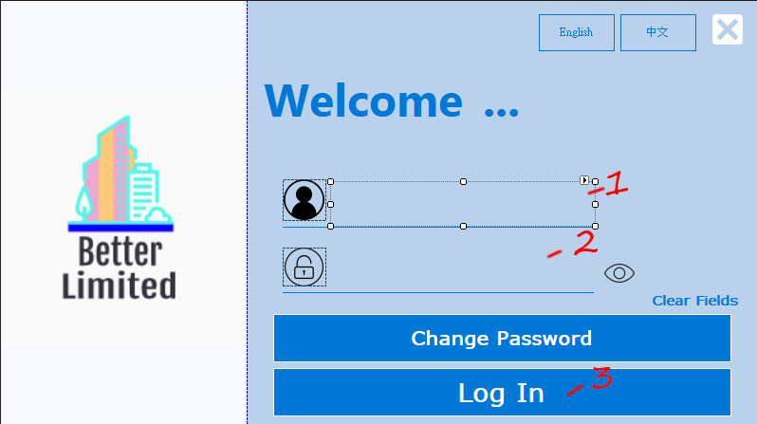

**Change system language**

**1. choose English or 中文, click it**

**2.Input user name**

**3.Input password**

**4.Click the Log In button**

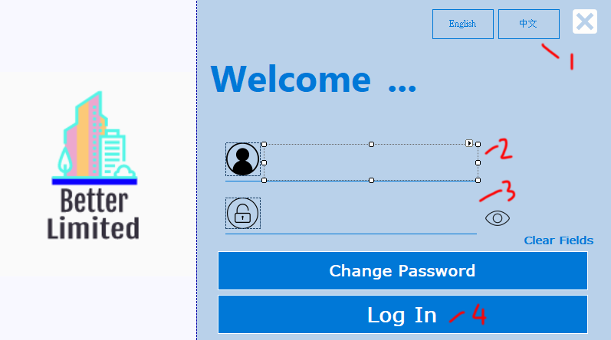

**Change password**

**1. Click the Change password button**

**2. Input user name**

**3. Input password**

**4. Input Security Answer**

**5.** **Input New Password**

**6. Input New Password again**

**7. Click the Change button**

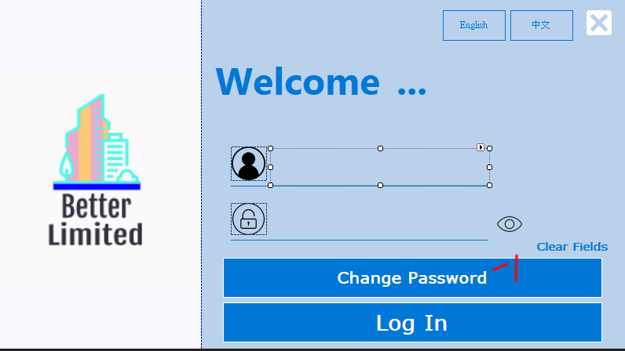

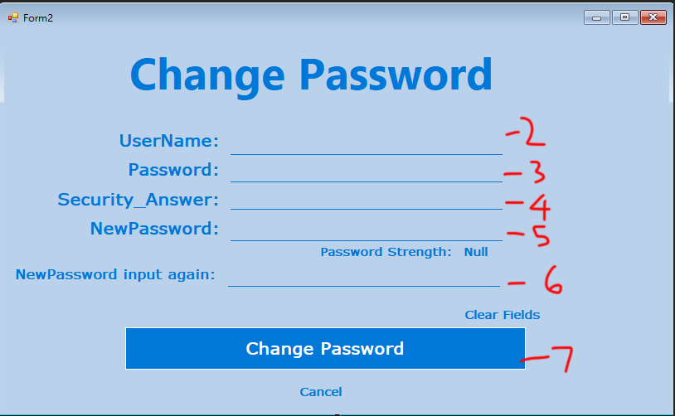

**2.Admin system**

**Create new staff account**

**1. Input staff ID**

**2. Input staff name**

**3.** **choose department**

**4. Input staff username**

**5. Input staff password**

**6. Input staff security answer**

**7. Click the Create button**

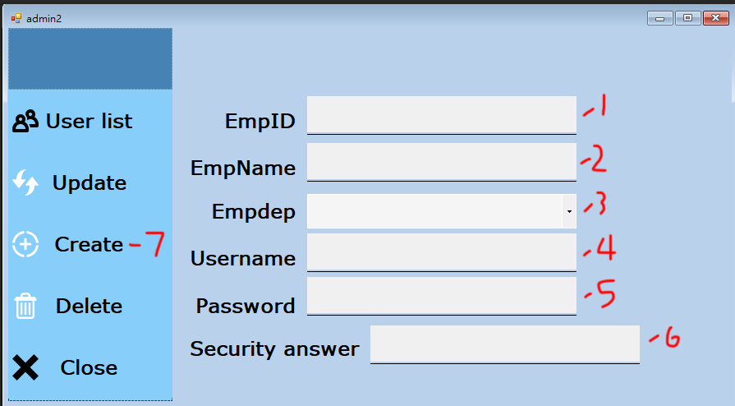

**Update new staff account**

**1. Input staff ID**

**2. Input staff username**

**3. Input staff name / Input new staff name**

**4.** **choose department / choose new department**

**5. Input staff password / Input new staff password**

**6. Input staff security answer / Input new staff security answer**

**7. Click the Update button**

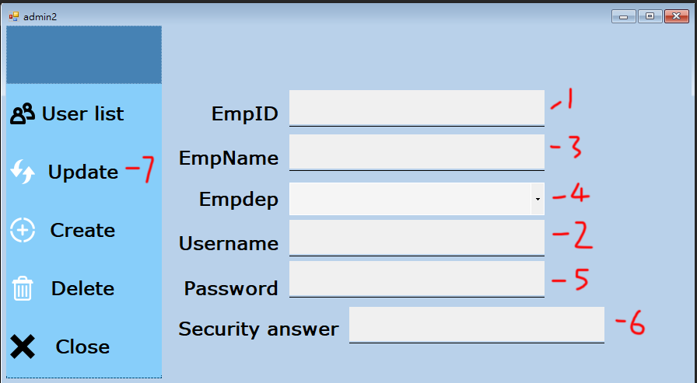

**Delete new staff account**

**1. Input staff ID**

**2. Input staff name**

**3.** **choose department**

**4. Input staff username**

**5. Input staff password**

**6. Input staff security answer**

**7. Click the Delete button**

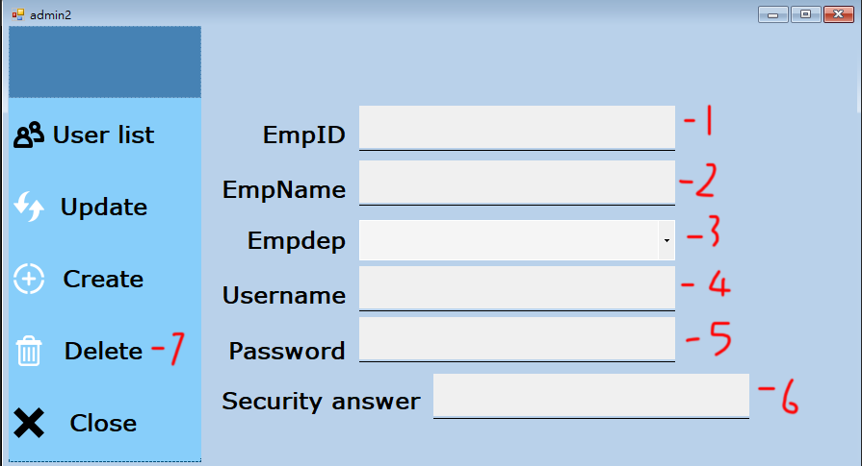

**Check the user list**

**1. Click the user list button**

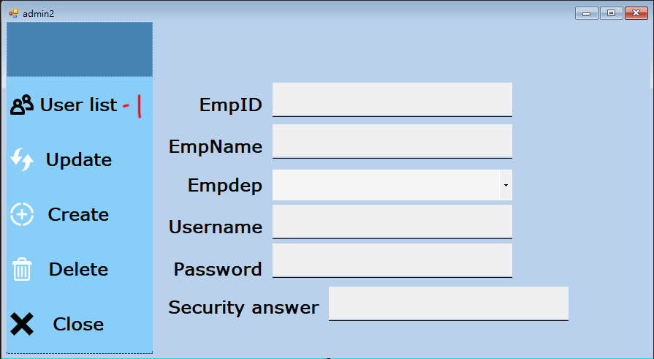

**3.Delivery Management System**

**3.1 Search Delivery order or installation order**

1. Enter Delivery order id or installation order id
2. Click **Track**

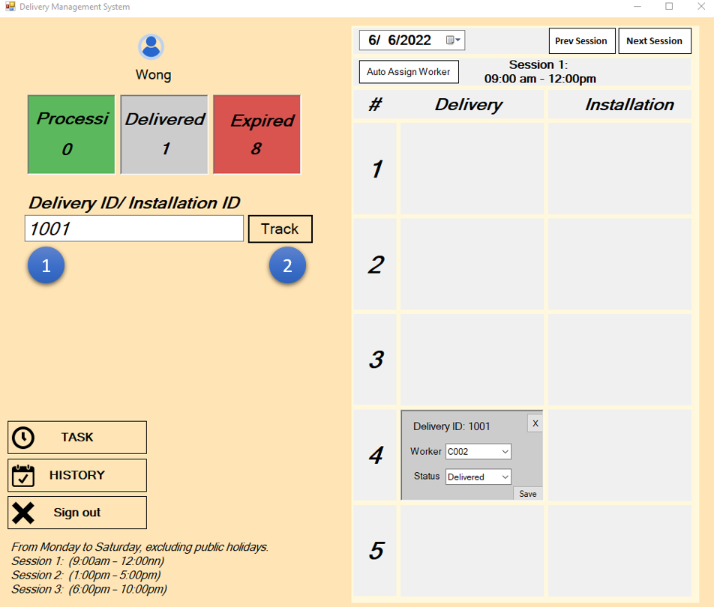

1. It will display **No Record Found** in the bottom of the input field when there are no existing record in database

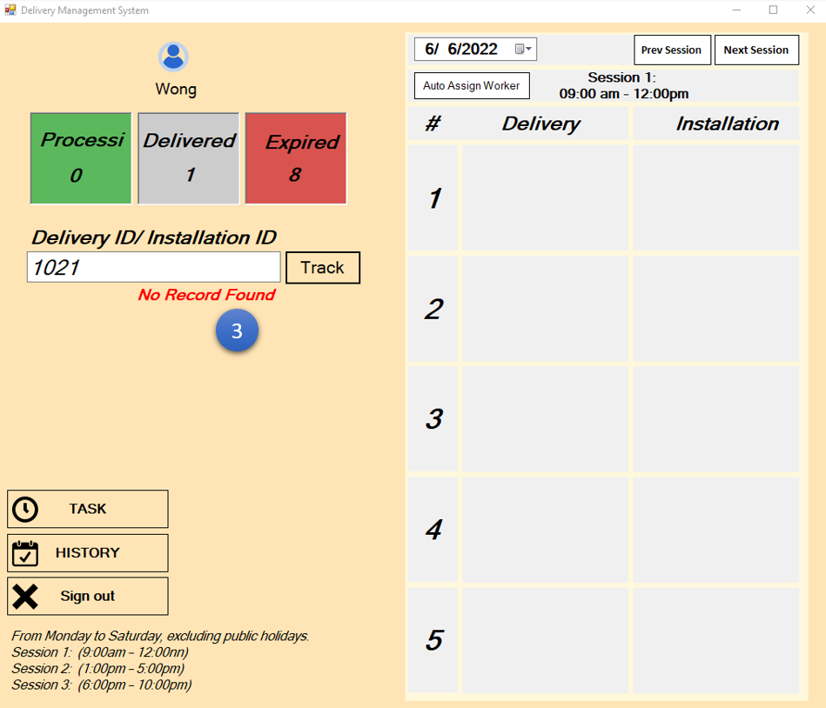

1. Delivery order will display on the left side of the time table and Installation orde will display on the right side of the time table

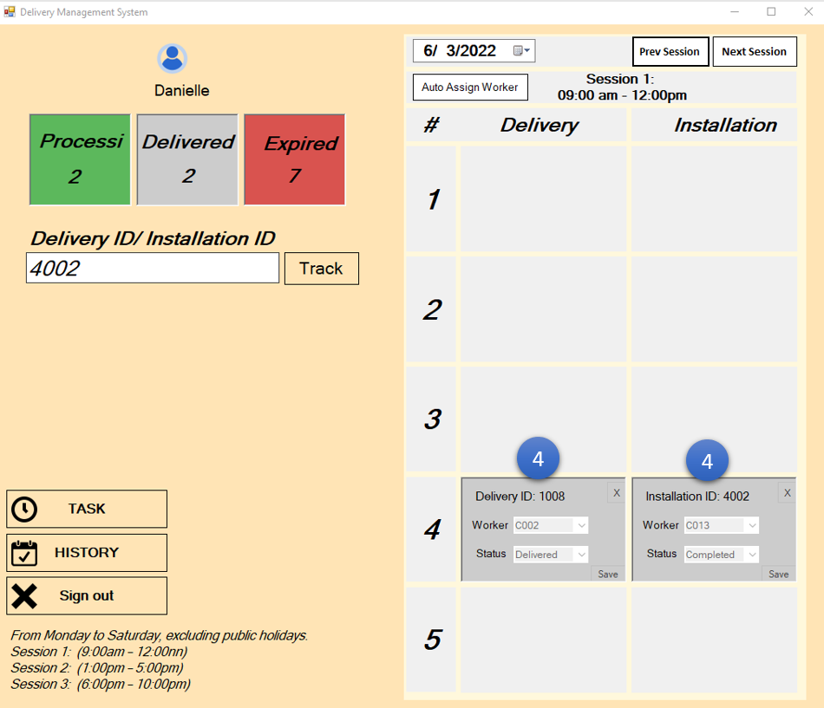

**3.2Using date time picker to searching Delivery order or installation order**

1. Click Datetime Picker for display date option on the top left side of the time table
2. Select the Date in Datetime Picker, Please notice that you cannot select non working days(Sunday)
3. Adjust the session by click the Prev session or Next Session button

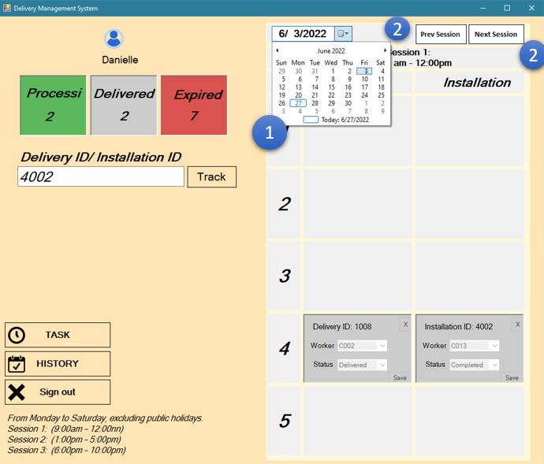

**3.3Assign Worker using Timetable, Function require Manager account**

1. Select existing delivery order or installation order in Timetable
2. Select an available worker id, the system will auto-display the correct response worker for the user to choose.
3. Click Save

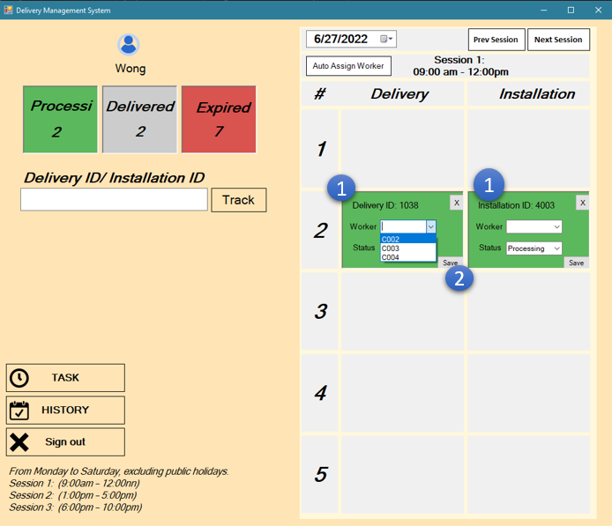

1. The System will display **Worker has been assign** if update success
2. Display **Worker assign fail** when update fail

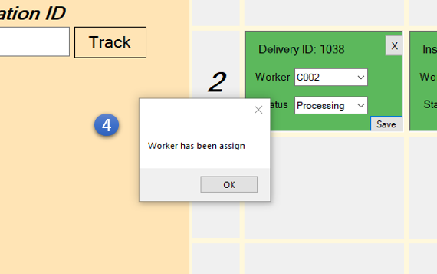

**3.4 Assign Worker using Automatic Assign Worker function on Timetable**

1. Click the **Auto Assign Worker** Button, the system will fill the empty Worker field for each order in your current selected date

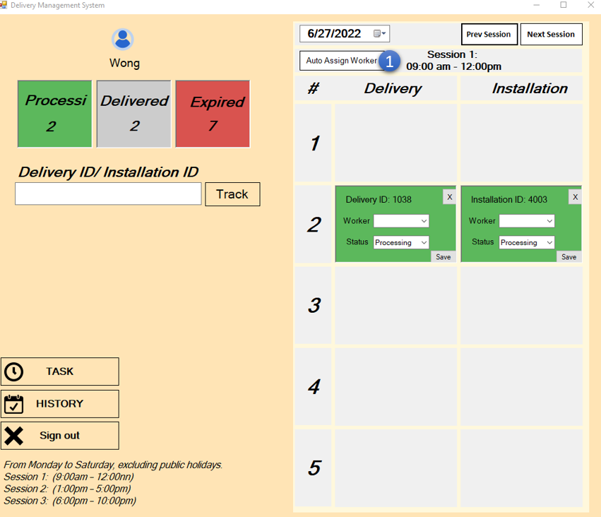

1. The system will assign worker for Delivery worker or installation worker base on role of the login user

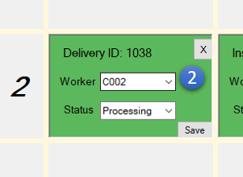

**3.5 Delete Delivery order or installation order using Timetable, Function require Manager account**

1. Select existing delivery order or installation order in Timetable
2. Select an existing order that the status are not completed or Delivered
3. Click the **X** button, and confirm the action

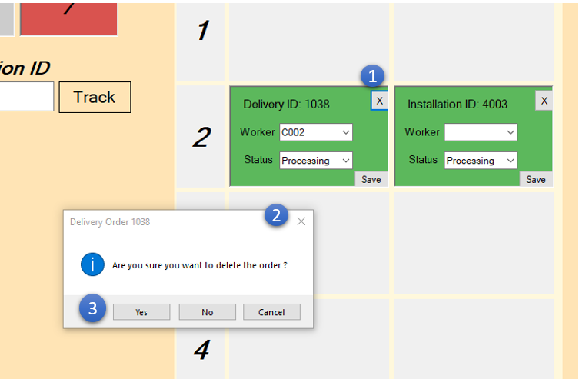

**3.6 Suspend Delivery order or Installation order using Timetable, require Manager account**

1. Select existing delivery order or installation order in Timetable

2. Update the status to Expired or Holding, the system will empty the worker field and disable any change unless the manager change the status back to Processing

3.Click Save

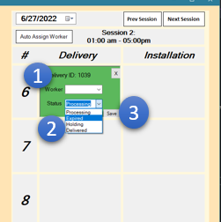 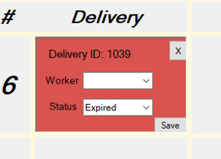

**3.7 Check Order Detail**

1. Click the existing delivery order or installation order in Timetable, the system will display order detail window

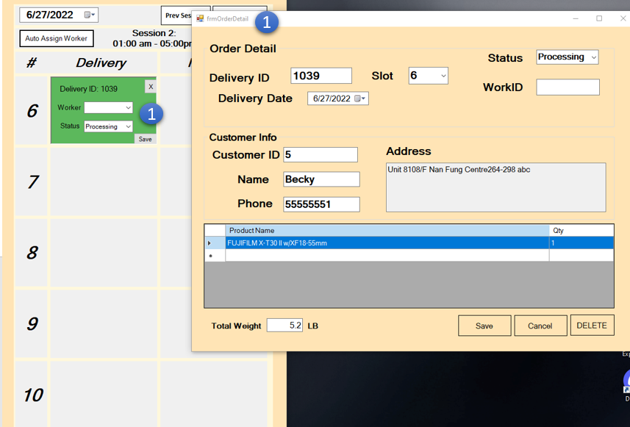

1. If the delivery order have installation need, the button Installation> will also appear on the Customer Info area

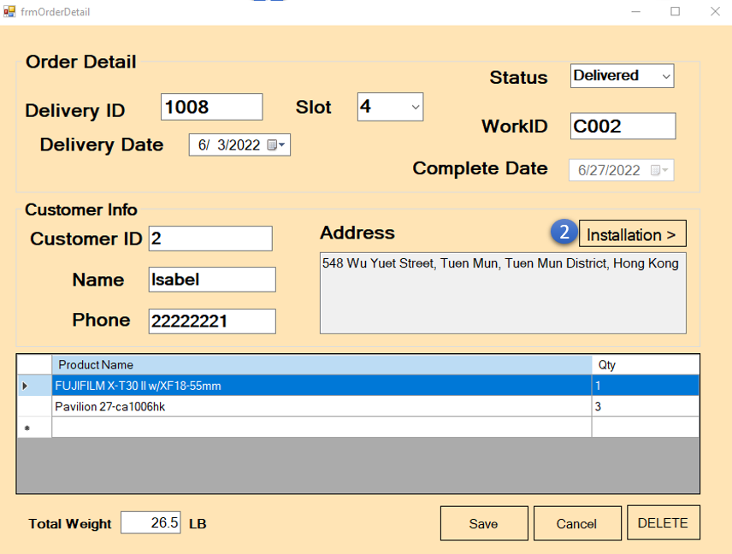

1. Installation order will also have a button call Delivery> for redirect to delivery order that it belongs

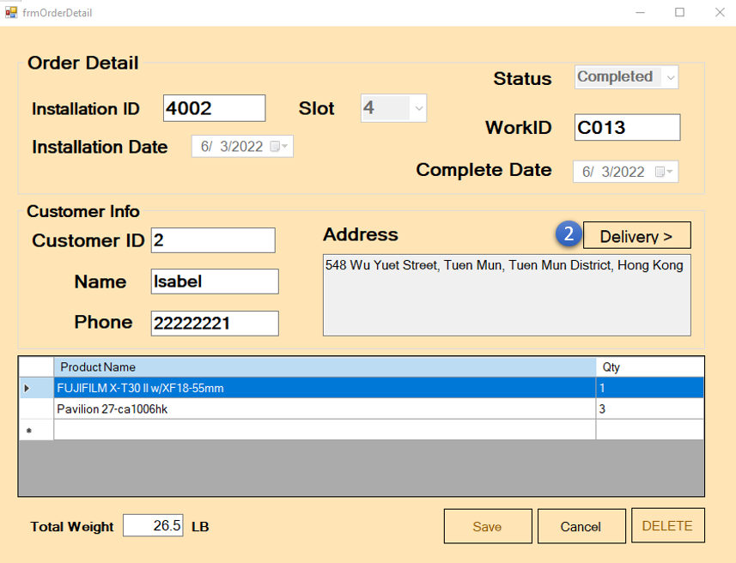

**3.8 Update Delivery order or installation order details using Order detail window, require Manager account**

1. Click the existing delivery order or installation order in Timetable, the system will display order detail window
2. User able to change the value of delivery date/installation date, time slot, status on the order detail window
3. Click the Save button when you finish,

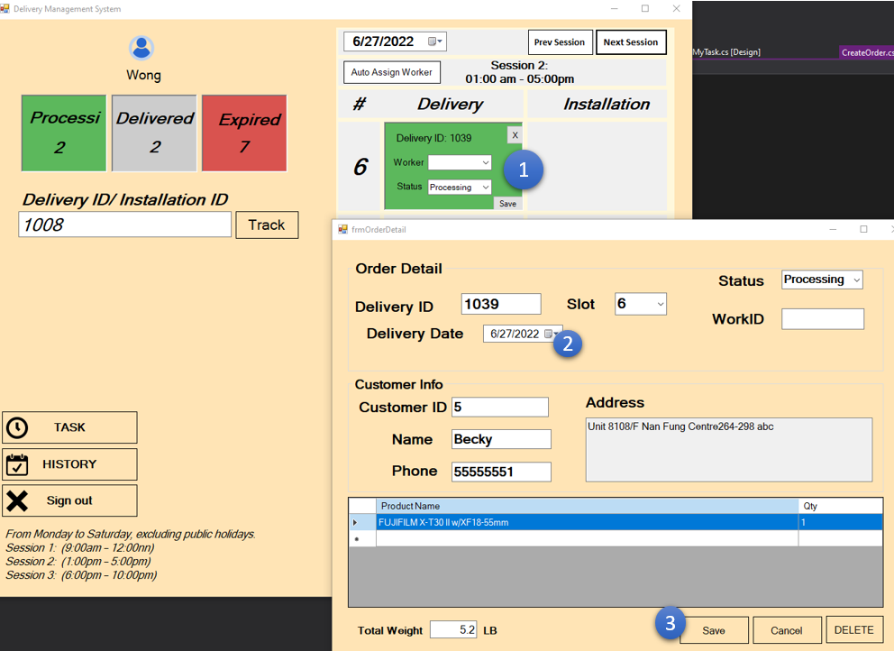

1. The system will display successful message if the update are vaild

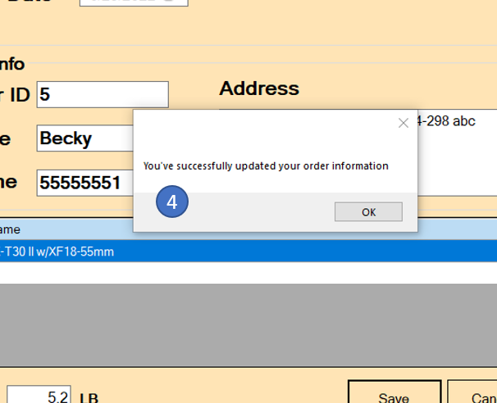

**3.9 Delete Delivery order or installation order details using Order detail window, require Manager account**

1. Click the existing delivery order or installation order in Timetable, the system will display order detail window

2. Click the **Delete** button on the bottom, make sure that the status of order are not completed or Delivered,

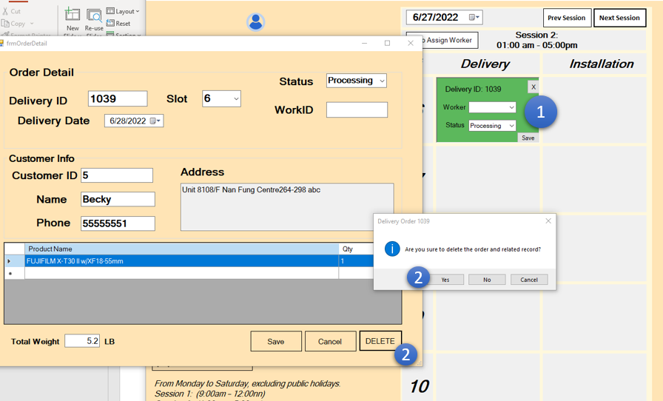

1. The system will delete the order if deletion are valid

**3.10 Suspend Delivery order or Installation order using Order Detail window, require Manager account**

1. Click the existing delivery order or installation order in Timetable, the system will display order detail window

2. Update the status to Expired or Holding, the system will empty the worker field and disable any change unless the manager change the status back to Processing

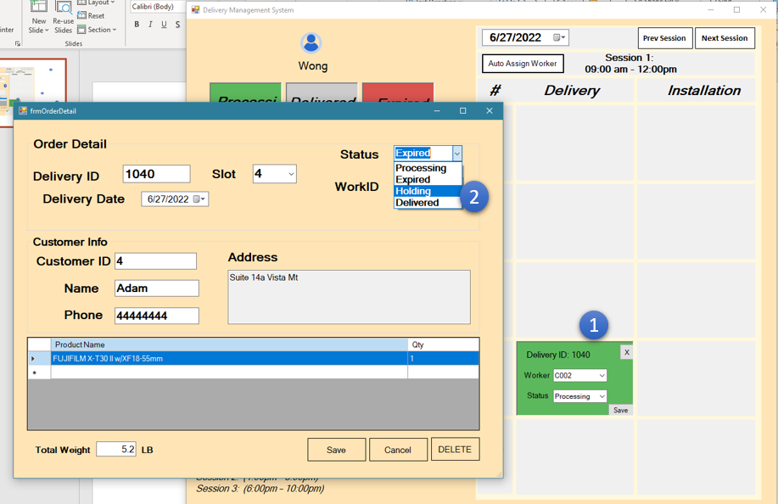

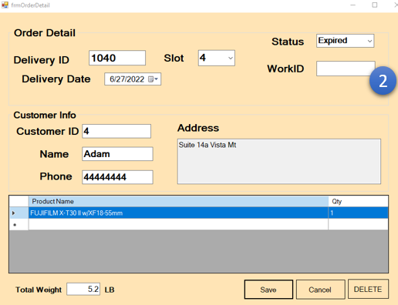

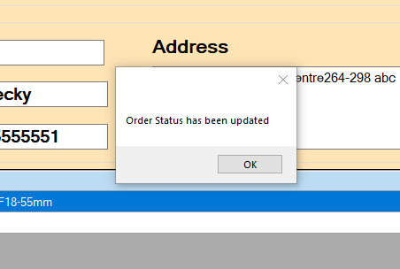

**3.11 Search for the Order history**

1. Click the **History** button in Delivery system front page, the system will display the History window

2. User can using filter to search for specify result, make the checkbox checked, the filter will be triggered

3. Click the Search button on the right side, the search result will be display.

4. Order detail window will be displayed if user click the record in the result field.

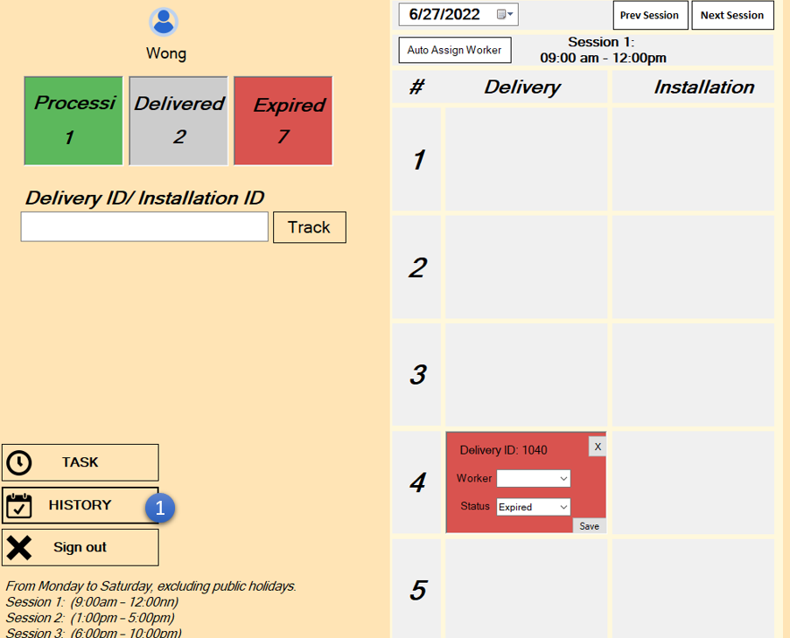

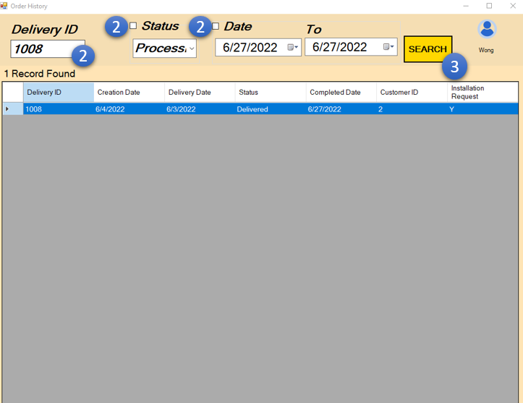

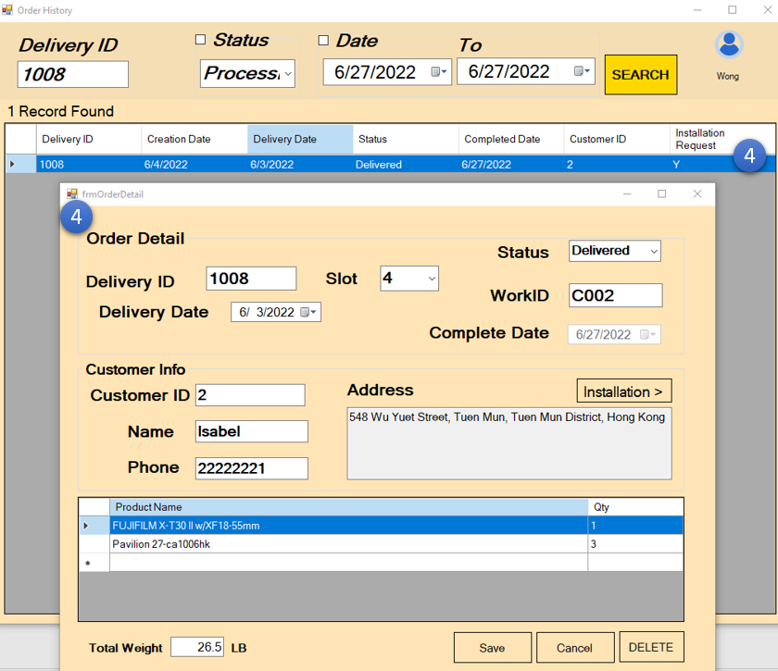

**3.12 Display Upcoming task for Delivery worker & technical support, require Worker or technical support account**

1. Click the **Task** button in Delivery system front page, the system will display the Worker Task Manager

2. Task will be appear into the **Upcoming delivery** or **Upcoming installation** field if the manager has assign the work for the worker and data are match

3. Workers click the **Complete** button and the status of the order will be updated to Completed or delivered.

4. Installation Order only appears if the delivery order has been completed.

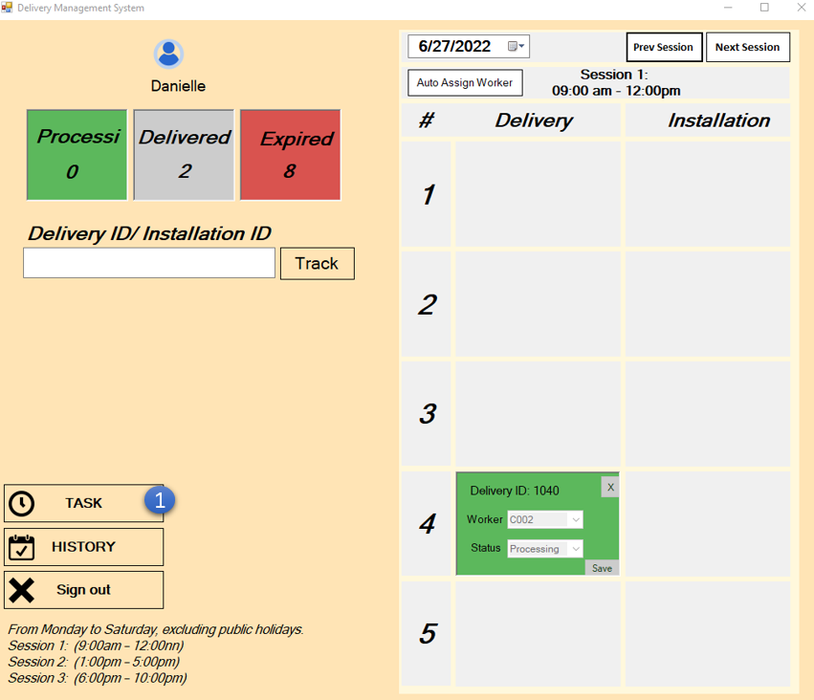

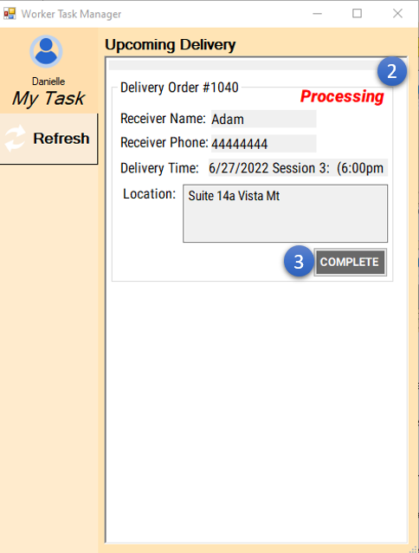 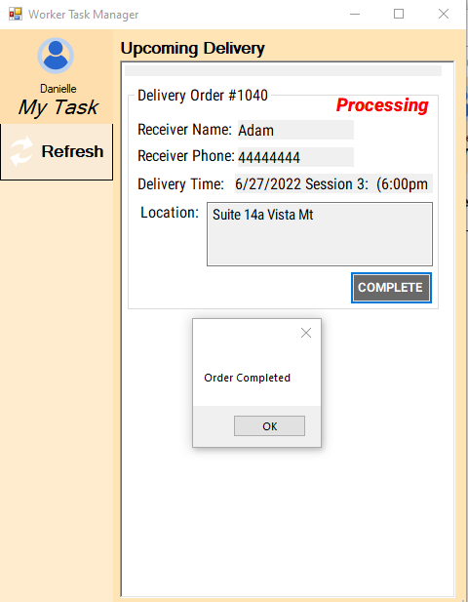

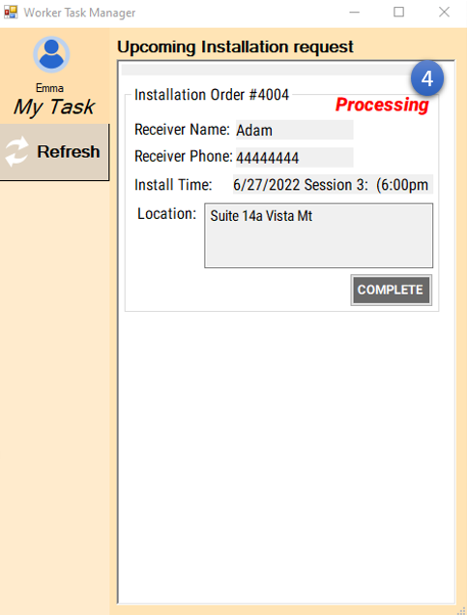

**3.13 Auto update the overduce order to expired**

1. The system will check if the overduce order existing and update the status of the overduce order to **Expired** when system startup

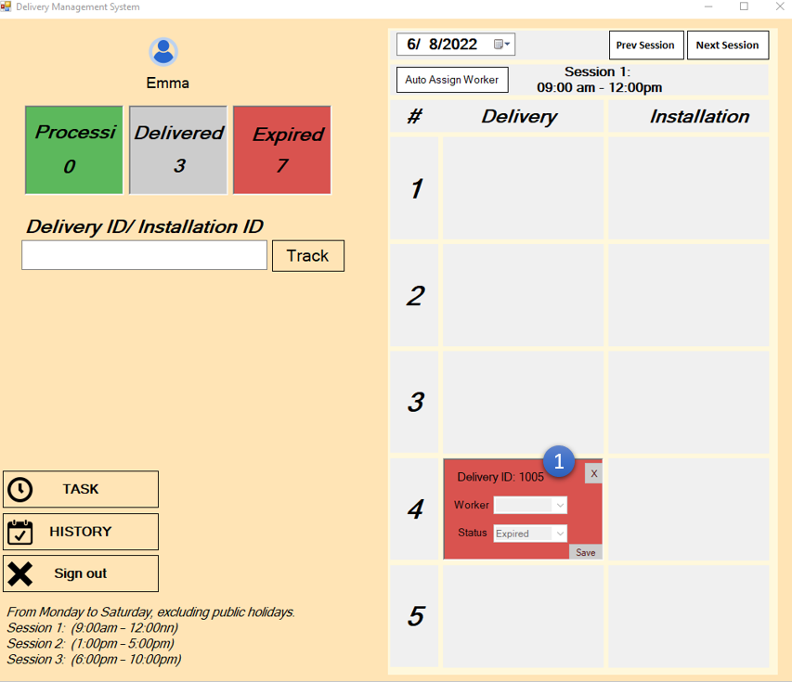

**4.Sales Department System**

**Create New Order (Payment Order)**

1. **Click “Create” Button to next picture**
2. **Input Order ID**
3. **Select items that have stock**
4. **Input quantity**
5. **Select Payment Method**
6. **Select Store Region**
7. **Click “Calculate” Button**
8. **Click “Finish” Button**

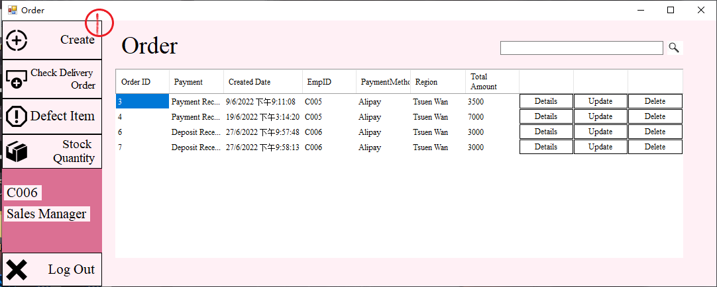

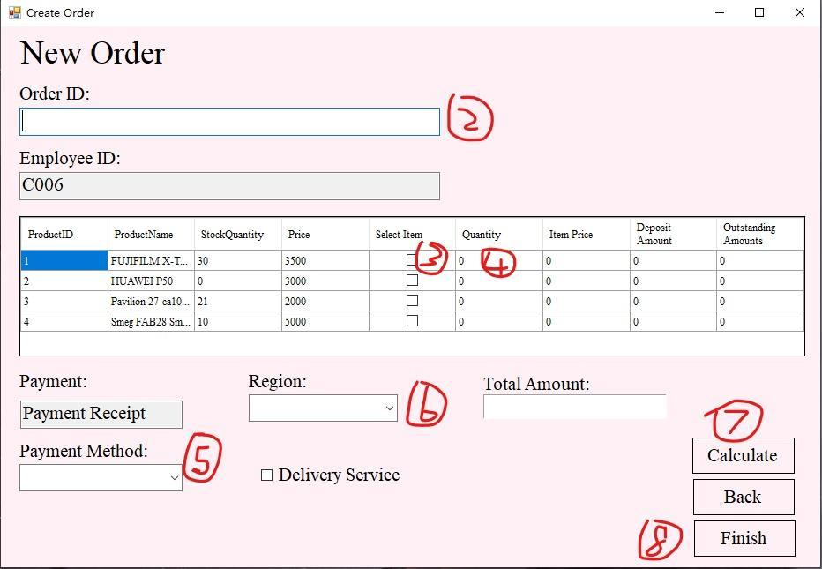

**Create New Order (Deposit Order)**

1. **Click “Create” Button to next picture**
2. **Input Order ID**
3. **Select items that have no stock**
4. **Input quantity**
5. **Select Payment Method**
6. **Select Store Region**
7. **Click “Calculate” Button**
8. **Input Customer ID**
9. **If no customer ID, click “Create New Customer” Button go to customer page**
10. **Input customer information**
11. **Click “Add Customer” Button**
12. **Click “Finish” Button**



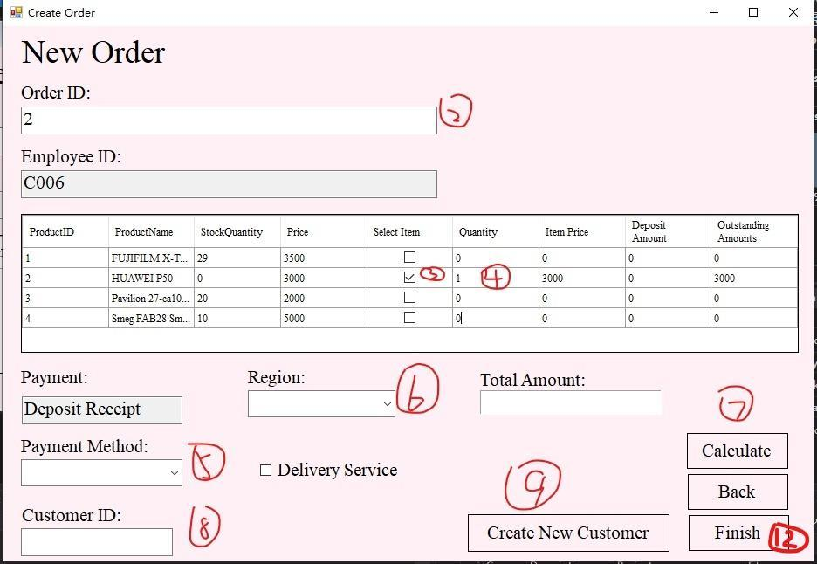

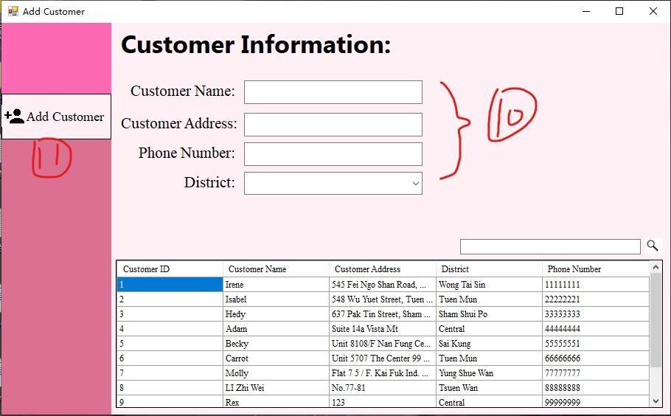

**Create Delivery Order**

1. **Select Delivery Service in creating sales order or click “Create” Button in check delivery order page.**
2. **Click “Finish” Button**
3. **Select Expected Delivery Date**
4. **Select Timeslot**
5. **Input Customer ID**
6. **Select Installation Service if need installation service**
7. **Click “Go to select item” Button. If timeslot is full, alert information, repeat step4**
8. **Select need delivery item**
9. **Input quantity**
10. **Click “Finish” Button**

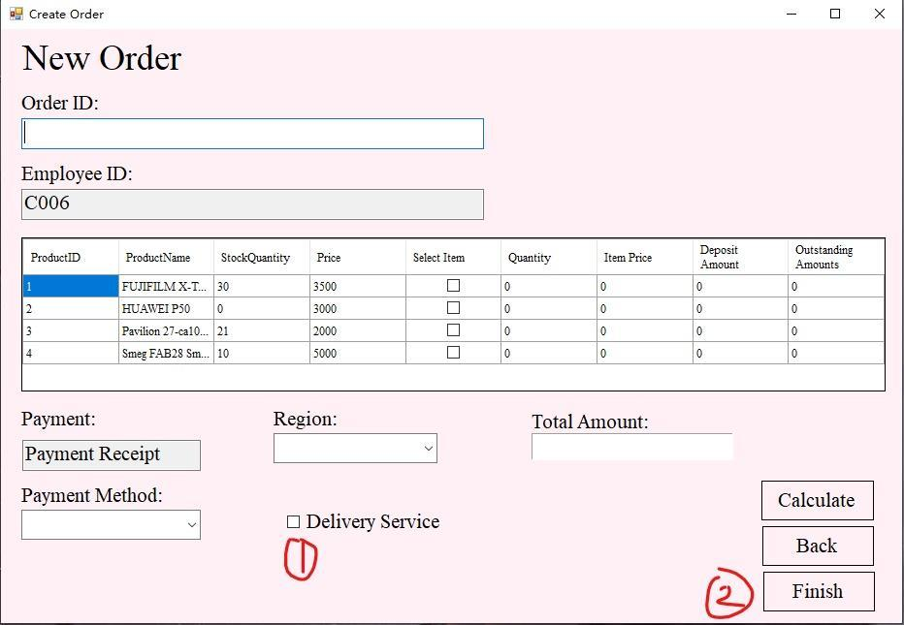

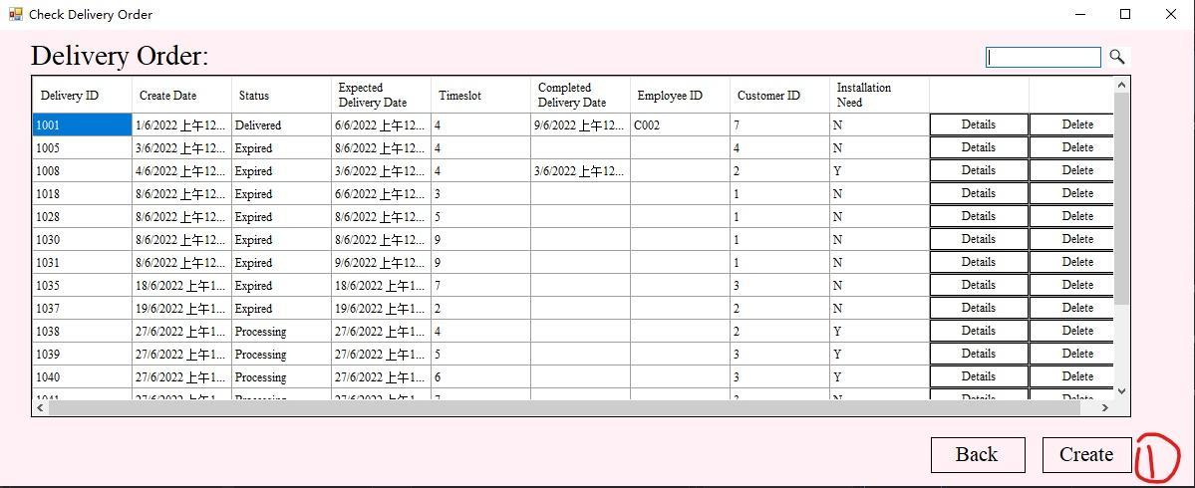

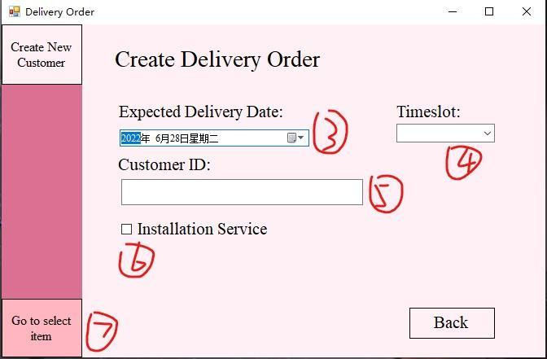

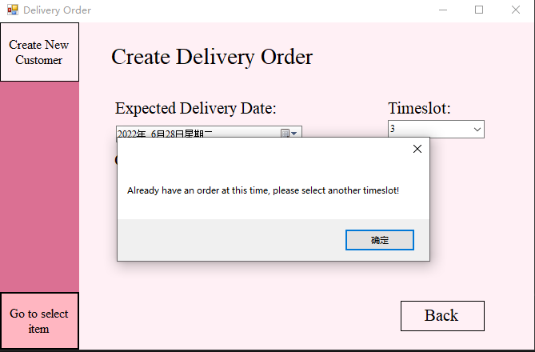

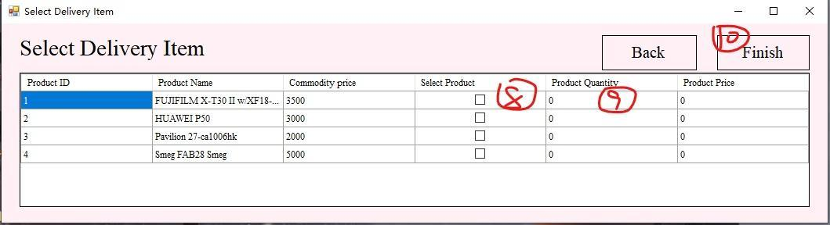

**Edit Order (Payment Order)**

1. **Click “Update” Button in want to edit order**
2. **Edit information that are wanting to modify**
3. **Click “Calculate” Button**
4. **Click “Finish” Button**

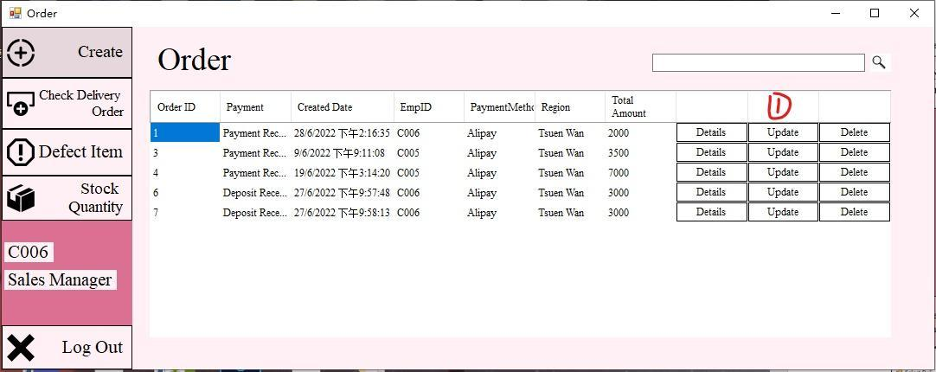

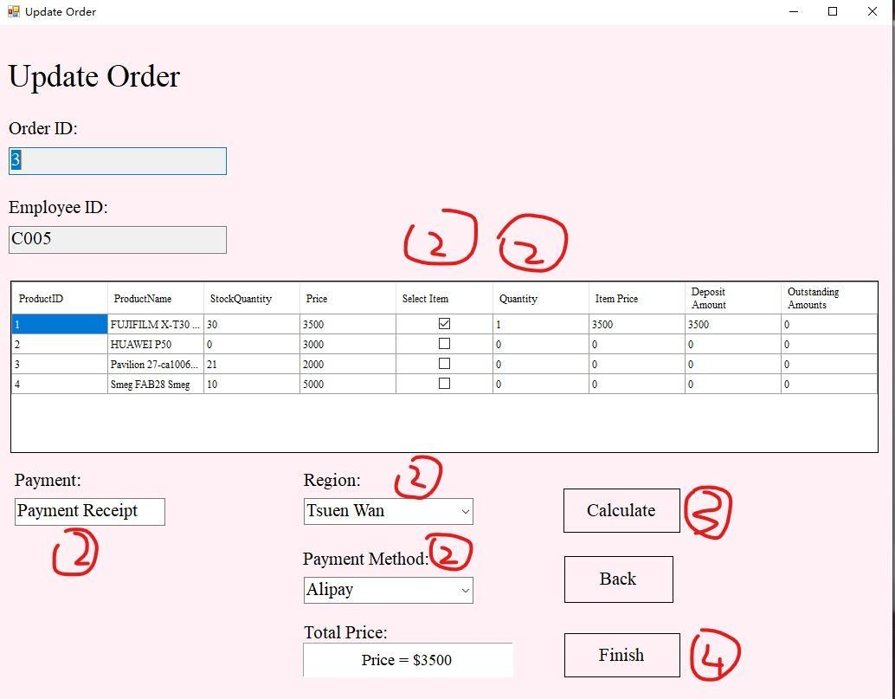

**Edit Order (Deposit Order)**

1. **Click “Update” Button in want to edit order**
2. **Edit information that are wanting to modify**
3. **Click “Calculate” Button**
4. **Click “Finish” Button**



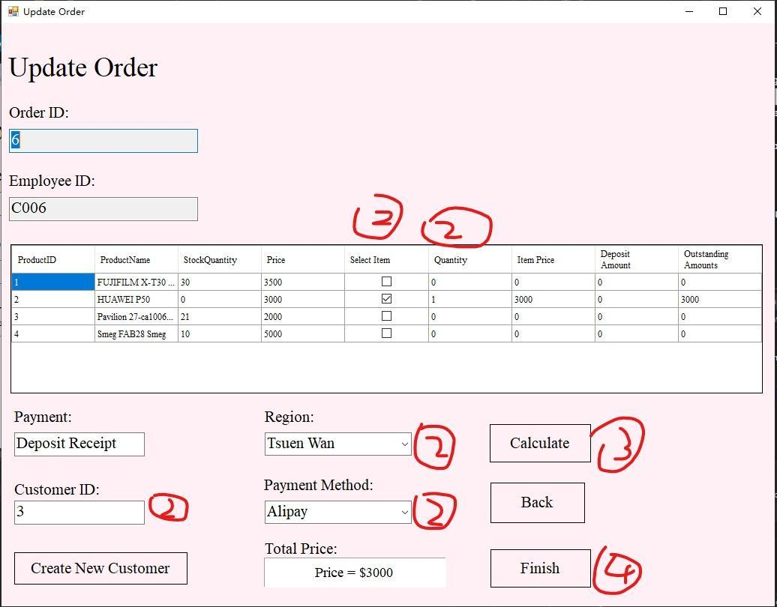

**Check Details (Payment Order)**

1. **Click “Details” Button in want to check**

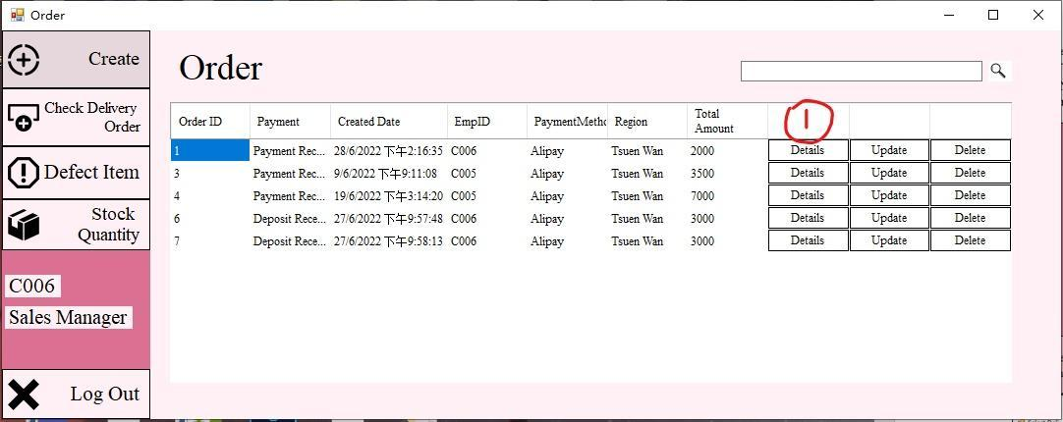



**Check Details (Deposit Order)**

**1. Click “Details” Button in want to check**





**Print Receipt (Payment Order)**

1. **Click “Details” Button in want to check**
2. **Click “Generate Receipt” Button**
3. **Click “Print”**



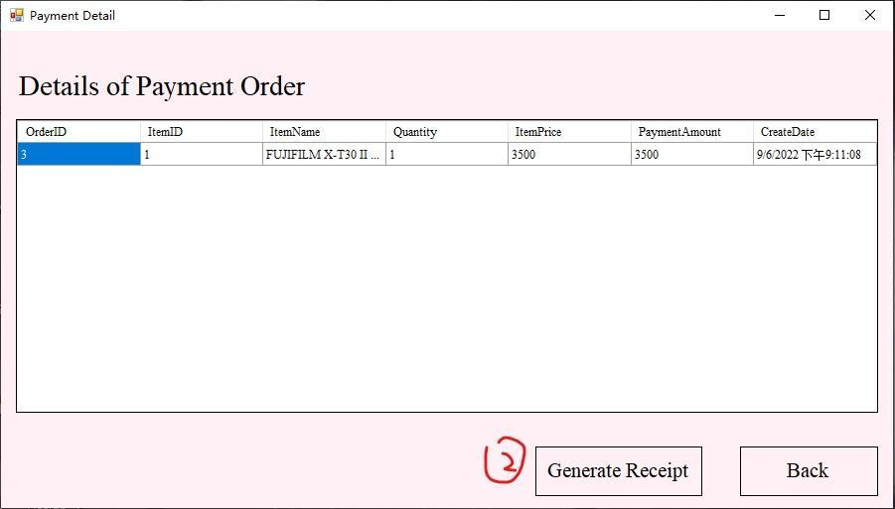

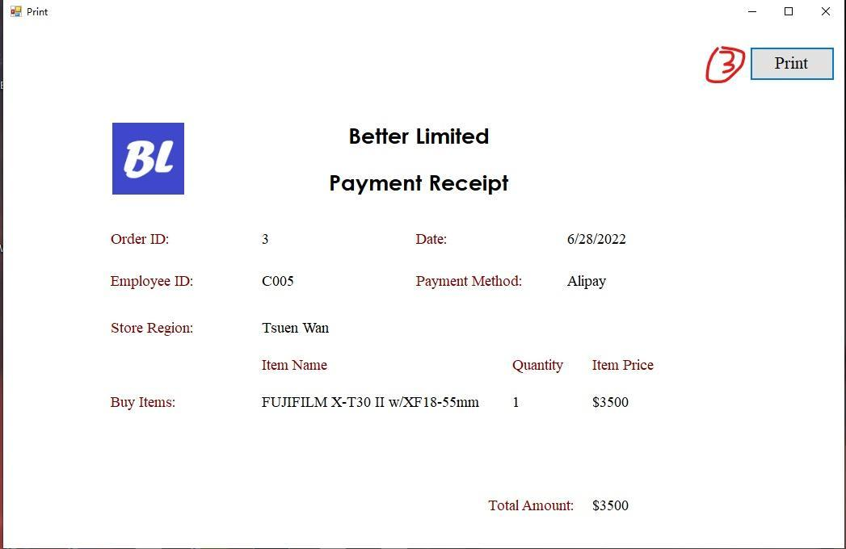

**Delete Sales Order**

1. **Click “Delete” Button in want to delete order**
2. **Click “是(Y)” Button to confirm delete**

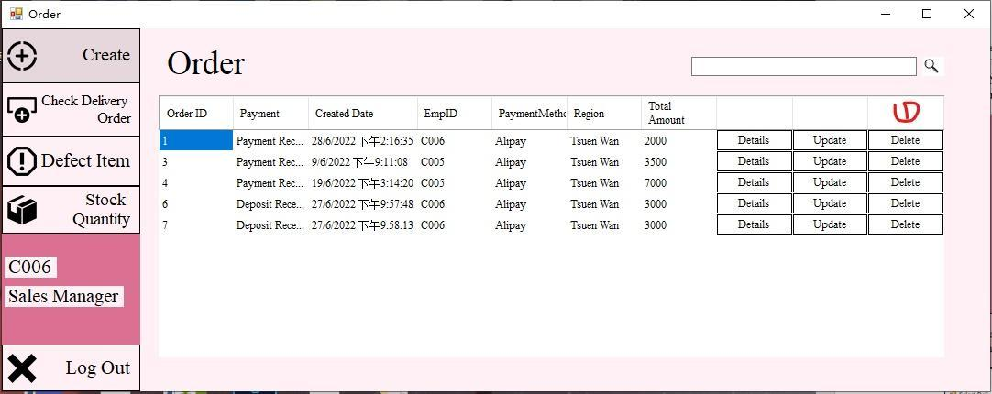

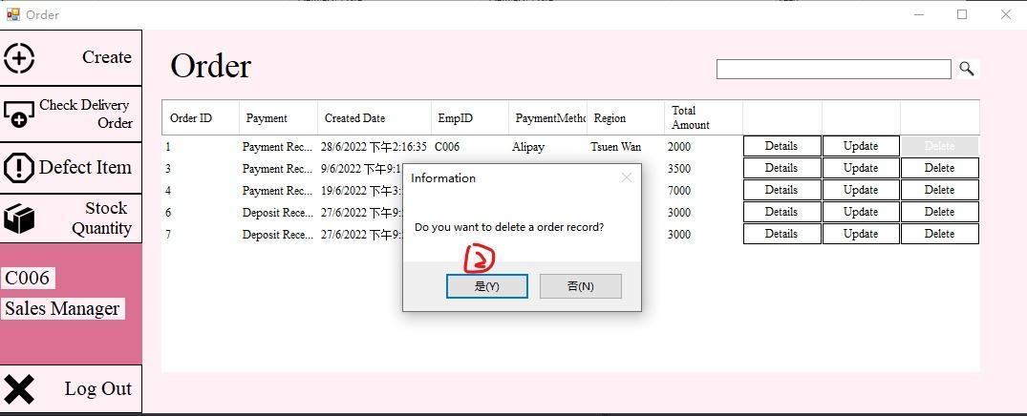

**Search Sales Order**

1. **Input order ID in search box**

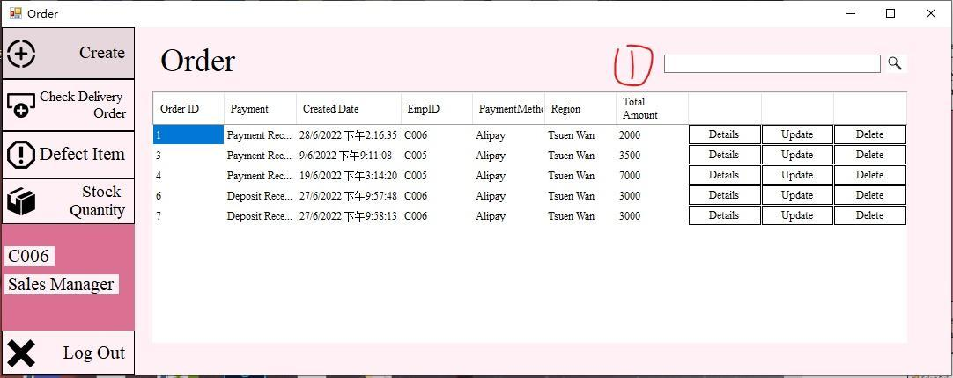

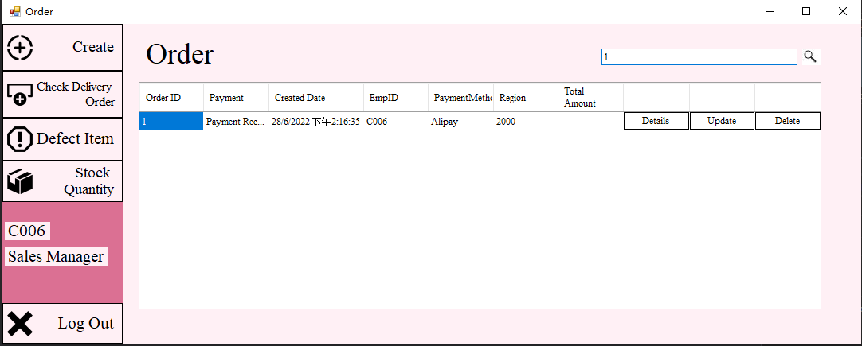

**Check Delivery Order**

1. **Click “Check Delivery Order”**

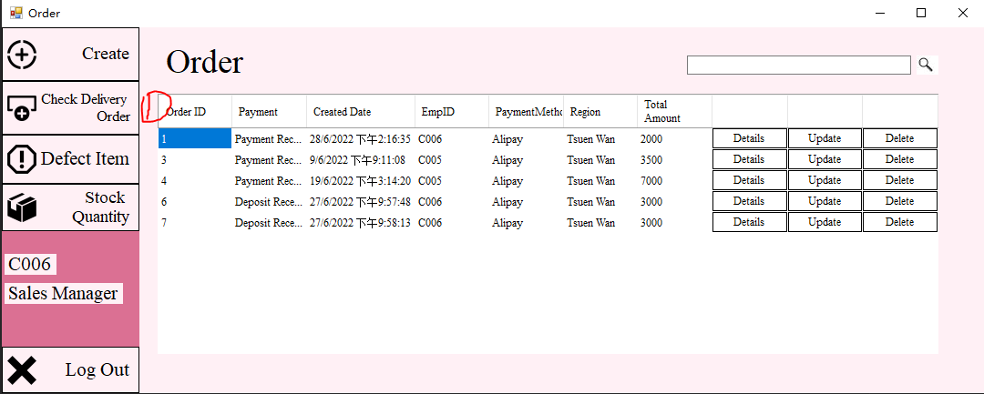



**Check Delivery Order Details**

1. **Click “Check Delivery Order”**
2. **Click “Details” Button in want to check delivery order**



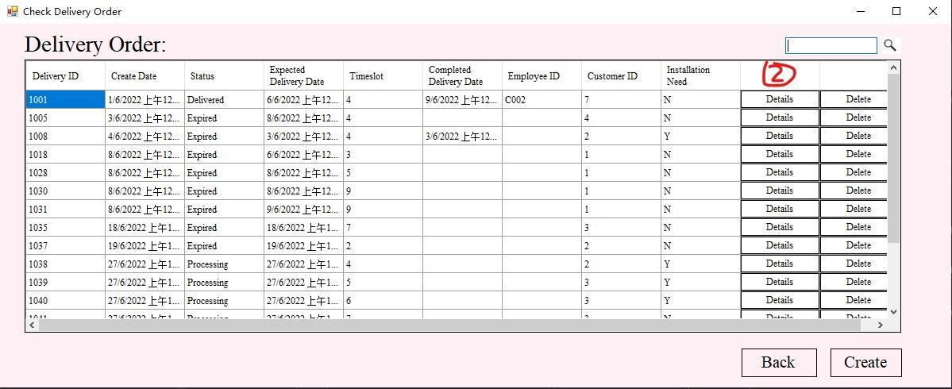



**Delete Delivery Order**

1. **Click “Check Delivery Order” Button**
2. **Click “Delete” Button in want to delete order**
3. **Click “是(Y)” Button to delete order**



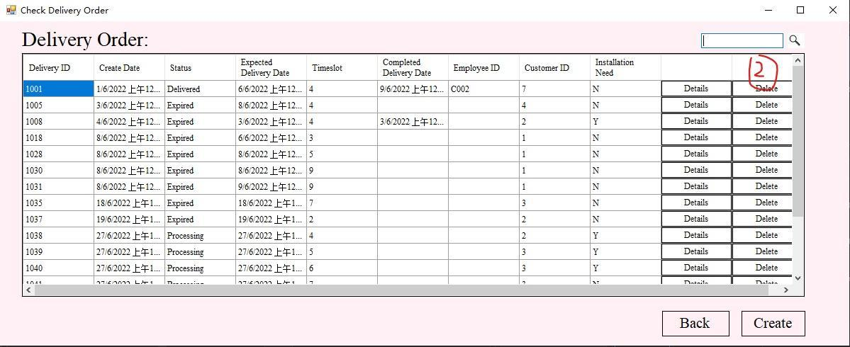



**Search Delivery Order**

1. **Click “Check Delivery Order” Button**
2. **Input delivery Order ID in search box**



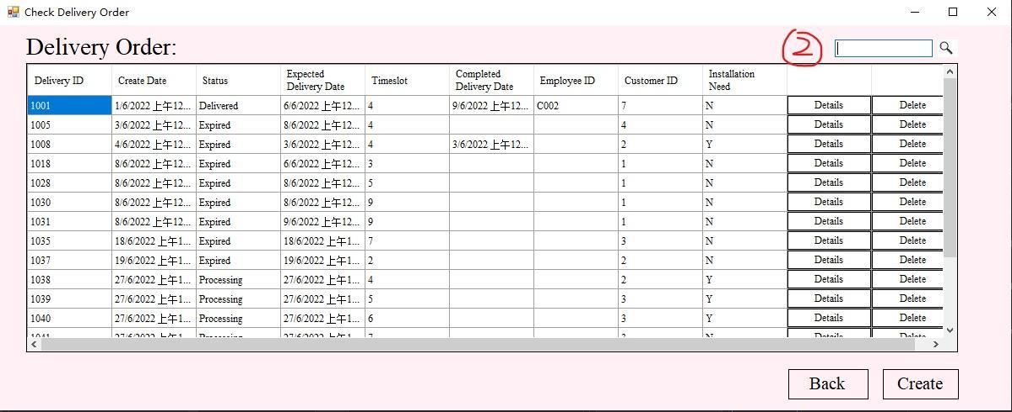

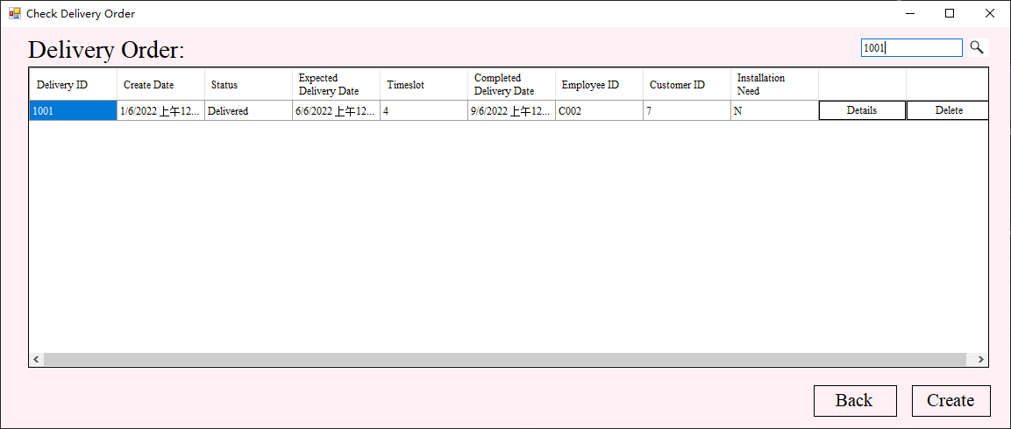

**Create Defect Item Order**

1. **Click “Defect Item” Button**
2. **Click “Create” Button**
3. **Select Item**
4. **Input Quantity**
5. **If defect item is not in store now, click old product**
6. **Input old product name**
7. **Input old product return price**
8. **Input old product quantity**
9. **Click “Finish” Button**

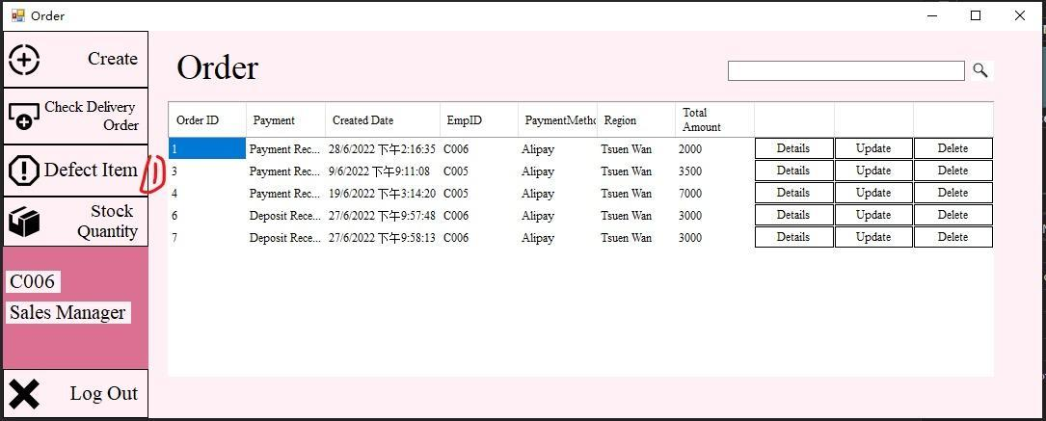

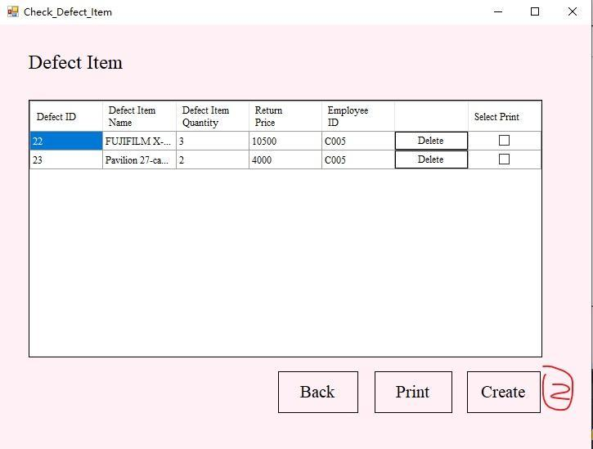

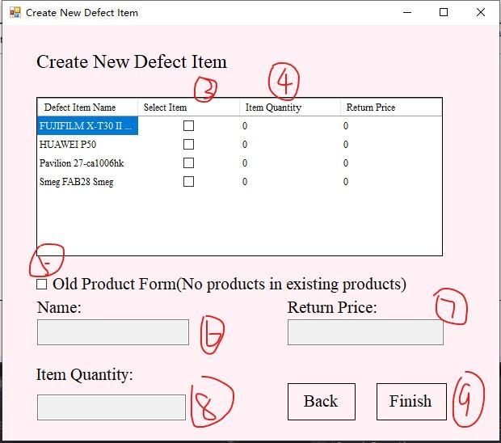

**Print Return Receipt**

1. **Click “Defect Item” Button**
2. **Select print item**
3. **Click “Print” Button**
4. **Click “Print” Button**



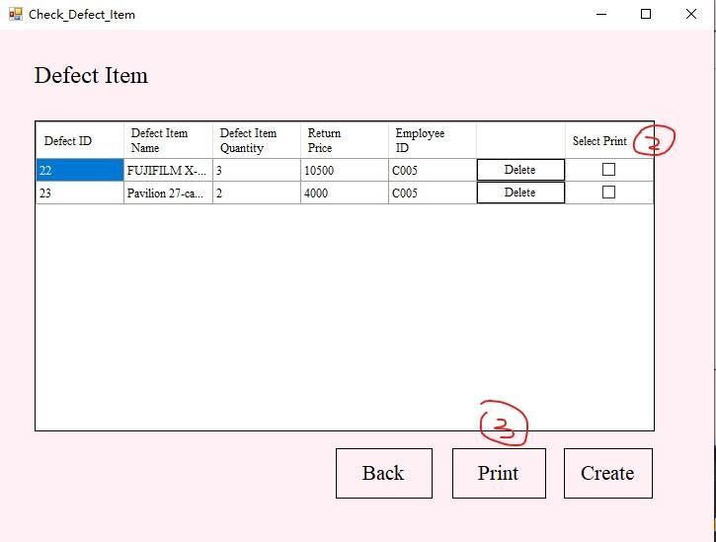

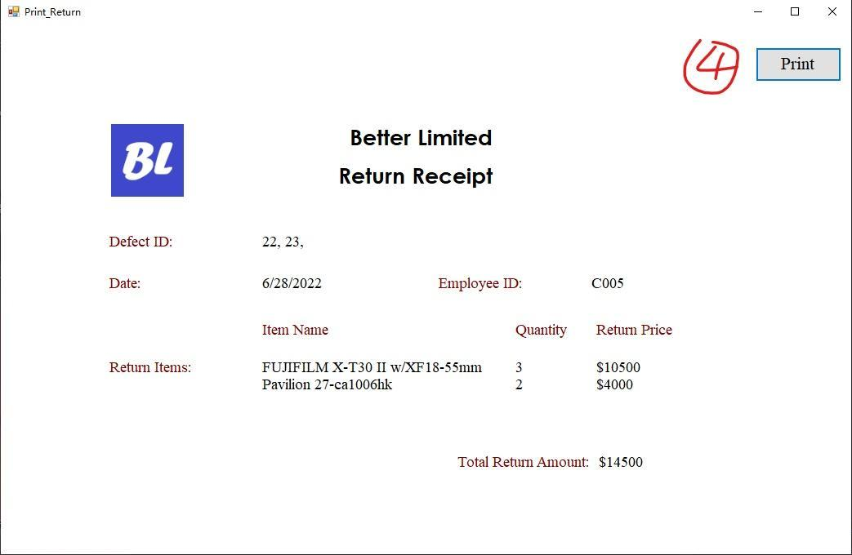

**Delete Defect Item**

1. **Click “Defect Item” Button**
2. **Click “Delete” Button in want to delete item**
3. **Click “是(Y)” Button to confirm delete**



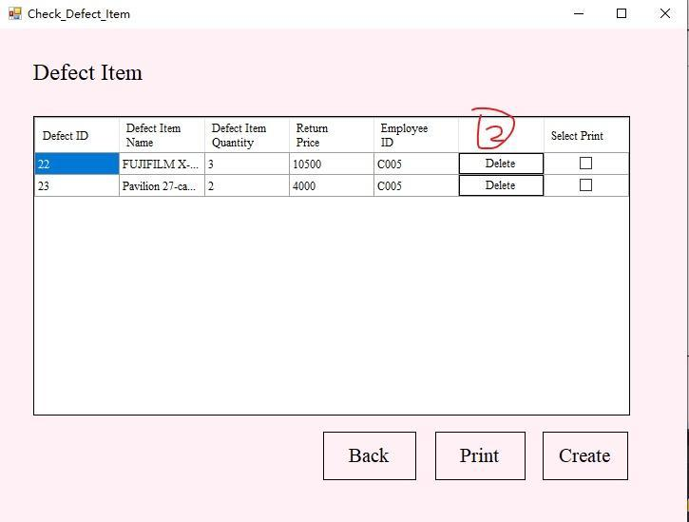

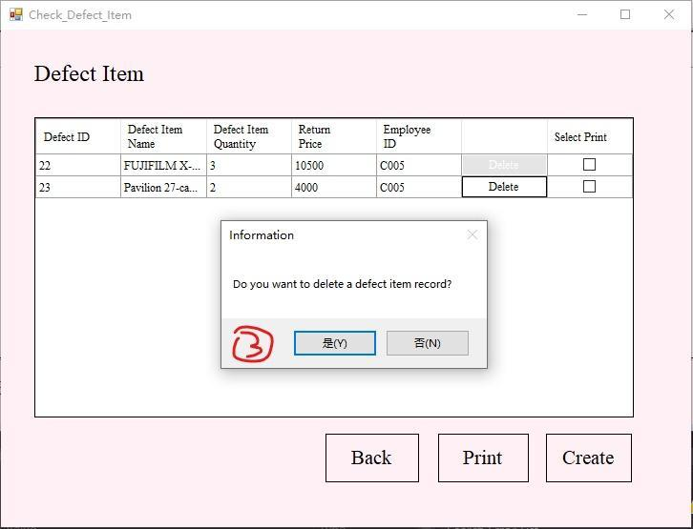

**Check Stock Quantity**

1. **Click “Stock Quantity” Button**
2. **Click “確定” in Alert information if stock have low level of items**

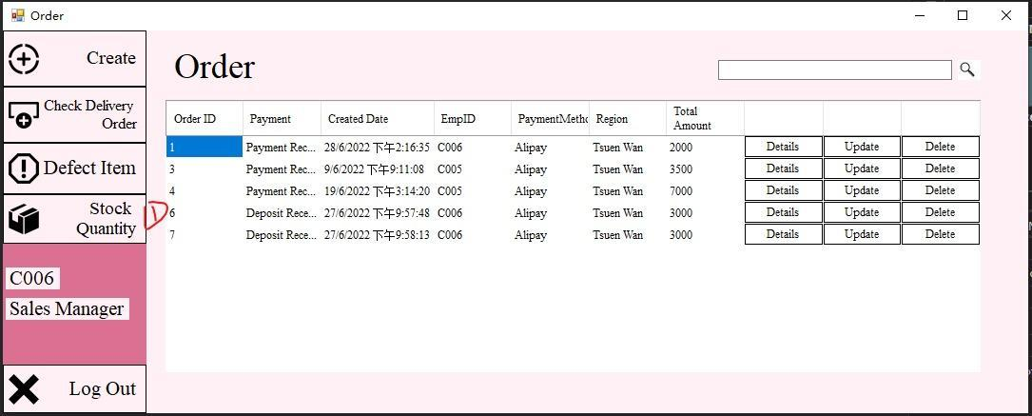

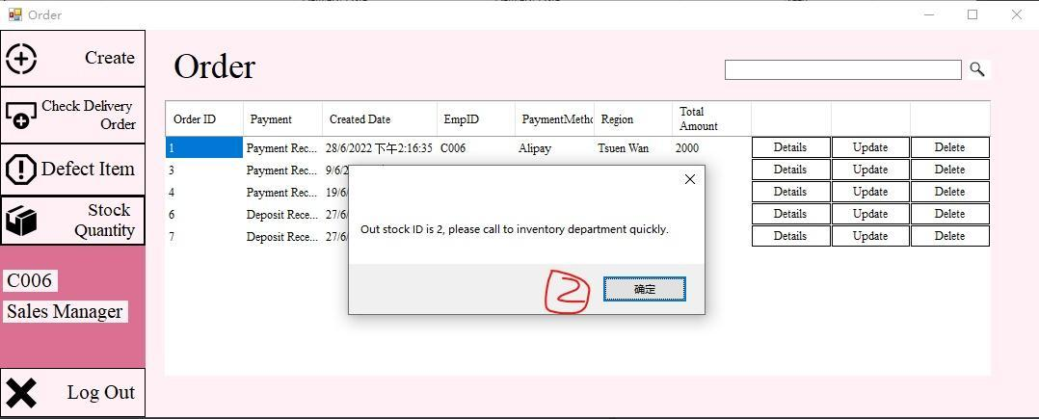



**Stock Permission Setting**

**If employee is staff, he don’t have permission to edit, delete and create stock item**

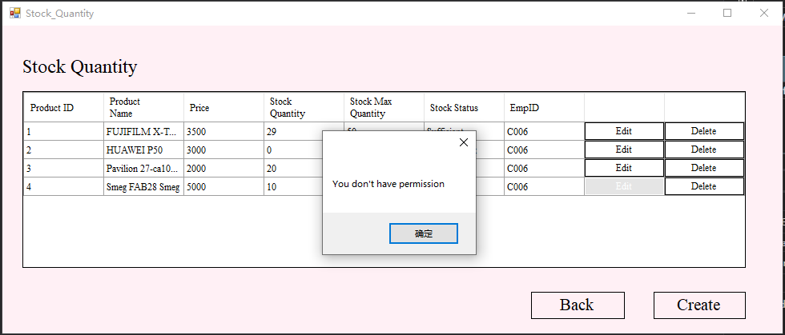

**Create New Stock Item**

1. **Click “Stock Quantity” Button**
2. **Click “確定” in Alert information if stock have low level of items**
3. **Click “Create” Button**
4. **Input Product Name**
5. **Input product quantity**
6. **Input Max stock quantity**
7. **Input product weight**
8. **Input product brand**
9. **Input product type**
10. **Input product price**
11. **Click “Finish” Button**





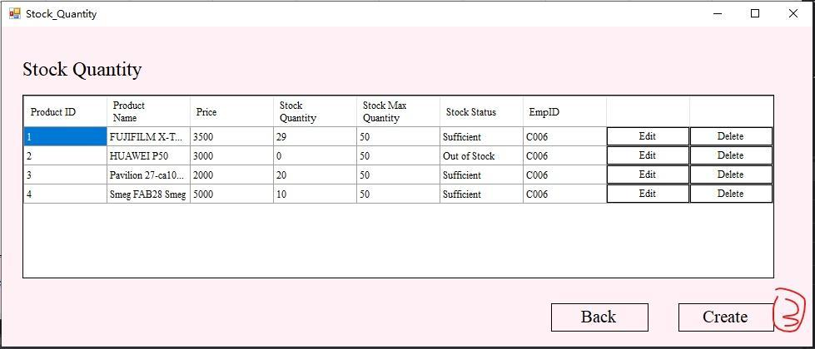

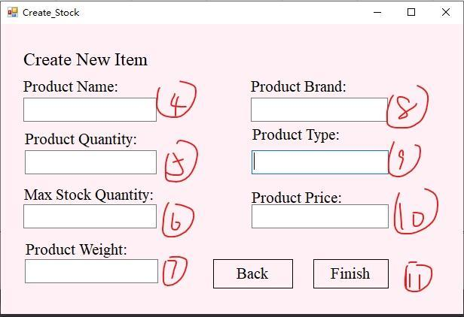

**Delete Stock Item**

1. **Click “Stock Quantity” Button**
2. **Click “確定” in Alert information if stock have low level of items**
3. **Click “Delete” Button in want to delete**
4. **Click “是(Y)” Button to confirm delete**





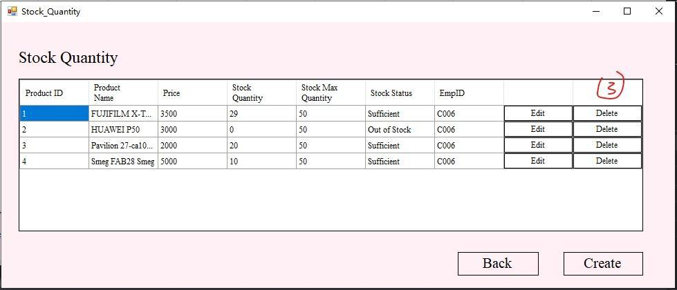

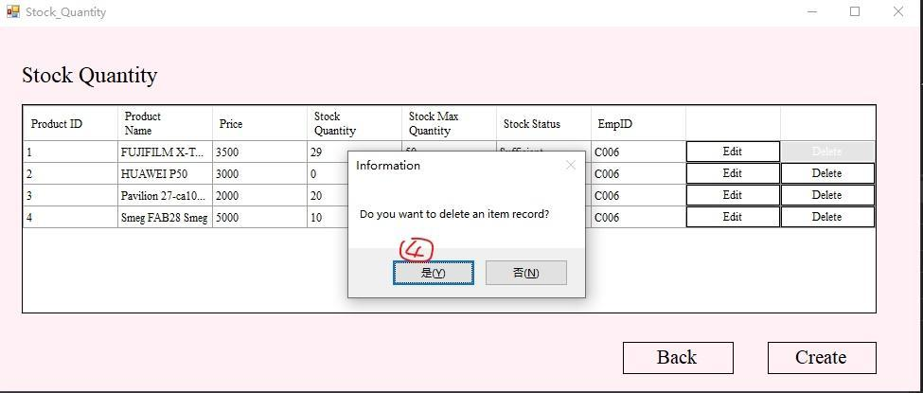

**Edit Stock Quantity**

1. **Click “Stock Quantity” Button**
2. **Click “確定” in Alert information if stock have low level of items**
3. **Click “Edit” in want to edit item**
4. **Edit information that are wanting to modify**
5. **Click “Finish” Button**





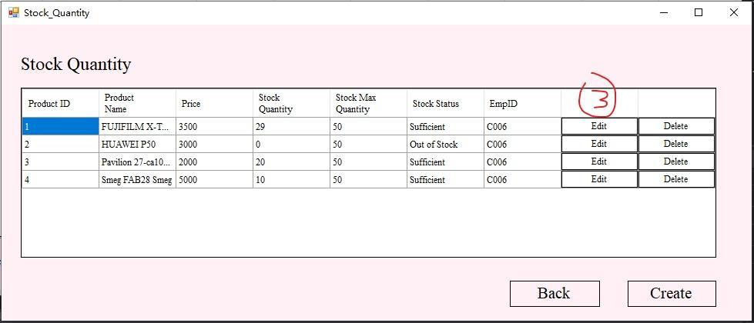

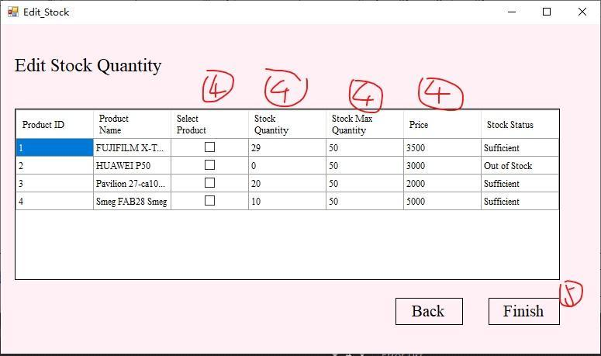

5.Inventory Management System

**Add items**

**1. Select the Add items menu.**

**2. Full in item information (You can click the cell in the grid view to fill in the form quicker.)**

**3. Select the “Add Item” button.**

**4. After submitted the form, the system will show the successful message.**

**5. Now, the form is showed on the table.**

1. Select the Add items menu.

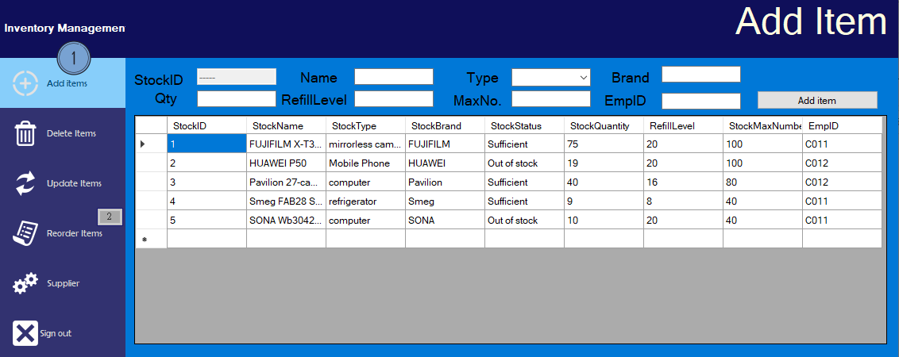

1. Full in item information (You can click the cell in the grid view to fill in the form quicker.)

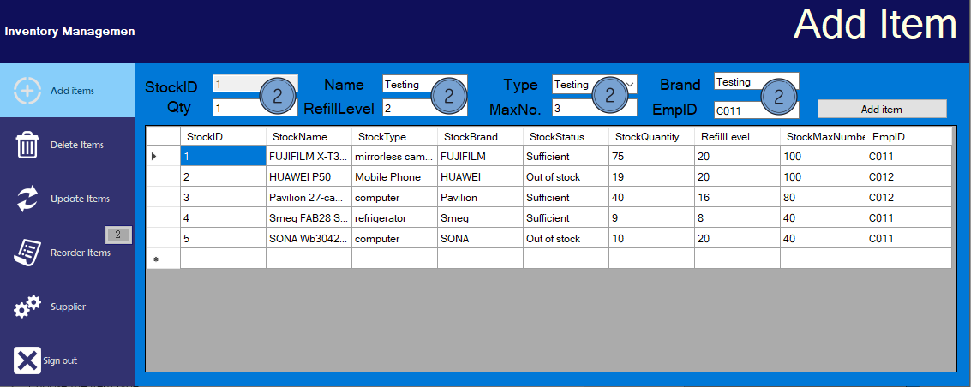

1. Select the “Add Item” button.

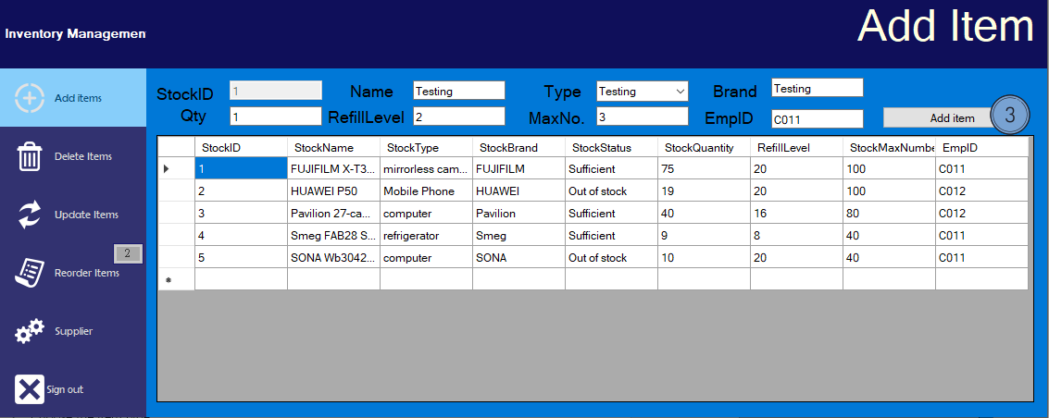

1. After submitted the form, the system will show the successful message.

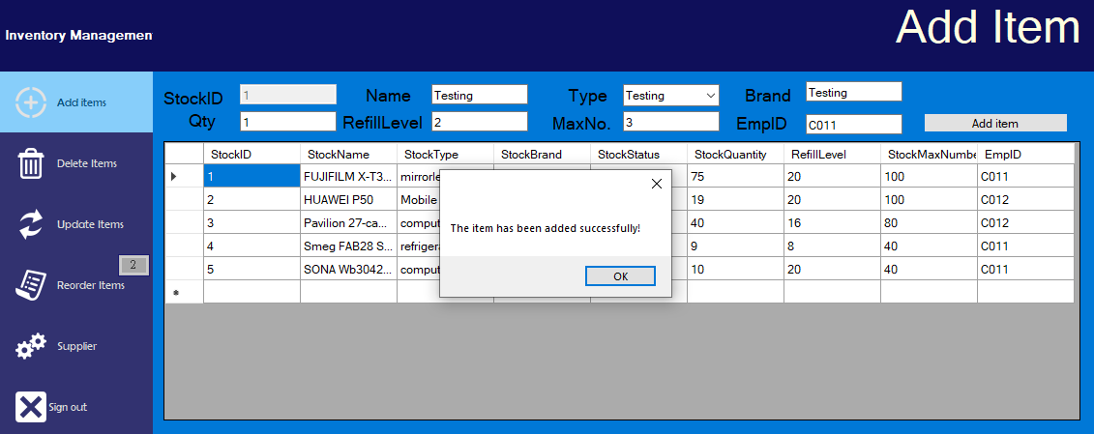

1. Now, the form is showed on the table.

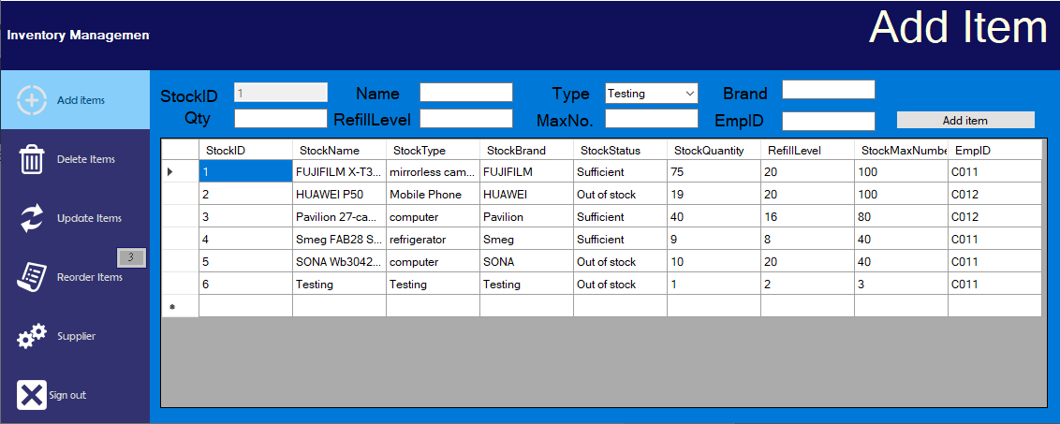

1. Before insert the form information into the system, the system will check whether the item information is all filled in. If not, the system will show the error message.

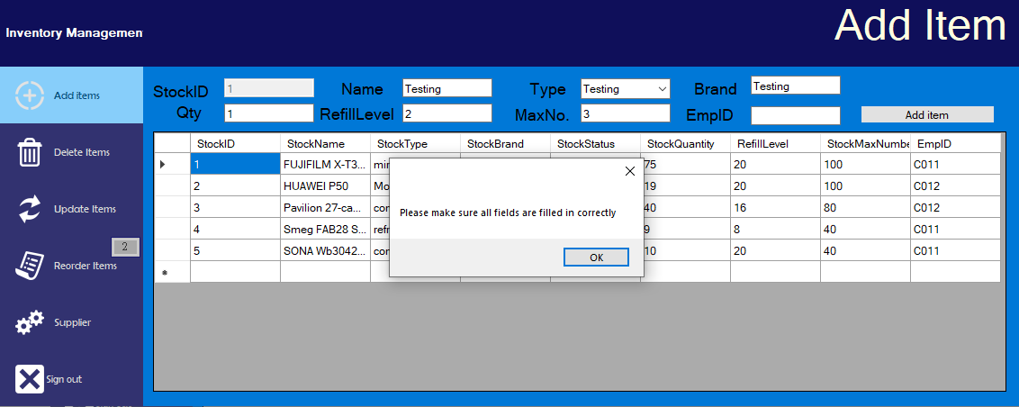

**Delete items**

**1. Select the Delete items menu.**

**2. Full in item information (Click the cell text in the grid view.)**

**3. Select the Delete item button.**

**4. After submitted the form, the system will show the successful message.**

**5. Now, the form is deleted from the table.**

1. Select the Delete items menu.

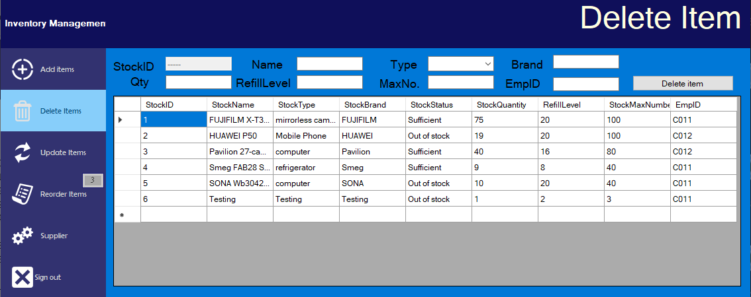

1. Full in item information (Click the cell text in the grid view.)

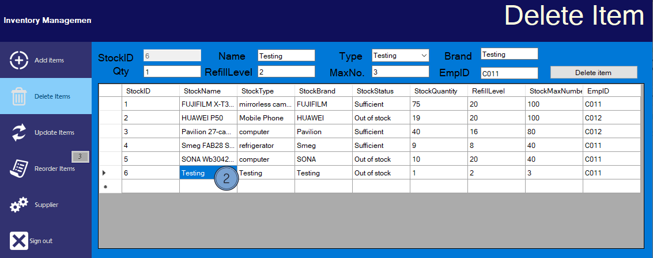

1. Select the Delete item button.

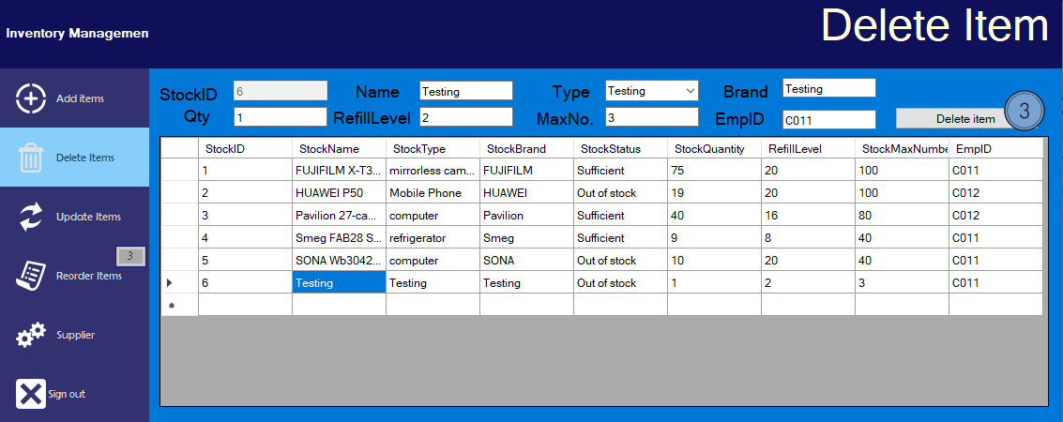

1. After submitted the form, the system will show the successful message.

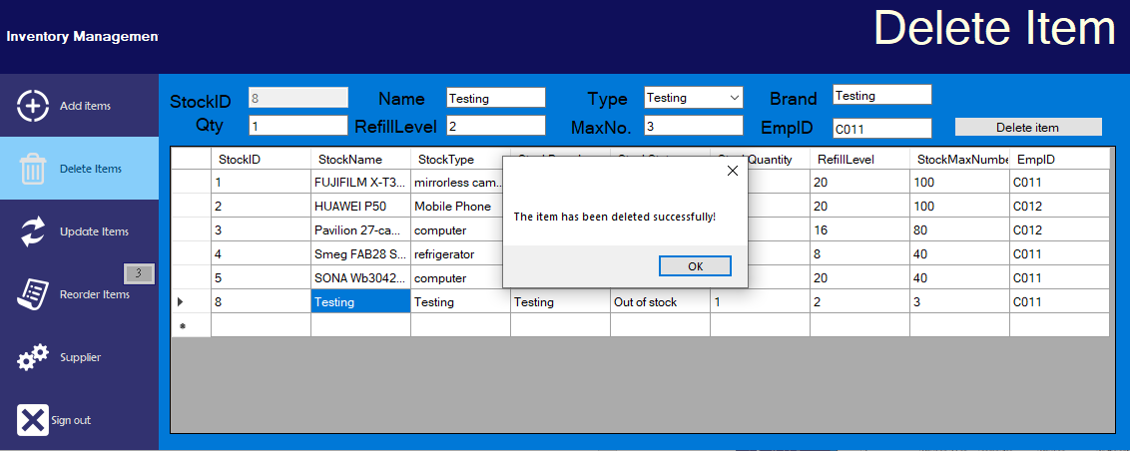

1. Now, the form is deleted from the table.

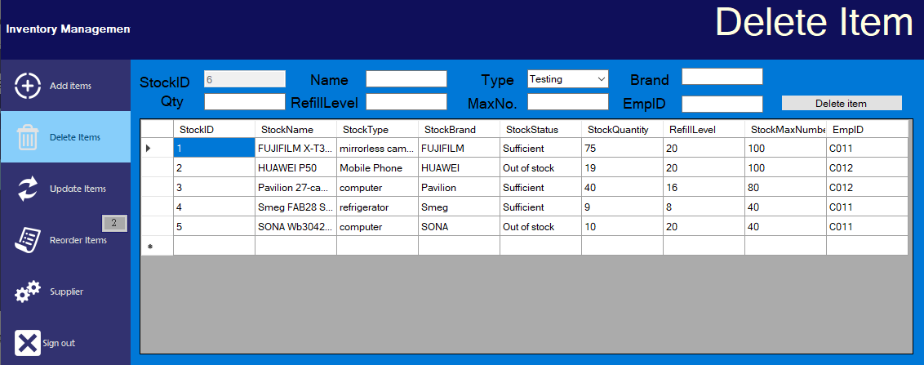

**Update items**

**1. Select the Update items menu.**

**2. Fill in item information (You can click the cell in the grid view to fill in the form quicker.)**

**3. Select the Update item button.**

**4. After submitted the form, the system will show the successful message.**

**5. Now, the form is updated to the table.**

**6. Before insert the form information into the system, the system will check whether the item information is all filled in.**

1. Select the Update items menu.

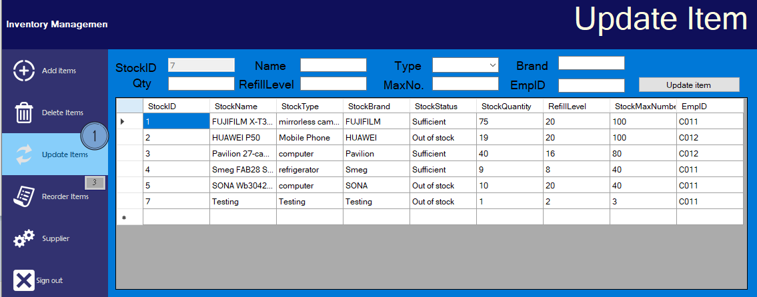

1. Fill in item information (You can click the cell in the grid view to fill in the form quicker.)

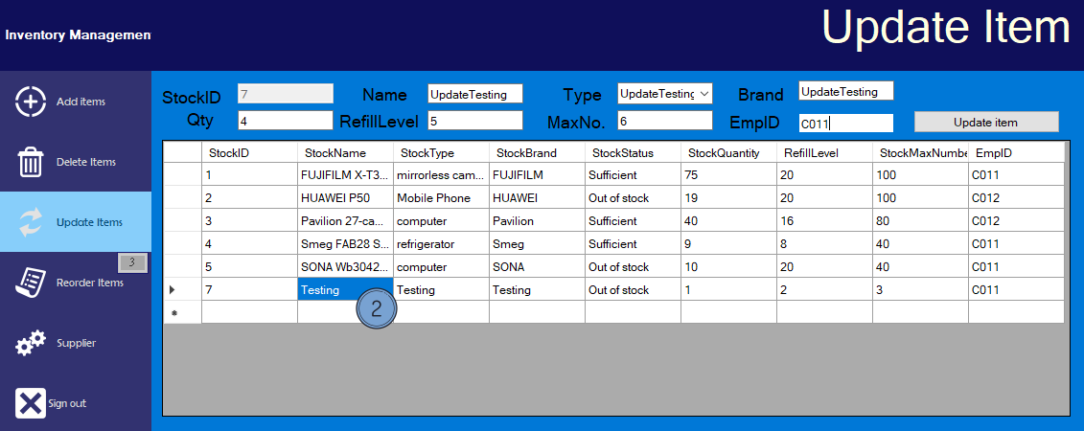

1. Select the Update item button.

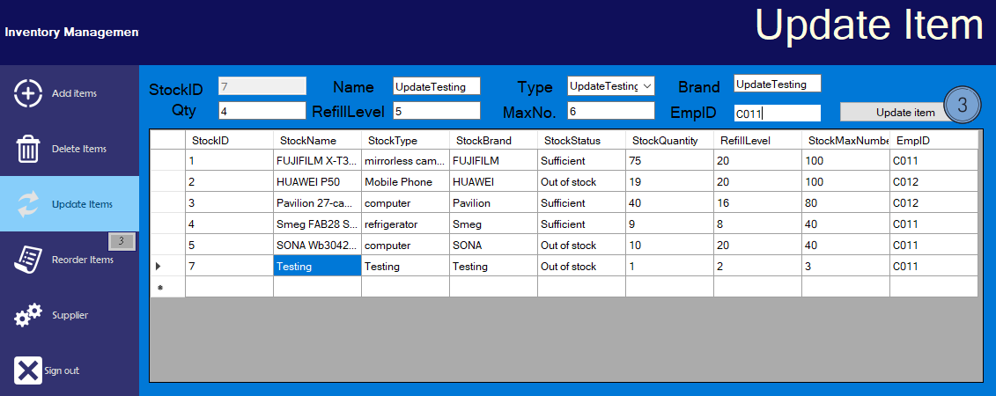

1. After submitted the form, the system will show the successful message.

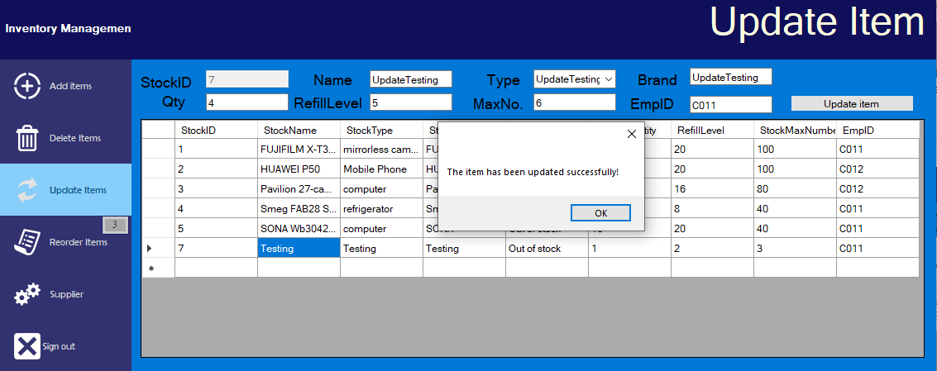

1. Now, the form is updated to the table.

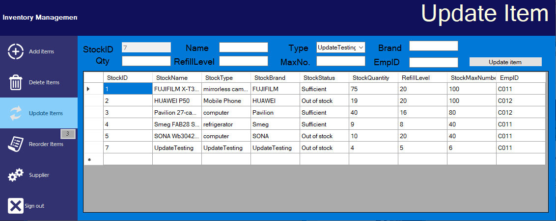

1. Before insert the form information into the system, the system will check whether the item information is all filled in.

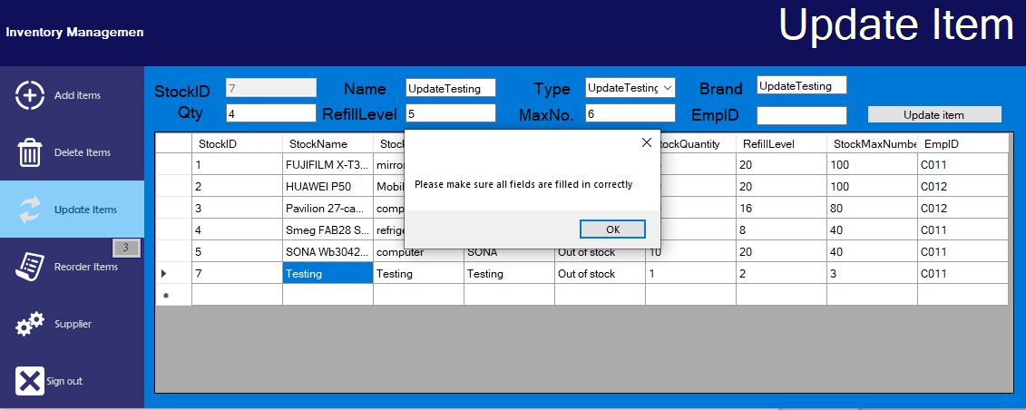

**Supplier (Add)**

**1. Select the Supplier items menu.**

**2. Full in Supplier information (You can select the cell in the grid view to fill in the form quicker.)**

**3. Select the “Add” button.**

**4. After submitted the form, the system will show the successful message.**

**5. Now, the form is showed on the table.**

1. Select the Supplier items menu.

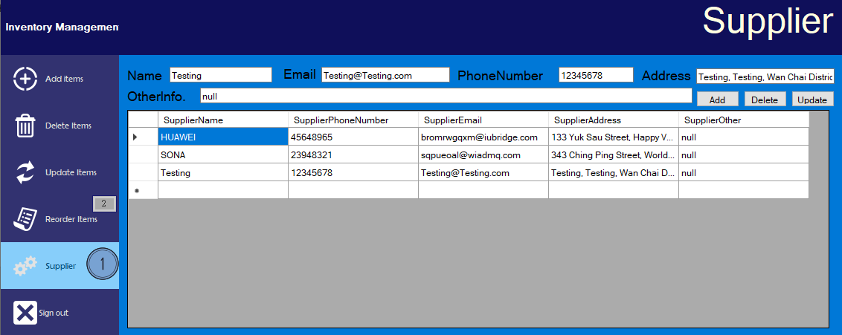

1. Full in Supplier information (You can select the cell in the grid view to fill in the form quicker.)

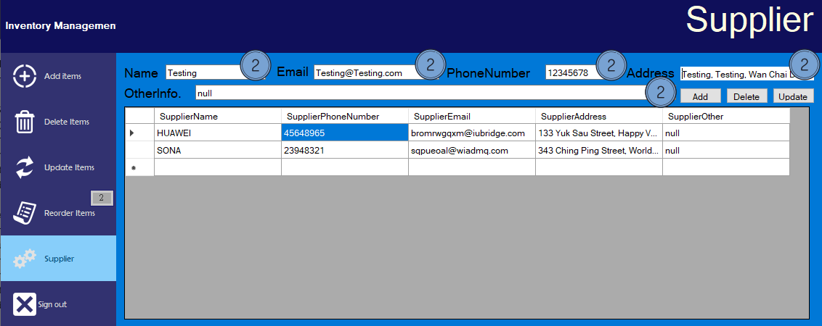

1. Select the “Add” button.

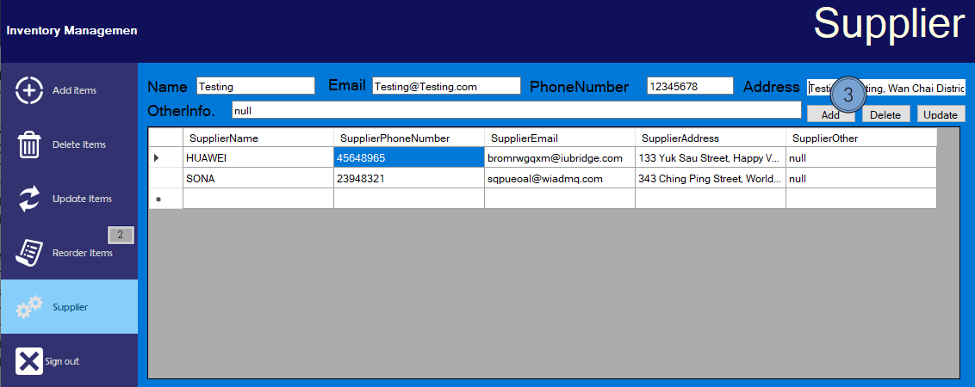

1. After submitted the form, the system will show the successful message.

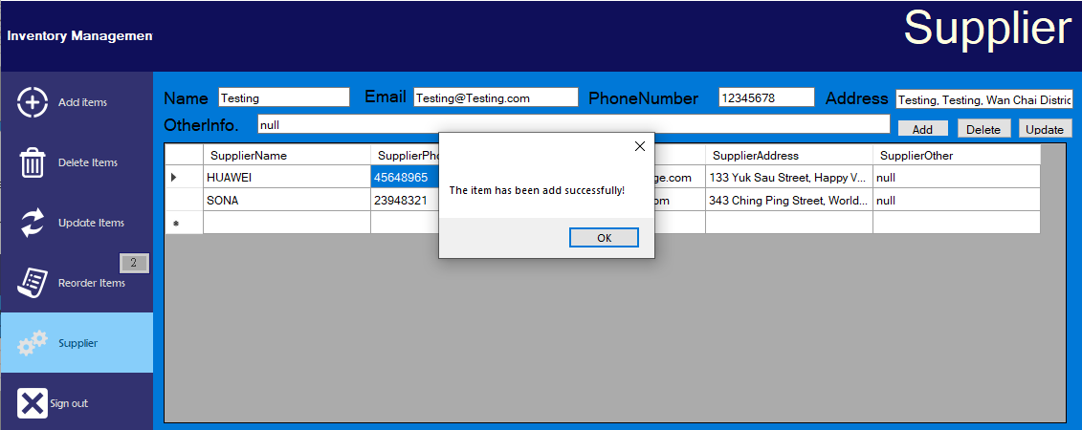

1. Now, the form is showed on the table.

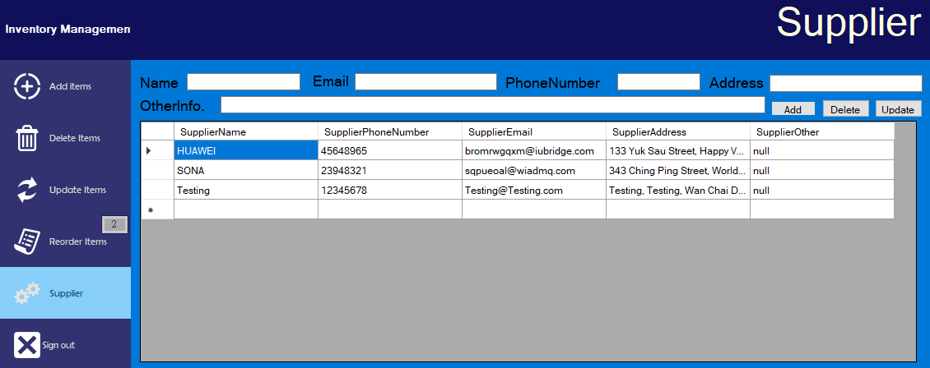

**Supplier (Delete)**

**1. Select the Supplier items menu.**

**2. Full in Supplier information (Click the cell text in the grid view.)**

**3. Select the “Delete” button.**

**4. After submitted the form, the system will show the successful message.**

**5. Now, the form is showed on the table.**

1. Select the Supplier items menu.



1. Full in Supplier information (Click the cell text in the grid view.)



1. Select the “Delete” button.

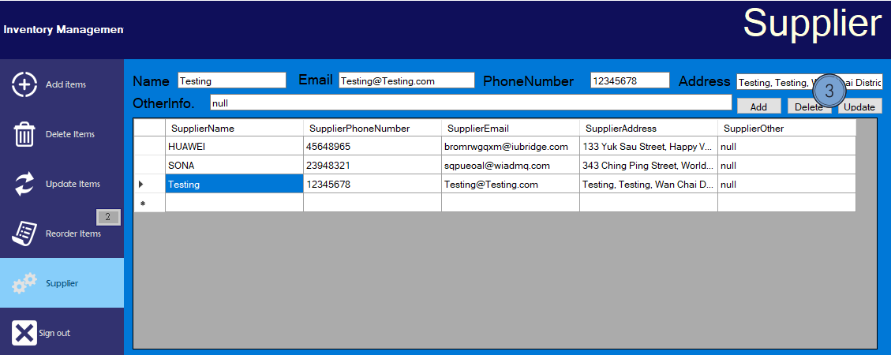

1. After submitted the form, the system will show the successful message.

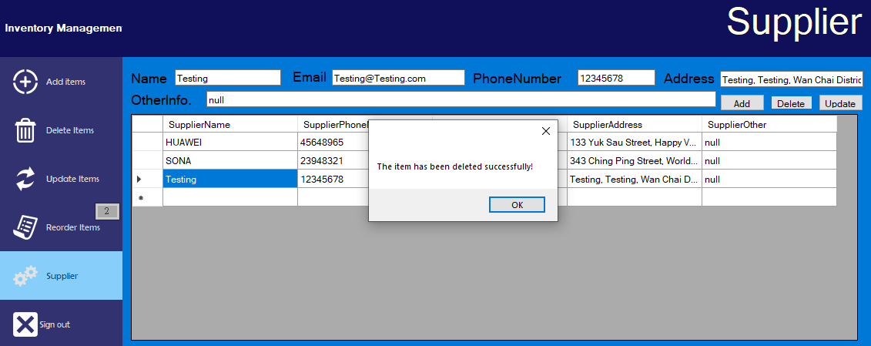

1. Now, the form is showed on the table.

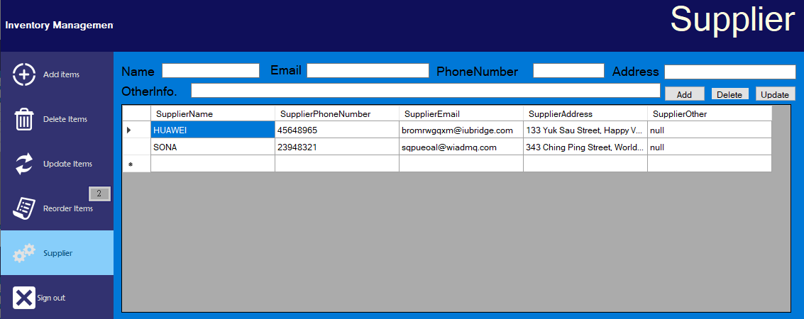

**Supplier (Update)**

**1. Select the Supplier items menu.**

**2. Full in Supplier information (Click the cell text in the grid view.)**

**3. Select the “Update” button.**

**4. After submitted the form, the system will show the successful message.**

**5. Now, the form is showed on the table.**

1. Select the Supplier items menu.



1. Full in Supplier information (Click the cell text in the grid view.)

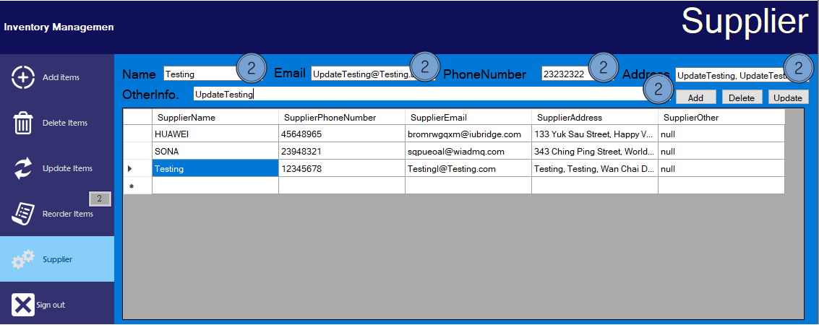

1. Select the “Update” button.

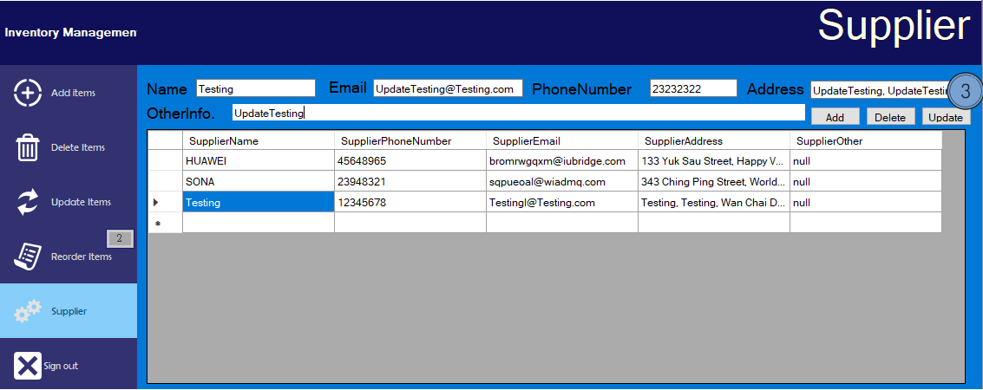

1. After submitted the form, the system will show the successful message.

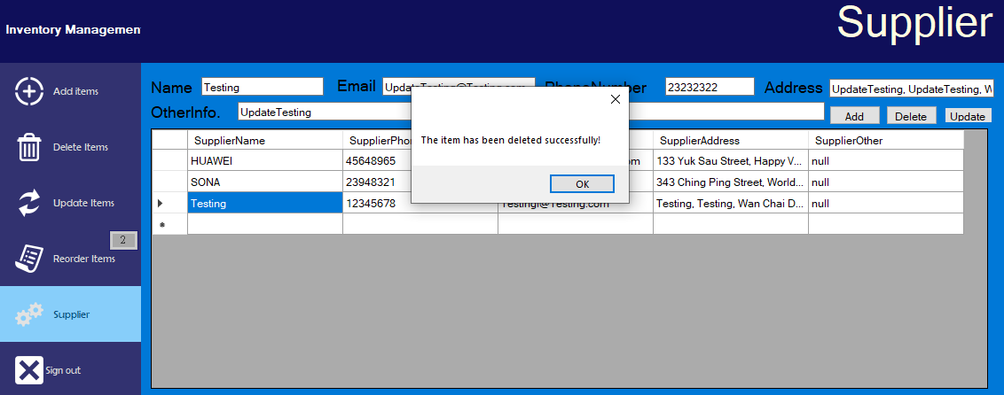

1. Now, the form is showed on the table.

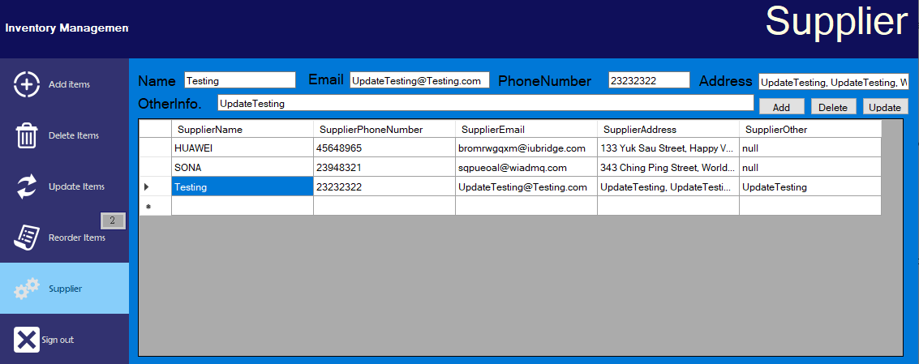

**Reorder items**

**1. Select the Update items menu.**

**2. The menu shows the item that is “Out of stock”. (StockQuantity < ReorderLevel).**

**3. Full in item information (You can select the cell in the grid view to fill in the form quicker.)**

**4. Select the Confirm button.**

**5. After submitted the form, the system will show the successful message.**

**6. Click the “View Ordering Item” button.**

**7. The reorder item that we just insert, is now shown on the “Ordering list”.**

**8. Before insert the form information into the system, the system will check whether the item information is all filled in.**

1. Select the Update items menu.

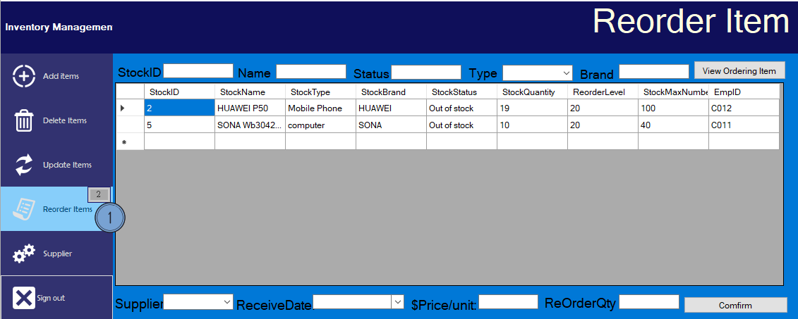

1. The menu shows the item that is “Out of stock”. (StockQuantity < ReorderLevel).

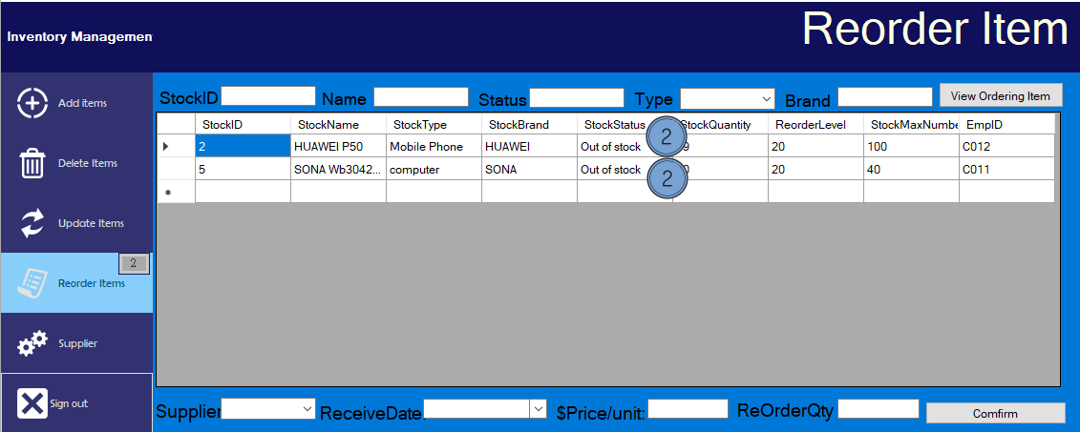

1. Full in item information (You can select the cell in the grid view to fill in the form quicker.)

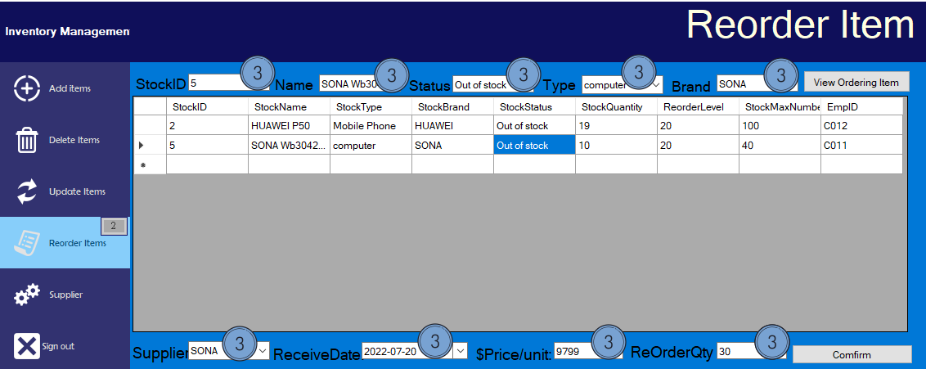

1. Select the Confirm button.

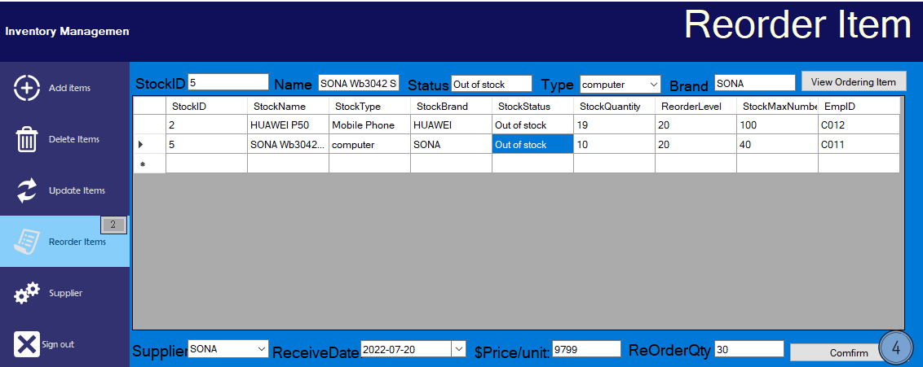

1. After submitted the form, the system will show the successful message.

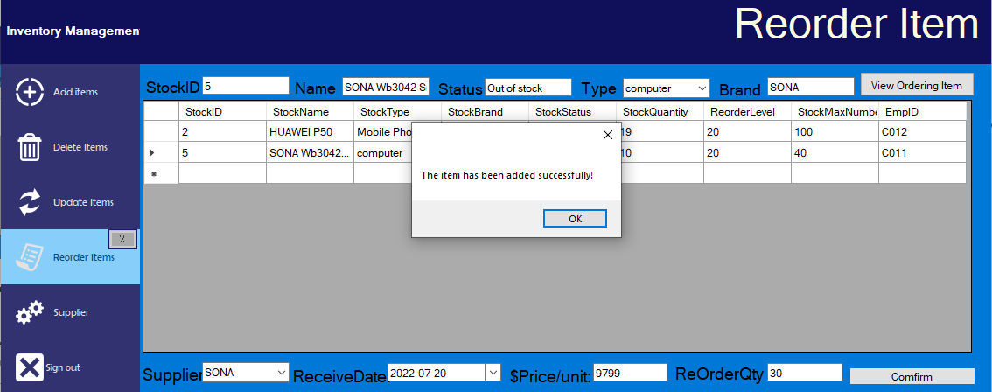

1. Click the “View Ordering Item” button.

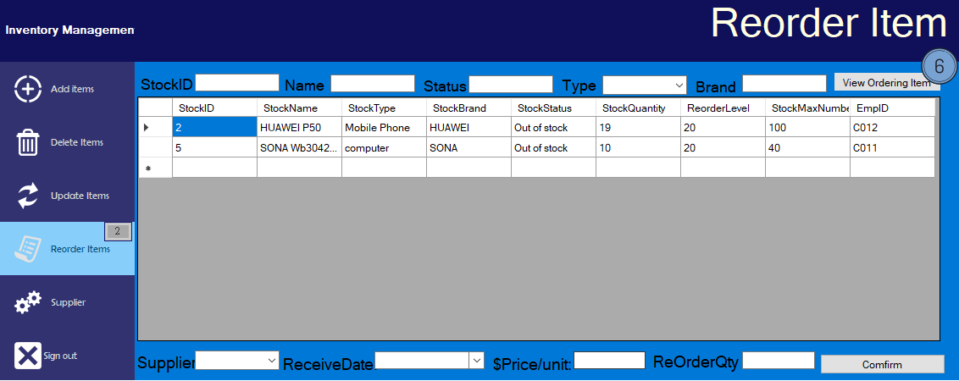

1. The reorder item that we just insert, is now shown on the “Ordering list”.

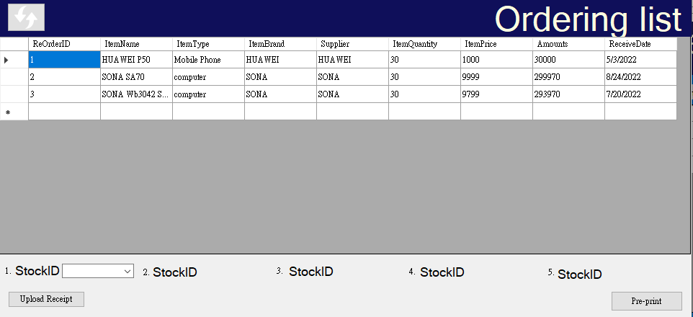

1. Before insert the form information into the system, the system will check whether the item information is all filled in.

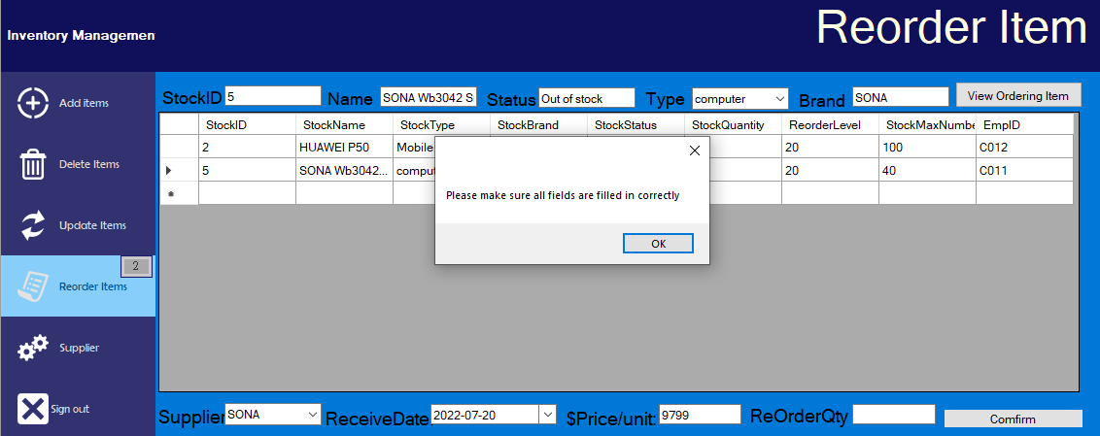

**Return inwards items**

**(Print Goods Receive Note)**

**1. Click the “View Ordering Item” button, and the “Ordering list” is shown.**

**2. Choose the Stock ID that is return inwards items.**

**3. Click the “Pre-print” button.**

**4. The Goods Receive Note is showed on the screen.**

**5. Click the “Print” button.**

**6. Prompt a print screen box.**

**7. Select “Microsoft Print to PDF” and click “OK” button.**

**8. Choose the save location path in the computer and click “Save” button.**

**9. The PDF is saved on the computer.**

**(Upload Goods Receive Note)**

**10. Click the “Upload Receipt” button.**

**11. Choose the receipt that we just signed.**

**12. Click “OK” button.**

**(Delete the Ordering Item)**

**13. Input Order ID of the item to be delete.**

**14. Click the “Delete Order” button.**

**15. The item is deleted successfully.**

**16. Click the “refresh” button.**

**17. The ordering item is deleted.**

(Print Goods Receive Note)

1. Click the “View Ordering Item” button, and the “Ordering list” is shown.

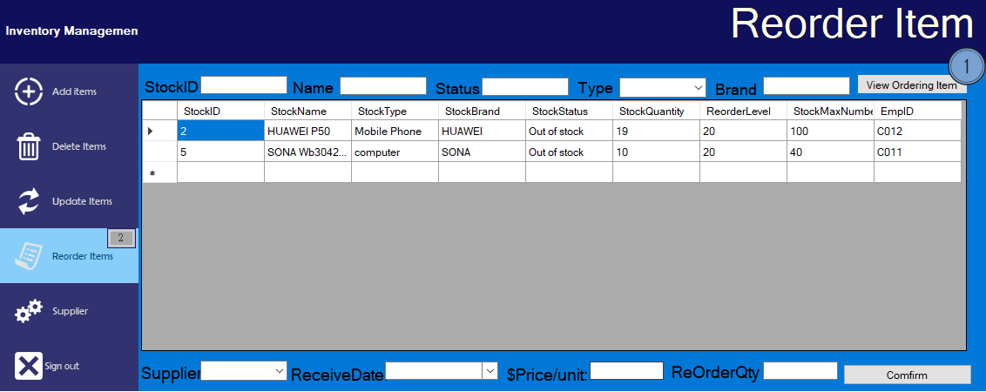

1. Choose the Stock ID that is return inwards items.

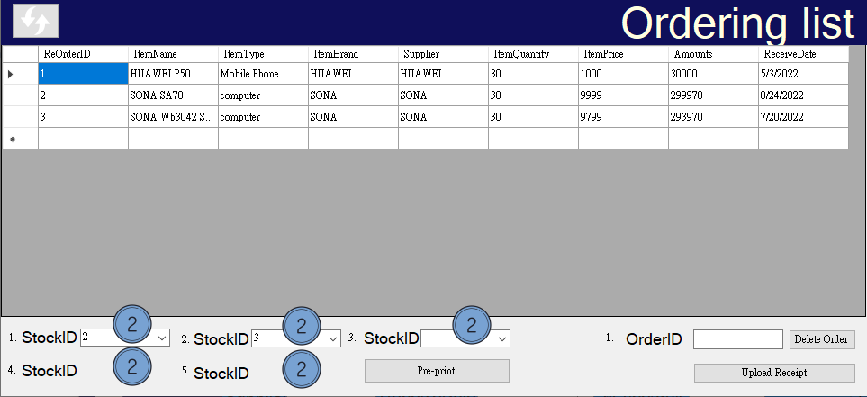

1. Click the “Pre-print” button.

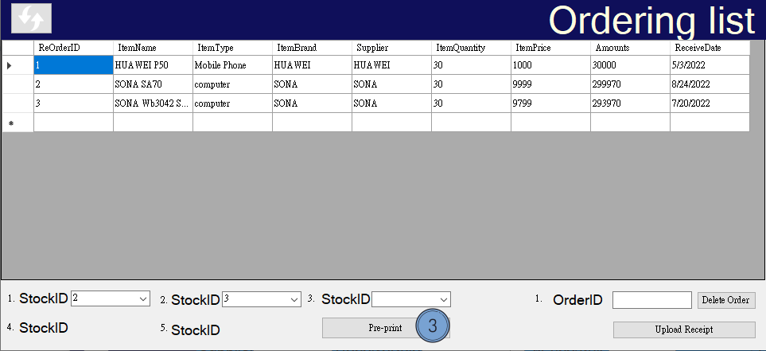

1. The Goods Receive Note is showed on the screen.

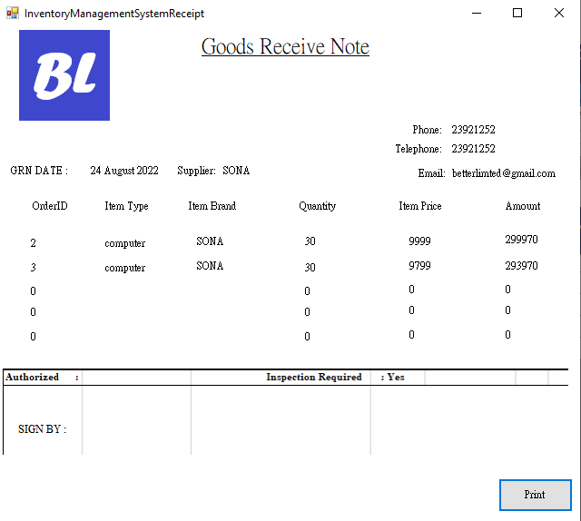

1. Click the “Print” button.

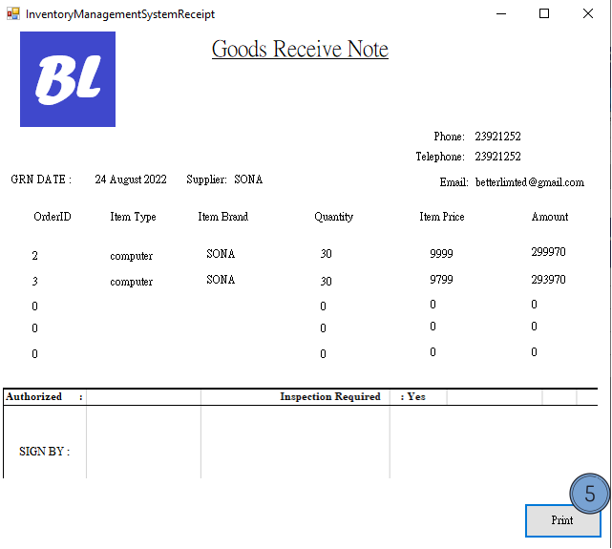

1. Prompt a print screen box.

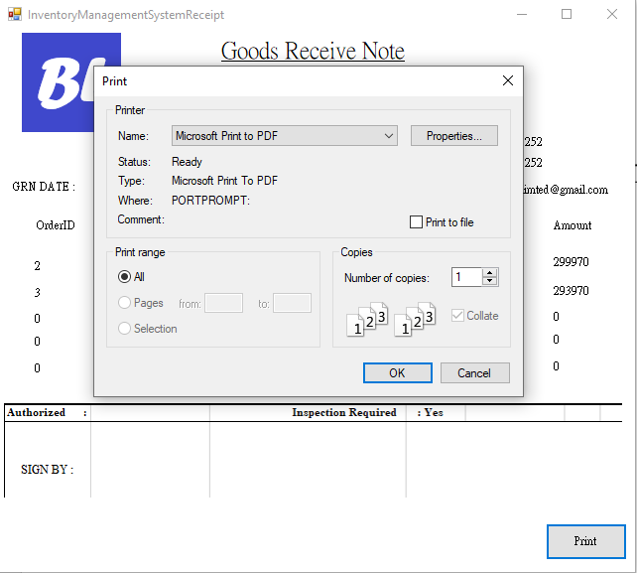

1. Select “Microsoft Print to PDF” and click “OK” button.

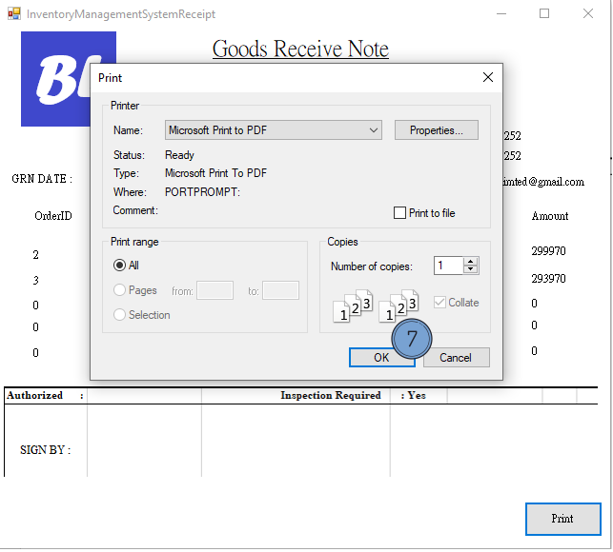

1. Choose the save location path in the computer and click “Save” button.

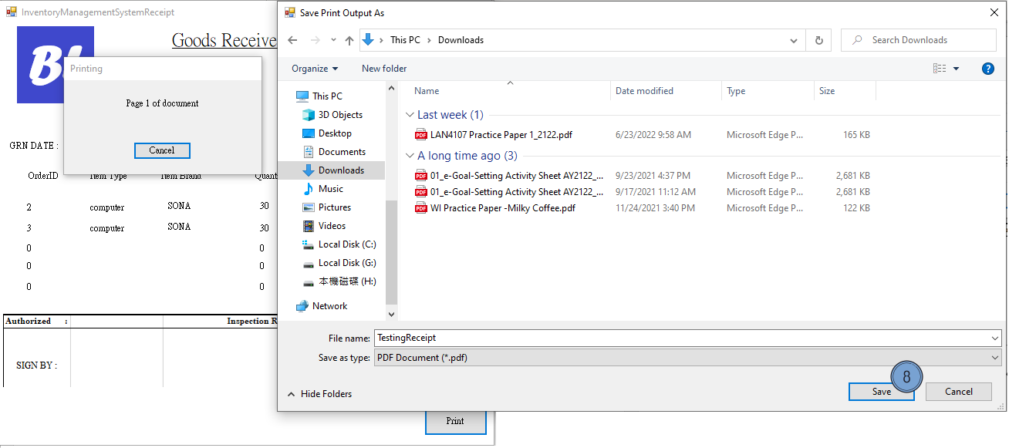

1. The PDF is saved on the computer.

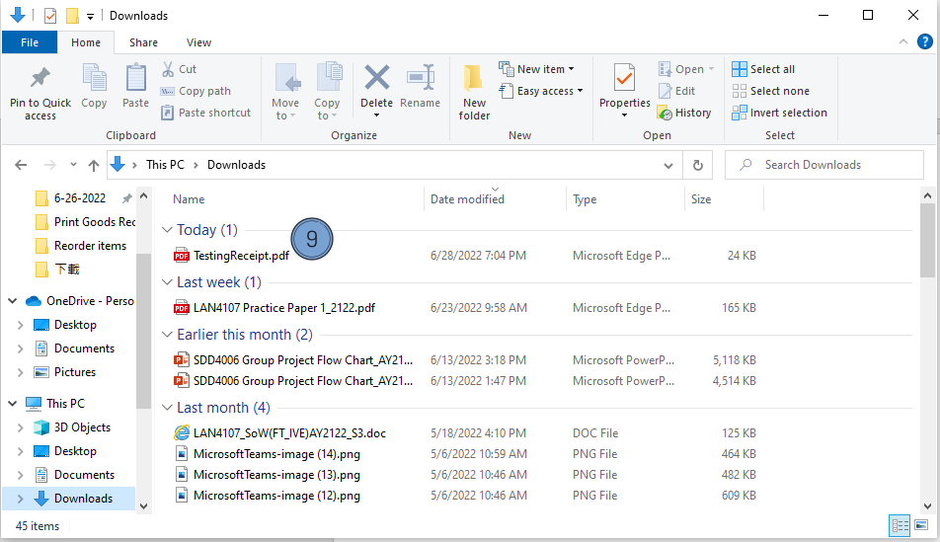

(Upload Goods Receive Note)

1. Click the “Upload Receipt” button.

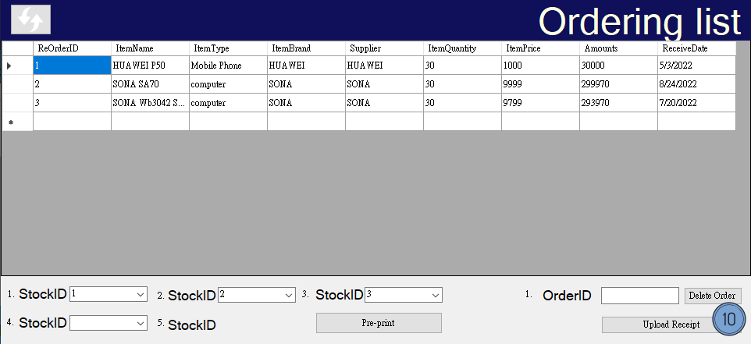

1. Choose the receipt that we just signed.

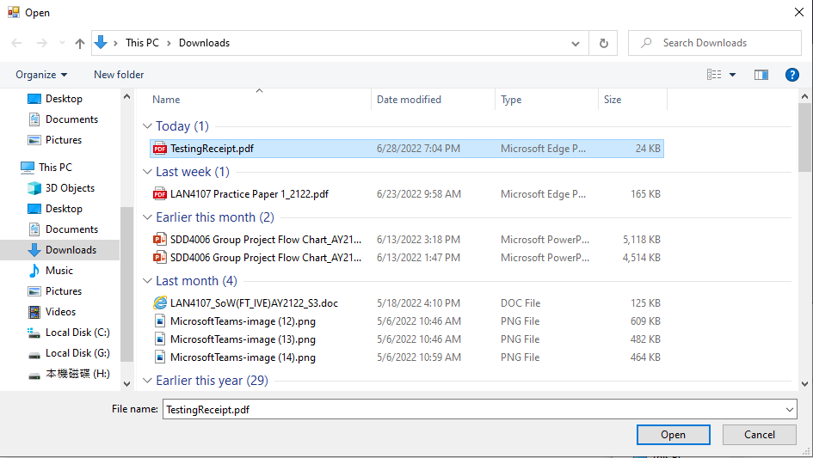

1. Click “OK” button.

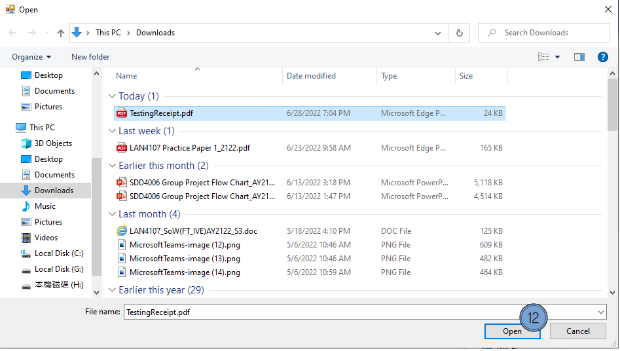

(Delete the Ordering Item)

1. Input Order ID of the item to be delete.

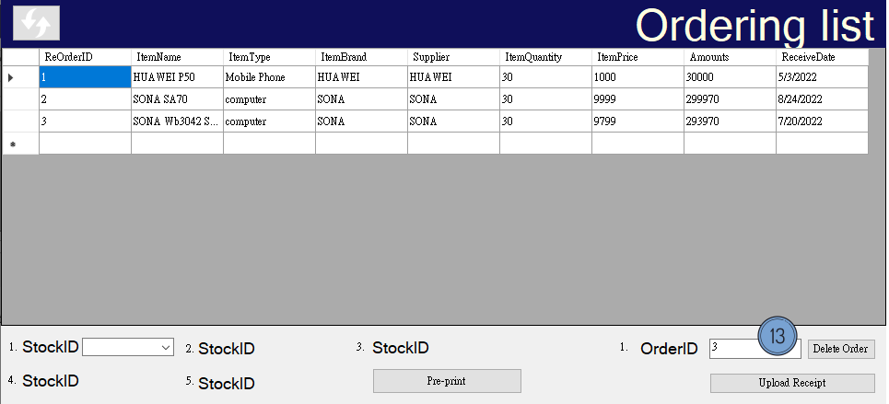

1. Click the “Delete Order” button.

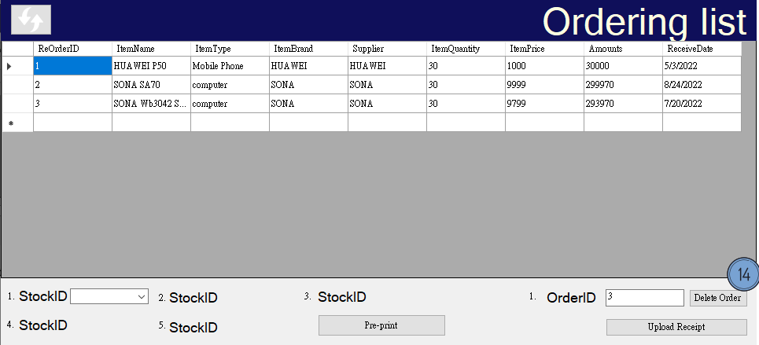

1. The item is deleted successfully.

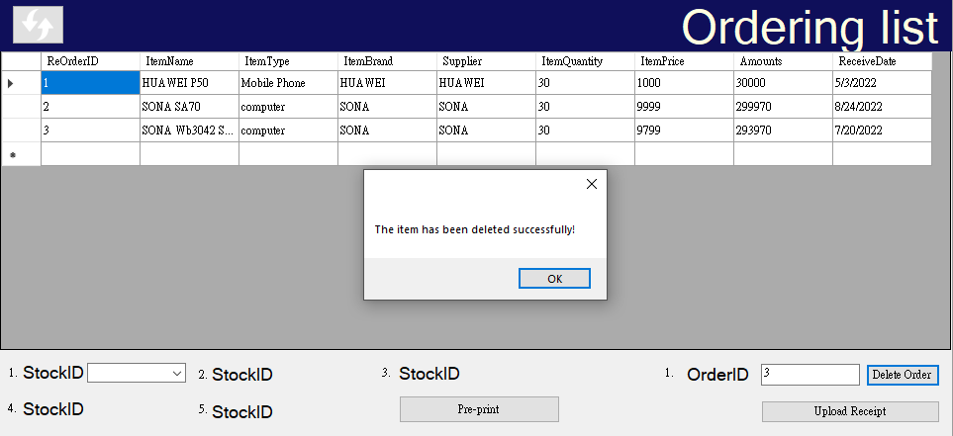

1. Click the “refresh” button.

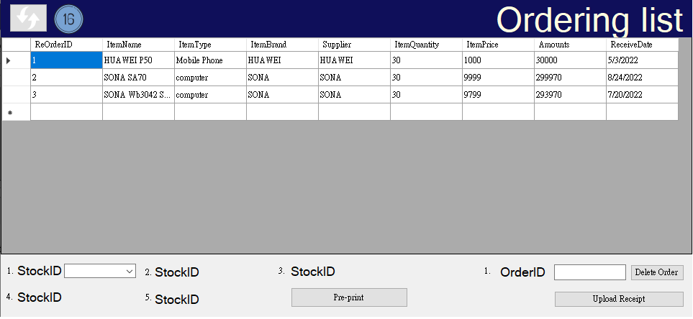

17. The ordering item is deleted.

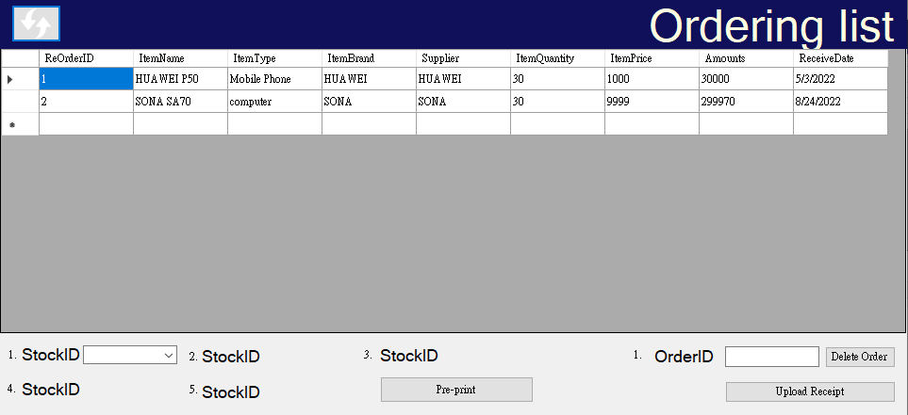

1. How ITP4510, ITP4522 and ITP4915M modules help you to finish the project

**ITP4510:**

In respect of the learning effectiveness and learning outcome in ITP4510. We have understood that how an algorithm or which type of algorithm is the most effective way for a program to work. Also, linked list, stack, queue, these are all the storing method that I have learnt from 4510. We have known more about how a search tree work, and read different pseudocode about search method.

Besides, ITP4510 taught me how to check for errors and helped me handle errors in the process of completing this assignment. Exception handling is very helpful for us to debug the program. We add appropriate try and catch statements for my program when designing the activity which include IO exception and runtime exception. Also, we will add the appropriate print-out message for the exception to help us to debug the program.

Therefore, after learning all of these data structure, we have an initial concept on how the data be store and how to search them in an effective way, the Big O notation had let us to know the code method affect the speed of the program run. ITP4510 has taught us how to check for errors and helped me handle errors in the process of completing this assignment.

**ITP4522:**

Regarding the learning effectiveness and learning outcome in ITP4522. This covers the basic process of how to build an application in planning phase, SDLC (Planning, Analysis, Design, Implementations), and what the system will do in analysis phase. We need to finish the programs in design phase and test the program is running correctly and solve errors in implementation phase.

In addition, we have learnt that a good project should be able to boosts project performance and the rate of success, since a good project planning include a good goal mapping and good resources searching. With all of these, we can avoid almost all of the problems that lead to project failure with proper project planning.

All in all, the assignment in ITP4522 help us to learnt how to finish an project with others effectively, and so it gives the potential and power for me to think about what should we do before actually start doing the project, since if we do not have a good project planning, it means that we don’t have a clear work goal and direction in finishing a project, and so we might lose our direction when doing the project.

**ITP4915M:**

With regards to the learning effectiveness and learning outcome in ITP4915M. This program requires action to make a C# application. During the production process, we practiced designing UI and database applications, which helped us to design UI and use database proficiently in this assignment.

Moreover, it has improved our team communication ability, since the assignment in ITP4915m is to do a company system with my groupmate. It has gain us a lot of experience in working for smooth project execution, and this can fit and apply to many projects with different size and type.

In conclude, the most encouraging and inspired to us is to keep hard-working, since finishing a big project is not an easy job, we need to keep communicate with our groupmate, and we've applied the outcome of learnt in 4915m for keeping us work hard. After finishing all of the above subject, we had learnt how to coordinate with our groupmate, and keep our motivation in doing the 4915M assignment.

**18. Conclusion**

Engaging in an unknown market that a company never steps in is a hazardous move, so a well-developed system is definitely needed for facing the challenge of expanding business. Nowadays, many data is stored in the computer system, since the computerized data can transmit in any place and anywhere, which is extremely conform to our current need, transmitting the data between Hong Kong and Pearl River Delta Region. Imagine if we remain the manual system, how can we transmit the business information, like the product price, returns inwards or returns outwards between 2 places immediately.

According to the Better Limited current situation, we found that they are using the hardcopy record of item prices and data record in each store, which cannot process and view the file in an efficient way, causing data redundancy and data inconsistency. Thus, it may lead to confusion of management, and causing losses for the company.

Due to the above situation, we are going to develop a **computerize management system for the company for the** Better Limited in order to replace the old storage and delivery system, the system would be including the order and delivery function, it also helps improve the efficiency of the store, and avoiding Data inconsistency.

Apart from that, we find out there is serval problems in developing the new system, which is Network security issues, System overload, System data backed up problem, System Data inconsistency, Access Control, Inventory management, delivery issues, and the stock level system.

To duel with these problems, some function would be required and involved in the system, These function and module, including Login, UI Language Changing, Select the Sales Order Type, Inventory Level, Generate Receipt, Requesting, Delivery Note Delivery Generation, Approval and Data Analysis, etc. All of these function would be the basic component of our new system.

Overall, the new computerized management system would be beneficial to the company, ecstatically for a company who decides to extend their business. The new system can provide a supportive platform for our company, and it brings a friendly and a stability environment to our users.

**19. Project Log**

|  |  |  |
| --- | --- | --- |
| DATA | ITEM | RESPONSIBLE |
| 2022-2-12 | Abstract | WONG WING FUNG |
| 2022-2-13 | Introduction | WONG WING FUNG |
| 2022-2-15 | Problem Findings | WONG WING FUNG |
| 2022-2-15 | Functional Requirement | LI Zhi Wei |
| 2022-2-15 | Non-Functional Requirement | Hui kwai shing |
| 2022-2-15 | Driving Question | Tam Chi Ka |
| 2022-3-5 | System Analysis and design | Hui kwai shing  LI Zhi Wei |
| 2022-3-8 | Use Case | Hui kwai shing  LI Zhi Wei |
| 2022-3-8 | Class Diagram | Hui kwai shing |
| 2022-3-9 | System Architecture | WONG WING FUNG |
| 2022-3-9 | Planning schedule | WONG WING FUNG |
| 2022-3-9 | Constraints and limitations | Tam Chi Ka |
| 2022-3-15 | Entity relation diagram | WONG WING FUNG |
| 2022-3-18 | State machine diagram | Hui Kwai Shing  LI Zhi Wei  Tam Chi Ka |
| 2022-3-19 | Sequence diagram | Hui Kwai Shing  LI Zhi Wei  Tam Chi Ka |
| 2022-3-21 | Conclusion | Tam Chi Ka |
| 2022-6-28 | UI design | Hui Kwai Shing  LI Zhi Wei  Tam Chi Ka  WONG WING FUNG |
| 2022-6-29 | Test Case | Hui Kwai Shing  LI Zhi Wei  Tam Chi Ka  WONG WING FUNG |
| 2022-6-29 | User Guideline | Hui Kwai Shing  LI Zhi Wei  Tam Chi Ka  WONG WING FUNG |
| 2022-6-30 | How ITP4510, ITP4522 and ITP4915M modules help you to finish the project | Hui Kwai Shing  LI Zhi Wei  Tam Chi Ka  WONG WING FUNG |

**20. Reference**

.Lippman, D. (n.d.). *Lumen learning mathematics for the Liberal Arts*. Lumen. Retrieved April 1, 2022, from https://courses.lumenlearning.com/math4liberalarts/chapter/introduction-representing-data-graphically/

*.What is a cyber attack?* IBM. (n.d.). Retrieved April 1, 2022, from https://www.ibm.com/topics/cyber-attack

*.What is an internal firewall?: Vmware glossary*. VMware. (2022, March 24). Retrieved April 1, 2022, from https://www.vmware.com/topics/glossary/content/internal-firewall.html

.Kaspersky. (2021, July 5). *What is VPN? how it works, types of VPN*. www.kaspersky.com. Retrieved April 1, 2022, from https://www.kaspersky.com/resource-center/definitions/what-is-a-vpn

*.Definition of buffer*. PCMAG. (n.d.). Retrieved April 1, 2022, from https://www.pcmag.com/encyclopedia/term/buffer

*.What is a distributed system? how a ... - stackpath blog*. (n.d.). Retrieved March 31, 2022, from https://blog.stackpath.com/distributed-system/

.Contributor, T. T. (2005, April 5). *What is refresh rate? - definition from whatis.com*. WhatIs.com. Retrieved April 1, 2022, from https://whatis.techtarget.com/definition/refresh-rate

*.What is an audit log? definition and software 2020*. DNSstuff. (2020, October 12). Retrieved April 1, 2022, from https://www.dnsstuff.com/what-is-audit-log

.Contributor, T. T. (2005, August 25). *What is module? - definition from whatis.com*. WhatIs.com. Retrieved April 1, 2022, from https://whatis.techtarget.com/definition/module

*.UX/UI傻傻分不清楚？其實差很多！*. Gremlin Works. (2021, January 18). Retrieved April 1, 2022, from https://gremlinworks.com.tw/ui-ux/ui-ux-comparison/

.Mailslask, F. (n.d.). *Where are fractal design serial numbers located*. Fractal Design Support. Retrieved April 1, 2022, from https://support.fractal-design.com/support/solutions/articles/4000028856-where-is-the-serial-number-located-

.Wisdomjobs. (1970, April 1). *What is Stock Register format: Wisdom Jobs India*. Wisdom Jobs. Retrieved April 1, 2022, from https://www.wisdomjobs.com/careeredge/what-is-stock-register-format-2957

*.Message bars*. Photon Design System. (n.d.). Retrieved April 1, 2022, from https://design.firefox.com/photon/components/message-bars.html

*.What is a rollback?* What is a Rollback? (2017, October 17). Retrieved April 1, 2022, from https://www.computerhope.com/jargon/r/rollback.htm

.Jones, M., & Martin JonesMartin Jones is a Senior Manager and Editor for CoxBLUE at Cox Business covering business technology. (n.d.). *Martin Jones*. Cox BLUE. Retrieved April 1, 2022, from <https://www.coxblue.com/how-to-setup-a-maintenance-schedule-for-your-business-technology-and-what-to-include/>

*.What's a good SQL server backup schedule?* Database Administrators Stack Exchange. Retrieved April 1, 2022, from https://dba.stackexchange.com/questions/26910/whats-a-good-sql-server-backup-schedule

*.Operational benefits of an advanced computerized procedures system*. IEEE Xplore. (n.d.). Retrieved April 1, 2022, from https://ieeexplore.ieee.org/abstract/document/474658

1. mainly represented graphically: <https://courses.lumenlearning.com/math4liberalarts/chapter/introduction-representing-data-graphically/>
2. **cyber-attacks:** [**https://www.ibm.com/topics/cyber-attack**](https://www.ibm.com/topics/cyber-attack)
3. **internal firewall:** [**https://www.vmware.com/topics/glossary/content/internal-firewall.html**](https://www.vmware.com/topics/glossary/content/internal-firewall.html)
4. **VPN:** [**https://www.kaspersky.com/resource-center/definitions/what-is-a-vpn**](https://www.kaspersky.com/resource-center/definitions/what-is-a-vpn)
5. **Buffer:** [**https://www.pcmag.com/encyclopedia/term/buffer**](https://www.pcmag.com/encyclopedia/term/buffer)
6. **Distributed system:** [**https://blog.stackpath.com/distributed-system/**](https://blog.stackpath.com/distributed-system/)
7. **data refresh rate:** [**https://whatis.techtarget.com/definition/refresh-rate**](https://whatis.techtarget.com/definition/refresh-rate)
8. **audit log:** [**https://www.dnsstuff.com/what-is-audit-log**](https://www.dnsstuff.com/what-is-audit-log)
9. module: <https://whatis.techtarget.com/definition/module>
10. UI: <https://gremlinworks.com.tw/ui-ux/ui-ux-comparison/>
11. Stock Book: <https://www.wisdomjobs.com/careeredge/what-is-stock-register-format-2957>
12. Roll back: <https://www.computerhope.com/jargon/r/rollback.htm>
13. Maintenance: <https://www.coxblue.com/how-to-setup-a-maintenance-schedule-for-your-business-technology-and-what-to-include/>
14. computerized management system:<https://ieeexplore.ieee.org/abstract/document/474658>